Tumor cell-derived exosomal hybrid nanosystems loaded with rhubarbic acid and tanshinone IIA for sepsis treatment
Qian Wu†^{,1}, Qing-Qing Dong†^{,1}, Si-Hui Wang¹, Yi Lu¹, Yi Shi¹, Xiao-Ling Xu^{*,2}, Wei Chen^{*,1}

¹Longhua Hospital Affiliated to Shanghai University of Traditional Chinese Medicine, Shanghai, PR China;
²Shulan International Medical College, Zhejiang Shuren University, Hangzhou, PR China;

†These authors contributed equally.
*Correspondence to:
Dr. W. Chen (Longhua Hospital Affiliated to Shanghai University of Traditional Chinese Medicine), 725 South WanPing Road, Shanghai, 200032, China. Tel: +86-021-64385700-3522. E-mail: cwdoctor@shutcm.edu.cn;
Dr. X. L. Xu (Shulan International Medical College, Zhejiang Shuren University), 8 Shuren Street, Hangzhou, 310015, China. E-mail: ziyao1988@zju.edu.cn

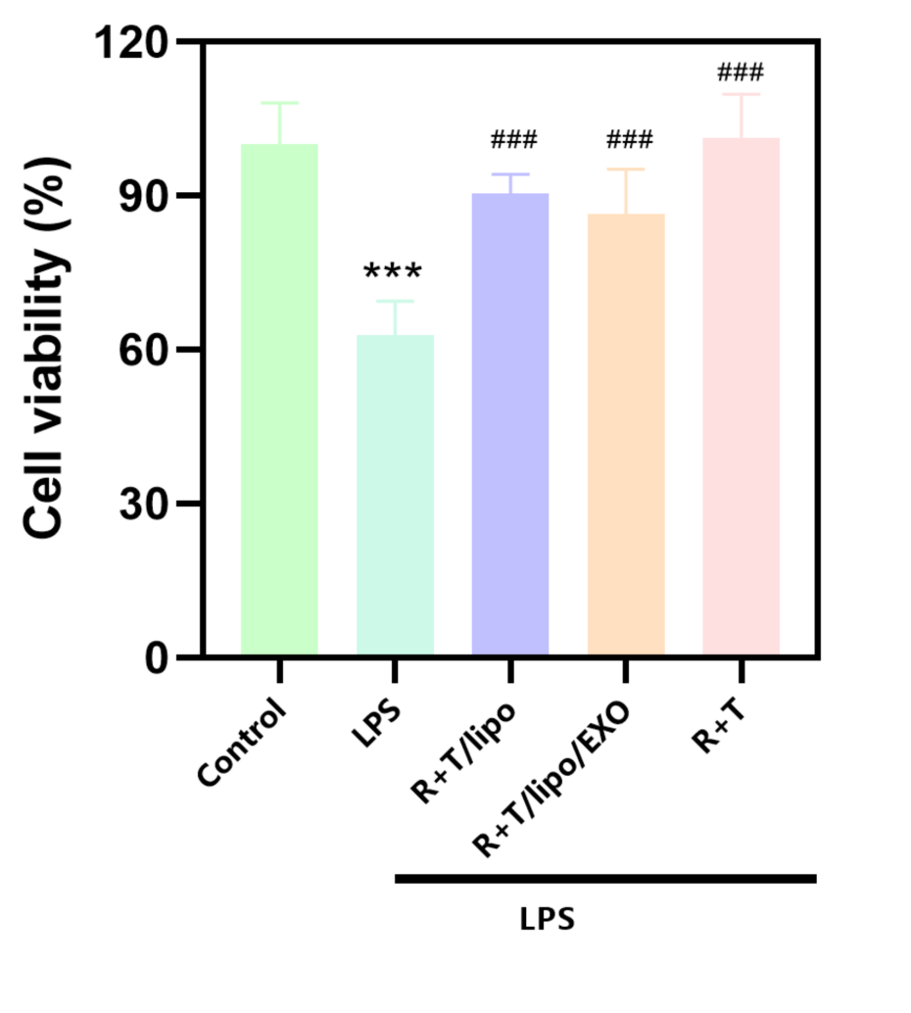
Figure S1. effects of different drug treatments on cell viability (compared with the normal group, *** P<0.001; compared with the LPS group, ### P<0.001)

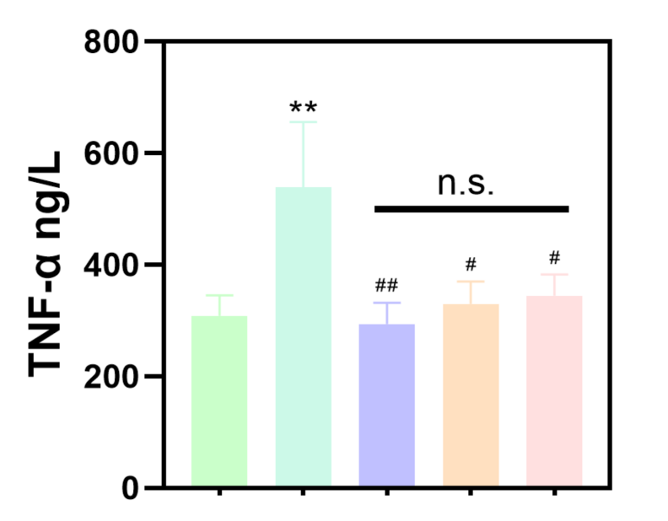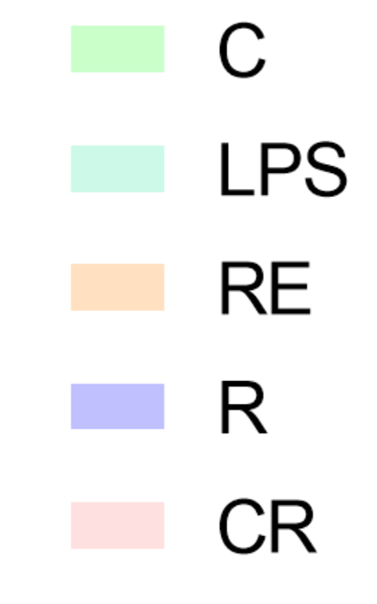

Figure S2. expression of inflammatory factors TNF-αof different drug treatments (compared with the normal group, ** P<0.01; compared with the LPS group, # P<0.05, ## P<0.01; C: Control group; LPS: LPS group; R: LPS+R+T/Lipo group; RE: LPS+R+T/Lipo/EXO group; CR: LPS+R+T group)

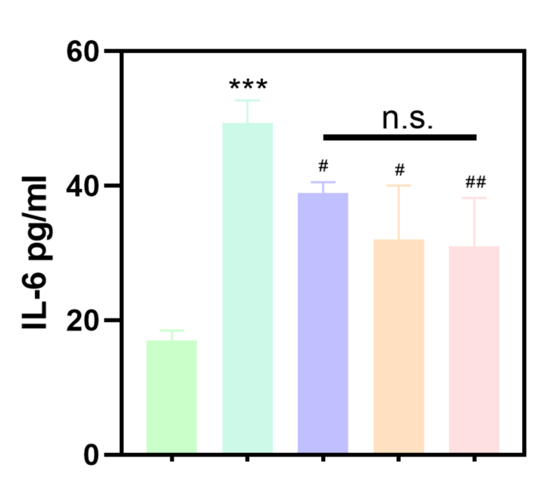
Figure S3. expression of inflammatory factors IL-6 of different drug treatments(compared with the normal group, *** P<0.001; compared with the LPS group, # P<0.05, ## P<0.01;C: Control group; LPS: LPS group; R: LPS+R+T/Lipo group; RE: LPS+R+T/Lipo/EXO group; CR: LPS+R+T group)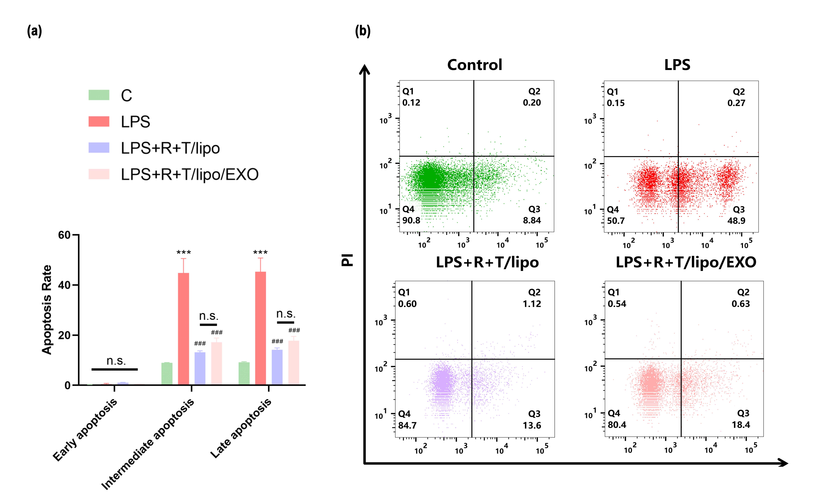

Figure S4. (a) flow cytometry analysis of the effect of nanocomposites on apoptosis (compared with the normal group, *** P<0.001; compared with the LPS group, ### P<0.001; n.s. no statistical difference);(b) flow cytometry detection of the effect of nanocomposites on apoptosis.

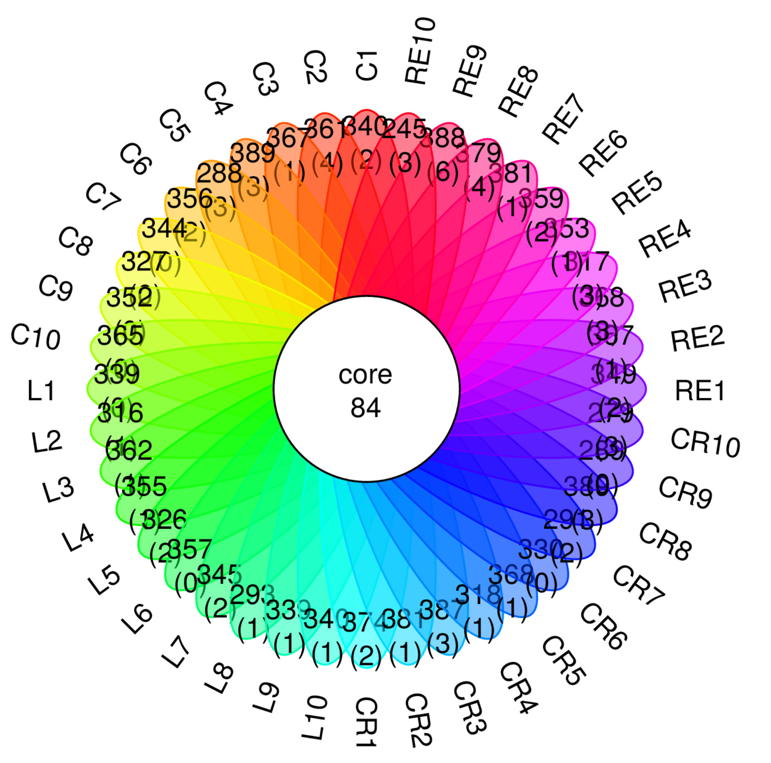

Figure S5. petal diagram of colony grouping;

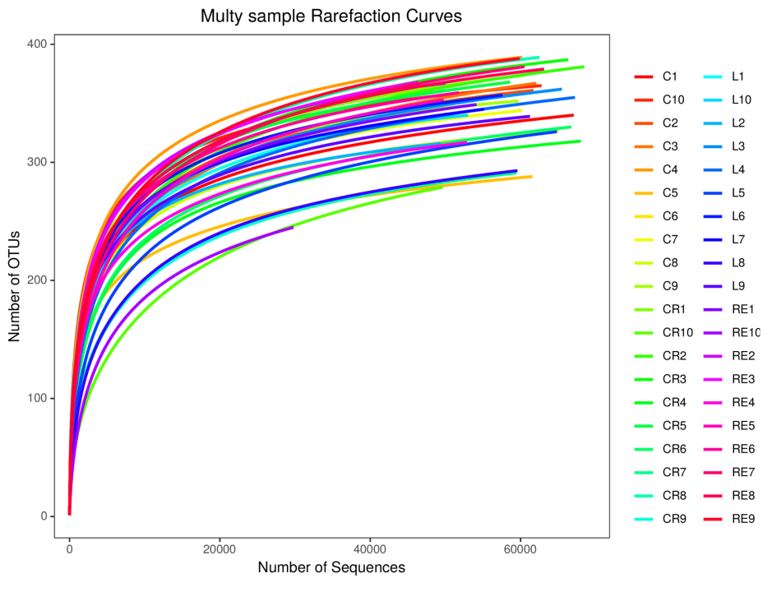
Figure S6. multy sample rarefaction curves;
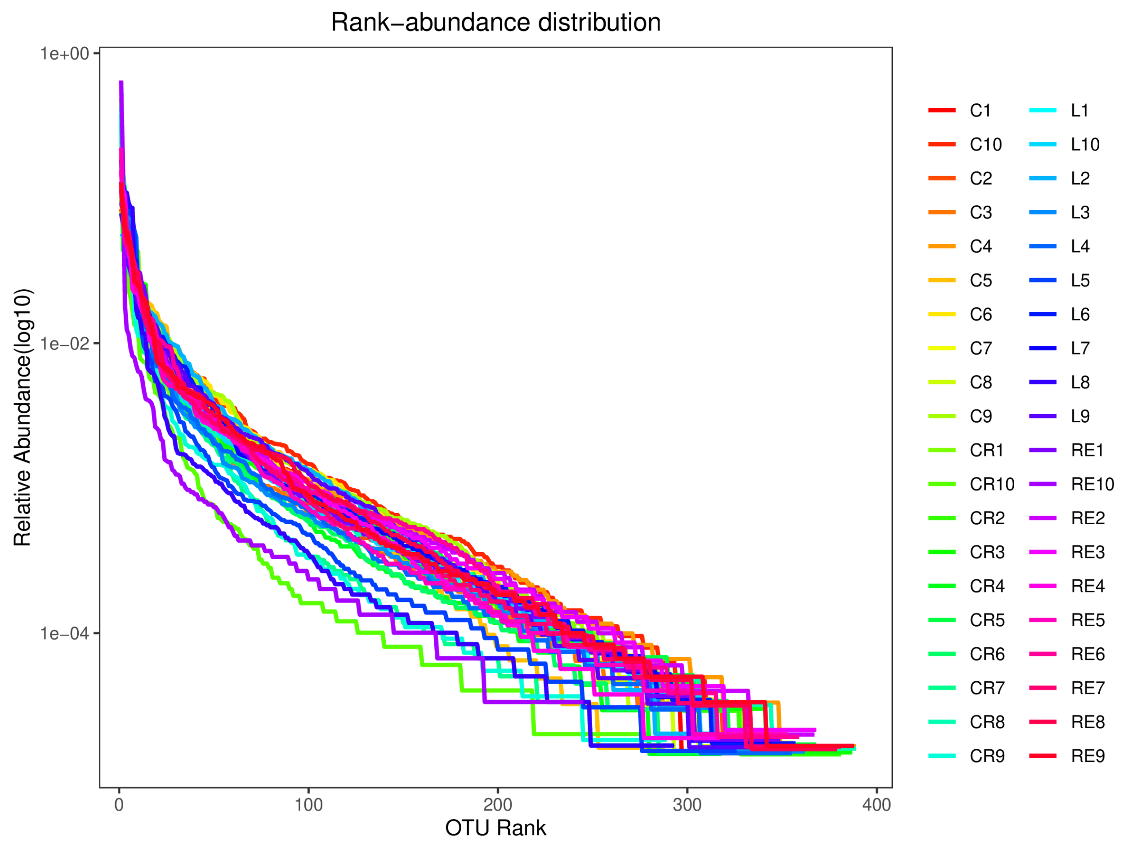
Figure S7. rank-bundance curve; Analysis of α-diversity of intestinal flora.

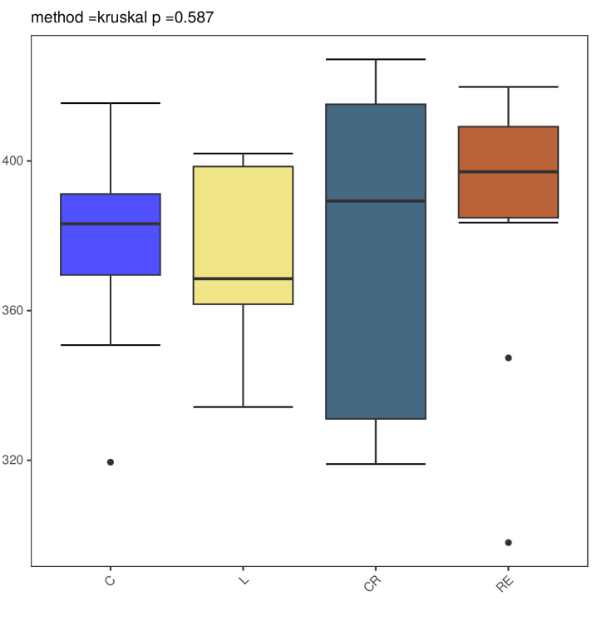
Figure S8. Chao index box plot; Analysis of β-diversity of intestinal flora.
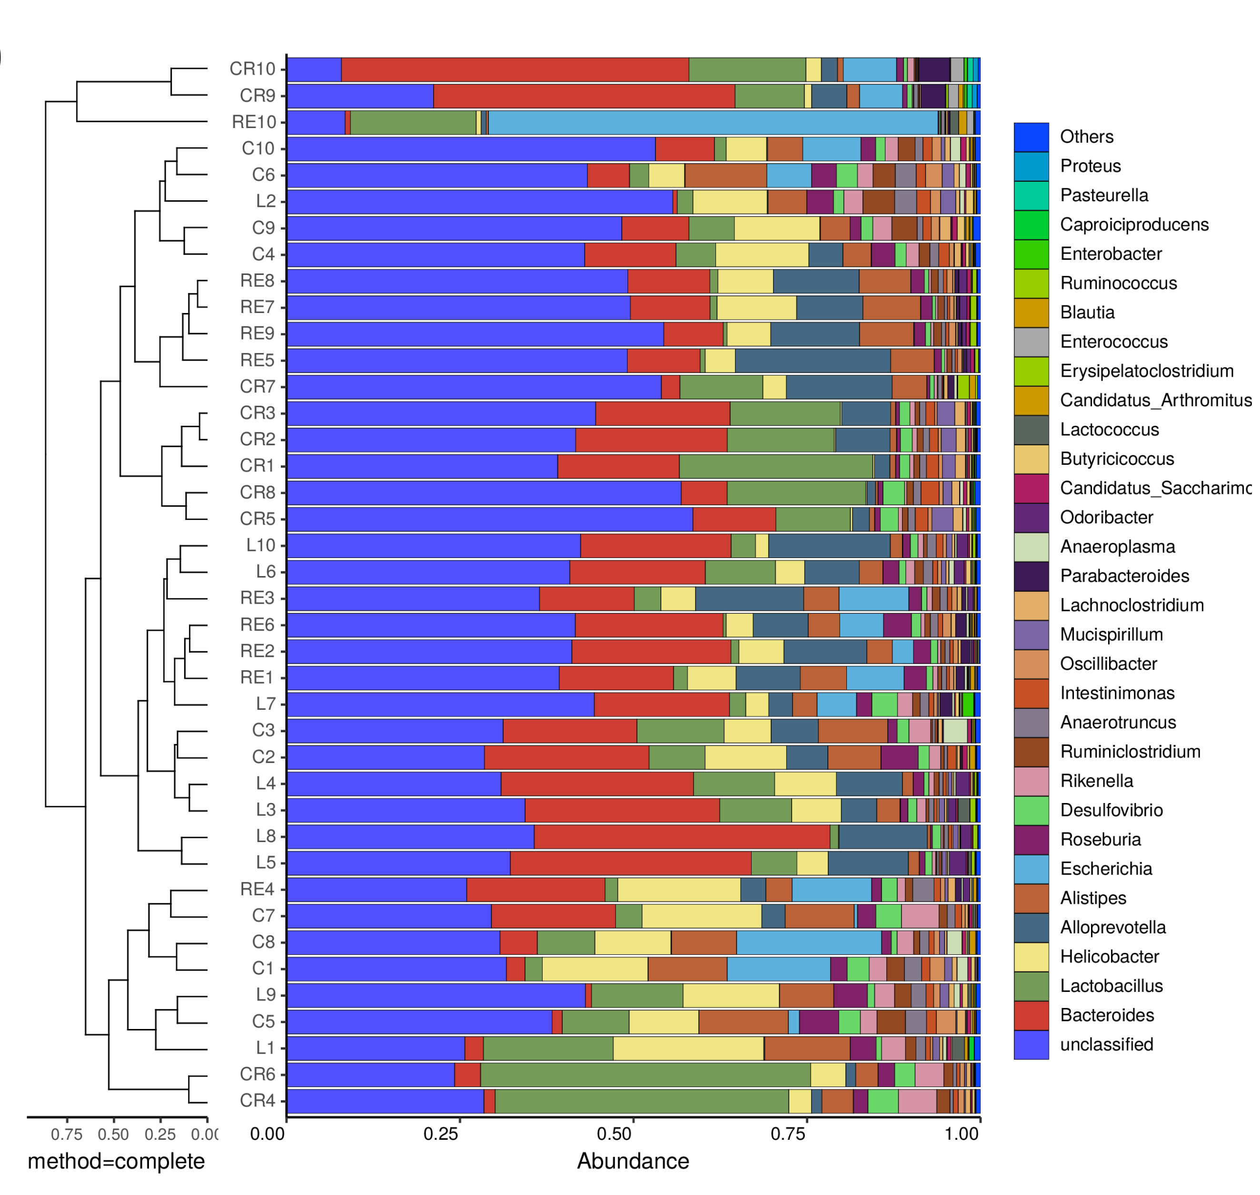
Figure S9. combination analysis diagram of cluster tree and bar chart of genus horizontal samples;

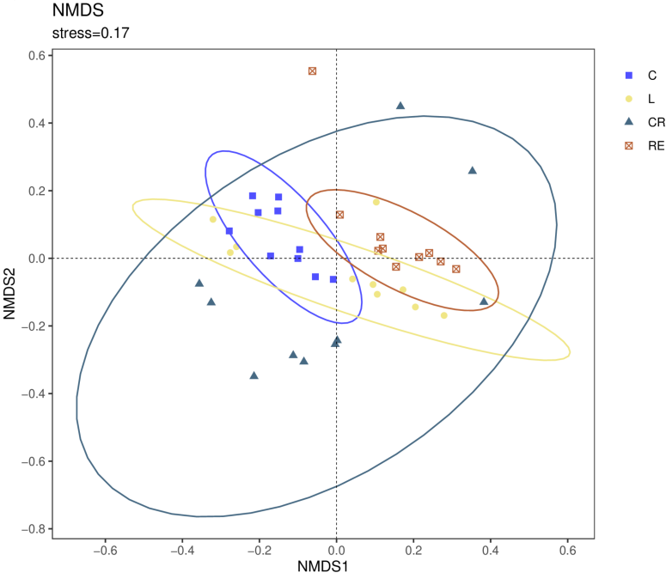
Figure S10. Beta-Bray Curtis.NMDS;(j) Beta-Bray Curtis.PCoA;
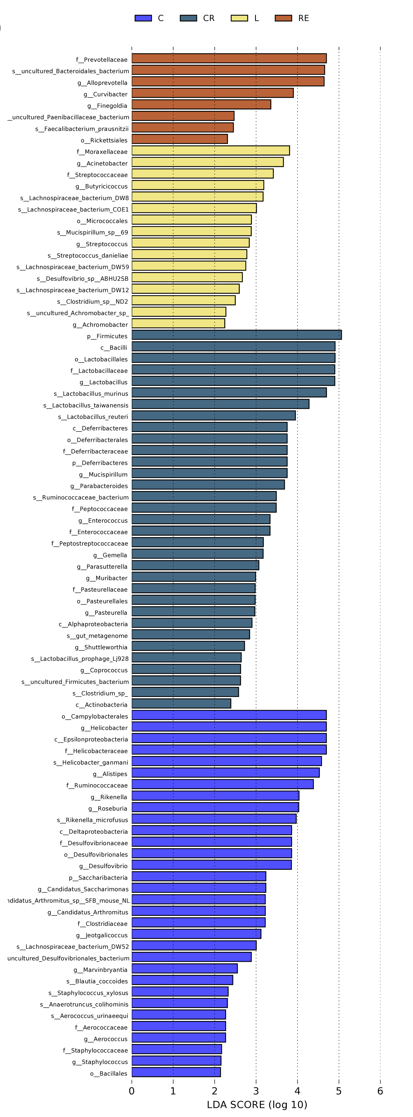
Figure S11. LEFSE tree diagram;

