1. The sizes is 31.03±5.59 nm in TEM.
Table S1 Statistics of particle size of nanoparticles
No. | Particle size/nm
1 | 37.31
2 | 42.57
3 | 35.42
4 | 37.88
5 | 34.66
6 | 33.85
7 | 38.24
8 | 32.37
9 | 32.63
10 | 33.56
11 | 32.16
12 | 36.33
13 | 31.62
14 | 32.59
15 | 30.41
16 | 33.81
17 | 24.53
18 | 20.21
19 | 19.61
20 | 27.61
21  22 | 22.36  27.31
23 | 26.97
24  25  26  27 | 26.10  31.65  29.41  26.78

2. The mathematical kinetic models was listed in Figure S1 and Table S2.

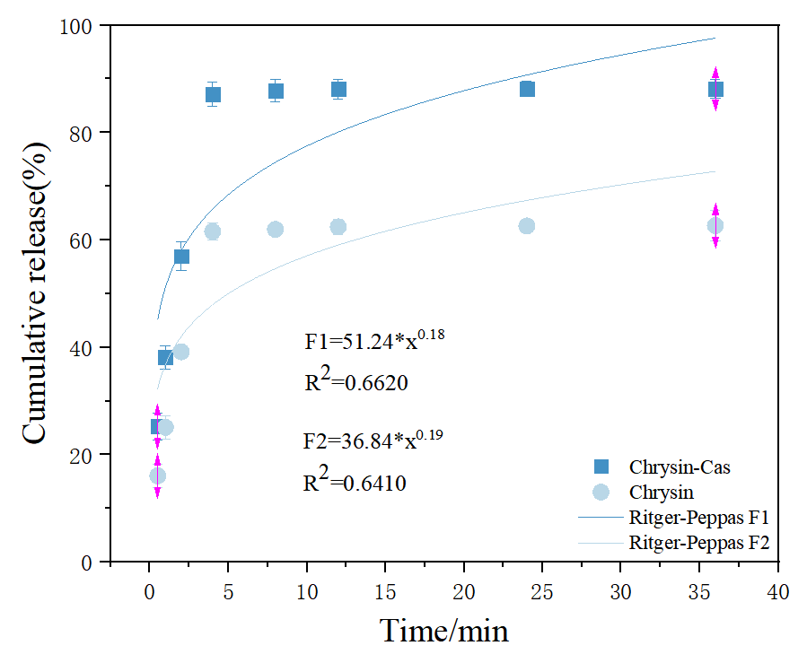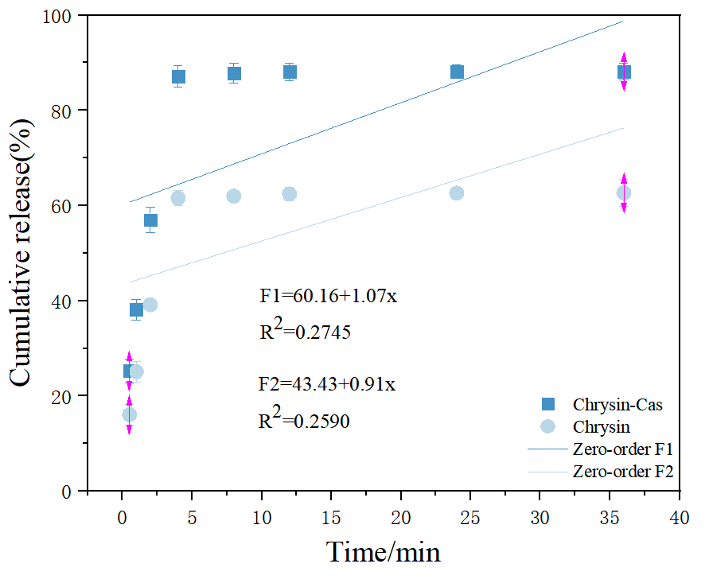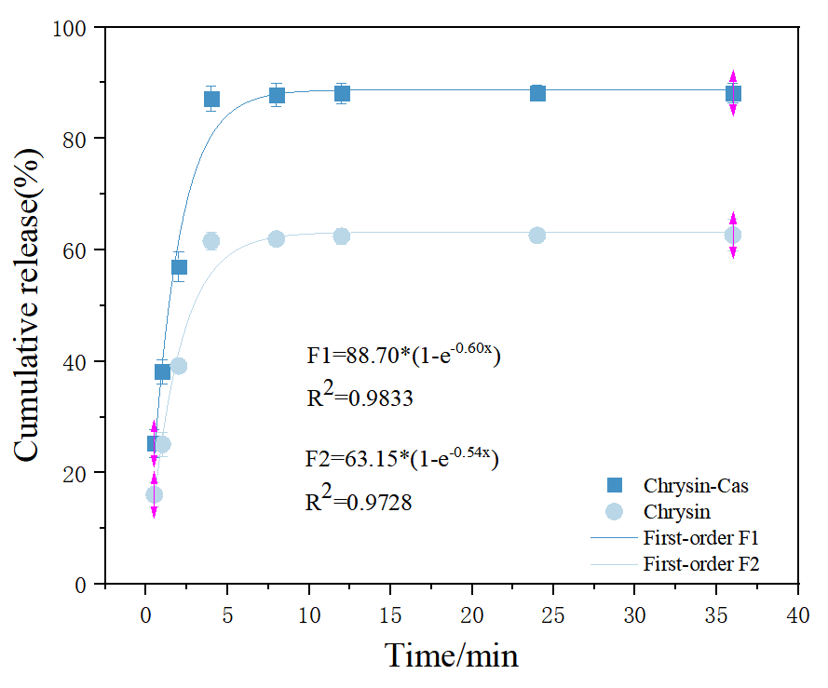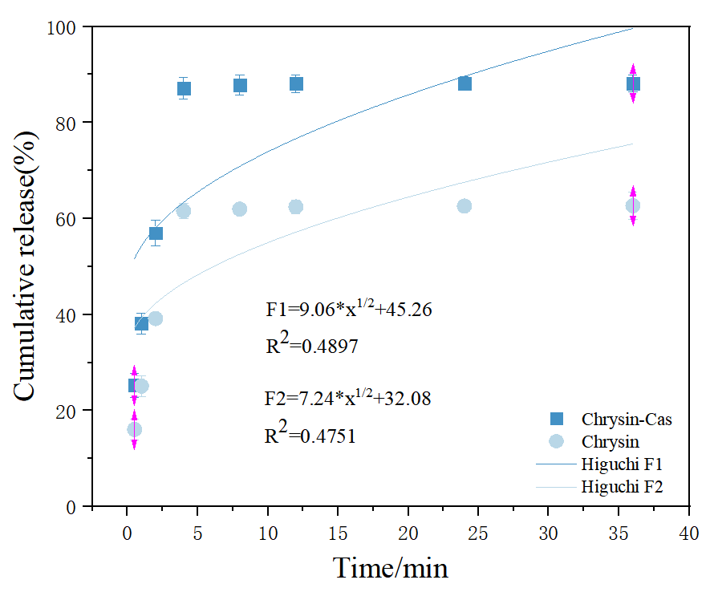
Figure S1 The mathematical kinetic models

Table S2 Kinetic mathematical models calculations
Formulation | Zero-order | First-order | Higuchi | Ritger-Peppas
 | R² | R² | R² | R²
F1 | 0.2745 | 0.9833 | 0.4897 | 0.6620
F2 | 0.2590 | 0.9728 | 0.4751 | 0.6410
ª F1 refers to CCP;F2 refers to Chrysin.

