Table S1. ICD Codes Used for Identifying COPD Patients in MIMIC-IV 2.2
icd_code | icd_version | long_title
49120 | 9 | Obstructive chronic bronchitis without exacerbation
49121 | 9 | Obstructive chronic bronchitis with (acute) exacerbation
49122 | 9 | Obstructive chronic bronchitis with acute bronchitis
496 | 9 | Chronic airway obstruction, not elsewhere classified
J44 | 10 | Other chronic obstructive pulmonary disease
J440 | 10 | Chronic obstructive pulmonary disease with (acute) lower respiratory infection
J441 | 10 | Chronic obstructive pulmonary disease with (acute) exacerbation
Note: ICD, international classification of diseases; COPD, chronic obstructive pulmonary disease

Table S2. Univariate analysis to identify risk factors for 90-day mortality in elderly COPD patients in the ICU.
Item | HR(95%CI) | P value
GNRI | 0.99 (0.98,0.99) | < 0.001
GNRI≤98 | 1（Ref）
GNRI＞98 | 0.57 (0.44,0.73) | < 0.001
Female | 1.18 (0.91,1.51) | 0.207
Age (years) | 1.02 (1.01,1.04) | 0.011
MAP（mmHg） | 0.98 (0.97,0.99) | 0.004
HR（/min） | 1.01 (1.01,1.02) | < 0.001
RR(/min) | 1.03 (1,1.07) | 0.046
SpO2（%） | 1.0028 (0.9482,1.0606) | 0.921
Temperature（℃） | 0.63 (0.52,0.76) | < 0.001
HB（g/dL） | 0.93 (0.88,0.99) | 0.026
WBC（10⁹/L） | 1.01 (1,1.02) | 0.017
Platelet(10⁹/L) | 0.9989 (0.9974,1.0004) | 0.151
pO₂（mmHg） | 0.9977 (0.9945,1.0008) | 0.15
ALB（g/dL） | 0.58 (0.47,0.71) | < 0.001
BUN(mg/dL) | 1.0095 (1.0052,1.0137) | < 0.001
Cr(mg/dL) | 1.09 (1.02,1.16) | 0.008
Myocardial infarction | 1.11 (0.85,1.45) | 0.458
Congestive heart failure | 1.11 (0.86,1.42) | 0.428
Sepsis | 2.54 (1.75,3.69) | < 0.001
CCI | 1.13 (1.08,1.19) | < 0.001
APSIII | 1.02 (1.02,1.03) | < 0.001
SOFA | 1.12 (1.06,1.19) | < 0.001
Note: GNRI, geriatric nutritional risk index; MAP, mean arterial pressure; HR, heart rate; RR, respiratory rate; SpO2, pulse oximetry-derived oxygen saturation；HB, hemoglobin; WBC, white blood cell; ALB, albumin; BUN, blood urea nitrogen; CR, creatine; CCI, Charlson comorbidity Index; APSIII, acute physiology score III; SOFA, sequential organ failure assessment; ICU, intensive care unit.

Table S3. Threshold effect analysis of the relationship of GNRI with 90-day mortality.
GNRI | Adjustd Model
 | HR(95%CI) | p-value
＜101.5 | 0.972 (0.956,0.988) | < 0.001
≥101.5 | 1.017 (0.999,1.035) | 0.0616
Likelihood ratio test |  | 0.004
Note: GNRI, geriatric nutritional risk index; HR, Hazard ratio; CI, confidence interval. Adjusted for age, gender, race, HR, MAP, SpO2, HB, BUN, CR, PLT, WBC, myocardial infarction, congestive heart failure, severe liver disease, CCI, SOFA.

Table S4 Baseline and Clinical Characteristics of the Study Population after adding four additional covariates
Variables | Total (n = 427) | GNRI |  |  |  | p value
Variables | Total (n = 427) | ≤81(n = 63) | 82-91(n = 75) | 92-98(n = 61) | ＞98(n = 228) | p value
Demographic variables
Male, n(%) | 243 (56.9) | 35 (55.6) | 44 (58.7) | 39 (63.9) | 125 (54.8) | 0.621
Age(years) | 76.7 ± 7.5 | 76.6 ± 7.6 | 78.4 ± 8.0 | 77.6 ± 7.7 | 75.9 ± 7.1 | 0.049
Ethnicity, n (%) |  |  |  |  |  | 0.581
Non-White | 154 (36.1) | 21 (33.3) | 25 (33.3) | 19 (31.1) | 89 (39)
White | 273 (63.9) | 42 (66.7) | 50 (66.7) | 42 (68.9) | 139 (61)
Vital signs
Temperature（℃） | 36.9 ± 0.5 | 36.8 ± 0.6 | 36.8 ± 0.5 | 36.7 ± 0.5 | 36.9 ± 0.4 | 0.013
HR（/min） | 86.2 ± 16.9 | 89.4 ± 17.8 | 88.5 ± 15.7 | 87.4 ± 17.5 | 84.2 ± 16.8 | 0.066
RR(/min) | 20.5 ± 3.8 | 20.9 ± 5.2 | 20.6 ± 4.2 | 20.0 ± 2.7 | 20.6 ± 3.5 | 0.616
MAP(mmHg) | 75.9 ± 9.0 | 74.5 ± 7.1 | 74.5 ± 10.1 | 77.7 ± 10.5 | 76.3 ± 8.6 | 0.098
Spo2（%） | 96.2 ± 2.6 | 96.4 ± 3.9 | 96.3 ± 2.8 | 96.0 ± 2.7 | 96.2 ± 2.0 | 0.81
Laboratory events
WBC(10^9/L) | 13.8 (10.1, 19.4) | 15.0 (11.4, 20.7) | 14.2 (9.6, 19.9) | 12.6 (9.5, 17.7) | 13.8 (10.4, 18.5) | 0.152
Platelet(10^9/L) | 218.0 (152.5, 285.0) | 222.0 (150.0, 321.5) | 224.0 (154.0, 343.5) | 210.0 (149.0, 298.0) | 211.5 (155.0, 261.8) | 0.249
ALB(g/dL) | 3.1 ± 0.6 | 2.2 ± 0.5 | 2.9 ± 0.4 | 3.1 ± 0.4 | 3.4 ± 0.5 | < 0.001
BUN(mg/dL) | 30.0 (20.0, 49.5) | 31.0 (17.5, 46.0) | 28.0 (17.0, 45.5) | 26.0 (20.0, 49.0) | 32.5 (21.8, 54.2) | 0.222
CR(mg/dL) | 1.3 (0.9, 2.2) | 1.1 (0.8, 2.0) | 1.3 (0.9, 2.0) | 1.2 (0.9, 2.1) | 1.4 (1.0, 2.3) | 0.034
pH | 7.3 ± 0.1 | 7.3 ± 0.1 | 7.3 ± 0.1 | 7.3 ± 0.1 | 7.3 ± 0.1 | 0.276
PO2(mmHg) | 70.0 (54.0, 93.0) | 72.0 (56.0, 91.0) | 71.0 (55.0, 96.5) | 69.0 (50.0, 87.0) | 69.5 (54.0, 93.2) | 0.765
pCO2(mmHg) | 51.0 (43.0, 61.0) | 52.0 (43.0, 61.0) | 52.0 (42.5, 60.0) | 47.0 (38.0, 57.0) | 52.0 (44.0, 63.0) | 0.282
Lactate（mmol/L） | 1.8 (1.2, 3.3) | 2.1 (1.4, 3.7) | 1.6 (1.2, 3.3) | 1.7 (1.2, 2.4) | 1.8 (1.3, 3.2) | 0.154
Comorbidities, n(%)
Myocardial infarction | 139 (32.6) | 14 (22.2) | 29 (38.7) | 19 (31.1) | 77 (33.8) | 0.208
Severe liver disease | 10 ( 2.3) | 2 (3.2) | 1 (1.3) | 2 (3.3) | 5 (2.2) | 0.814
Diabetes with complication | 69 (16.2) | 5 (7.9) | 8 (10.7) | 9 (14.8) | 47 (20.6) | 0.041
Sepsis | 328 (76.8) | 54 (85.7) | 61 (81.3) | 45 (73.8) | 168 (73.7) | 0.155
Severity of disease
AECOPD, n (%) | 171 (40.0) | 24 (38.1) | 29 (38.7) | 22 (36.1) | 96 (42.1) | 0.81
Respiratory failure, n (%) | 275 (64.4) | 42 (66.7) | 50 (66.7) | 38 (62.3) | 145 (63.6) | 0.921
Vasopressin treatment, n (%) | 350 (82.0) | 44 (69.8) | 61 (81.3) | 53 (86.9) | 192 (84.2) | 0.045
Ventilation status, n (%) |  |  |  |  |  | 0.321
Without oxygen | 21 ( 4.9) | 4 (6.3) | 4 (5.3) | 4 (6.6) | 9 (3.9)
Noninvasive | 27 ( 6.3) | 1 (1.6) | 4 (5.3) | 6 (9.8) | 16 (7)
Invasive | 248 (58.1) | 45 (71.4) | 42 (56) | 32 (52.5) | 129 (56.6)
Highflow | 40 ( 9.4) | 6 (9.5) | 10 (13.3) | 5 (8.2) | 19 (8.3)
Oxygen | 91 (21.3) | 7 (11.1) | 15 (20) | 14 (23) | 55 (24.1)
CCI | 8.0 ± 2.3 | 7.9 ± 2.7 | 7.9 ± 2.0 | 8.5 ± 2.8 | 8.0 ± 2.2 | 0.329
APSIII | 56.0 (42.0, 75.0) | 71.0 (54.0, 87.0) | 58.0 (44.0, 69.0) | 56.0 (41.0, 74.0) | 53.0 (41.0, 73.0) | < 0.001
OASIS | 38.6 ± 9.1 | 42.7 ± 9.4 | 39.3 ± 8.5 | 38.6 ± 9.5 | 37.3 ± 8.9 | < 0.001
SOFA | 3.0 (2.0, 4.0) | 4.0 (2.0, 5.0) | 4.0 (3.0, 5.0) | 3.0 (2.0, 4.0) | 3.0 (2.0, 4.0) | 0.058
Clinical outcome
Hospital LOS(d) | 9.8 (5.8, 16.9) | 12.9 (4.9, 20.0) | 10.2 (6.0, 15.8) | 9.5 (5.6, 16.0) | 9.8 (6.1, 16.6) | 0.871
ICU LOS(d) | 4.1 (2.3, 8.0) | 3.8 (2.5, 6.4) | 4.9 (2.2, 7.6) | 4.1 (2.0, 7.7) | 4.0 (2.5, 8.2) | 0.907
30-day mortality, n (%) | 128 (30.0) | 33 (52.4) | 26 (34.7) | 19 (31.1) | 50 (21.9) | < 0.001
60-day mortality, n (%) | 146 (34.2) | 37 (58.7) | 28 (37.3) | 24 (39.3) | 57 (25) | < 0.001
90-day mortality, n (%) | 159 (37.2) | 40 (63.5) | 29 (38.7) | 26 (42.6) | 64 (28.1) | < 0.001
Note: GNRI, geriatric nutritional risk index; HR, heart rate; RR, respiratory rate; MAP, mean arterial pressure; SpO2, pulse oximetry-derived oxygen saturation；WBC, white blood cell; ALB, albumin; BUN, blood urea nitrogen; CR, creatine; pO2, partial pressure of oxygen; pCO2, partial pressure of carbon dioxide; AECOPD, acute exacerbation of chronic obstructive pulmonary disease; CCI, Charlson comorbidity Index; APSIII, acute physiology score III; OASIS, oxford acute severity of illness score; SOFA, sequential organ failure assessment; LOS, length of stay; ICU, intensive critical care.

Table S5. Baseline characteristics between survivors and non-survivors after adding four additional covariates
Variables | Total | Survival | Non-survival | p value
Variables | (n = 427) | (n = 268) | (n = 159) | p value
Demographic variables
Male, n(%) | 243 (56.9) | 160 (59.7) | 83 (52.2) | 0.13
Age(years) | 76.7 ± 7.5 | 76.1 ± 7.3 | 77.6 ± 7.7 | 0.04
Ethnicity, n (%) |  |  |  | 0.11
Non-White | 154 (36.1) | 89 (33.2) | 65 (40.9)
White | 273 (63.9) | 179 (66.8) | 94 (59.1)
Vital signs
Temperature（℃） | 36.9 ± 0.5 | 36.9 ± 0.4 | 36.8 ± 0.6 | 0.002
HR（/min） | 86.2 ± 16.9 | 84.4 ± 15.8 | 89.2 ± 18.3 | 0.005
RR(/min) | 20.5 ± 3.8 | 20.3 ± 3.7 | 20.9 ± 4.1 | 0.119
MAP(mmHg) | 75.9 ± 9.0 | 76.7 ± 9.0 | 74.5 ± 8.9 | 0.016
Spo2（%） | 96.2 ± 2.6 | 96.2 ± 2.2 | 96.1 ± 3.2 | 0.544
Laboratory events
WBC(10^9/L) | 13.8 (10.1, 19.4) | 13.6 (10.2, 18.8) | 14.7 (10.4, 20.3) | 0.161
Platelet(10^9/L) | 218.0 (152.5, 285.0) | 219.0 (157.8, 277.5) | 208.0 (136.0, 291.5) | 0.258
ALB(g/dL) | 3.1 ± 0.6 | 3.2 ± 0.6 | 2.9 ± 0.7 | < 0.001
BUN(mg/dL) | 30.0 (20.0, 49.5) | 27.0 (17.8, 44.0) | 40.0 (24.0, 61.0) | < 0.001
CR(mg/dL) | 1.3 (0.9, 2.2) | 1.3 (0.9, 1.8) | 1.6 (1.0, 2.6) | 0.001
pH | 7.3 ± 0.1 | 7.3 ± 0.1 | 7.3 ± 0.1 | 0.006
PO2(mmHg) | 70.0 (54.0, 93.0) | 69.0 (54.0, 94.0) | 72.0 (53.5, 87.0) | 0.579
pCO2(mmHg) | 51.0 (43.0, 61.0) | 51.0 (43.0, 63.0) | 51.0 (43.0, 61.0) | 0.763
Lactate（mmol/L） | 1.8 (1.2, 3.3) | 1.7 (1.2, 3.2) | 1.8 (1.2, 3.4) | 0.421
Comorbidities, n(%)
Myocardial infarction | 139 (32.6) | 88 (32.8) | 51 (32.1) | 0.871
Severe liver disease | 10 ( 2.3) | 4 (1.5) | 6 (3.8) | 0.185
Diabetes with complication | 69 (16.2) | 45 (16.8) | 24 (15.1) | 0.645
Sepsis | 328 (76.8) | 187 (69.8) | 141 (88.7) | < 0.001
Severity of disease
AECOPD, n (%) | 171 (40.0) | 106 (39.6) | 65 (40.9) | 0.787
Reapiratory failure, n (%) | 275 (64.4) | 169 (63.1) | 106 (66.7) | 0.452
Vasopressin treatment, n (%) | 350 (82.0) | 242 (90.3) | 108 (67.9) | < 0.001
Ventilation status, n (%) |  |  |  | 0.007
Without oxygen | 21 ( 4.9) | 18 (6.7) | 3 (1.9)
Noninvasive | 27 ( 6.3) | 17 (6.3) | 10 (6.3)
Invasive | 248 (58.1) | 139 (51.9) | 109 (68.6)
Highflow | 40 ( 9.4) | 28 (10.4) | 12 (7.5)
Oxygen | 91 (21.3) | 66 (24.6) | 25 (15.7)
CCI | 8.0 ± 2.3 | 7.7 ± 2.2 | 8.6 ± 2.4 | < 0.001
APSIII | 56.0 (42.0, 75.0) | 50.5 (38.0, 66.2) | 69.0 (54.0, 89.0) | < 0.001
SAPSII | 45.8 ± 13.2 | 42.4 ± 11.6 | 51.6 ± 13.8 | < 0.001
OASIS | 38.6 ± 9.1 | 36.8 ± 8.6 | 41.8 ± 9.2 | < 0.001
SOFA | 3.0 (2.0, 4.0) | 3.0 (2.0, 4.0) | 4.0 (3.0, 5.0) | < 0.001
Clinical outcome
Hospital LOS(d) | 9.8 (5.8, 16.9) | 9.8 (6.6, 16.9) | 10.1 (4.2, 16.8) | 0.029
ICU LOS(d) | 4.1 (2.3, 8.0) | 3.8 (2.1, 7.0) | 4.9 (2.7, 9.0) | 0.033
Note: GNRI, geriatric nutritional risk index; HR, heart rate; RR, respiratory rate; MAP, mean arterial pressure; SpO2, pulse oximetry-derived oxygen saturation；WBC, white blood cell; ALB, albumin; BUN, blood urea nitrogen; CR, creatine; pO2, partial pressure of oxygen; pCO2, partial pressure of carbon dioxide; AECOPD, acute exacerbation of chronic obstructive pulmonary disease; CCI, Charlson comorbidity Index; APSIII, acute physiology score III; OASIS, oxford acute severity of illness score; SOFA, sequential organ failure assessment; LOS, length of stay; ICU, intensive critical care.

Table S6. Multivariable Cox regression analysis after adjusting severity of respiratory failure
Variable | Unadjusted |  |  | Model 1 |  |  | Model 2 |  |  | Model 3
 | HR 95% CI | P-value |  | HR 95% CI | P-value |  | HR 95% CI | P-value |  | HR 95% CI | P-value
GNRIª | 0.982 (0.974~0.990) | < 0.001 |  | 0.983 (0.974~0.991) | <0.001 |  | 0.982 (0.973~0.991) | <0.001 |  | 0.979 (0.97~0.988) | <0.001
GNRI (vs. Q4)
Q4(＞98) | Ref. |  |  | Ref. |  |  | Ref. |  |  | Ref.
Q3(92-98) | 1.68 (1.07~2.66) | 0.025 |  | 1.68(1.06~2.66) | 0.027 |  | 1.93 (1.21~3.07) | 0.006 |  | 1.95(1.21~3.16) | 0.007
Q2(82-91) | 1.55(1.00~2.40) | 0.051 |  | 1.49 (0.95~2.32) | 0.080 |  | 1.51 (0.96~2.38) | 0.078 |  | 1.55 (0.97~2.48) | 0.065
Q1(≤81) | 3.10 (2.09~4.61) | <0.001 |  | 3.02 (2.09~4.61) | <0.001 |  | 3.29 (2.18~4.96) | <0.001 |  | 3.42 (2.25~5.21) | <0.001
P for trend |  | <0.001 |  |  | <0.001 |  |  | <0.001 |  |  | <0.001
Notes: GNRI, Geriatric Nutritional Risk Index. GNRIª was entered as a continuous variable per 1 unit.
Model 1 = Adjusted for (age + gender). gen saturation; BUN, blood urea nitrogen; Cr, creatinine; PLT, platelet; WBC, white blood cell; AECOPD, acute exacerbation of chronic obstructive pulmonary disease; CCI, Charlson comorbidity Index; SOFA, sequential organ failure assessment
Model 2 = Model1 + (race + HR + MAP + SpO2 + BUN+ Cr + PLT + WBC).
Model 3 = Model 2 + (myocardial infarction + severe liver disease + AECOPD+ Vasopressin treatment + ventilation + Reapiratory failure + CCI + SOFA).
Abbreviations: GNRI, geriatric nutritional risk index; HR, heart rate; MAP, mean arterial pressure; RR, respiratory rate; SpO2, pulse oximetry-derived oxygen saturation; BUN, blood urea nitrogen; Cr, creatinine; PLT, platelet; WBC, white blood cell; AECOPD, acute exacerbation of chronic obstructive pulmonary disease; CCI, Chalson comorbidity Index; SOFA, sequential organ failure assessment

Fig. S1. Flowchart of patient selection.
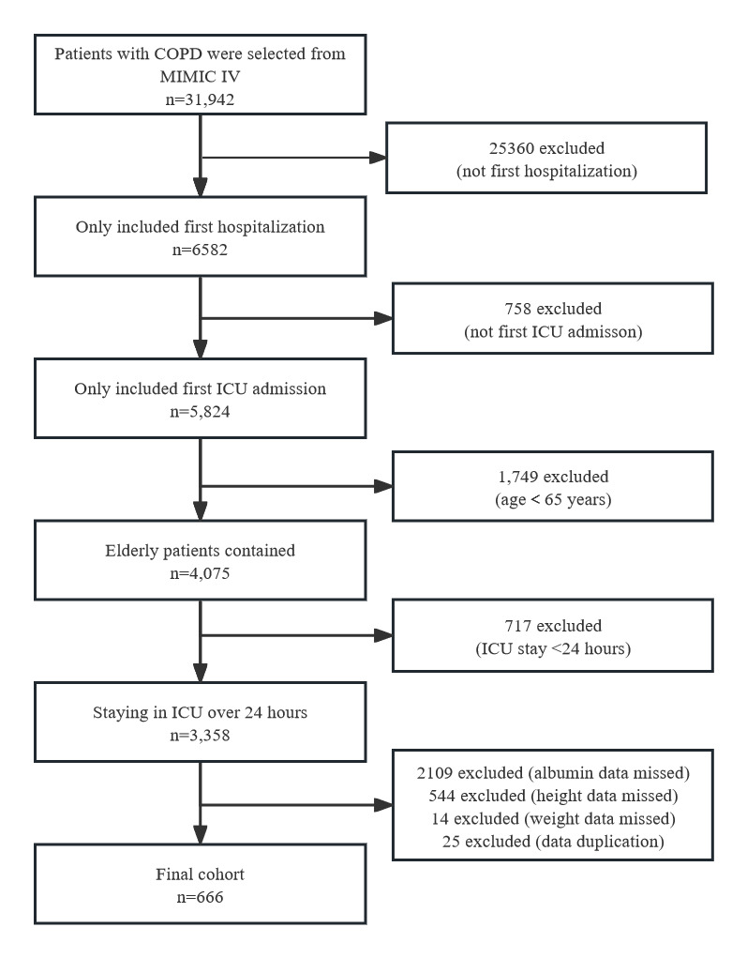

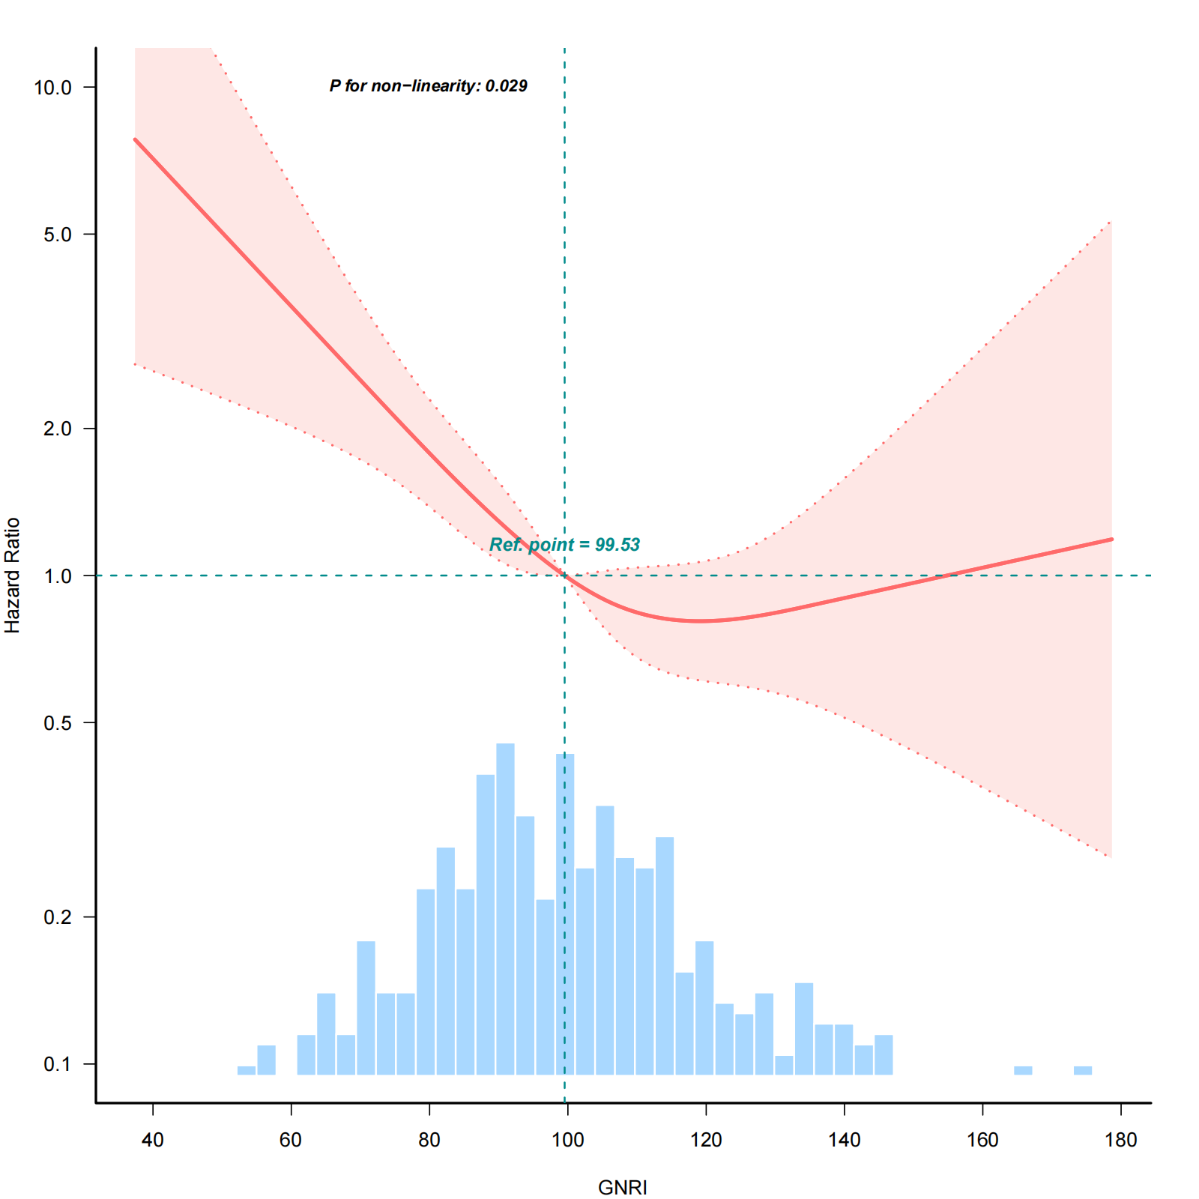
Fig. S2. Relationship between GNRI（X）and 90-day Mortality（Y）after adjusting severity of respiratory failure
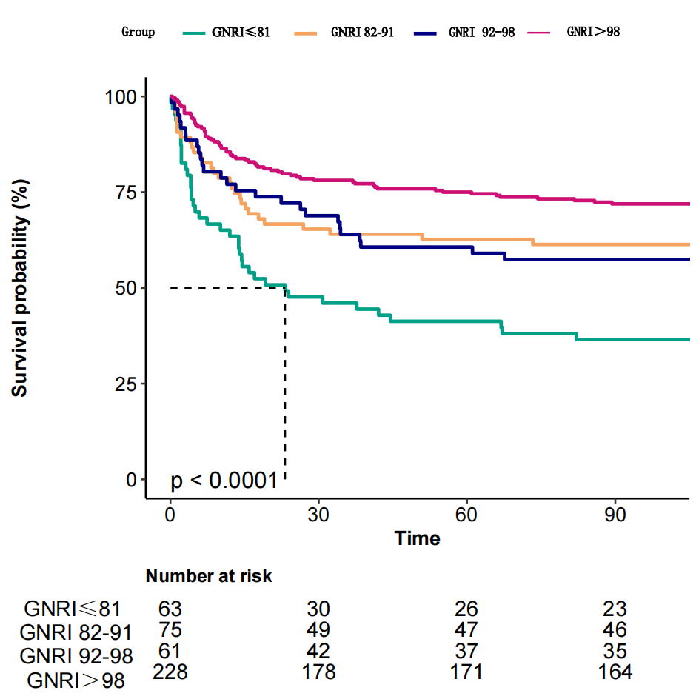
Fig. S3. Kaplan-Meier curves of 90-day mortality according to GNRI after adjusting severity of respiratory failure.

