Supplementary material

Table S1 Weight Yield % of LNPs DPPC:Chol:DOTAP 1:1:x, with variable amounts of DOPE-Rhod. Mean ± SD

Weight yield of LNPs
DPPC:Chol:DOTAP 1:1:x
DOPE-Rhod 0-100 µg/formulation
DOTAP | µg DOPE-Rhod | Weight Yield ± SD %
0.05 | 0 | 60 ± 7
0.05 | 10 | 63 ± 8
0.05 | 50 | 61 ± 8
0.05 | 100 | 61 ± 6
0.1 | 0 | 59 ± 6
0.1 | 10 | 59 ± 9
0.1 | 50 | 73 ± 5
0.1 | 100 | 70 ± 5
0.5 | 0 | 67 ± 9
0.5 | 10 | 80 ± 6
0.5 | 50 | 60 ± 8
0.5 | 100 | 71 ± 6

Figure S1: Optimization of the formulative parameters for LNP formulation. Optimization of the FRR from 1:1 to 1:0.3: size, PDI, and Zeta potential of neutral LNPs formulated with different FRR and constituted by a molar ratio of DPPC:Chol of A) 1:0.5, B) 1:1, C) 1:2. Neutral LNPs produced with DPPC:Chol 1:0.1 molar ratio were not graphed as they displayed a size > 1 µm and PDI > 0.8 independent from the FRR used.
Optimization of the aqueous phase: size, PDI, and Zeta potential of cationic LNPs with FRR 1:1 and different amounts of Dotap (DPPC:Chol:Dotap 1:1:X) from 0.01 to 0.5, freshly prepared (t0) or after 7 days at 4°C (t7), formulated with either MilliQ water (D) or TE buffer (E) as aqueous phase.

Figure S2 AFM image of empty LNPs of DPPC:Chol:DOTAP 1:1:0.1 with 10 µg of DOPE-Rhod. A) Topography image. B) Profile analysis.

Table S2 Weight Yield % of plasmid loaded LNPs with the two methods.
Weight yield % with the two methods and with different plasmid concentrations
Method | Plasmid concentration mg/mL | Weight Yield ± SD %
«Post» | 5 | 57 ± 7
«Post» | 10 | 68 ± 5
«Post» | 15 | 61 ± 7
«Pre» | 5 | 57 ± 7
«Pre» | 10 | 68 ± 5
«Pre» | 15 | 61 ± 7
«Pre» | 30 | 64 ± 7
«Pre» | 50 | 65 ± 5
«Pre» | 100 | 49 ± 6

Figure S3 Dimensional stability of plasmid loaded LNPs. A) Size, PDI, and Zeta potential of LNPs at different plasmid concentrations after 1 month storage at 4°C. B) Electrophoretic run for plasmid retention; the wells correspond to the respective bars above (representative gel). All samples were analyzed in triplicate, data represent Mean ± SD.

Table S3 Weight Yield % of plasmid loaded neutral LNPs formulated with the two methods.
Weight yield % of neutral LNPs with the two methods and with different plasmid concentrations
Method | Plasmid concentration mg/mL | Weight Yield ± SD %
«Post» | 5 | 79 $±$ 5
«Post» | 10 | 68 $±$ 7
«Post» | 15 | 76 $±$ 5
«Pre» | 5 | 79 $±$ 5
«Pre» | 10 | 68 $±$ 7
«Pre» | 15 | 76 $±$ 5
«Pre» | 30 | 72 $±$ 4
«Pre» | 50 | 70 $±$ 7
«Pre» | 100 | 67 $±$ 6

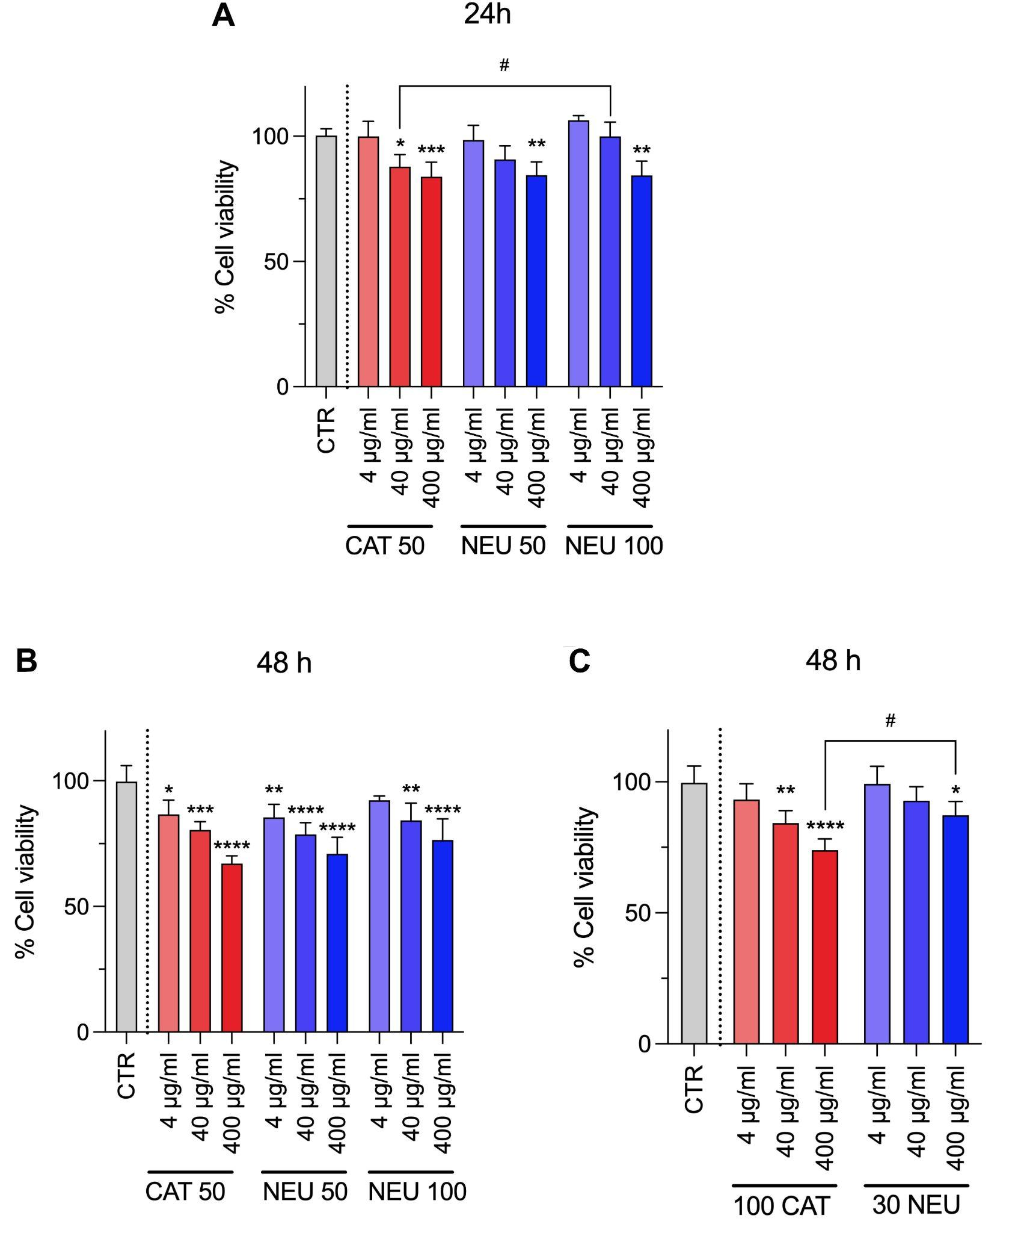

Figure S4 Cell viability of ARPE-19 cells after administration of LNPs.
Cationic LNPs with 50 µg/mL pDNA and neutral LNPs with 50 µg/mL or 100 µg/mL pDNA (A) after 24h, and (B) after 48h from administration. (C) Cationic LNPs with 100 µg/mL pDNA and neutral LNPs with 30 µg/mL after 48h from administration. Untreated cells were set at 100% cell viability and used as control; asterisks represent significance compared to control, hashtags represent significance between the marked groups: # or * p < 0.5, ** p < 0.01, *** p < 0.001, and **** p < 0.0001.

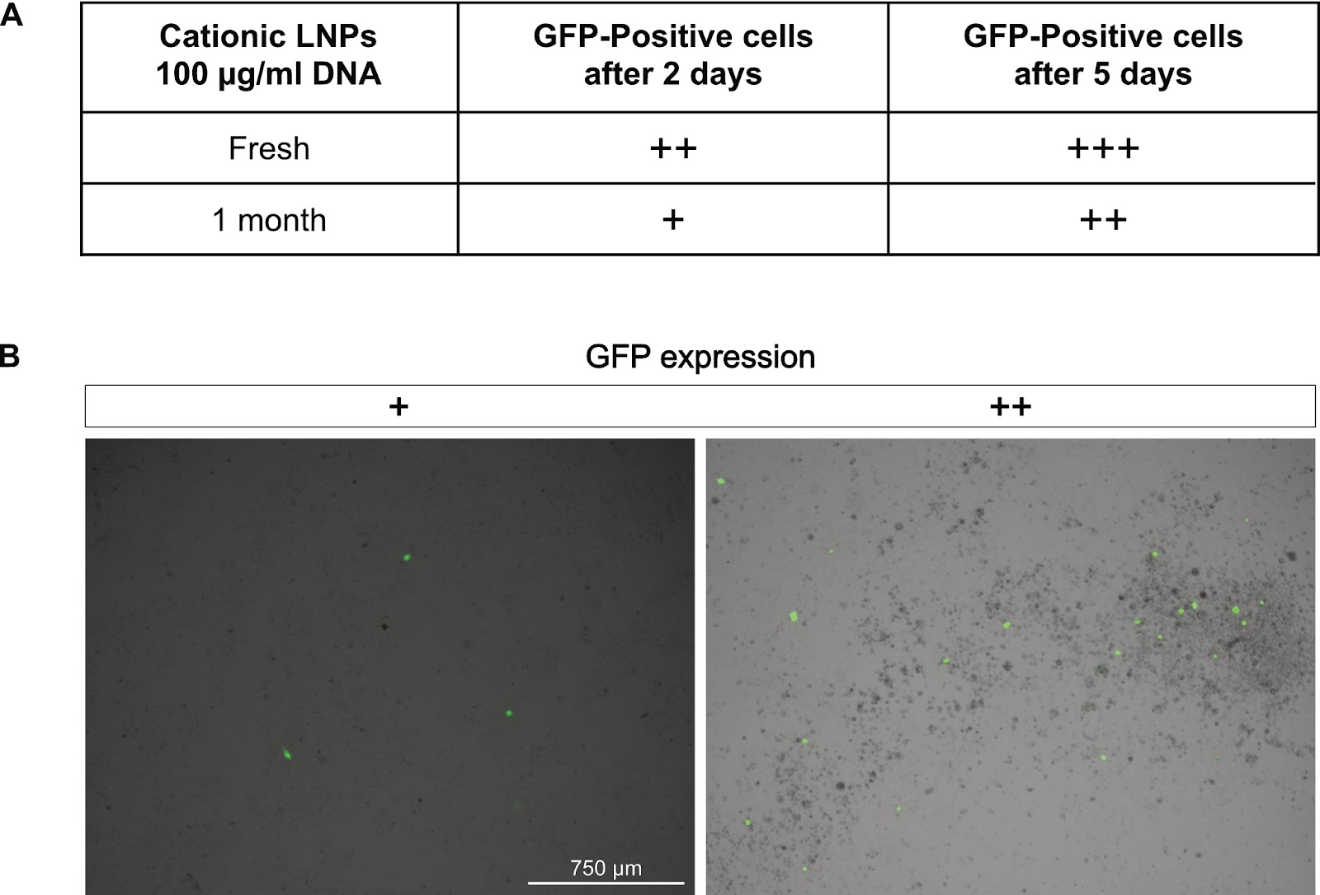

Figure S5 GFP expression after administration of fresh or 1 month old Cationic LNPs with 100 µg/mL pDNA on COS-7 cells. A) eGFP expression was analyzed after 2 and 5 days of incubation with LNPs and detection of eGFP was expressed as +. B) Examples of COS-7 images reporting different levels of expression.

