Supplementary materials
Supplementary materials legends:
Supplementary Table 1: Comparison of the modeling and validation groups.
Supplementary Figure 1: Validation of nomogram in the modelling group. (A): AUC=0.788, 95% CI: 0.747-0.829. (B): Nomogram calibration curve. Internal validation (n=2112, sampling frequency=1000) with an absolute error of 0.011). Abbreviations: AUC=the area under the receiver operating characteristic curve.
Supplementary Figure 2: Validation of nomogram in the validation group. (A): AUC= 0.789, 95% CI: 0.730-0.848. (B): Nomogram calibration curve. Internal validation (n=874, sampling frequency=1000) with an absolute error of 0.009). Abbreviations: AUC=the area under the receiver operating characteristic curve.
Supplementary Figure 3: DCA curves of the prediction model. Abbreviations: DCA= decision curve analysis.
Supplementary Figure 4: Predictive performances of different models. Abbreviations: ROC= receiver operating characteristic curve. SOFA=sequential organ failure assessment. BISAP= bedside Index of severity in acute pancreatitis.

Supplementary Table 1: Comparison of the modeling and validation groups
Variables | Modeling group（n=2112） |  |  | Validation group（n=874） |  |  | P value
Variables | median | P₂₅ | P₇₅ | median | P₂₅ | P₇₅ | P value
Age(years) | 45 | 35 | 56 | 44 | 35 | 56 | 0.648
T（℃） | 36.6 | 36.5 | 36.9 | 36.7 | 36.5 | 36.9 | 0.082
SBP(mmHg) | 133 | 121 | 149 | 133 | 122 | 148 | 0.863
DBP(mmHg) | 81 | 74 | 90 | 80 | 73 | 89 | 0.072
HR(No./min) | 82 | 74 | 92 | 82 | 74 | 93 | 0.464
RR(No./min) | 20 | 20 | 20 | 20 | 20 | 22 | 0.573
WBC(*10⁹/l) | 11.39 | 8.22 | 14.85 | 11.33 | 8.25 | 14.60 | 0.702
N(*10⁹/l) | 9.10 | 6.00 | 12.39 | 9.00 | 6.02 | 12.16 | 0.840
L(*10⁹/l) | 1.50 | 0.98 | 2.15 | 1.50 | 1.00 | 2.10 | 0.899
HCT(%) | 43 | 39 | 47 | 43 | 39 | 47 | 0.788
PLT(*10⁹/l) | 211.00 | 167.00 | 259.00 | 211.00 | 172.00 | 258.00 | 0.507
PDW(fL) | 12.40 | 10.50 | 14.30 | 12.35 | 10.60 | 14.10 | 0.705
PT（s） | 11.20 | 10.40 | 12.00 | 11.20 | 10.40 | 12.00 | 0.281
APTT（s） | 26.20 | 22.50 | 29.20 | 26.10 | 22.70 | 29.20 | 0.924
ALB（g/L） | 43.00 | 39.00 | 46.10 | 43.10 | 39.20 | 46.00 | 0.787
ALT(u/L) | 32.00 | 19.00 | 61.00 | 33.00 | 20.00 | 67.00 | 0.176
TBIL(umol/L) | 13.00 | 8.30 | 20.56 | 13.23 | 8.00 | 21.00 | 0.719
BUN(umol/L) | 4.33 | 3.33 | 5.50 | 4.42 | 3.49 | 5.50 | 0.494
SCR(umol/L) | 65.80 | 52.00 | 77.00 | 64.00 | 52.15 | 76.55 | 0.419
AMY(u/L) | 180.00 | 60.00 | 618.00 | 220.00 | 64.75 | 783.50 | 0.040
LPS(u/L) | 172.00 | 0.00 | 632.25 | 207.50 | 26.00 | 786.50 | 0.070
CK(u/L) | 68.65 | 33.00 | 111.00 | 72.00 | 37.00 | 110.00 | 0.631
Ca(mmol/L) | 2.35 | 2.22 | 2.46 | 2.35 | 2.23 | 2.46 | 0.395
HDL(mmol/L) | 0.79 | 0.50 | 1.13 | 0.80 | 0.50 | 1.20 | 0.497
LDL(mmol/L) | 2.05 | 1.27 | 2.90 | 2.16 | 1.20 | 3.00 | 0.545
TG(mmol/L) | 4.22 | 1.15 | 16.40 | 3.93 | 1.78 | 17.00 | 0.765
Gender (%) | Male | 1523 | 72.1% |  | 609 | 69.7% | 0.181
 | Female | 589 | 27.9% |  | 265 | 30.3%
Diabetes (%) | No | 1737 | 82.2% |  | 712 | 81.5% | 0.614
 | Yes | 375 | 17.8% |  | 162 | 18.5%
Hypertension (%) | No | 1719 | 81.4% |  | 709 | 81.1% | 0.863
 | Yes | 393 | 18.6% |  | 165 | 18.9%
Biliary (%) | No | 1669 | 79% |  | 682 | 78% | 0.546
 | Yes | 443 | 21% |  | 192 | 22%
Hypertriglyceridemia(%) | No | 1232 | 58.3% |  | 518 | 59.3% | 0.637
 | Yes | 880 | 41.7% |  | 356 | 40.7%
SAP(%) | No | 1946 | 92.1% |  | 799 | 91.4% | 0.510
 | Yes | 166 | 7.9% |  | 75 | 8.6%
Abbreviations: T=Temperature SBP=systolic blood pressure, DBP=diastolic blood pressure, HR=heart rate, RR=respiratory rate, WBC=white blood cell count, N=neutrophil, L=lymphocyte, HCT=hematocrit, PLT=platelet, PDW=platelet volume distribution width, PT=prothrombin time, APTT=activated partial thromboplastin time, ALB, albumin, ALT=alanine aminotransferase, TBIL=total bilirubin, BUN=blood urea nitrogen, SCR=serum creatinine, AMY=amylase, LPS=lipase, CK=creatine kinase, Ca=calcium, HDL=high density lipoprotein, LDL=low density lipoprotein, TG=triglyceride, SAP=severe acute pancreatitis.
P₂₅ and P₇₅ represent the percentile values of the data at 25% and 75%, respectively.

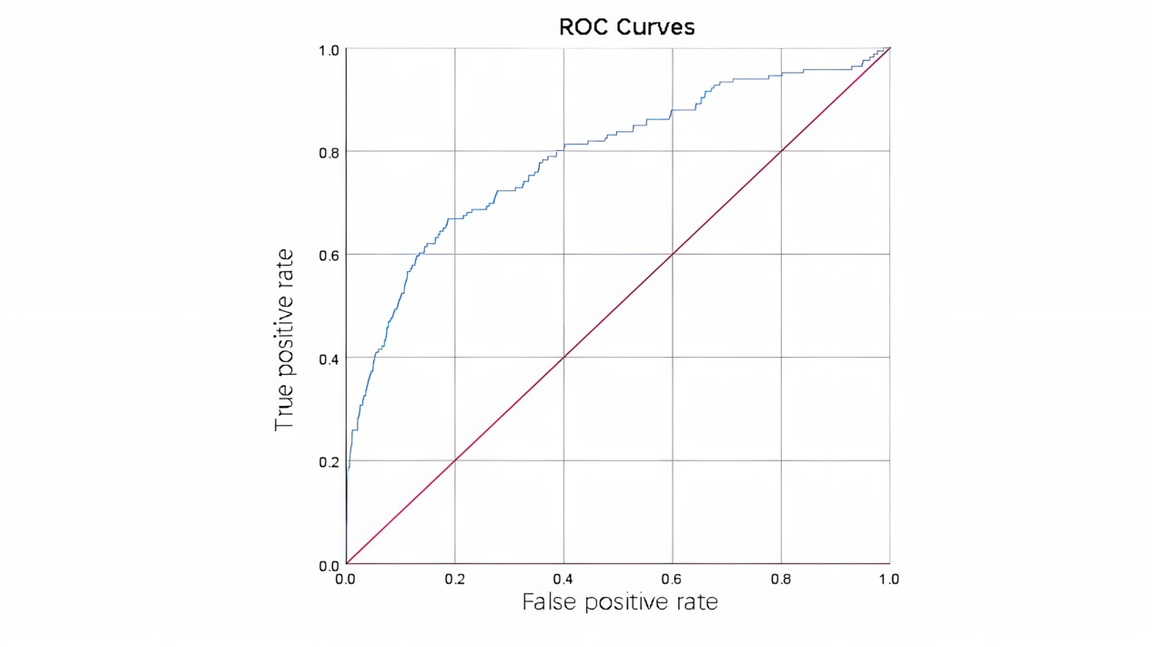
(A)
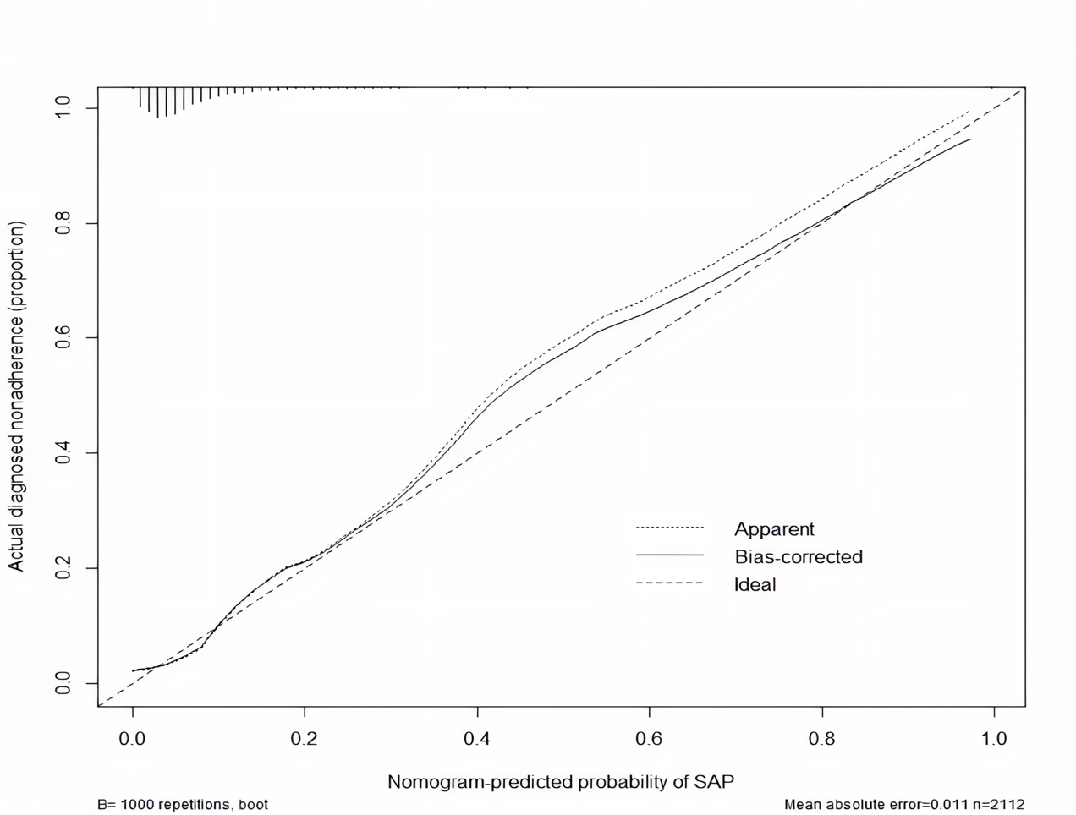
(B)
Supplementary Figure 1: Validation of nomogram in the modelling group. (A): AUC=0.788, 95% CI: 0.747-0.829. (B): Nomogram calibration curve. Internal validation (n=2112, sampling frequency=1000) with an absolute error of 0.011). Abbreviations: AUC=the area under the receiver operating characteristic curve.
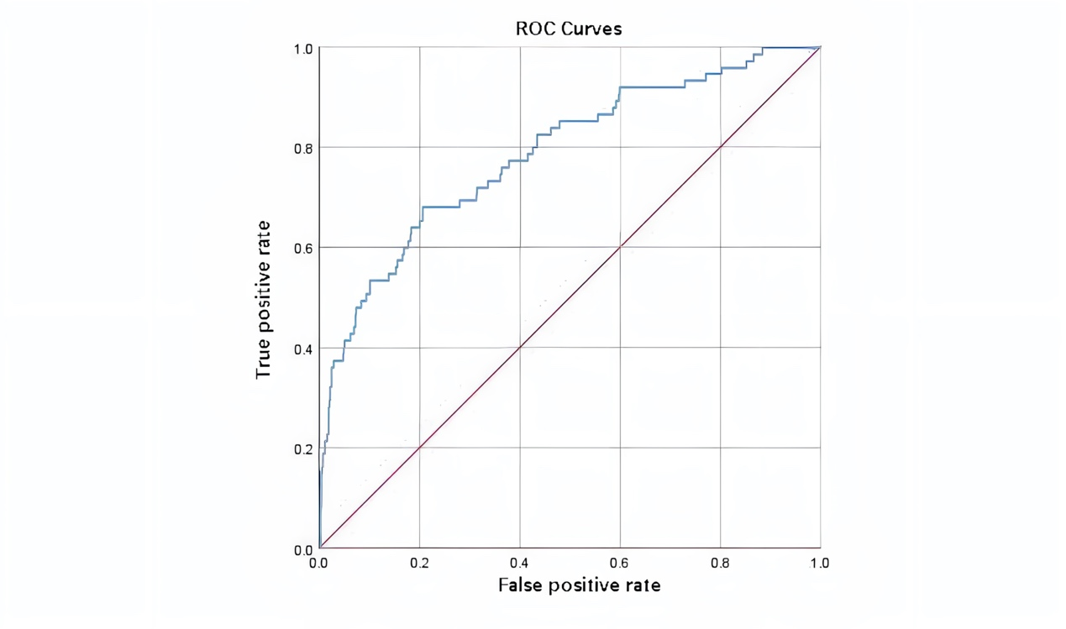
(A)
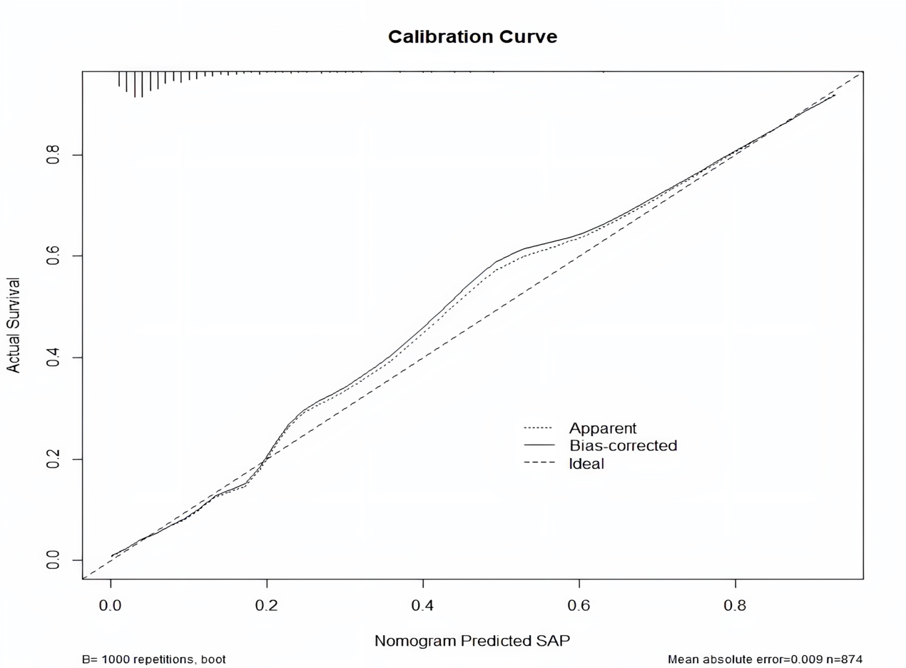
(B)
Supplementary Figure 2: Validation of nomogram in the validation group. (A): AUC= 0.789, 95% CI: 0.730-0.848. (B): Nomogram calibration curve. Internal validation (n=874, sampling frequency=1000) with an absolute error of 0.009). Abbreviations: AUC=the area under the receiver operating characteristic curve.
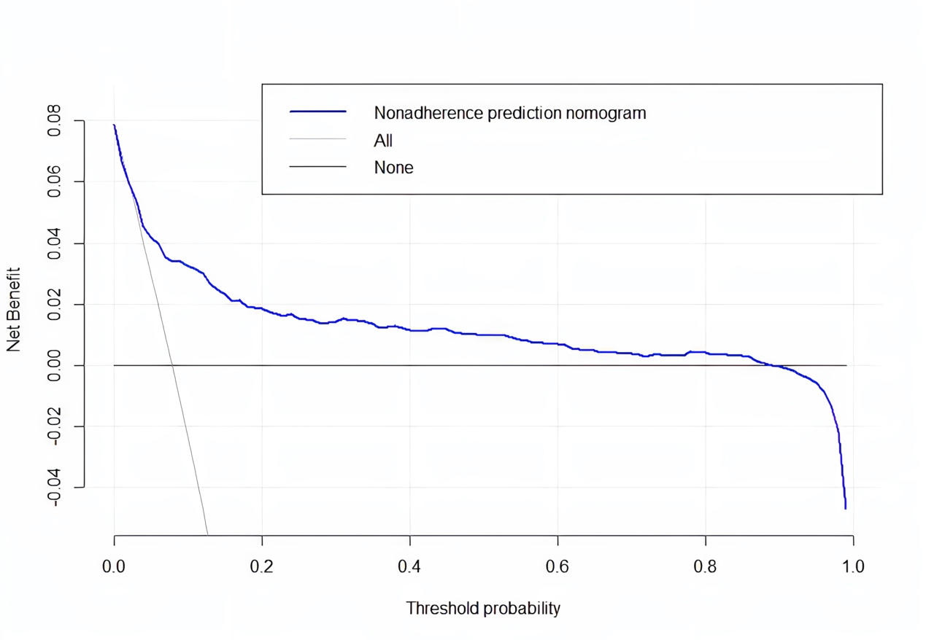
Supplementary Figure 3: DCA curves of the prediction model. Abbreviations: DCA= decision curve analysis.

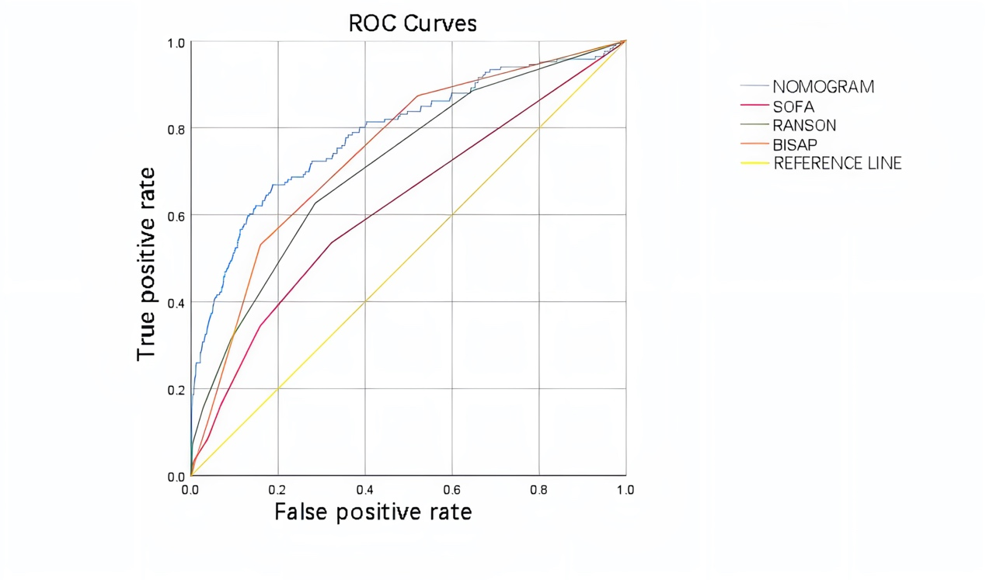
Supplementary Figure 4: Predictive performances of different models. Abbreviations: ROC= receiver operating characteristic curve. SOFA=sequential organ failure assessment. BISAP= bedside Index of severity in acute pancreatitis.

