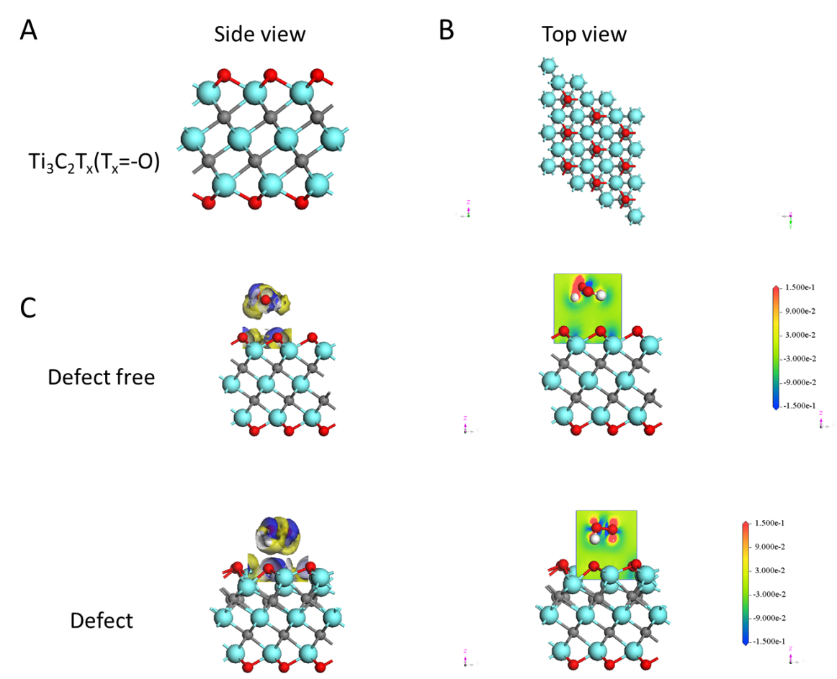

Figure S1. DFT calculations. (A)Side views of Ti₃C₂T_{x}(T_{x}=-O) monolayer structural forms; (B)Top view of Ti₃C₂T_{x}(T_{x}=-O) monolayer structural forms; (C)Side view of adsorption behaviors between Ti₃C₂T_{x}(T_{x}=-O) and H₂O₂ molecule. The electron density difference of the Ti₃C₂T_{x}(T_{x}=-O) at the defect-free system and Ti –defected system.

Figure S2. (A) Cell viability of Hep3B, Bel-7402, SK-Hep-1 cells incubated with Ti₃C₂ at various irradiation times after NIR light irradiation (808 nm, 1.5W/ cm², 20 ppm); (B) Cell viability of Hep3B, Bel-7402, SK-Hep-1 cells incubated with Ti₃C₂ at various laser irradiation density (808 nm, 1.5W/ cm², 2min. (C) Cell viability of Hep3B, Bel-7402, SK-Hep-1 cells incubated with Ti₃C₂ at various ultrasonic powers under ultrasound after 12 h (3 min, 20 ppm); (D) Cell viability of Hep3B, Bel-7402, SK-Hep-1 cells incubated with Ti₃C₂ at various ultrasonic powers density under ultrasonic after 18 h (3 min, 20 ppm); (E) Cell viability of Hep3B, Bel-7402, SK-Hep-1 cells incubated with Ti₃C₂ at various ultrasonic times under ultrasonic after 12 h; (F) Cell viability of Hep3B, Bel-7402, SK-Hep-1 cells incubated with Ti₃C₂ at various ultrasonic times under ultrasonic after 18 h. * indicates p<0.05, **indicates p<0.01, ***indicates p<0.005, ****indicates p<0.001.

Figure S3. The ROS generation of the tumor mammospheres formed from SK-Hep-1 under different treatment. Scale bar: 50μm.
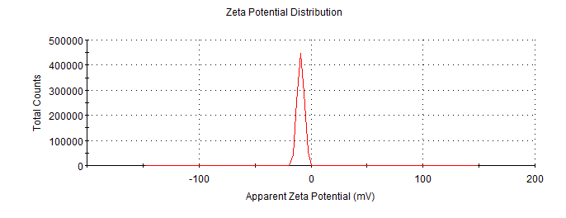
Figure S4 The Zeta potential Ti₃C₂/TiO₂
Figure S5 The quantity of the Ti₃C₂ intercellular uptake. * indicates p<0.05, ***indicates p<0.005, ****indicates p<0.001.

Figure S6 Infiltration of CD4⁺ and CD8⁺ T cells and IFN-γ secretion in tumor tissues were examined by immunohistochemical assays. Brown puncta were considered positive expression while blue signals represent nucleus of cells. Scale bar: 50μm.

Figure S7
A. Increase of CD80⁺/CD86⁺ cells gated on CD45⁺/CD11c⁺ from lymph nodes resected from bilateral tumor models were investigated by flow cytometry assays (T+U+L indicates Ti3C2+Ultrasond+Laser).
B. Statistical analysis of mean fluorescence intensity (MFI) from flow cytometry assays were analyzed from lymph nodes resected from treatment by Ti₃C₂ plus ultrasound and laser.
C. Western blot assays of P53 expression from lysates of tumors from bilateral models. GAPDH was used as a loading control.
D. Tumor were harvested and photographed from bilateral subcutaneous models of H22 cells.
E. Tumor weights were recorded and statistically analyzed. ** indicates p<0.01. n.s. indicates no significant difference.

Treatments | Major findings and mechanisms
Ti₃C₂/TiO₂ | Peroxidase activity. The generation ROS upon reaction with H₂O₂ in tumor microenvironment.
Ti₃C₂/TiO₂ nanozyme plus phototherapy | Photothermal conversion.
Ti₃C₂/TiO₂ nanozyme plus sonotherapy | The enhanced generation of ROS by ultrasound and the deeper tumor treatment.
Ti₃C₂/TiO₂ nanozyme plus phototherapy and sonotherapy | Integrating photothermal and sonodynamic effects to achieve image-guided tumor therapy and induce multiple anticancer immune responses

Table S1 Summarization of major findings in this study.

