Supplementary Material
Tumor-targeted cRGD-coated liposomes encapsulating optimized synergistic cepharanthine and IR783 for chemotherapy and photothermal therapy
Yumei Wu^{1,2,3,}*, Chunhua Zeng^{1,2,3,}*, Jiajia Lv^{1,2,3}, Hongyu Li^{1,2,3}, Jie Gao^{1,2,3}, Zhidong Liu⁴, and Zeli Yuan^{1,2,3}

¹Key Laboratory of Basic Pharmacology of Ministry of Education and Joint International Research Laboratory of Ethnomedicine of Ministry of Education, Zunyi Medical University, Zunyi 563000, China; ²Key Laboratory of Biocatalysis & Chiral Drug Synthesis of Guizhou Province, School of Pharmacy, Zunyi Medical University, Zunyi 563000, China; ³Guizhou International Scientific and Technological Cooperation Base for Medical Photo-Theranostics Technology and Innovative Drug Development, Zunyi Medical University, Zunyi 563000, China; ⁴Engineering Research Center of Modern Chinese Medicine Discovery and Preparation Technique, Ministry of Education, Tianjin University of Traditional Chinese Medicine, Tianjin 301617, China.
*These authors contributed equally to this work.

Correspondence: Jie Gao, Zunyi Medical University, Zunyi 563000, China, Email jiegao@mail.nankai.edu.cn; Zhidong Liu, Tianjin University of Traditional Chinese Medicine, No. 10 Poyanghu Road, Jinghai District, Tianjin 301617, China, Email lonerliuzd@163.com; Zeli Yuan, Zunyi Medical University, Zunyi 563000, China, Email zlyuan@zmu.edu.cn.

Supplementary Material

Methods

Calculation of combination index values
The combination of CEP and IR783 was evaluated using the combination index (CI) method established by Chou and Talalay. The CI values were then calculated using the following formula:
$$CI=\frac{D_{c1}}{D_{s1}}+\frac{D_{c2}}{D_{s2}}+\frac{D_{c1}D_{c2}}{D_{s1}D_{s2}}$$
where D_{s1} and D_{s2} represent the IC₅₀ of CEP and IR783 applied separately, while D_{c1} and D_{c2} are the IC₅₀ values of the drugs applied in combination. The CEP and IR783 combination effects are explained as follows: CI < 0.9, synergism; = 0.9-1.1, additive effect; > 1.1, antagonism. CI values were calculated at different fractions affected (Fa ranges from 0 to 1), where Fa = 0 represents 100% viability, and Fa = 1 represents 0% viability. By calculating the CI value, the best combination ratio of CEP and IR783 was obtained.
The CompuSyn software developed by Chou was used for data processing to input the IC₅₀ of free drug CEP and IR783 and the corresponding drug concentration when different combination ratios led to different degrees of Fa to obtain CI values and other relevant information.
Method validation for determination of CEP and IR783 by HPLC
The concentration of CEP and IR783 was determined by HPLC system (Agilent technologies 1260 series) and a C18 column (250 mm × 4. 6 mm, i.d 5 µm) operating at 30 °C. The mobile phase composed of methanol and 0.5% triethylamine solution (v/v = 95/5) for CEP, acetonitrile and water was allowed as Table S1 for IR783. The flow rate was set at 1 mL/min. The detection wavelength was set at 285 nm for CEP and 775 nm for IR783, and the injected volume of the sample was 10 µL. The method was linear over the concentration range of 25.8-921.6 μg/mL for CEP and 9.43-452.7 μg/mL for IR783. The linear regression equation was Y=7.25X-73.97 with a correlation coefficient (R) of 0.999 9 for CEP, and Y=145.71X+223.49 with a correlation coefficient (R) of 0.999 9 for IR783. The % RSDs for intraday and inter-day precision, repeatability, accuracy, stability studies of the method were below 3% for CEP and IR783.
Table S1. Determination of mobile phase composition of IR783 by HPLC
Time (min) | Water (%) | Acetonitrile (%)
3 | 65 | 35
10 | 48 | 52
13 | 65 | 35
15 | 65 | 35

Determination of encapsulation efficiency and drug loading content
The encapsulation efficiency was measured by ultrafiltration centrifugation method. Different formulations were transferred to the upper chamber of a centrifuge tube fitted with an ultrafilter (Amicon ultra, MWCO 50 kDa; Millipore Company) and centrifuged at 4000 rpm for 20 min. The ultrafiltrate containing unencapsulated CEP and IR783 was determined by HPLC method. To determine the total content of CEP or IR783, different formulations were dissolved in methanol and sonicated for 10 mins, and diluted appropriately by methanol, respectively. The obtained dispersion was filtered through a 0.22 μm filter and analyzed with the validated HPLC methods above. Encapsulation efficiency (EE%) was calculated by the following formula:
$$EE\%=\frac{w_{total}-W_{free}}{W_{total}}100$$
Where, W_{total} and W_{free} are the total weight of CEP or IR783 in the liposomes, and the weight of free CEP or IR783, respectively.
Dug loading content (DL%) was calculated by the following formula:
$$DL\%=\frac{w_{total}}{w_{total}+W_{lipid}}×100$$
Where, W_{total} and W_{lipid} are the total weight of CEP or IR783 in the liposomes, and the weight of lipids, respectively.

In vitro release study
The dialysis method was used to study the in vitro release behavior of PEG-CEP-IR783-Lip and cRGD-CEP-IR783-Lip. The 0.1% Tween-80 PBS buffer solution (10 mM, pH 7.4) was selected as the release medium. One milliliter of the formulation was placed in the dialysis bag. Both ends of the dialysis bag were fastened, and the bag was placed into the vessel containing 40 ml release medium. The rotation speed was set at 120 r/min and the temperature was maintained at (37 ± 1) ºC. Five hundred microliters sample was taken at 0, 0.5, 1, 2, 4, 8, 12, 24, 36, 48 h, and then blank release medium with the same volume and temperature was added. The sample was added to 1.5 ml methanol solution to conduct as the previous method and filtered with 0.22 μm membrane, and the filtrate was taken to determine the contents of CEP or IR783 according to the validated HPLC methods.

Cytotoxicity study of the liposomes
The cytotoxicity of different formulations on B16F10 cells was evaluated by MTT assay. Cells were seeded in 96-well plates with 5×10³ cells per well and incubated for 24 h at 37ºC in a 5% CO₂ incubator. Subsequently, the culture medium was replaced with a medium containing free CEP + IR783, PEG-CEP-IR783-Lip or cRGD-CEP-IR783-Lip (0.16, 0.31, 0.62, 1.25, 2.49, 4.98, 9.96, 19.92 μM in the dose of IR783) or blank liposomes (0.94, 1.9, 3.8, 7.5, 15, 30, 60 μM), and the cells were incubated for an additional 24 h. Then, a laser of 808 nm was used to irradiate each cell well, and the power density was 0.2 W/cm² and 1 min/well (no laser irradiation in blank liposomes group). After the irradiation was completed, the drug-containing medium was sucked out, and 10% MTT solution (5 mg/ml) was added to each well for 4 h. Then, the MTT containing medium was sucked out, and 100 µL DMSO was added to each well to detect absorbance at a wavelength of 490 nm. Cell viability was calculated according to the formula described above.

Investigation of hemolysis of liposomes
Whole blood of healthy BALB/c mice was taken into a heparin sodium centrifuge tube containing anticoagulant, centrifuged (4°C, 10000 rpm, 10 min), the supernatant was removed, the precipitation was cleaned with normal saline, and the operation was rinsed and repeated three times, and the red blood cells were re-suspended with normal saline. Drug-free liposomes PEG-Lip and cRGD-Lip were diluted with PBS buffer solution to 0 µM, 25 µM, 50 µM, 100 µM, 200 µM, 400 µM, and 800 µM, respectively. Liposomes with the above concentration and 1% Triton solution of 100 μL were added to 2% erythrocytes of the same volume, incubated at 37°C for 4 h, centrifuged (3000 rpm, 5 min), and the supernatant of each group was taken at 540 nm to measure the release of hemoglobin.

Results
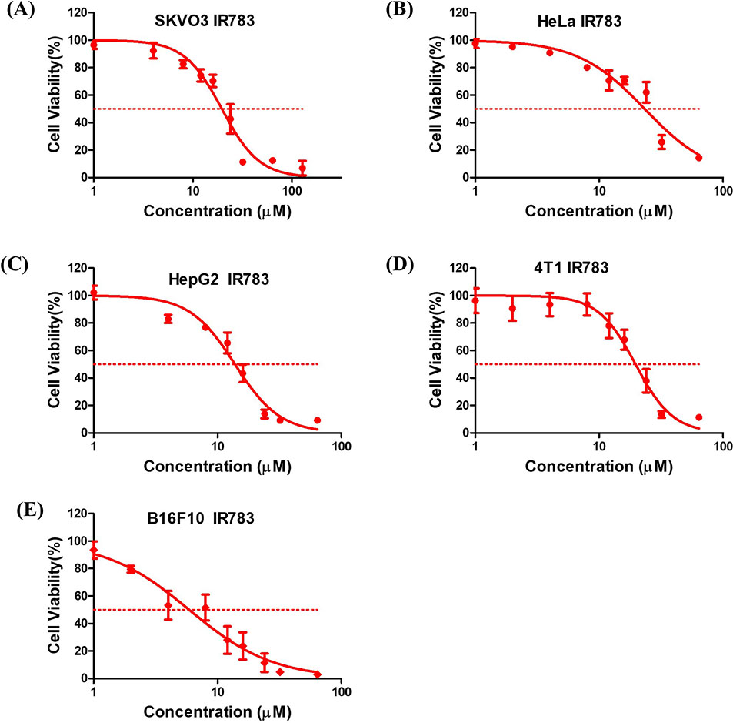
Figure S1. IR783 dose-response curves with SKVO3 cells (A), HeLa cells (B), HepG2 cells (C), 4T1 cells (D) and B16F10 cells (E), respectively.
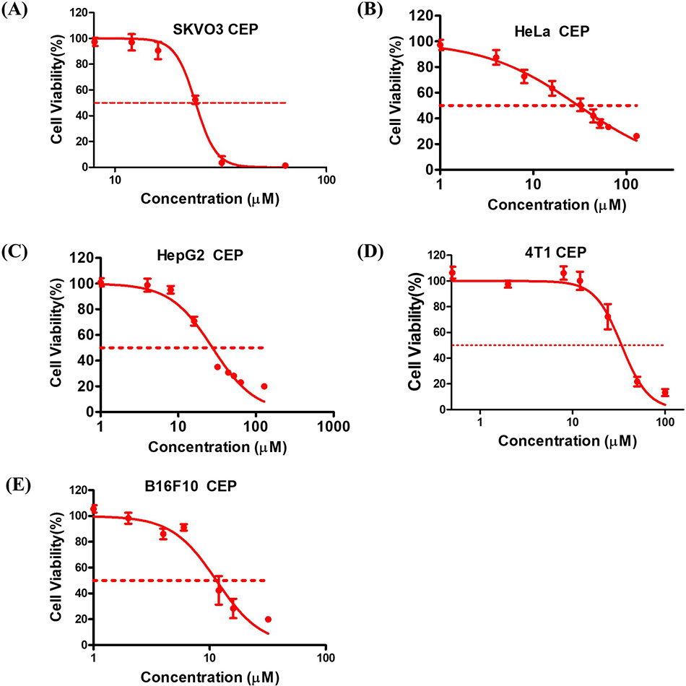

Figure S2. CEP dose-response curves with SKVO3 cells (A), HeLa cells (B), HepG2 cells (C), 4T1 cells (D) and B16F10 cells (E), respectively.

Table S2. Particle size, PDI and zeta potential of different liposomes
Groups | Particle size（nm） | PDI | Zeta potential（mV）
PEG-Blank-Lip | 110.92 ± 0.77 | 0.174 ± 0.005 | –38.15 ± 0.25
cRGD-Blank-Lip | 119.03 ± 0.98 | 0.167 ± 0.016 | –38.13 ± 0.45
PEG-CEP-Lip | 106.38 ± 1.12 | 0.157 ± 0.018 | –38.52 ± 0.37
PEG-IR783-Lip | 86.61 ± 0.62 | 0.154 ± 0.006 | –38.48 ± 0.69
PEG-CEP-IR783-Lip | 94.47 ± 1.19 | 0.143 ± 0.027 | –38.46 ± 0.28
cRGD-CEP-IR783-Lip | 120.05 ± 1.48 | 0.197 ± 0.015 | –38.03 ± 0.38

Table S3. Drug loading and encapsulation efficiency of drug-loaded liposomes
Groups | Component | EE （%） | DL （%）
PEG-CEP-Lip | CEP | 100 ± 0.00 | 2.60 ± 0.07
PEG-IR783-Lip | R783 | 99.95 ± 0.00 | 8.59 ± 0.05
PEG-CEP-IR783-Lip | CEP | 88.71 ± 0.35 | 3.30 ± 0.14
PEG-CEP-IR783-Lip | IR783 | 95.70 ± 0.02 | 8.68 ± 0.12
cRGD-CEP-IR783-Lip | CEP | 98.16 ± 0.10 | 2.91 ± 0.00
cRGD-CEP-IR783-Lip | IR783 | 99.96 ± 0.00 | 7.40 ± 0.13

Figure S3. Changes in particle size (A) and PDI (B) of liposomes within 7 days (n = 3).
Figure S4. Changes in particle size (A) and PDI (B) of PEG-Blank-Lip in different solutions.
Figure S5. Changes in particle size (A) and PDI (B) of cRGD-Blank-Lip in different solutions.
Figure S6. Photothermal properties of IR783. (A) Time-dependent changes in temperature with IR783 at a concentration of 0.50 mM under irradiation of an 808 nm laser with different power densities. (B)Time-dependent changes in temperature of IR783 at different concentrations irradiated by an 808 nm laser at 0.2 W/cm².
Figure S7. The mice were dissected 8 h after intravenous injection, and fluorescence imaging of major organs (heart, liver, spleen, lung, and kidney) and tumor tissues was performed.
Figure S8. Weight change curves of mice in each treatment period.
Figure S9. In vivo anti-tumor efficacy in BALB/c mice bearing 4T1 tumors under different treatment modalities. cRGD-CEP-IR783-Lip and PBS hematologic parameters irradiated and non-irradiated: liver function markers: AST (A), ALT (B), and AST/ALT (C), renal function markers: UA (D), Urea (E), and Cr (F). n = 5.
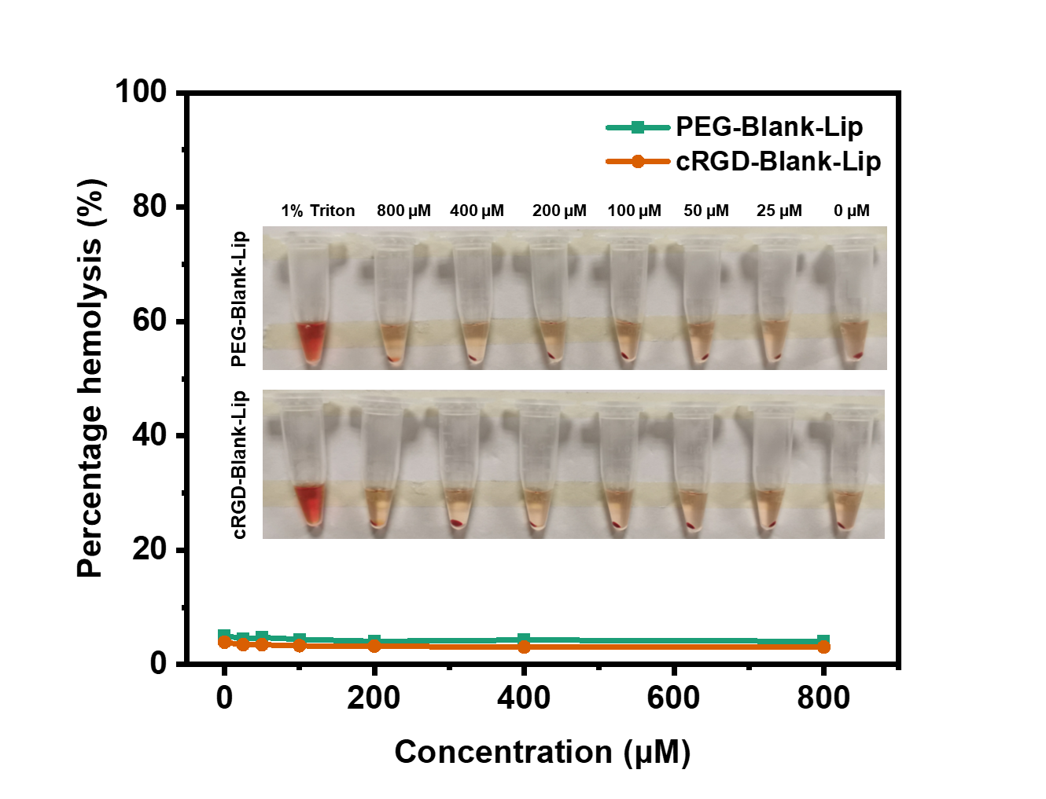
Figure S10. Hemolysis of PEG-Blank-Lip and cRGD-Blank-Lip with different concentrations.

