Figure S1 Kernel density plots of Total Expenditures across three phases of care by specific chronic conditions
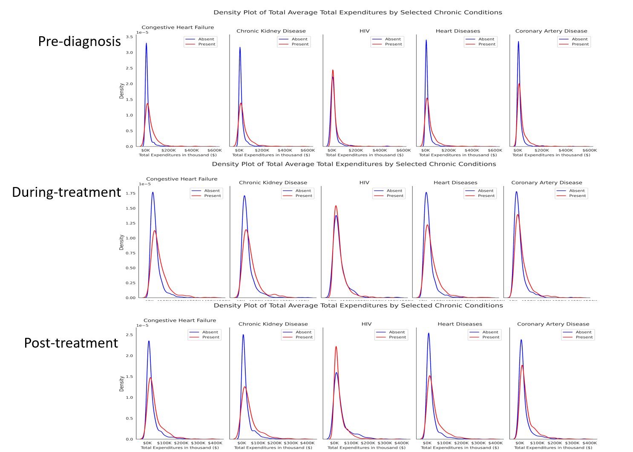

Figure S2 Shapley Additive exPlanations - Summary Plot with top 15 Leading Predictors of Total Expenditures Across Beneficiaries That Met Inclusion Criteria Across All Three Phases Of Care (N=1,029) Older Adults (≥67 years old)) Medicare Beneficiaries with Merkel Cell Carcinoma, Linked SEER Cancer Registry and Medicare Claims files, 2009-2017
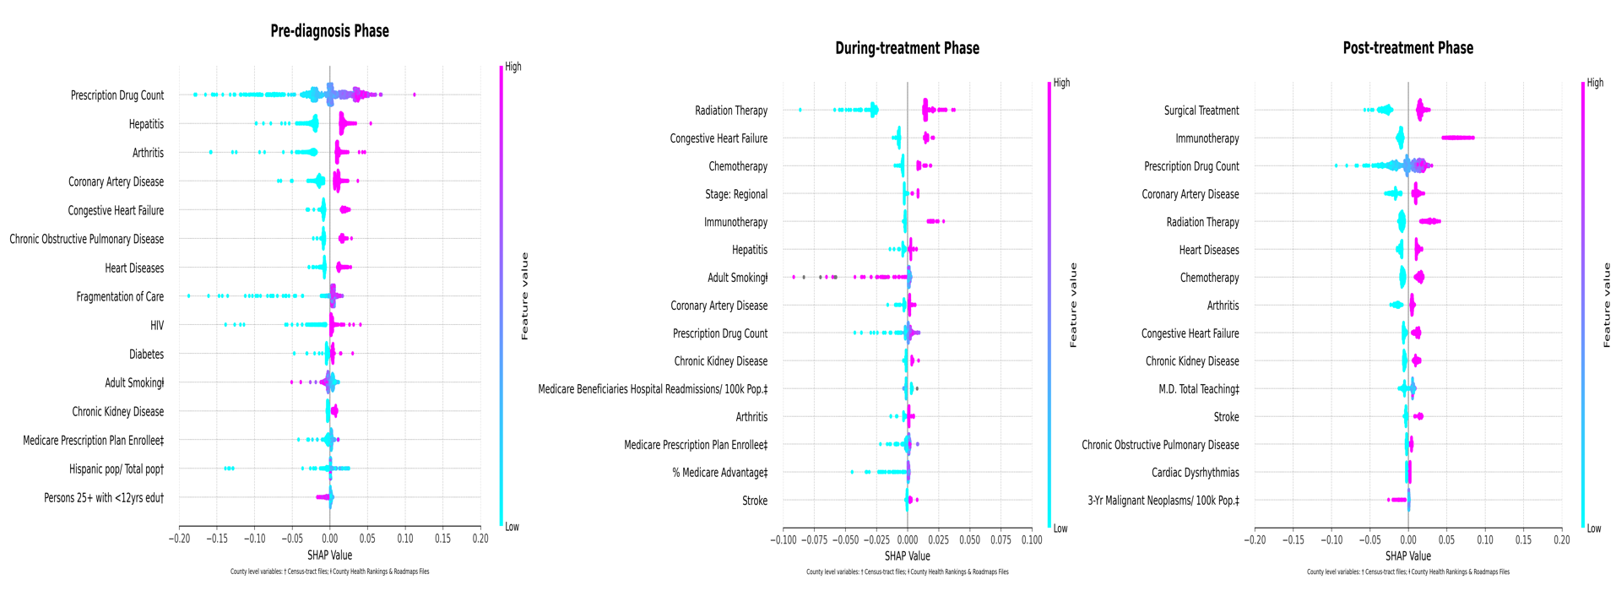

Figure S3 Shapley Additive exPlanations - Summary Plot with top 15 Leading Predictors of OOP Expenditures Across Beneficiaries That Met The Inclusion Criteria Across All Three Phases Of Care (N=1,029) Older Adults (≥67 years old)) Medicare Beneficiaries with Merkel Cell Carcinoma, Linked SEER Cancer Registry and Medicare Claims files, 2009-2017

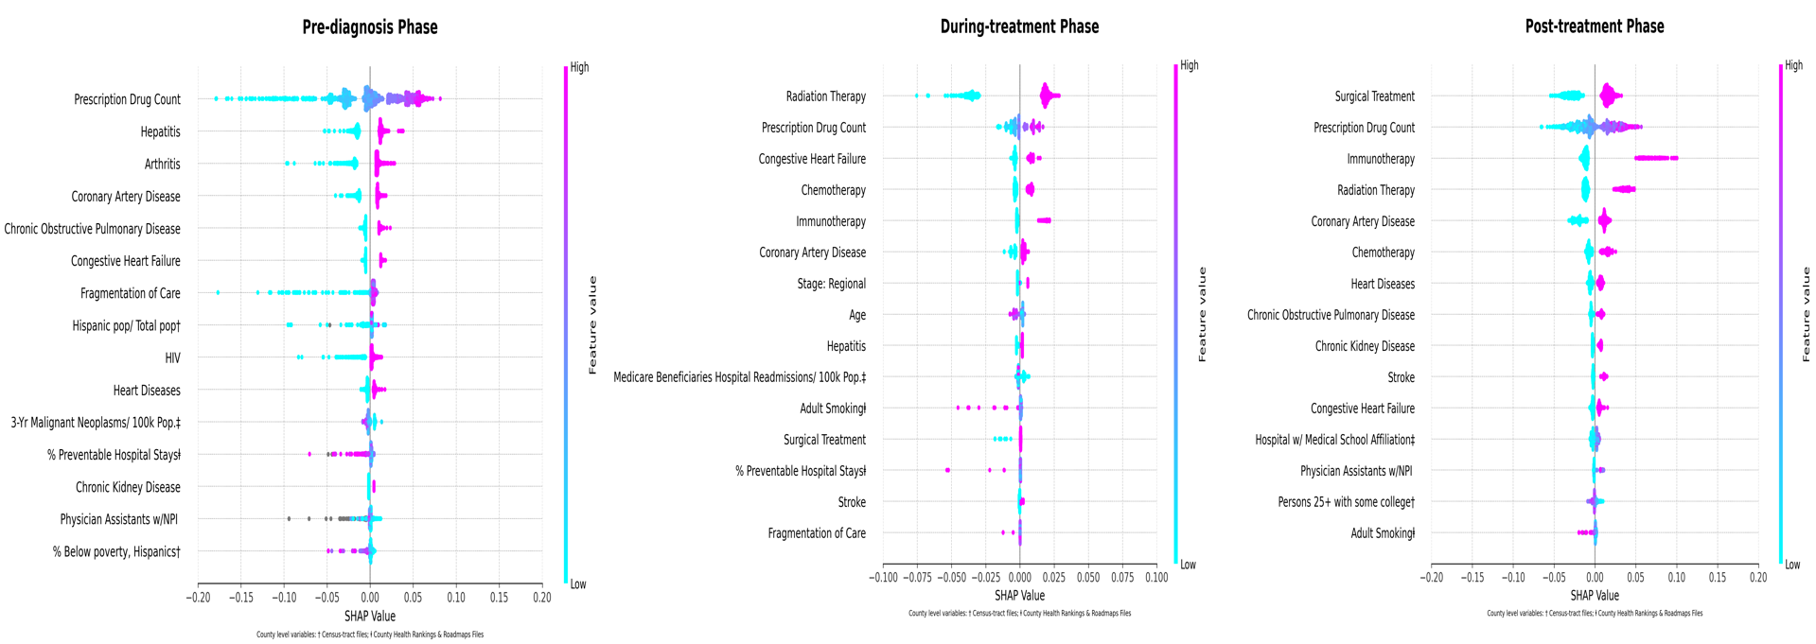

Table S1: Unadjusted GLM for total expenditures based on Selected Sample Characteristics among Fee-for-Service Medicare Beneficiaries (age ≥67 years at index date) with MCC, Linked SEER Cancer Registry and Medicare Claims files, 2009-2017
 |  | Pre-diagnosis |  |  | During-treatment |  |  | Post-treatment
Variable |  | Estimate | SE | p-value | Estimate | SE | p-value | Estimate | SE | p-value
Sex
 | Female | 22,427.62 | 2,050.33 | <0.001 | 45,878.20 | 2,402.13 | <0.001 | 29,652.66 | 2,460.95 | 0.04
 | Male (ref) | 28,288.72 | 1,338.14 | <0.001 | 52,702.98 | 1,554.58 | <0.001 | 34,701.26 | 1,618.31 | <0.001
Age
 | 70-74 | 25,453.91 | 4,555.25 | 0.01 | 55,149.94 | 4,756.04 | 0.57 | 34,299.52 | 4,726.18 | 0.84
 | 75-79 | 25,000.55 | 4,531.61 | 0.01 | 51,183.77 | 4,746.88 | 0.16 | 31,238.50 | 4,726.18 | 0.66
 | 80-84 | 24,278.08 | 4,528.13 | 0.01 | 48,642.83 | 4,767.80 | 0.05 | 33,557.60 | 4,740.16 | 0.96
 | 85,+ | 25,161.81 | 4,249.51 | 0.01 | 43,456.09 | 4,554.59 | <0.001 | 30,921.47 | 4,613.18 | 0.60
 | 66-69 (ref) | 36,659.15 | 3,898.47 | <0.001 | 57,836.09 | 3,987.04 | <0.001 | 33,335.63 | 3,931.28 | <0.001
Race
 | Non-White | 27,177.98 | 3,923.00 | 0.70 | 56,967.22 | 4,604.25 | 0.10 | 31,328.88 | 4,825.06 | 0.79
 | White | 25,684.15 | 1,055.07 | <0.001 | 49,295.07 | 1,232.21 | <0.001 | 32,605.94 | 1,265.57 | <0.001
Cancer Stage
 | Local | 31,411.62 | 4,879.67 | 0.53 | 69,621.01 | 6,776.62 | <0.001 | 62,138.51 | 7,821.52 | <0.001
 | Regional | 25,230.50 | 3,662.25 | 0.39 | 43,020.91 | 4,479.54 | 0.08 | 29,963.60 | 4,499.66 | 0.05
 | Distant | 24,205.31 | 4,007.84 | 0.30 | 68,306.56 | 4,838.90 | <0.001 | 39,548.05 | 4,937.92 | <0.001
 | Unknown (ref) | 28,366.78 | 3,416.0 | <0.001 | 35,230.23 | 4,243.08 | <0.001 | 21,043.09 | 4,247.91 | <0.001
Dual Medicaid coverage
 | Yes | 35,345.51 | 2,699.19 | <0.001 | 57,822.84 | 3,212.97 | <0.001 | 38,631.61 | 3,348.44 | 0.03
 | No (ref) | 23,852.51 | 1,108.88 | <0.001 | 48,298.30 | 1,294.58 | <0.001 | 31,377.36 | 1,327.81 | <0.001
Asthma
 | Yes | 35,557.29 | 3,078.05 | <0.001 | 55,666.45 | 3,479.98 | 0.05 | 44,347.14 | 3,560.14 | <0.001
 | No (ref) | 24,417.29 | 1,081.36 | <0.001 | 48,940.79 | 1,275.68 | <0.001 | 30,682.73 | 1,304.76 | <0.001
Arthritis
 | Yes | 29,707.38 | 2,181.69 | <0.001 | 53,522.00 | 2,677.78 | <0.001 | 35,666.98 | 2,780.62 | <0.001
 | No (ref) | 16,959.27 | 1,816.02 | <0.001 | 39,482.68 | 2,300.50 | <0.001 | 23,304.26 | 2,400.51 | <0.001
Congestive heart failure
 | Yes | 43,648.36 | 2,167.79 | <0.001 | 66,730.03 | 2,507.62 | <0.001 | 43,636.14 | 2,583.07 | <0.001
 | No (ref) | 18,644.00 | 1,159.07 | <0.001 | 42,508.82 | 1,380.02 | <0.001 | 27,358.98 | 1,454.23 | <0.001
Coronary artery disease
 | Yes | 32,476.68 | 2,033.33 | <0.001 | 55,967.88 | 2,411.91 | <0.001 | 37,506.34 | 2,490.71 | <0.001
 | No (ref) | 15,889.28 | 1,571.08 | <0.001 | 39,851.61 | 1,899.22 | <0.001 | 24,294.49 | 1,965.04 | <0.001
Cardiac dysrythmias
 | Yes | 33,234.45 | 2,003.64 | <0.001 | 56,126.14 | 2,353.59 | <0.001 | 38,249.18 | 2,420.43 | <0.001
 | No (ref) | 18,781.39 | 1,395.48 | <0.001 | 43,210.61 | 1,686.79 | <0.001 | 26,328.10 | 1,744.13 | <0.001
Chronic kidney disease
 | Yes | 42,342.87 | 2,237.83 | <0.001 | 63,796.43 | 2,600.98 | <0.001 | 47,334.27 | 2,657.74 | <0.001
 | No (ref) | 19,818.45 | 1,152.46 | <0.001 | 44,445.99 | 1,373.82 | <0.001 | 26,776.81 | 1,404.53 | <0.001
COPD
 | Yes | 39,996.55 | 2,103.74 | <0.001 | 58,790.37 | 2,437.81 | <0.001 | 39,601.14 | 2,505.11 | <0.001
 | No (ref) | 18,847.86 | 1,205.50 | <0.001 | 44,658.33 | 1,476.81 | <0.001 | 28,310.78 | 1,529.24 | <0.001
Diabetes
 | Yes | 32,494.93 | 2,006.32 | <0.001 | 55,574.34 | 2,357.53 | <0.001 | 36,460.69 | 2,432.94 | <0.001
 | No (ref) | 18,870.48 | 1,430.04 | <0.001 | 43,956.32 | 1,678.36 | <0.001 | 28,721.26 | 1,704.07 | <0.001
Heart diseases
 | Yes | 39,300.81 | 2,057.66 | <0.001 | 61,124.10 | 2,349.36 | <0.001 | 42,528.52 | 2,396.31 | <0.001
 | No (ref) | 18,233.67 | 1,232.51 | <0.001 | 41,531.94 | 1,530.31 | <0.001 | 24,203.57 | 1,614.13 | <0.001
Hypertension
 | Yes | 27,161.25 | 2,657.27 | <0.001 | 48,995.83 | 2,638.72 | 0.25 | 28,892.60 | 2,497.32 | <0.001
 | No (ref) | 19,418.14 | 2,410.94 | <0.001 | 52,001.30 | 2,235.29 | <0.001 | 38,351.38 | 1,961.16 | <0.001
HIV
 | Yes | 26,845.85 | 3,076.72 | 0.01 | 49,477.08 | 2,781.86 | 0.58 | 29,480.10 | 2,536.00 | <0.001
 | No (ref) | 18,348.36 | 2,879.66 | <0.001 | 51,007.63 | 2,424.99 | <0.001 | 37,968.37 | 2,032.12 | <0.001
Hepatitis
 | Yes | 33,968.86 | 1,995.59 | <0.001 | 54,702.00 | 2,378.07 | <0.001 | 33,220.91 | 2,442.43 | 0.56
 | No (ref) | 15,823.97 | 1,479.12 | <0.001 | 43,592.82 | 1,783.96 | <0.001 | 31,797.77 | 1,737.63 | <0.001
High cholesterol
 | Yes | 26,264.70 | 2,705.08 | 0.30 | 51,302.80 | 3,362.10 | <0.001 | 33,405.74 | 3,448.47 | 0.08
 | No (ref) | 23,483.99 | 2,464.57 | <0.001 | 41,266.36 | 3,108.27 | <0.001 | 27,350.81 | 3,185.68 | <0.001
Stroke
 | Yes | 40,877.95 | 2,616.87 | <0.001 | 66,409.06 | 3,037.94 | <0.001 | 45,113.12 | 3,200.66 | <0.001
 | No (ref) | 22,513.61 | 1,105.70 | <0.001 | 46,172.78 | 1,294.05 | <0.001 | 29,886.84 | 1,330.52 | <0.001
Thyroid diseases
 | Yes | 31,279.92 | 2,111.88 | <0.001 | 54,159.51 | 2,415.99 | <0.001 | 39,312.58 | 2,445.15 | <0.001
 | No (ref) | 22,752.18 | 1,260.93 | <0.001 | 46,938.40 | 1,532.69 | <0.001 | 27,444.08 | 1,598.76 | <0.001
Depression
 | Yes | 43,013.93 | 2,466.21 | <0.001 | 66,739.90 | 2,747.27 | <0.001 | 46,494.59 | 2,817.88 | <0.001
 | No (ref) | 21,368.73 | 1,114.89 | <0.001 | 44,684.21 | 1,328.87 | <0.001 | 28,144.79 | 1,375.66 | <0.001
Anxiety
 | Yes | 38,027.22 | 2,709.15 | <0.001 | 64,142.47 | 2,770.34 | <0.001 | 43,778.35 | 2,775.66 | <0.001
 | No (ref) | 23,358.67 | 1,103.46 | <0.001 | 45,510.72 | 1,336.11 | <0.001 | 28,702.92 | 1,396.33 | <0.001
 | No (ref) | 22,882.74 | 1,086.45 | <0.001 | 42,920.94 | 1,401.82 | <0.001 | 24,635.87 | 1,425.48 | <0.001
Region
 | Northeast | 21,440.94 | 2,947.49 | 0.03 | 44,052.10 | 3,461.32 | 0.01 | 28,967.52 | 3,639.80 | 0.11
 | South | 17,561.87 | 3,868.76 | 0.01 | 39,453.32 | 4,399.81 | <0.001 | 29,140.19 | 4,642.44 | 0.23
 | Midwest | 27,272.54 | 2,350.92 | 0.78 | 51,355.66 | 2,752.63 | 0.54 | 31,954.24 | 2,820.59 | 0.32
 | West(ref) | 27,934.94 | 1,565.79 | <0.001 | 53,034.49 | 1,821.29 | <0.001 | 34,762.76 | 1,833.65 | <0.001
Metro
 | Metro | 26,452.61 | 3,847.78 | 0.02 | 51,007.96 | 4,629.54 | <0.001 | 33,167.95 | 4,985.68 | 0.04
 | Non-Metro (ref) | 17,670.71 | 3,700.27 | <0.001 | 34,449.48 | 4,463.95 | <0.001 | 22,994.94 | 4,823.81 | <0.001
Diagnosis year
 | 2007 |2009 | 26,172.28 | 4,367.46 | 0.61 | 43,749.76 | 5,234.70 | <0.001 | 28,251.50 | 5,456.10 | <0.001
 | 2008 | 2010 | 28,172.27 | 4,577.05 | 0.96 | 58,152.43 | 5,358.13 | 0.84 | 24,743.63 | 5,600.27 | <0.001
 | 2009 | 2011 | 25,670.29 | 4,565.30 | 0.55 | 55,869.00 | 5,461.21 | 0.54 | 29,316.60 | 5,928.37 | <0.001
 | 2010 | 2012 | 28,753.47 | 4,122.17 | 0.94 | 44,218.00 | 4,916.30 | <0.001 | 26,707.35 | 4,868.51 | <0.001
 | 2011 | 2013 | 23,254.87 | 3,909.68 | 0.19 | 43,342.74 | 4,500.10 | <0.001 | 28,840.22 | 4,524.82 | <0.001
 | 2012 | 2014 | 23,649.16 | 4,004.57 | 0.23 | 48,188.98 | 4,549.73 | 0.02 | 29,989.26 | 4,626.61 | <0.001
 | 2013 | 2015 | 26,015.78 | 3,853.64 | 0.53 | 49,036.71 | 4,453.88 | 0.02 | 29,192.23 | 4,619.32 | <0.001
 | 2014 | 2016 | 23,264.26 | 3,763.11 | 0.17 | 48,660.56 | 4,453.88 | 0.02 | 39,693.04 | 4,604.96 | 0.11
 | 2015 | 2017 (ref) | 28,426.08 | 2,642.56 | <0.001 | 59,254.30 | 3,122.57 | <0.001 | 47,029.16 | 3,227.00 | <0.001

Table S2: Unadjusted GLM for Total OOP based on Selected Sample Characteristics among Fee-for-Service Medicare Beneficiaries (age ≥67 years at index date) with MCC, Linked SEER Cancer Registry and Medicare Claims files, 2009-2017
 |  | Pre-diagnosis |  |  | During-treatment |  |  | Post-treatment
Variable |  | Estimate | SE | p-value | Estimate | SE | p-value | Estimate | SE | p-value
Sex
 | Female | 4,643.50 | 328.88 | <0.001 | 9,556.57 | 362.95 | <0.001 | 6,148.47 | 421.38 | 0.03
 | Male (ref) | 5,616.21 | 214.64 | <0.001 | 11,094.38 | 234.89 | <0.001 | 7,050.44 | 277.10 | <0.001
Age
 | 70-74 | 5,385.18 | 730.49 | 0.03 | 11,724.83 | 714.31 | 0.50 | 7,064.03 | 807.99 | 0.85
 | 75-79 | 4,856.08 | 726.70 | <0.001 | 10,677.28 | 712.93 | 0.03 | 6,590.04 | 807.99 | 0.69
 | 80-84 | 5,186.88 | 726.14 | 0.01 | 10,512.85 | 716.08 | 0.02 | 7,130.05 | 810.38 | 0.79
 | 85,+ | 4,965.96 | 681.46 | <0.001 | 8,786.19 | 684.05 | <0.001 | 5,891.76 | 788.67 | 0.19
 | 66-69 (ref) | 6,981.36 | 625.17 | <0.001 | 12,204.49 | 598.81 | <0.001 | 6,915.97 | 672.09 | <0.001
Race
 | Non-White | 5,508.08 | 629.35 | 0.60 | 11,090.73 | 698.43 | 0.32 | 6,623.44 | 826.34 | 0.96
 | White | 5,178.01 | 169.26 | <0.001 | 10,400.90 | 186.92 | <0.001 | 6,663.13 | 216.74 | <0.001
Cancer Stage
 | Local | 5,946.26 | 783.24 | 0.49 | 14,750.95 | 1,012.93 | <0.001 | 11,224.87 | 1,343.04 | <0.001
 | Regional | 5,118.35 | 587.83 | 0.63 | 9,206.44 | 669.57 | 0.12 | 6,188.58 | 772.64 | 0.19
 | Distant | 5,068.05 | 643.30 | 0.60 | 13,566.60 | 723.29 | <0.001 | 7,867.91 | 847.89 | <0.001
 | Unknown (ref) | 5,401.18 | 548.30 | <0.001 | 8,166.44 | 634.23 | <0.001 | 5,179.08 | 729.41 | <0.001
Dual Medicaid coverage
 | Yes | 7,445.54 | 430.45 | <0.001 | 11,680.61 | 487.04 | <0.001 | 7,966.06 | 572.82 | 0.01
 | No (ref) | 4,746.33 | 176.84 | <0.001 | 10,211.86 | 196.24 | <0.001 | 6,416.78 | 227.15 | <0.001
Asthma
 | Yes | 6,687.59 | 494.00 | <0.001 | 11,435.24 | 527.40 | 0.03 | 8,950.21 | 608.67 | <0.001
 | No (ref) | 4,992.70 | 173.55 | <0.001 | 10,297.40 | 193.33 | <0.001 | 6,305.12 | 223.07 | <0.001
Arthritis
 | Yes | 5,802.65 | 350.30 | <0.001 | 11,006.01 | 405.98 | <0.001 | 7,178.26 | 476.49 | <0.001
 | No (ref) | 3,846.50 | 291.59 | <0.001 | 8,884.49 | 348.78 | <0.001 | 5,145.13 | 411.36 | <0.001
Congestive heart failure
 | Yes | 7,846.53 | 349.74 | <0.001 | 12,551.17 | 384.09 | <0.001 | 8,328.27 | 444.03 | <0.001
 | No (ref) | 4,143.17 | 187.00 | <0.001 | 9,537.60 | 211.38 | <0.001 | 5,886.46 | 249.99 | <0.001
Coronary artery disease
 | Yes | 6,192.10 | 327.13 | <0.001 | 11,377.19 | 365.66 | <0.001 | 7,519.54 | 426.49 | <0.001
 | No (ref) | 3,734.89 | 252.76 | <0.001 | 8,937.67 | 287.94 | <0.001 | 5,244.02 | 336.48 | <0.001
Cardiac dysrhythmias
 | Yes | 6,215.62 | 322.79 | <0.001 | 11,083.90 | 358.84 | <0.001 | 7,388.16 | 416.36 | <0.001
 | No (ref) | 4,246.91 | 224.81 | <0.001 | 9,781.17 | 257.18 | <0.001 | 5,874.36 | 300.03 | <0.001
Chronic kidney disease
 | Yes | 7,829.53 | 359.23 | <0.001 | 12,266.07 | 396.26 | <0.001 | 8,760.76 | 458.65 | <0.001
 | No (ref) | 4,253.47 | 185.00 | <0.001 | 9,747.71 | 209.30 | <0.001 | 5,846.51 | 242.38 | <0.001
COPD
 | Yes | 7,289.08 | 339.08 | <0.001 | 11,764.13 | 369.83 | <0.001 | 7,844.91 | 429.18 | <0.001
 | No (ref) | 4,181.47 | 194.30 | <0.001 | 9,688.63 | 224.04 | <0.001 | 5,956.81 | 261.99 | <0.001
Diabetes
 | Yes | 6,344.83 | 321.32 | <0.001 | 11,190.99 | 358.21 | <0.001 | 7,348.76 | 416.58 | <0.001
 | No (ref) | 4,021.60 | 229.03 | <0.001 | 9,689.13 | 255.01 | <0.001 | 5,997.49 | 291.78 | <0.001
Heart diseases
 | Yes | 7,148.95 | 332.02 | <0.001 | 11,887.31 | 358.64 | <0.001 | 8,122.71 | 413.05 | <0.001
 | No (ref) | 4,112.43 | 198.88 | <0.001 | 9,391.28 | 233.61 | <0.001 | 5,445.83 | 278.23 | <0.001
Hypertension
 | Yes | 5,445.44 | 426.07 | <0.001 | 10,439.79 | 400.21 | 0.93 | 5,929.63 | 426.71 | <0.001
 | No (ref) | 4,067.93 | 386.57 | <0.001 | 10,477.02 | 339.02 | <0.001 | 7,836.19 | 335.10 | <0.001
HIV
 | Yes | 5,355.35 | 493.79 | 0.01 | 10,397.52 | 421.73 | 0.60 | 6,004.38 | 433.12 | <0.001
 | No (ref) | 4,117.67 | 462.17 | <0.001 | 10,617.35 | 367.63 | <0.001 | 7,837.33 | 347.07 | <0.001
Hepatitis
 | Yes | 6,455.55 | 320.81 | <0.001 | 11,124.15 | 360.95 | <0.001 | 6,590.55 | 418.31 | 0.74
 | No (ref) | 3,673.53 | 237.79 | <0.001 | 9,583.03 | 270.78 | <0.001 | 6,731.98 | 297.60 | <0.001
High cholesterol
 | Yes | 5,380.82 | 433.38 | 0.02 | 10,682.98 | 509.53 | <0.001 | 6,862.48 | 589.99 | 0.02
 | No (ref) | 4,327.76 | 394.84 | <0.001 | 9,081.57 | 471.06 | <0.001 | 5,484.07 | 545.03 | <0.001
Stroke
 | Yes | 7,142.30 | 421.94 | <0.001 | 12,378.86 | 463.41 | <0.001 | 8,417.25 | 549.84 | <0.001
 | No (ref) | 4,780.17 | 178.28 | <0.001 | 10,022.81 | 197.39 | <0.001 | 6,293.37 | 228.57 | <0.001
Thyroid diseases
 | Yes | 6,020.39 | 339.03 | <0.001 | 11,212.84 | 365.86 | <0.001 | 7,958.04 | 417.75 | <0.001
 | No (ref) | 4,748.45 | 202.42 | <0.001 | 9,936.72 | 232.10 | <0.001 | 5,691.35 | 273.15 | <0.001
Depression
 | Yes | 7,810.40 | 396.61 | <0.001 | 12,229.01 | 421.21 | <0.001 | 8,780.37 | 484.38 | <0.001
 | No (ref) | 4,531.87 | 179.29 | <0.001 | 9,907.03 | 203.74 | <0.001 | 5,997.05 | 236.47 | <0.001
Anxiety
 | Yes | 6,978.27 | 435.29 | <0.001 | 11,995.89 | 423.16 | <0.001 | 8,486.01 | 475.94 | <0.001
 | No (ref) | 4,848.56 | 177.30 | <0.001 | 9,981.82 | 204.09 | <0.001 | 6,041.85 | 239.43 | <0.001
Region
 | Northeast | 4,512.65 | 473.21 | 0.02 | 9,582.84 | 524.78 | 0.02 | 6,191.38 | 623.48 | 0.17
 | South | 4,217.16 | 621.12 | 0.03 | 8,852.84 | 667.07 | <0.001 | 6,534.58 | 795.23 | 0.52
 | Midwest | 5,293.56 | 377.44 | 0.43 | 10,783.54 | 417.33 | 0.87 | 6,382.38 | 483.16 | 0.17
 | West(ref) | 5,592.66 | 251.38 | <0.001 | 10,853.28 | 276.13 | <0.001 | 7,046.68 | 314.10 | <0.001
Metro
 | Metro | 5,283.58 | 617.68 | 0.08 | 10,580.80 | 703.23 | 0.01 | 6,764.20 | 854.01 | 0.06
 | Non-Metro (ref) | 4,197.14 | 594.00 | <0.001 | 8,723.49 | 678.07 | <0.001 | 5,139.26 | 826.28 | <0.001
Diagnosis year
 | 2007 |2009 | 5,201.59 | 700.21 | 0.36 | 10,414.51 | 794.83 | 0.07 | 5,609.56 | 928.60 | <0.001
 | 2008 | 2010 | 5,274.27 | 733.81 | 0.44 | 11,574.70 | 813.57 | 0.73 | 5,631.79 | 953.14 | <0.001
 | 2009 | 2011 | 5,430.12 | 731.93 | 0.57 | 10,912.51 | 829.22 | 0.26 | 5,480.07 | 1,008.98 | <0.001
 | 2010 | 2012 | 5,491.09 | 660.88 | 0.60 | 9,782.04 | 746.49 | 0.01 | 5,934.66 | 828.60 | <0.001
 | 2011 | 2013 | 4,603.20 | 626.82 | 0.05 | 9,530.29 | 683.29 | <0.001 | 5,807.58 | 770.10 | <0.001
 | 2012 | 2014 | 4,710.41 | 642.03 | 0.08 | 10,006.10 | 690.83 | 0.01 | 6,167.38 | 787.43 | <0.001
 | 2013 | 2015 | 5,508.48 | 617.83 | 0.59 | 10,417.87 | 676.27 | 0.03 | 5,741.44 | 786.19 | <0.001
 | 2014 | 2016 | 4,809.08 | 603.32 | 0.09 | 9,983.66 | 676.27 | 0.01 | 7,980.40 | 783.74 | 0.02
 | 2015 | 2017 (ref) | 5,841.71 | 423.67 | <0.001 | 11,851.49 | 474.13 | <0.001 | 9,754.85 | 549.22 | <0.001

