Supplementary Table 1. Multivariate logistic regression analysis of ischemic stroke risk
 | OR | 95%CI | p-value
Model 1
Degree of stenosis | 2.370 | 1.429–3.932 | 0.001
Plaque echogenicity | 2.013 | 1.248–3.248 | 0.004
Smoking | 1.873 | 1.177–2.979 | 0.008
Model 2
Degree of stenosis | 2.440 | 1.442–4.130 | 0.001
Plaque echogenicity | 1.984 | 1.207–3.262 | 0.007
Smoking | 1.716 | 1.056–2.787 | 0.029
IPN | 2.684 | 1.654-4.352 | <0.0001
Abbreviations: IPN: intraplaque neovascularization; CI, confidence interval; OR, odds ratio

Supplementary Figure 1 Calibration curves for the optimal model
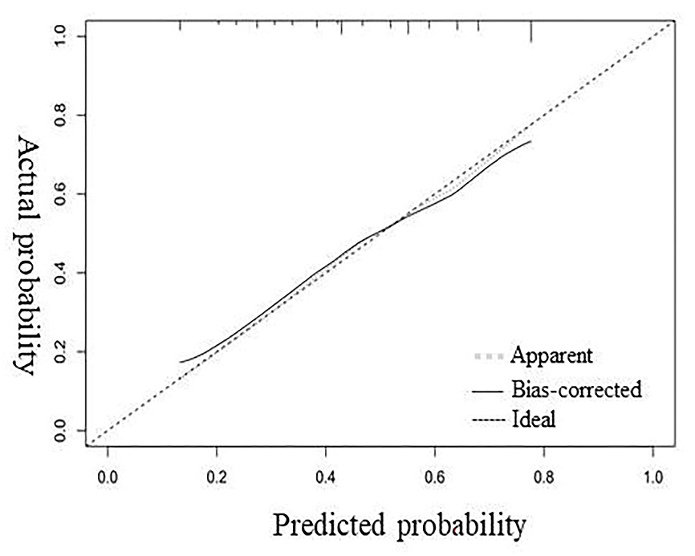

The calibration curve shows good agreement between the predicted probabilities and actual observations.

