Figure Supplementary 1
hdWGCNA Dendrogram indicating four modules labeled as M1, M2, M3, and M4, each marked with different colors, derived from the E1 cell subpopulation.

Figure Supplementary 2
Spearman correlation analysis between the remaining eight DEGs of SSc skin and the EndMT pathway, with a correlation coefficient (cor) < 0.5.
S3
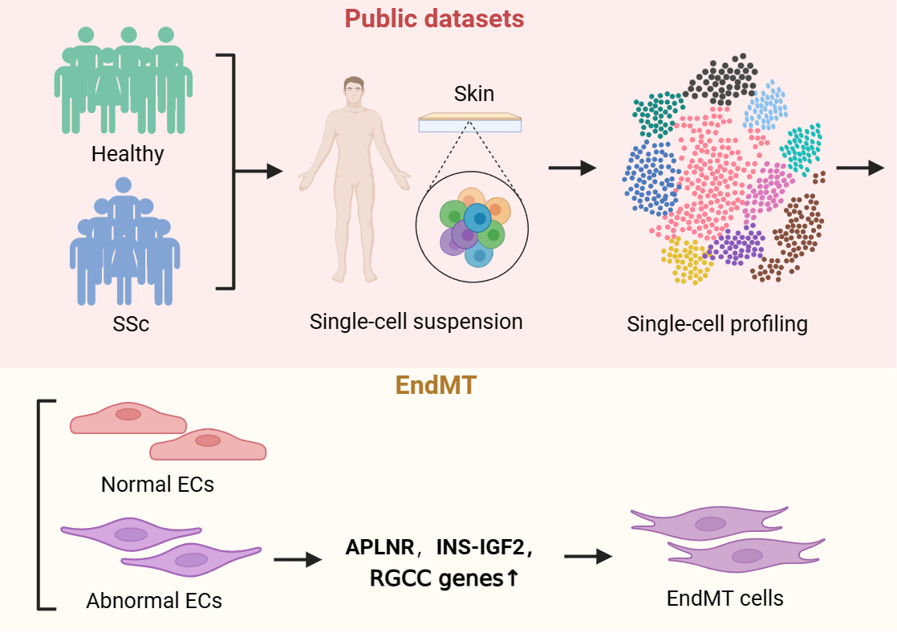
Figure Supplementary 3
The sequencing flow chart and key findings of this study

