Supplementary Table 1. Detailed information of studies and datasets used in the present study
Exposure or outcome | Year | Participants | Ancestry | Download | Ref
Circulating cytokines | 2017 | 8,293 individuals | European | 27989323 | 24
MS | 2019 | 47,429 cases and 68,374 controls | European | 31604244 | 25
NMO | 2018 | 215 cases and 1,244 controls | European | 29769526 | 26
CIDP | 2021 | 456,348 individuals | European | 34737426 | 28
MG | 2021 | 232 cases and 217,056 controls | European | finn-b-G6_MYASTHENIA | -
Abbreviations: MS: multiple sclerosis; NMO: neuromyelitis optica; GBS: Guillain-Barré syndrome; CIDP: chronic inflammatory demyelinating polyneuropathy; MG: myasthenia gravi.

Supplementary Table 2. Characteristics of genetic variants associated with each circulating cytokine concentration
Cytokine abbreviation | Cytokine full name | N | SNP ID | MS IVs | NMO IVs | CIDP IVs | MG IVs | CHR | Effect allele | Ref allele | EAF | Beta | SE | P-value | F | Fmean value
bNGF | beta nerve growth factor | 3,531 | rs28637706 | rs28637706 | rs28637706 | rs28637706 | rs28637706 | 19 | G | T | 0.31 | 0.16 | 0.03 | 1.42E-09 | 36.48 | 36.48
CCL-2 (MCP1) | Monocyte chemotactic protein 1 | 8,293 | rs12075 | rs12075 | rs12075 | rs12075 | rs12075 | 1 | A | G | 0.59 | 0.22 | 0.02 | 1.44E-44 | 198.67 | 105.62
 |  |  | rs2036297 | rs2036297 | rs2036297 | rs2036297 | rs2036297 | 3 | A | G | 0.66 | 0.12 | 0.02 | 1.09E-13 | 55.30
 |  |  | rs2228467 | rs2228467 | rs2228467 | rs2228467 | rs2228467 | 3 | C | T | 0.07 | 0.26 | 0.03 | 9.19E-20 | 82.10
 |  |  | rs7632755 | rs7632755 | rs7632755 | rs7632755 | rs7632755 | 3 | A | G | 0.09 | 0.29 | 0.03 | 1.18E-20 | 86.42
CCL-4 (MIP1b) | Macrophage inflammatory protein-1b | 8,243 | rs113010081 | rs6782522# | rs113010081 | rs113010081 | rs113010081 | 3 | C | T | 0.11 | 0.60 | 0.02 | 3.85E-140 | 636.34 | 122.28
 |  |  | rs2673050 | rs2673050 | rs2673050 | rs2673050 | rs2673050 | 3 | T | G | 0.5 | 0.13 | 0.02 | 3.14E-16 | 66.59
 |  |  | rs4683315 | rs4683315 | rs4683315 | rs4683315 | rs4683315 | 3 | G | A | 0.09 | 0.13 | 0.02 | 8.97E-09 | 32.57
 |  |  | rs73074316 | rs73074316 | rs73074316 | rs73074316 | rs73074316 | 3 | G | A | 0.08 | 0.14 | 0.02 | 2.80E-11 | 44.19
 |  |  | rs79091774 | — | rs79091774 | rs79091774 | rs79091774 | 3 | C | A | 0.04 | 0.46 | 0.08 | 8.83E-10 | 37.61
 |  |  | rs10491120 | rs10491120 | rs10491120 | rs10491120 | rs10491120 | 17 | A | G | 0.11 | 0.30 | 0.03 | 5.15E-21 | 89.04
 |  |  | rs111942332 | — | rs111942332 | rs111942332 | rs111942332 | 17 | G | T | 0.03 | 0.47 | 0.06 | 1.70E-16 | 68.04
 |  |  | rs113877493 | — | rs113877493 | rs113877493 | rs113877493 | 17 | C | T | 0.12 | 0.61 | 0.02 | 1.62E-173 | 788.95
 |  |  | rs117453826 | — | — | rs117453826 | rs117453826 | 17 | G | A | 0.02 | 0.58 | 0.06 | 5.07E-22 | 94.78
 |  |  | rs117620244 | — | rs117620244 | rs117620244 | rs117620244 | 17 | C | T | 0.02 | 0.35 | 0.05 | 1.87E-12 | 50.79
 |  |  | rs117715247 | — | rs117715247 | rs117715247 | rs117715247 | 17 | G | A | 0.02 | 0.35 | 0.06 | 3.09E-09 | 35.38
 |  |  | rs17693183 | rs17693183 | rs17693183 | rs17693183 | rs17693183 | 17 | G | A | 0.02 | 0.58 | 0.08 | 8.93E-13 | 53.12
 |  |  | rs2190980 | rs2190980 | rs2190980 | rs2190980 | rs2190980 | 17 | G | A | 0.39 | 0.11 | 0.02 | 1.43E-10 | 40.81
 |  |  | rs4795162 | rs4795162 | rs4795162 | rs4795162 | rs4795162 | 17 | A | G | 0.43 | 0.13 | 0.02 | 1.14E-15 | 63.68
 |  |  | rs4796072 | rs4796072 | rs4796072 | rs4796072 | rs4796072 | 17 | G | T | 0.21 | 0.11 | 0.02 | 8.12E-11 | 42.13
 |  |  | rs60516659 | rs60516659 | rs60516659 | rs60516659 | rs60516659 | 17 | A | G | 0.1 | 0.27 | 0.02 | 3.64E-27 | 117.71
 |  |  | rs6505501 | rs6505501 | rs6505501 | rs6505501 | rs6505501 | 17 | C | T | 0.19 | 0.16 | 0.02 | 3.71E-16 | 66.35
 |  |  | rs7221878 | rs7210540# | rs7221878 | rs7221878 | rs7221878 | 17 | C | T | 0.05 | 0.30 | 0.05 | 7.37E-11 | 43.24
 |  |  | rs76842834 | — | rs76842834 | rs76842834 | rs76842834 | 17 | C | T | 0.04 | 0.42 | 0.05 | 7.33E-19 | 79.39
 |  |  | rs76960253 | — | — | rs76960253 | rs76960253 | 17 | T | C | 0.01 | 0.52 | 0.06 | 5.45E-19 | 80.00
 |  |  | rs80007108 | ~— | rs80007108 | rs80007108 | rs80007108 | 17 | A | C | 0.08 | 0.23 | 0.03 | 2.73E-13 | 53.09
 |  |  | rs9330240 | rs80007108 | rs80007108 | rs80007108 | rs80007108 | 17 | C | T | 0.95 | 0.47 | 0.05 | 5.84E-25 | 106.38
CCL-5 (RANTES) | Regulated on Activation, Normal T Cell Expressed and Secreted | 3,421 | rs74472919 | ~— | rs74472919 | rs74472919 | rs74472919 | 13 | T | C | 0.02 | 0.33 | 0.06 | 3.97E-08 | 29.97 | 29.97
CCL-7* (MCP3) | Monocyte specific chemokine 3 | 843 | rs10892381 | rs10892381 | rs10892381 | rs10892381 | rs10892381 | 11 | T | C | 0.7 | 0.24 | 0.05 | 3.56E-07 | 25.62 | 25.62
CCL-11 (Eotaxin) | Eotaxin | 8,153 | rs12075 | rs12075 | rs12075 | rs12075 | rs12075 | 1 | A | G | 0.59 | 0.17 | 0.02 | 1.33E-26 | 114.71 | 85.04
 |  |  | rs2228467 | rs2228467 | rs2228467 | rs2228467 | rs2228467 | 3 | C | T | 0.07 | 0.42 | 0.03 | 2.27E-46 | 203.21
 |  |  | rs3091309 | rs3091309 | rs3091309 | rs3091309 | rs3091309 | 3 | A | G | 0.83 | 0.13 | 0.02 | 3.63E-10 | 39.94
 |  |  | rs342511 | rs342511 | rs342511 | rs342511 | rs342511 | 3 | A | G | 0.52 | 0.09 | 0.02 | 3.60E-09 | 34.85
 |  |  | rs2024050 | rs2024050 | rs2024050 | rs2024050 | rs2024050 | 7 | A | G | 0.91 | 0.17 | 0.03 | 1.10E-08 | 32.52
CCL-27 (CTACK) | Cutaneous T-cell attracting | 3,631 | rs2070074 | rs2070074 | rs2070074 | rs2070074 | rs2070074 | 9 | A | G | 0.1 | 0.45 | 0.04 | 1.79E-32 | 142.58 | 65.45
 |  |  | rs58704839 | rs58704839 | rs913835# | rs58704839 | rs3176820# | 9 | A | G | 0.22 | 0.18 | 0.03 | 3.29E-10 | 39.48
 |  |  | rs55764737 | rs55764737 | rs55764737 | rs55764737 | rs55764737 | 15 | T | C | 0.02 | 0.53 | 0.10 | 4.62E-08 | 29.86
 |  |  | rs135564 | rs135564 | rs135564 | rs135562# | rs135564 | 22 | G | A | 0.73 | 0.19 | 0.03 | 2.43E-12 | 49.86
CXCL-1 (GROa) | Growth regulated oncogene-alpha | 3,505 | rs12075 | rs80007108 | rs80007108 | rs80007108 | rs80007108 | 1 | A | G | 0.59 | 0.38 | 0.02 | 1.24E-55 | 250.35 | 217.31
 |  |  | rs508977 | rs508977 | rs508977 | rs508977 | rs508977 | 4 | G | T | 0.22 | 0.38 | 0.03 | 7.56E-42 | 184.27
CXCL-9 (MIG) | Monokine induced by interferon- gamma | 3,685 | rs55876513 | rs55876513 | rs1857821# | rs55876513 | rs55876513 | 4 | T | G | 0.22 | 0.17 | 0.03 | 8.23E-11 | 42.35 | 42.35
CXCL-10 (IP10) | Interferon gamma-induced protein 10 | 3,685 | rs113831257 | — | rs113831257 | rs113831257 | rs113831257 | 4 | A | G | 0.04 | 0.36 | 0.06 | 2.53E-08 | 31.09 | 31.56
HGF | Hepatocyte growth factor | 8,292 | rs3748034 | rs3748034 | rs3748034 | rs3748034 | rs3748034 | 4 | T | G | 0.15 | 0.15 | 0.02 | 1.81E-10 | 40.81 | 49.02
 |  |  | rs5745687 | rs5745687 | rs5745687 | rs5745687 | rs5745687 | 7 | C | T | 0.06 | 0.31 | 0.04 | 2.75E-14 | 57.24
IFNg* | Interferon-gamma | 7,701 | rs78296352 | — | rs78296352 | rs78296352 | rs78296352 | 1 | T | G | 0.03 | 0.34 | 0.07 | 1.38E-07 | 27.67 | 27.67
IL-1Ra* | Interleukin-1 receptor antagonist | 3,638 | rs146151667 | — | — | rs146151667 | — | 2 | A | G | 0.01 | 0.51 | 0.10 | 3.36E-07 | 26.88 | 26.69
 |  |  | rs35803309 | ~— | ~— | ~— | rs35803309 | 7 | A | AT | 0.08 | 0.21 | 0.04 | 2.36E-07 | 26.49
IL-2* | Interleukin-2 | 3,475 | rs13412535 | rs13412535 | rs13412535 | rs13412535 | rs13412535 | 2 | A | G | 0.22 | 0.18 | 0.03 | 1.18E-07 | 28.21 | 28.21
IL-2Rα | Interleukin-2 receptor alpha | 3,677 | rs12722497 | rs12722497 | rs12722497 | rs12722497 | rs12722497 | 10 | A | C | 0.14 | 0.63 | 0.05 | 1.57E-38 | 167.52 | 167.52
IL-4* | Interleukin-4 | 8,124 | rs17713451 | — | rs17713451 | rs17713451 | rs17713451 | 7 | A | G | 0.15 | 0.13 | 0.03 | 4.97E-07 | 25.35 | 25.77
 |  |  | rs10512267 | rs10512267 | rs10512267 | rs10512267 | rs10512267 | 9 | C | T | 0.35 | 0.08 | 0.02 | 2.94E-07 | 26.19
IL-5 | Interleukin-5 | 3,364 | rs7767396 | rs7767396 | rs7767396 | rs7767396 | rs7767396 | 6 | A | G | 0.47 | 0.15 | 0.02 | 7.69E-10 | 37.91 | 37.91
IL-6* | Interleukin-6 | 8,189 | rs13412535 | rs13412535 | rs13412535 | rs13412535 | rs13412535 | 2 | G | A | 0.22 | 0.12 | 0.02 | 7.34E-08 | 29.30 | 28.71
 |  |  | rs72831623 | rs72831623 | rs72831623 | — | rs72831623 | 17 | A | G | 0.06 | 0.20 | 0.04 | 1.08E-07 | 28.12
IL-7 | Interleukin-7 | 3,409 | rs4320361 | rs4320361 | rs4320361 | rs4320361 | rs4320361 | 6 | G | T | 0.47 | 0.32 | 0.02 | 6.87E-39 | 169.74 | 169.74
IL-8* | Interleukin-8 | 3,526 | rs12075 | rs12075 | rs12075 | rs12075 | rs12075 | 1 | A | G | 0.59 | 0.12 | 0.02 | 3.88E-07 | 25.84 | 25.84
IL-9* | Interleukin-9 | 3,634 | rs76963786 | — | rs76963786 | rs76963786 | rs76963786 | 12 | C | T | 0.07 | 0.29 | 0.06 | 4.50E-07 | 26.44 | 26.44
 |  |  | rs9450351 | rs9450351 | — | rs9450351 | rs9359670# | 6 | T | C | 0.07 | 0.28 | 0.05 | 1.48E-08 | 32.02
IL-10 | Interleukin-10 | 7,681 | rs282258 | rs282258 | rs282258 | rs282258 | rs282258 | 2 | T | C | 0.58 | 0.10 | 0.02 | 1.00E-09 | 37.49 | 168.19
 |  |  | rs4349809 | rs4349809 | rs4349809 | rs4349809 | rs4349809 | 6 | T | G | 0.47 | 0.29 | 0.02 | 5.77E-67 | 298.90
IL12p70 | Interleukin-12p70 | 8,270 | rs12199215 | rs12199215 | rs12199215 | rs12199215 | rs12199215 | 6 | T | C | 0.26 | 0.13 | 0.02 | 5.11E-11 | 44.29 | 171.98
 |  |  | rs145023524 | — | — | rs145023524 | rs145023524 | 6 | A | G | 0.02 | 0.28 | 0.04 | 1.54E-12 | 50.13
 |  |  | rs4349809 | rs4349809 | rs4349809 | rs4349809 | rs4349809 | 6 | T | G | 0.47 | 0.38 | 0.02 | 2.56E-124 | 564.15
 |  |  | rs7754905 | rs7754905 | rs7754905 | rs7754905 | rs7754905 | 6 | G | A | 0.25 | 0.10 | 0.02 | 4.28E-08 | 29.32
IL-13 | Interleukin-13 | 3,557 | rs75438658 | — | — | rs75438658 | rs75438658 | 6 | C | T | 0.02 | 0.34 | 0.06 | 4.12E-08 | 30.10 | 161.39
 |  |  | rs9472168 | rs11757903# | rs9472168 | rs9472168 | rs9472168 | 6 | A | G | 0.47 | 0.42 | 0.02 | 1.08E-65 | 292.69
IL-16 | Interleukin-16 | 3,483 | rs4253283 | rs34899763# | rs4253283 | rs4253283 | rs4253283 | 4 | T | C | 0.67 | 0.15 | 0.03 | 1.75E-08 | 31.04 | 67.84
 |  |  | rs1801020 | rs2731674# | rs1801020 | rs1801020 | rs1801020 | 5 | A | G | 0.77 | 0.17 | 0.03 | 4.53E-10 | 40.57
 |  |  | rs4778636 | rs4778636 | rs4778636 | rs4778636 | rs4778636 | 15 | G | A | 0.07 | 0.73 | 0.06 | 1.11E-30 | 131.90
IL-17 | Interleukin-17 | 7,760 | rs1530455 | rs1530455 | rs1530455 | rs1530455 | rs1530455 | 3 | T | C | 0.58 | 0.11 | 0.02 | 4.87E-10 | 38.96 | 38.96
IL-18 | Interleukin-18 | 3,636 | rs385076 | rs385076 | rs385076 | rs385076 | rs385076 | 2 | C | T | 0.64 | 0.24 | 0.02 | 1.66E-22 | 96.11 | 688.26
 |  |  | rs115267715 | — | rs115267715 | rs115267715 | rs115267715 | 2 | C | T | 0.02 | 0.45 | 0.01 | 1.72E-08 | 3173.58
 |  |  | rs116656892 | ~— | rs116656892 | rs116656892 | rs116656892 | 5 | T | C | 0.02 | 0.53 | 0.09 | 1.05E-08 | 32.79
 |  |  | rs17229943 | — | rs17229943 | rs17229943 | rs17229943 | 5 | C | A | 0.05 | 0.31 | 0.05 | 1.62E-11 | 45.38
 |  |  | rs71478720 | rs71478720 | rs71478720 | rs71478720 | rs71478720 | 11 | C | T | 0.22 | 0.27 | 0.03 | 3.71E-22 | 93.46
MCSF | Macrophage colony-stimulating factor | 840 | rs56367447 | rs56367447 | rs56367447 | rs56367447 | rs56367447 | 8 | C | T | 0.04 | 0.50 | 0.09 | 1.72E-08 | 31.57 | 31.57
PDGFBB | Platelet derived growth factor BB | 8,293 | rs12990266 | rs12990266 | — | rs12990266 | — | 2 | A | G | 0.05 | 0.24 | 0.03 | 3.18E-12 | 47.73 | 78.43
 |  |  | rs13024765 | rs13024765 | rs13024765 | rs13024765 | rs13024765 | 2 | C | T | 0.39 | 0.10 | 0.02 | 1.14E-10 | 41.18
 |  |  | rs13412535 | rs13412535 | rs13412535 | rs13412535 | rs13412535 | 2 | A | G | 0.22 | 0.34 | 0.02 | 2.46E-55 | 245.29
 |  |  | rs2324229 | rs2324229 | rs2324229 | rs2324229 | rs2324229 | 6 | T | C | 0.39 | 0.09 | 0.02 | 3.48E-08 | 30.83
 |  |  | rs28406863 | rs28406863 | rs28406863 | rs28406863 | rs28406863 | 15 | G | T | 0.04 | 0.21 | 0.04 | 4.78E-08 | 29.90
 |  |  | rs4965869 | rs4965869 | rs4965869 | rs4965869 | rs4965869 | 15 | T | C | 0.26 | 0.18 | 0.02 | 5.66E-24 | 103.32
 |  |  | rs9806745 | rs9806745 | rs9806745 | rs9806745 | rs9806745 | 15 | A | C | 0.67 | 0.12 | 0.02 | 1.10E-12 | 50.81
SCF | Stem cell factor | 8,290 | rs1557570 | rs1557570 | rs1557570 | rs1557570 | rs1557570 | 1 | T | G | 0.32 | 0.12 | 0.02 | 2.74E-12 | 48.66 | 40.23
 |  |  | rs4841899 | rs4841899 | rs4841899 | rs4841899 | rs4841899 | 9 | C | T | 0.31 | 0.10 | 0.02 | 1.78E-08 | 31.81
SCGF-β | Stem cell growth factor-beta | 3,682 | rs4656185 | rs4656185 | rs4656185 | rs4656185 | rs4656185 | 1 | A | G | 0.32 | 0.21 | 0.03 | 1.16E-15 | 64.09 | 64.19
 |  |  | rs17876031 | rs17876031 | rs17876031 | rs17876031 | rs17876031 | 5 | G | A | 0.68 | 0.15 | 0.03 | 2.25E-09 | 35.23
 |  |  | rs117716477 | ~— | rs117716477 | rs117716477 | rs117716477 | 12 | A | C | 0.02 | 0.84 | 0.08 | 1.34E-23 | 99.33
 |  |  | rs73185877 | rs73185877 | rs73185877 | rs73185877 | rs73185877 | 12 | A | G | 0.03 | 0.52 | 0.07 | 1.18E-13 | 54.47
 |  |  | rs116924815 | rs41275788# | rs116924815 | rs116924815 | rs116924815 | 19 | T | C | 0.03 | 0.61 | 0.07 | 1.74E-16 | 67.81
TNF-β | Tumor necrosis factor-beta | 1,559 | rs116196280 | ~— | rs116196280 | rs116196280 | — | 1 | T | G | 0.02 | 0.72 | 0.10 | 4.98E-13 | 50.86 | 65.36
 |  |  | rs78296352 | — | rs78296352 | rs78296352 | rs78296352 | 1 | T | G | 0.03 | 1.22 | 0.14 | 4.76E-21 | 79.86
TRAIL | TNF-related apoptosis inducing ligand | 8,186 | rs3136596 | rs3136596 | rs3136596 | rs3136596 | rs3136596 | 3 | A | G | 0.2 | 0.11 | 0.02 | 3.65E-08 | 30.11 | 171.24
 |  |  | rs79287178 | — | rs79287178 | rs79287178 | rs79287178 | 3 | G | A | 0.03 | 0.43 | 0.04 | 9.12E-25 | 105.12
 |  |  | rs11081739 | ~— | ~— | rs11081739 | rs11081739 | 18 | A | G | 0.76 | 0.14 | 0.02 | 3.34E-12 | 48.78
 |  |  | rs141603697 | — | — | rs141603697 | rs141603697 | 18 | T | C | 0.02 | 0.75 | 0.08 | 4.50E-23 | 99.36
 |  |  | rs193112415 | ~— | rs193112415 | rs193112415 | rs193112415 | 18 | C | T | 0.01 | 1.04 | 0.06 | 2.15E-62 | 279.73
 |  |  | rs57396456 | rs57396456 | ~— | rs75582879# | rs75582879# | 18 | C | T | 0.02 | 0.56 | 0.05 | 1.25E-27 | 117.93
 |  |  | rs62093514 | — | rs62093514 | rs62093514 | rs62093514 | 18 | T | C | 0.02 | 1.06 | 0.06 | 6.86E-82 | 369.91
 |  |  | rs62093947 | rs62093947 | rs62093947 | rs62093947 | rs62093947 | 18 | C | T | 0.04 | 0.76 | 0.05 | 3.31E-61 | 272.61
 |  |  | rs74778900 | — | rs74778900 | rs74778900 | rs74778900 | 18 | T | C | 0.01 | 0.59 | 0.05 | 2.59E-28 | 123.21
 |  |  | rs77451439 | rs11875279# | rs77451439 | rs77451439 | rs77451439 | 18 | G | A | 0.07 | 0.43 | 0.04 | 1.21E-31 | 137.15
 |  |  | rs9952273 | rs28653063# | — | rs9952273 | rs9952273 | 18 | T | C | 0.02 | 0.86 | 0.05 | 3.86E-69 | 299.72
VEGF | Vascular endothelial growth factor | 7,118 | rs41282660 | rs41282660 | rs41282660 | rs41282660 | rs41282660 | 6 | G | A | 0.13 | 0.16 | 0.03 | 1.33E-09 | 37.60 | 128.08
 |  |  | rs4507572 | rs4507572 | rs4507572 | rs4507572 | rs4507572 | 6 | T | C | 0.48 | 0.10 | 0.02 | 3.34E-09 | 34.67
 |  |  | rs67798973 | rs67798973 | rs67798973 | rs67798973 | rs67798973 | 6 | A | G | 0.45 | 0.14 | 0.02 | 1.29E-15 | 62.98
 |  |  | rs6920532 | rs6920532 | rs6920532 | rs6920532 | rs6920532 | 6 | T | C | 0.89 | 0.18 | 0.03 | 8.68E-12 | 45.59
 |  |  | rs6921438 | rs4513773# | rs6921438 | rs6921438 | rs6921438 | 6 | G | A | 0.49 | 0.49 | 0.02 | 2.09E-171 | 783.78
 |  |  | rs74675876 | rs6914863# | rs74675876 | rs74675876 | rs74675876 | 6 | C | T | 0.03 | 0.28 | 0.04 | 7.62E-15 | 59.43
 |  |  | rs9381249 | rs9381249 | — | — | rs9381249 | 6 | C | T | 0.01 | 0.25 | 0.04 | 3.09E-10 | 39.08
 |  |  | rs9472183 | rs9472183 | rs9472183 | ~— | rs9472183 | 6 | G | A | 0.51 | 0.13 | 0.02 | 5.19E-14 | 56.85
 |  |  | rs34881325 | — | rs34881325 | rs34881325 | rs34881325 | 9 | C | T | 0.47 | 0.11 | 0.02 | 1.04E-08 | 32.76
Abbreviations: MS: multiple sclerosis; NMO: neuromyelitis optica; GBS: Guillain-Barré syndrome; CIDP: chronic inflammatory demyelinating polyneuropathy; MG: myasthenia gravi; CHR: chromosome; SNP: single nucleotide polymorphism; EAF: effect allele frequency; SE: standard error of beta;* No genetic variants were available on p< 5×10-08 threshold. Thus, genetic variants were identified using a more liberal threshold of p< 5×10-07;— SNP can not be found in outcome GWAS data; ~ palindrome SNP; # proxy SNP; ~— palindrome SNP has no proxy SNPs, or proxy SNPs can not be found in GWAS data.

Supplementary Table 3. MR estimate results of cytokines on MS
Cytokine abbreviation | Methods | Nsnp | Beta | SE | OR | or_lci95 | or_uci95 | P value | Horizontal pleiotropy |  |  | Heterogeneity
 |  |  |  |  |  |  |  |  | MR-Egger regression |  |  | Cochran’s Q | Q_P value
 |  |  |  |  |  |  |  |  | Egger intercept | SE | P value | Cochran’s Q | Q_P value
bNGF | Wald ratio | 1 | -0.109 | 0.127 | 0.897 | 0.699 | 1.150 | 0.389
CCL-2 | Weighted mode | 4 | -0.201 | 0.071 | 0.818 | 0.711 | 0.940 | 0.067
CCL-2 | Weighted median | 4 | -0.123 | 0.076 | 0.884 | 0.761 | 1.027 | 0.107
CCL-2 | MR Egger | 4 | 0.091 | 0.334 | 1.095 | 0.569 | 2.107 | 0.811
CCL-2 | IVW | 4 | -0.091 | 0.092 | 0.913 | 0.762 | 1.093 | 0.321 | -0.039 | 0.068 | 0.624 | 9.549 | 0.023
CCL-4 | Weighted mode | 13 | 0.004 | 0.036 | 1.004 | 0.935 | 1.078 | 0.918
CCL-4 | Weighted median | 13 | 0.011 | 0.036 | 1.012 | 0.942 | 1.086 | 0.751
CCL-4 | MR Egger | 13 | -0.017 | 0.049 | 0.983 | 0.894 | 1.081 | 0.731
CCL-4 | IVW | 13 | 0.002 | 0.028 | 1.002 | 0.949 | 1.058 | 0.950 | 0.006 | 0.012 | 0.642 | 11.633 | 0.476
CCL-7 | Wald ratio | 1 | 0.110 | 0.082 | 1.116 | 0.950 | 1.312 | 0.181
CCL-11 | Weighted mode | 5 | 0.002 | 0.091 | 1.002 | 0.838 | 1.199 | 0.981
CCL-11 | Weighted median | 5 | -0.021 | 0.074 | 0.979 | 0.847 | 1.131 | 0.772
CCL-11 | MR Egger | 5 | -0.093 | 0.212 | 0.911 | 0.601 | 1.380 | 0.690
CCL-11 | IVW | 5 | -0.067 | 0.085 | 0.936 | 0.791 | 1.106 | 0.435 | 0.005 | 0.037 | 0.897 | 10.102 | 0.039
CCL-27 | Weighted mode | 4 | 0.074 | 0.057 | 1.076 | 0.962 | 1.204 | 0.289
CCL-27 | Weighted median | 4 | 0.073 | 0.053 | 1.075 | 0.970 | 1.192 | 0.167
CCL-27 | MR Egger | 4 | 0.193 | 0.102 | 1.213 | 0.994 | 1.481 | 0.197
CCL-27 | IVW | 4 | 0.017 | 0.055 | 1.017 | 0.914 | 1.132 | 0.759 | -0.052 | 0.027 | 0.195 | 4.752 | 0.191
CXCL-1 | IVW | 2 | -0.057 | 0.092 | 0.945 | 0.788 | 1.132 | 0.537 |  |  |  | 7.704 | 0.006
CXCL-9 | Wald ratio | 1 | -0.226 | 0.123 | 0.798 | 0.627 | 1.015 | 0.066
CXCL-10 | Wald ratio | 1 | 0.340 | 0.127 | 1.404 | 1.094 | 1.803 | 0.008
HGF | IVW | 2 | -0.090 | 0.205 | 0.914 | 0.612 | 1.366 | 0.661 |  |  |  | 4.962 | 0.026
IL-2 | Wald ratio | 1 | 0.260 | 0.168 | 1.297 | 0.933 | 1.802 | 0.121
IL-2Rα | Wald ratio | 1 | 0.196 | 0.042 | 1.216 | 1.120 | 1.320 | 3.20E-06
IL-4 | Wald ratio | 1 | 0.084 | 0.209 | 1.088 | 0.722 | 1.640 | 0.687
IL-5 | Wald ratio | 1 | -0.097 | 0.109 | 0.908 | 0.733 | 1.125 | 0.377
IL-6 | IVW | 2 | -0.493 | 0.414 | 0.611 | 0.271 | 1.376 | 0.234 |  |  |  | 2.801 | 0.094
IL-7 | Wald ratio | 1 | -0.045 | 0.051 | 0.956 | 0.864 | 1.057 | 0.379
IL-8 | Wald ratio | 1 | -0.434 | 0.139 | 0.648 | 0.494 | 0.851 | 0.002
IL-10 | IVW | 2 | -0.066 | 0.055 | 0.937 | 0.840 | 1.044 | 0.237 |  |  |  | 0.505 | 0.477
IL12P70 | Weighted mode | 3 | -0.035 | 0.044 | 0.965 | 0.885 | 1.053 | 0.508
IL12P70 | Weighted median | 3 | -0.033 | 0.043 | 0.967 | 0.889 | 1.052 | 0.439
IL12P70 | MR Egger | 3 | -0.040 | 0.107 | 0.961 | 0.778 | 1.186 | 0.772
IL12P70 | IVW | 3 | -0.035 | 0.041 | 0.966 | 0.891 | 1.048 | 0.402 | 0.002 | 0.028 | 0.962 | 1.674 | 0.433
IL-13 | Wald ratio | 1 | 0.044 | 0.043 | 1.045 | 0.961 | 1.135632 | 0.305
IL-16 | Weighted mode | 3 | -0.042 | 0.042 | 0.959 | 0.883 | 1.041 | 0.424
IL-16 | Weighted median | 3 | -0.039 | 0.040 | 0.962 | 0.890 | 1.040 | 0.326
IL-16 | MR Egger | 3 | -0.055 | 0.075 | 0.946 | 0.816 | 1.097 | 0.596
IL-16 | IVW | 3 | -0.031 | 0.038 | 0.970 | 0.901 | 1.044 | 0.411 | 0.010 | 0.024 | 0.744 | 1.963 | 0.375
IL-17 | Wald ratio | 1 | 0.253 | 0.155 | 1.288 | 0.951 | 1.744 | 0.102
IL-18 | IVW | 2 | 0.009 | 0.052 | 1.009 | 0.911 | 1.118 | 0.856 |  |  |  | 0.445 | 0.505
MCSF | Wald ratio | 1 | -0.146 | 0.116 | 0.864 | 0.689 | 1.083 | 0.205
PDGFBB | Weighted mode | 7 | 0.004 | 0.084 | 1.004 | 0.852 | 1.182 | 0.967
PDGFBB | Weighted median | 7 | -0.041 | 0.070 | 0.960 | 0.836 | 1.102 | 0.562
PDGFBB | MR Egger | 7 | 0.082 | 0.168 | 1.086 | 0.781 | 1.509 | 0.646
PDGFBB | IVW | 7 | 0.017 | 0.069 | 1.017 | 0.889 | 1.164 | 0.807 | -0.011 | 0.026 | 0.683 | 9.930 | 0.128
SCF | IVW | 2 | -0.021 | 0.112 | 0.979 | 0.786 | 1.220 | 0.852 |  |  |  | 0.703 | 0.402
SCGF-β | Weighted mode | 4 | -0.003 | 0.080 | 0.997 | 0.852 | 1.168 | 0.976
SCGF-β | Weighted median | 4 | -0.016 | 0.061 | 0.984 | 0.874 | 1.109 | 0.794
SCGF-β | MR Egger | 4 | -0.189 | 0.108 | 0.828 | 0.671 | 1.022 | 0.221
SCGF-β | IVW | 4 | -0.025 | 0.058 | 0.976 | 0.871 | 1.092 | 0.668 | 0.046 | 0.027 | 0.226 | 3.877 | 0.275
TRAIL | Weighted mode | 5 | -0.031 | 0.060 | 0.969 | 0.861 | 1.090 | 0.629
TRAIL | Weighted median | 5 | -0.032 | 0.054 | 0.969 | 0.872 | 1.077 | 0.559
TRAIL | MR Egger | 5 | -0.045 | 0.076 | 0.956 | 0.824 | 1.110 | 0.597
TRAIL | IVW | 5 | -0.012 | 0.047 | 0.988 | 0.901 | 1.084 | 0.801 | 0.014 | 0.025 | 0.620 | 2.639 | 0.620
VEGF | Weighted mode | 8 | -0.034 | 0.032 | 0.967 | 0.908 | 1.030 | 0.327
VEGF | Weighted median | 8 | -0.034 | 0.033 | 0.967 | 0.906 | 1.032 | 0.316
VEGF | MR Egger | 8 | -0.039 | 0.066 | 0.962 | 0.846 | 1.095 | 0.579
VEGF | IVW | 8 | -0.026 | 0.035 | 0.974 | 0.909 | 1.043 | 0.452 | 0.004 | 0.017 | 0.829 | 9.469 | 0.221
Abbreviations: CHR: chromosome; SNP: single nucleotide polymorphism; EAF: effect allele frequency; SE: standard error of beta.

Supplementary Table 4. MR estimate results of cytokines on NMO
Cytokine abbreviation | Methods | Nsnp | Beta | SE | OR | or_lci95 | or_uci95 | P value | Horizontal pleiotropy |  |  | Heterogeneity
 |  |  |  |  |  |  |  |  | MR-Egger regression |  |  | Cochran’s Q | Q_P value
 |  |  |  |  |  |  |  |  | Egger intercept | SE | P value | Cochran’s Q | Q_P value
bNGF | Wald ratio | 1 | 0.936 | 0.742 | 2.549 | 0.595 | 10.925 | 0.208
CCL-2 | Weighted mode | 4 | 0.370 | 0.481 | 1.447 | 0.564 | 3.716 | 0.498
CCL-2 | Weighted median | 4 | 0.367 | 0.401 | 1.443 | 0.657 | 3.168 | 0.361
CCL-2 | MR Egger | 4 | 0.133 | 1.084 | 1.142 | 0.136 | 9.568 | 0.914
CCL-2 | IVW | 4 | 0.225 | 0.340 | 1.253 | 0.643 | 2.441 | 0.508 | 0.020 | 0.222 | 0.937 | 0.596 | 0.897
CCL-4 | Weighted mode | 20 | 0.309 | 0.218 | 1.362 | 0.888 | 2.090 | 0.173
CCL-4 | Weighted median | 20 | 0.254 | 0.197 | 1.289 | 0.877 | 1.896 | 0.196
CCL-4 | MR Egger | 20 | 0.281 | 0.249 | 1.325 | 0.813 | 2.160 | 0.274
CCL-4 | IVW | 20 | 0.104 | 0.141 | 1.110 | 0.841 | 1.464 | 0.462 | -0.061 | 0.071 | 0.400 | 10.387 | 0.943
CCL-5 | Wald ratio | 1 | -1.637 | 1.147 | 0.194 | 0.021 | 1.843 | 0.153
CCL-7 | Wald ratio | 1 | -0.582 | 0.503 | 0.559 | 0.209 | 1.498 | 0.247
CCL-11 | Weighted mode | 5 | -0.184 | 0.464 | 0.832 | 0.335 | 2.066 | 0.712
CCL-11 | Weighted median | 5 | 0.129 | 0.406 | 1.138 | 0.514 | 2.520 | 0.750
CCL-11 | MR Egger | 5 | -0.396 | 0.705 | 0.673 | 0.169 | 2.679 | 0.613
CCL-11 | IVW | 5 | 0.011 | 0.339 | 1.011 | 0.520 | 1.964 | 0.975 | 0.084 | 0.128 | 0.557 | 2.119 | 0.714
CCL-27 | Weighted mode | 4 | -0.012 | 0.430 | 0.988 | 0.425 | 2.296 | 0.979
CCL-27 | Weighted median | 4 | 0.076 | 0.337 | 1.079 | 0.557 | 2.088 | 0.822
CCL-27 | MR Egger | 4 | 0.178 | 0.672 | 1.195 | 0.320 | 4.461 | 0.816
CCL-27 | IVW | 4 | 0.148 | 0.290 | 1.159 | 0.656 | 2.046 | 0.611 | -0.009 | 0.183 | 0.964 | 0.922 | 0.820
CXCL-1 | IVW | 2 | 0.042 | 0.224 | 1.043 | 0.671 | 1.619 | 0.853 |  |  |  | 0.792 | 0.374
CXCL-9 | Wald ratio | 1 | 0.813 | 0.763 | 2.254 | 0.505 | 10.061 | 0.287
CXCL-10 | Wald ratio | 1 | 0.270 | 0.817 | 1.311 | 0.264 | 6.496 | 0.740
HGF | IVW | 2 | -0.721 | 0.559 | 0.486 | 0.163 | 1.455 | 0.197 |  |  |  | 0.133 | 0.715
IFNg | Wald ratio | 1 | -0.031 | 0.889 | 0.969 | 0.170 | 5.533 | 0.972
IL-2 | Wald ratio | 1 | -0.770 | 0.752 | 0.463 | 0.106 | 2.019 | 0.305
IL-2Rα | Wald ratio | 1 | 0.002 | 0.306 | 1.002 | 0.550 | 1.825 | 0.995
IL-4 | IVW | 2 | -0.363 | 0.916 | 0.696 | 0.116 | 4.187 | 0.692 |  |  |  | 0.964 | 0.326
IL-5 | Wald ratio | 1 | 0.362 | 0.713 | 1.436 | 0.355 | 5.804 | 0.612
IL-6 | IVW | 2 | 0.868 | 0.840 | 2.381 | 0.459 | 12.362 | 0.302 |  |  |  | 0.152 | 0.696
IL-7 | Wald ratio | 1 | 0.187 | 0.336 | 1.206 | 0.624 | 2.331 | 0.578
IL-8 | Wald ratio | 1 | 0.689 | 0.942 | 1.992 | 0.315 | 12.617 | 0.464
IL-9 | Wald ratio | 1 | -0.121 | 0.655 | 0.886 | 0.245 | 3.197 | 0.853
IL-10 | IVW | 2 | 0.037 | 0.423 | 1.038 | 0.453 | 2.380 | 0.930 |  |  |  | 1.377 | 0.241
IL12P70 | Weighted mode | 3 | 0.130 | 0.301 | 1.139 | 0.632 | 2.054 | 0.708
IL12P70 | Weighted median | 3 | 0.107 | 0.281 | 1.113 | 0.641 | 1.932 | 0.704
IL12P70 | MR Egger | 3 | 0.149 | 0.923 | 1.161 | 0.190 | 7.079 | 0.898
IL12P70 | IVW | 3 | 0.098 | 0.331 | 1.103 | 0.576 | 2.112 | 0.767 | -0.015 | 0.235 | 0.959 | 3.020 | 0.221
IL-13 | Wald ratio | 1 | 0.138 | 0.257 | 1.148 | 0.694 | 1.900 | 0.591
IL-16 | Weighted mode | 3 | -0.283 | 0.247 | 0.754 | 0.464 | 1.223 | 0.371
IL-16 | Weighted median | 3 | -0.256 | 0.240 | 0.774 | 0.483 | 1.239 | 0.286
IL-16 | MR Egger | 3 | -0.545 | 0.345 | 0.580 | 0.295 | 1.139 | 0.359
IL-16 | IVW | 3 | -0.179 | 0.252 | 0.836 | 0.510 | 1.370 | 0.478 | 0.168 | 0.121 | 0.397 | 2.592 | 0.274
IL-17 | Wald ratio | 1 | -1.062 | 1.028 | 0.346 | 0.046 | 2.593 | 0.301
IL-18 | Weighted mode | 5 | -0.528 | 0.393 | 0.590 | 0.273 | 1.274 | 0.250
IL-18 | Weighted median | 5 | -0.454 | 0.327 | 0.635 | 0.335 | 1.205 | 0.164
IL-18 | MR Egger | 5 | -1.166 | 1.125 | 0.312 | 0.034 | 2.827 | 0.376
IL-18 | IVW | 5 | -0.428 | 0.267 | 0.652 | 0.386 | 1.100 | 0.109 | 0.218 | 0.323 | 0.548 | 2.992 | 0.559
MCSF | Wald ratio | 1 | -0.155 | 0.601 | 0.856 | 0.263 | 2.783 | 0.796
PDGFBB | Weighted mode | 6 | -0.093 | 0.382 | 0.911 | 0.431 | 1.928 | 0.817
PDGFBB | Weighted median | 6 | 0.007 | 0.359 | 1.007 | 0.498 | 2.037 | 0.984
PDGFBB | MR Egger | 6 | -0.224 | 0.965 | 0.799 | 0.120 | 5.303 | 0.828
PDGFBB | IVW | 6 | -0.111 | 0.407 | 0.895 | 0.403 | 1.988 | 0.786 | 0.023 | 0.172 | 0.901 | 9.764 | 0.082
SCF | IVW | 2 | 0.826 | 0.916 | 2.283 | 0.379 | 13.760 | 0.368 |  |  |  | 1.549 | 0.213
SCGF-β | Weighted mode | 5 | 0.169 | 0.378 | 1.184 | 0.565 | 2.481 | 0.678
SCGF-β | Weighted median | 5 | 0.154 | 0.340 | 1.166 | 0.599 | 2.269 | 0.651
SCGF-β | MR Egger | 5 | 0.669 | 0.473 | 1.952 | 0.772 | 4.935 | 0.253
SCGF-β | IVW | 5 | -0.025 | 0.265 | 0.975 | 0.580 | 1.640 | 0.924 | -0.240 | 0.136 | 0.175 | 4.007 | 0.405
TNF-β | IVW | 2 | 0.061 | 0.219 | 1.063 | 0.692 | 1.634 | 0.779 |  |  |  | 0.345 | 0.557
TRAIL | Weighted mode | 7 | 0.183 | 0.263 | 1.201 | 0.717 | 2.012 | 0.513
TRAIL | Weighted median | 7 | 0.078 | 0.224 | 1.081 | 0.697 | 1.676 | 0.729
TRAIL | MR Egger | 7 | 0.106 | 0.283 | 1.112 | 0.639 | 1.936 | 0.723
TRAIL | IVW | 7 | -0.041 | 0.182 | 0.960 | 0.672 | 1.371 | 0.822 | -0.099 | 0.146 | 0.528 | 2.700 | 0.846
VEGF | Weighted mode | 8 | 0.003 | 0.207 | 1.003 | 0.668 | 1.506 | 0.989
VEGF | Weighted median | 8 | -0.002 | 0.214 | 0.998 | 0.655 | 1.519 | 0.992
VEGF | MR Egger | 8 | 0.022 | 0.325 | 1.023 | 0.541 | 1.935 | 0.947
VEGF | IVW | 8 | 0.023 | 0.191 | 1.023 | 0.704 | 1.487 | 0.905 | 0.000 | 0.079 | 0.999 | 5.933 | 0.548
Abbreviations: CHR: chromosome; SNP: single nucleotide polymorphism; EAF: effect allele frequency; SE: standard error of beta.

Supplementary Table 5. MR estimate results of cytokines on CIDP
Cytokine abbreviation | Methods | Nsnp | Beta | SE | OR | or_lci95 | or_uci95 | P value | Horizontal pleiotropy |  |  | Heterogeneity
 |  |  |  |  |  |  |  |  | MR-Egger regression |  |  | Cochran’s Q | Q_P value
 |  |  |  |  |  |  |  |  | Egger intercept | SE | P value | Cochran’s Q | Q_P value
bNGF | Wald ratio | 1 | 0.363 | 0.369 | 1.438 | 0.697 | 2.964 | 0.326
CCL-2 | Weighted mode | 4 | -0.269 | 0.247 | 0.764 | 0.471 | 1.242 | 0.357
CCL-2 | Weighted median | 4 | -0.248 | 0.209 | 0.780 | 0.518 | 1.176 | 0.236
CCL-2 | MR Egger | 4 | 0.132 | 0.589 | 1.141 | 0.360 | 3.616 | 0.844
CCL-2 | IVW | 4 | -0.191 | 0.182 | 0.826 | 0.579 | 1.180 | 0.293 | -0.069 | 0.120 | 0.623 | 1.203 | 0.752
CCL-4 | Weighted mode | 22 | -0.066 | 0.114 | 0.936 | 0.749 | 1.169 | 0.566
CCL-4 | Weighted median | 22 | -0.057 | 0.108 | 0.945 | 0.764 | 1.168 | 0.600
CCL-4 | MR Egger | 22 | -0.149 | 0.146 | 0.862 | 0.648 | 1.147 | 0.320
CCL-4 | IVW | 22 | -0.007 | 0.084 | 0.993 | 0.842 | 1.171 | 0.932 | 0.050 | 0.042 | 0.251 | 28.783 | 0.119
CCL-5 | Wald ratio | 1 | -1.222 | 0.535 | 0.295 | 0.103 | 0.841 | 0.022
CCL-7 | Wald ratio | 1 | -0.014 | 0.264 | 0.986 | 0.587 | 1.655 | 0.956
CCL-11 | Weighted mode | 5 | 0.149 | 0.303 | 1.161 | 0.642 | 2.100 | 0.648
CCL-11 | Weighted median | 5 | -0.275 | 0.225 | 0.759 | 0.489 | 1.179 | 0.220
CCL-11 | MR Egger | 5 | 0.373 | 0.397 | 1.452 | 0.667 | 3.163 | 0.417
CCL-11 | IVW | 5 | -0.169 | 0.182 | 0.845 | 0.591 | 1.206 | 0.353 | -0.106 | 0.069 | 0.222 | 2.536 | 0.638
CCL-27 | Weighted mode | 4 | 0.006 | 0.219 | 1.006 | 0.655 | 1.544 | 0.980
CCL-27 | Weighted median | 4 | 0.069 | 0.171 | 1.071 | 0.766 | 1.498 | 0.688
CCL-27 | MR Egger | 4 | 0.129 | 0.357 | 1.138 | 0.565 | 2.292 | 0.753
CCL-27 | IVW | 4 | 0.039 | 0.142 | 1.040 | 0.787 | 1.372 | 0.784 | -0.028 | 0.100 | 0.805 | 2.542 | 0.468
CXCL-1 | IVW | 2 | -0.135 | 0.115 | 0.874 | 0.697 | 1.095 | 0.242 |  |  |  | 0.086 | 0.769
CXCL-9 | Wald ratio | 1 | 0.207 | 0.398 | 1.230 | 0.564 | 2.682 | 0.603
CXCL-10 | IVW | 2 | 0.106 | 0.601 | 1.112 | 0.343 | 3.612 | 0.859 |  |  |  | 4.009 | 0.045
HGF | IVW | 2 | 0.384 | 0.366 | 1.469 | 0.716 | 3.011 | 0.294 |  |  |  | 1.420 | 0.233
IFNg | Wald ratio | 1 | 0.092 | 0.427 | 1.096 | 0.475 | 2.531 | 0.830
IL-1Ra | Wald ratio | 1 | 0.600 | 0.737 | 1.823 | 0.430 | 7.731 | 0.415
IL-2 | Wald ratio | 1 | 0.240 | 0.381 | 1.271 | 0.602 | 2.683 | 0.530
IL-2Rα | Wald ratio | 1 | -0.048 | 0.164 | 0.953 | 0.691 | 1.314 | 0.769
IL-4 | IVW | 2 | 0.184 | 0.487 | 1.202 | 0.463 | 3.122 | 0.706 |  |  |  | 0.455 | 0.500
IL-5 | Wald ratio | 1 | -0.118 | 0.373 | 0.889 | 0.428 | 1.847 | 0.752
IL-6 | Wald ratio | 1 | -0.363 | 0.578 | 0.695 | 0.224 | 2.159 | 0.530
IL-7 | Wald ratio | 1 | -0.064 | 0.178 | 0.938 | 0.661 | 1.331 | 0.721
IL-8 | Wald ratio | 1 | -0.513 | 0.478 | 0.598 | 0.234 | 1.527 | 0.283
IL-9 | Wald ratio | 1 | 0.030 | 0.342 | 1.030 | 0.527 | 2.015 | 0.931
IL-10 | IVW | 2 | -0.247 | 0.568 | 0.781 | 0.256 | 2.378 | 0.664 |  |  |  | 9.045 | 0.003
IL12P70 | Weighted mode | 4 | -0.040 | 0.143 | 0.961 | 0.726 | 1.272 | 0.799
IL12P70 | Weighted median | 4 | -0.040 | 0.137 | 0.961 | 0.734 | 1.258 | 0.772
IL12P70 | MR Egger | 4 | -0.054 | 0.279 | 0.947 | 0.548 | 1.637 | 0.864
IL12P70 | IVW | 4 | -0.021 | 0.140 | 0.979 | 0.744 | 1.289 | 0.882 | 0.010 | 0.071 | 0.902 | 0.752 | 0.861
IL-13 | IVW | 2 | -0.069 | 0.136 | 0.934 | 0.715 | 1.218 | 0.613 |  |  |  | 0.461 | 0.497
IL-16 | Weighted mode | 3 | 0.174 | 0.134 | 1.190 | 0.916 | 1.546 | 0.323
IL-16 | Weighted median | 3 | 0.139 | 0.125 | 1.149 | 0.899 | 1.469 | 0.266
IL-16 | MR Egger | 3 | 0.306 | 0.189 | 1.358 | 0.938 | 1.965 | 0.352
IL-16 | IVW | 3 | 0.108 | 0.136 | 1.114 | 0.854 | 1.454 | 0.425 | -0.086 | 0.063 | 0.402 | 2.512 | 0.285
IL-17 | Wald ratio | 1 | -0.334 | 0.546 | 0.716 | 0.246 | 2.089 | 0.541
IL-18 | Weighted mode | 5 | 0.000 | 0.289 | 1.000 | 0.568 | 1.762 | 0.999
IL-18 | Weighted median | 5 | -0.169 | 0.203 | 0.844 | 0.568 | 1.256 | 0.404
IL-18 | MR Egger | 5 | 0.471 | 0.944 | 1.601 | 0.252 | 10.192 | 0.652
IL-18 | IVW | 5 | -0.201 | 0.204 | 0.818 | 0.548 | 1.220 | 0.324 | 0.010 | 0.071 | 0.902 | 8.297 | 0.081
MCSF | Wald ratio | 1 | 0.194 | 0.305 | 1.214 | 0.667 | 2.207 | 0.526
PDGFBB | Weighted mode | 7 | 0.094 | 0.187 | 1.098 | 0.761 | 1.585 | 0.634
PDGFBB | Weighted median | 7 | 0.055 | 0.179 | 1.056 | 0.744 | 1.499 | 0.760
PDGFBB | MR Egger | 7 | 0.152 | 0.377 | 1.164 | 0.555 | 2.438 | 0.705
PDGFBB | IVW | 7 | -0.024 | 0.167 | 0.976 | 0.703 | 1.355 | 0.886 | -0.036 | 0.068 | 0.620 | 7.674 | 0.263
SCF | IVW | 2 | -0.058 | 0.390 | 0.944 | 0.439 | 2.028 | 0.882 |  |  |  | 0.205 | 0.651
SCGF-β | Weighted mode | 5 | -0.365 | 0.227 | 0.694 | 0.445 | 1.082 | 0.183
SCGF-β | Weighted median | 5 | -0.320 | 0.167 | 0.726 | 0.524 | 1.006 | 0.055
SCGF-β | MR Egger | 5 | -0.347 | 0.256 | 0.707 | 0.428 | 1.167 | 0.268
SCGF-β | IVW | 5 | -0.294 | 0.142 | 0.745 | 0.565 | 0.984 | 0.038 | 0.018 | 0.073 | 0.820 | 0.679 | 0.954
TNF-β | IVW | 2 | 0.088 | 0.144 | 1.092 | 0.824 | 1.447 | 0.538 |  |  |  | 1.705 | 0.192
TRAIL | Weighted mode | 11 | 0.031 | 0.123 | 1.032 | 0.811 | 1.313 | 0.803
TRAIL | Weighted median | 11 | 0.022 | 0.101 | 1.022 | 0.838 | 1.247 | 0.826
TRAIL | MR Egger | 11 | 0.111 | 0.126 | 1.117 | 0.873 | 1.430 | 0.401
TRAIL | IVW | 11 | 0.029 | 0.082 | 1.030 | 0.877 | 1.210 | 0.720 | -0.050 | 0.058 | 0.414 | 4.157 | 0.940
VEGF | Weighted mode | 7 | -0.042 | 0.115 | 0.959 | 0.765 | 1.201 | 0.727
VEGF | Weighted median | 7 | -0.058 | 0.112 | 0.944 | 0.759 | 1.175 | 0.606
VEGF | MR Egger | 7 | -0.032 | 0.175 | 0.968 | 0.686 | 1.365 | 0.860
VEGF | IVW | 7 | -0.101 | 0.103 | 0.904 | 0.739 | 1.106 | 0.327 | -0.022 | 0.045 | 0.650 | 5.196 | 0.519
Abbreviations: CHR: chromosome; SNP: single nucleotide polymorphism; EAF: effect allele frequency; SE: standard error of beta.
Supplementary Table 6. MR estimate results of cytokines on MG
Cytokine abbreviation | Methods | Nsnp | Beta | SE | OR | or_lci95 | or_uci95 | P value | Horizontal pleiotropy |  |  | Heterogeneity
 |  |  |  |  |  |  |  |  | MR-Egger regression |  |  | Cochran’s Q | Q_P value
 |  |  |  |  |  |  |  |  | Egger intercept | SE | P value | Cochran’s Q | Q_P value
bNGF | Wald ratio | 1 | -0.518 | 0.634 | 0.596 | 0.172 | 2.063 | 0.414
CCL-2 | Weighted mode | 4 | -0.410 | 0.401 | 0.664 | 0.303 | 1.456 | 0.382
CCL-2 | Weighted median | 4 | -0.324 | 0.384 | 0.724 | 0.341 | 1.535 | 0.399
CCL-2 | MR Egger | 4 | -0.275 | 1.687 | 0.760 | 0.028 | 20.750 | 0.886
CCL-2 | IVW | 4 | 0.113 | 0.433 | 1.120 | 0.479 | 2.618 | 0.794 | 0.083 | 0.345 | 0.832 | 6.836 | 0.077
CCL-4 | Weighted mode | 22 | -0.180 | 0.150 | 0.835 | 0.622 | 1.121 | 0.243
CCL-4 | Weighted median | 22 | -0.193 | 0.150 | 0.824 | 0.614 | 1.106 | 0.197
CCL-4 | MR Egger | 22 | -0.166 | 0.210 | 0.847 | 0.562 | 1.278 | 0.438
CCL-4 | IVW | 22 | -0.224 | 0.119 | 0.799 | 0.633 | 1.009 | 0.060 | -0.021 | 0.062 | 0.738 | 25.397 | 0.230
CCL-5 | Wald ratio | 1 | 0.377 | 0.731 | 1.457 | 0.348 | 6.111 | 0.607
CCL-7 | Wald ratio | 1 | -0.161 | 0.410 | 0.852 | 0.381 | 1.904 | 0.696
CCL-11 | Weighted mode | 5 | -0.283 | 0.364 | 0.754 | 0.369 | 1.538 | 0.481
CCL-11 | Weighted median | 5 | -0.299 | 0.337 | 0.741 | 0.383 | 1.435 | 0.374
CCL-11 | MR Egger | 5 | -0.308 | 0.654 | 0.735 | 0.204 | 2.649 | 0.670
CCL-11 | IVW | 5 | -0.303 | 0.289 | 0.739 | 0.419 | 1.302 | 0.295 | 0.001 | 0.119 | 0.992 | 3.549 | 0.470
CCL-27 | Weighted mode | 4 | 0.126 | 0.293 | 1.135 | 0.639 | 2.014 | 0.695
CCL-27 | Weighted median | 4 | 0.052 | 0.290 | 1.054 | 0.597 | 1.860 | 0.857
CCL-27 | MR Egger | 4 | 0.534 | 0.565 | 1.705 | 0.564 | 5.160 | 0.445
CCL-27 | IVW | 4 | 0.009 | 0.240 | 1.009 | 0.630 | 1.615 | 0.972 | -0.157 | 0.153 | 0.412 | 0.333 | 0.750
CXCL-1 | IVW | 2 | -0.129 | 0.191 | 0.879 | 0.605 | 1.277 | 0.500 |  |  |  | 1.037 | 0.308
CXCL-9 | Wald ratio | 1 | -0.040 | 0.621 | 0.960 | 0.284 | 3.245 | 0.948
CXCL-10 | IVW | 2 | -0.677 | 0.461 | 0.508 | 0.206 | 1.254 | 0.142 |  |  |  | 0.351 | 0.554
HGF | IVW | 2 | -0.015 | 0.588 | 0.985 | 0.311 | 3.116 | 0.979 |  |  |  | 0.284 | 0.594
IFNg | Wald ratio | 1 | -1.860 | 1.165 | 0.156 | 0.016 | 1.528 | 0.110
IL-1Ra | Wald ratio | 1 | -0.675 | 0.733 | 0.509 | 0.121 | 2.142 | 0.357
IL-2 | Wald ratio | 1 | -0.420 | 0.662 | 0.657 | 0.180 | 2.407 | 0.526
IL-2Rα | Wald ratio | 1 | -0.019 | 0.294 | 0.981 | 0.552 | 1.743 | 0.947
IL-4 | IVW | 2 | -0.984 | 0.828 | 0.374 | 0.074 | 1.892 | 0.234 |  |  |  | 1.042 | 0.307
IL-5 | Wald ratio | 1 | -0.939 | 0.612 | 0.391 | 0.118 | 1.297 | 0.125
IL-6 | IVW | 2 | -0.303 | 0.875 | 0.739 | 0.133 | 4.109 | 0.730 |  |  |  | 1.635 | 0.201
IL-7 | Wald ratio | 1 | -0.442 | 0.288 | 0.643 | 0.365 | 1.131 | 0.125
IL-8 | Wald ratio | 1 | -0.920 | 0.775 | 0.399 | 0.087 | 1.820 | 0.235
IL-9 | Wald ratio | 1 | -0.333 | 0.764 | 0.716 | 0.160 | 3.203 | 0.663
IL-10 | IVW | 2 | -0.498 | 0.309 | 0.608 | 0.332 | 1.113 | 0.107 |  |  |  | 0.024 | 0.876
IL12P70 | Weighted mode | 4 | -0.397 | 0.237 | 0.672 | 0.423 | 1.069 | 0.192
IL12P70 | Weighted median | 4 | -0.393 | 0.248 | 0.675 | 0.415 | 1.098 | 0.113
IL12P70 | MR Egger | 4 | -0.613 | 0.524 | 0.542 | 0.194 | 1.513 | 0.363
IL12P70 | IVW | 4 | -0.315 | 0.229 | 0.730 | 0.466 | 1.143 | 0.169 | 0.088 | 0.136 | 0.582 | 3.148 | 0.369
IL-13 | IVW | 2 | -0.286 | 0.211 | 0.751 | 0.497 | 1.137 | 0.176 |  |  |  | 0.448 | 0.503
IL-16 | Weighted mode | 3 | 0.336 | 0.292 | 1.399 | 0.789 | 2.482 | 0.369
IL-16 | Weighted median | 3 | 0.268 | 0.276 | 1.308 | 0.761 | 2.248 | 0.332
IL-16 | MR Egger | 3 | 0.628 | 0.410 | 1.874 | 0.838 | 4.188 | 0.368
IL-16 | IVW | 3 | 0.192 | 0.265 | 1.212 | 0.721 | 2.036 | 0.468 | -0.151 | 0.112 | 0.405 | 2.172 | 0.338
IL-17 | Wald ratio | 1 | -0.956 | 0.899 | 0.384 | 0.066 | 2.238 | 0.287
IL-18 | Weighted mode | 5 | -0.210 | 0.310 | 0.810 | 0.442 | 1.487 | 0.534
IL-18 | Weighted median | 5 | -0.249 | 0.260 | 0.780 | 0.468 | 1.299 | 0.340
IL-18 | MR Egger | 5 | -0.704 | 0.997 | 0.495 | 0.070 | 3.492 | 0.531
IL-18 | IVW | 5 | -0.296 | 0.220 | 0.744 | 0.483 | 1.145 | 0.179 | 0.120 | 0.286 | 0.703 | 0.671 | 0.955
MCSF | Wald ratio | 1 | -0.267 | 0.531 | 0.766 | 0.270 | 2.168 | 0.615
PDGFBB | Weighted mode | 6 | -0.253 | 0.303 | 0.777 | 0.429 | 1.405 | 0.442
PDGFBB | Weighted median | 6 | -0.225 | 0.300 | 0.798 | 0.444 | 1.436 | 0.452
PDGFBB | MR Egger | 6 | -0.505 | 0.557 | 0.604 | 0.202 | 1.799 | 0.416
PDGFBB | IVW | 6 | -0.247 | 0.253 | 0.781 | 0.476 | 1.282 | 0.329 | 0.051 | 0.098 | 0.628 | 4.609 | 0.465
SCF | IVW | 2 | 0.513 | 1.043 | 1.671 | 0.216 | 12.909 | 0.623 |  |  |  | 2.510 | 0.113
SCGF-β | Weighted mode | 5 | -0.206 | 0.419 | 0.814 | 0.358 | 1.850 | 0.649
SCGF-β | Weighted median | 5 | -0.221 | 0.283 | 0.802 | 0.460 | 1.397 | 0.436
SCGF-β | MR Egger | 5 | -0.143 | 0.405 | 0.867 | 0.392 | 1.918 | 0.748
SCGF-β | IVW | 5 | -0.143 | 0.228 | 0.867 | 0.555 | 1.355 | 0.531 | 0.000 | 0.117 | 1.000 | 2.419 | 0.659
TNF-β | Wald ratio | 1 | -0.522 | 0.327 | 0.593 | 0.312 | 1.126 | 0.110
TRAIL | Weighted mode | 11 | -0.267 | 0.177 | 0.765 | 0.541 | 1.083 | 0.162
TRAIL | Weighted median | 11 | -0.264 | 0.169 | 0.768 | 0.552 | 1.068 | 0.117
TRAIL | MR Egger | 11 | -0.338 | 0.202 | 0.714 | 0.480 | 1.060 | 0.129
TRAIL | IVW | 11 | -0.121 | 0.129 | 0.886 | 0.688 | 1.141 | 0.347 | 0.138 | 0.100 | 0.198 | 4.242 | 0.581
VEGF | Weighted mode | 9 | -0.343 | 0.189 | 0.710 | 0.490 | 1.029 | 0.108
VEGF | Weighted median | 9 | -0.323 | 0.174 | 0.724 | 0.515 | 1.019 | 0.064
VEGF | MR Egger | 9 | -0.369 | 0.300 | 0.692 | 0.384 | 1.246 | 0.259
VEGF | IVW | 9 | -0.226 | 0.164 | 0.798 | 0.578 | 1.100 | 0.168 | 0.041 | 0.072 | 0.582 | 8.595 | 0.378
Abbreviations: CHR: chromosome; SNP: single nucleotide polymorphism; EAF: effect allele frequency; SE: standard error of beta.
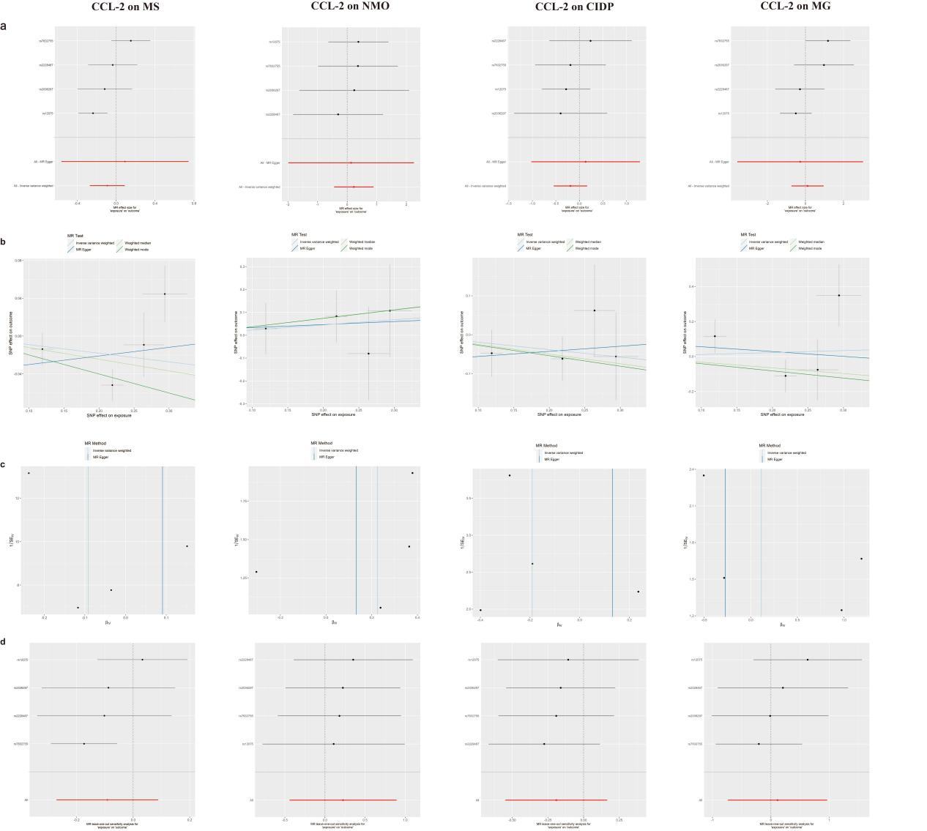
Supplementary Fig. 1 MR estimate results of CCL-2 on ANDs
Legend: a: Forest plot; b: Scatter plot; c: Funnel plot; d: Leave-one-out plot.
Abbreviations: CCL-2: Monocyte chemotactic protein 1; ANDs: autoimmune neuroinflammatory diseases; MS: multiple sclerosis; NMO: neuromyelitis optica; CIDP: chronic inflammatory demyelinating polyneuropathy; MG: myasthenia gravi.
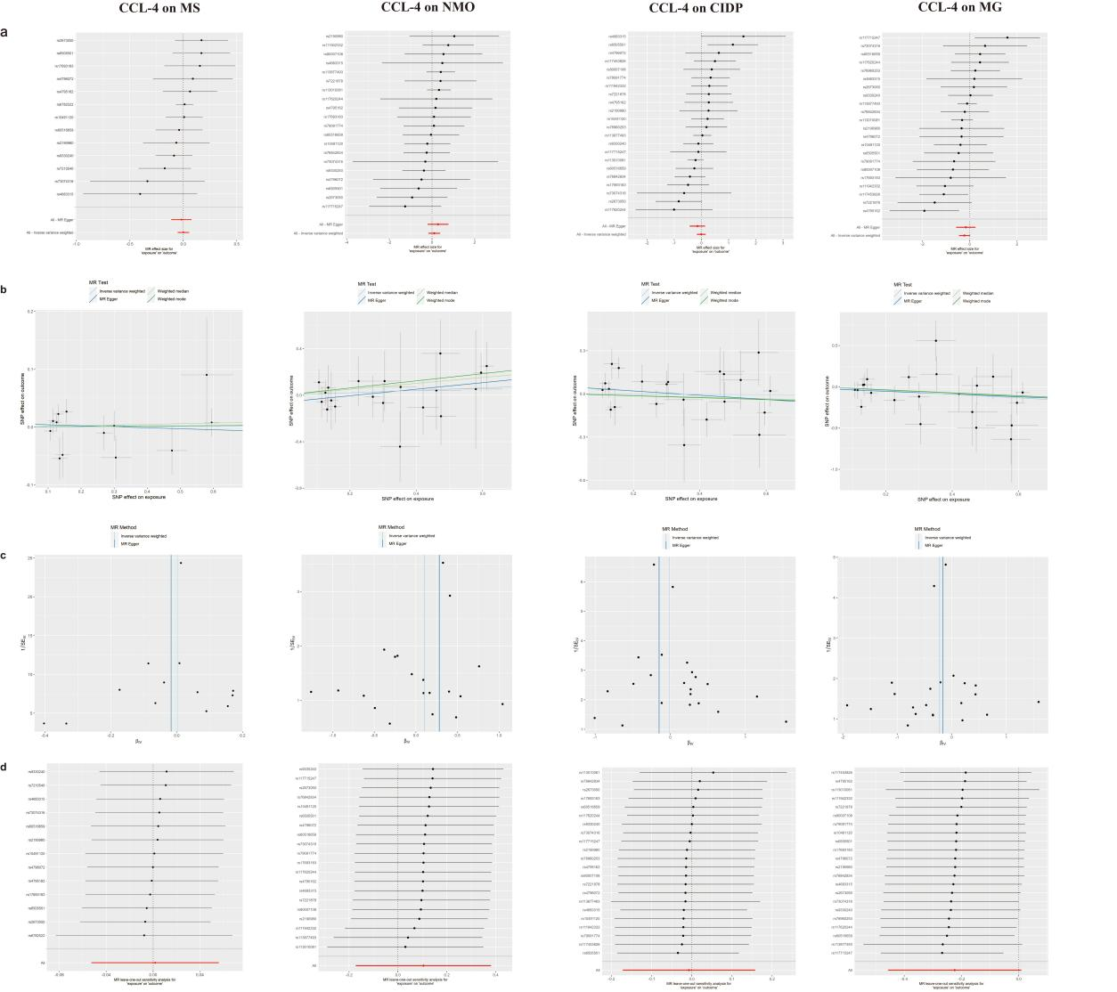
Supplementary Fig. 2 MR estimate results of CCL-4 on ANDs
Legend: a: Forest plot; b: Scatter plot; c: Funnel plot; d: Leave-one-out plot.
Abbreviations: CCL-4: Macrophage inflammatory protein-1b; ANDs: autoimmune neuroinflammatory diseases; MS: multiple sclerosis; NMO: neuromyelitis optica; CIDP: chronic inflammatory demyelinating polyneuropathy; MG: myasthenia gravi.

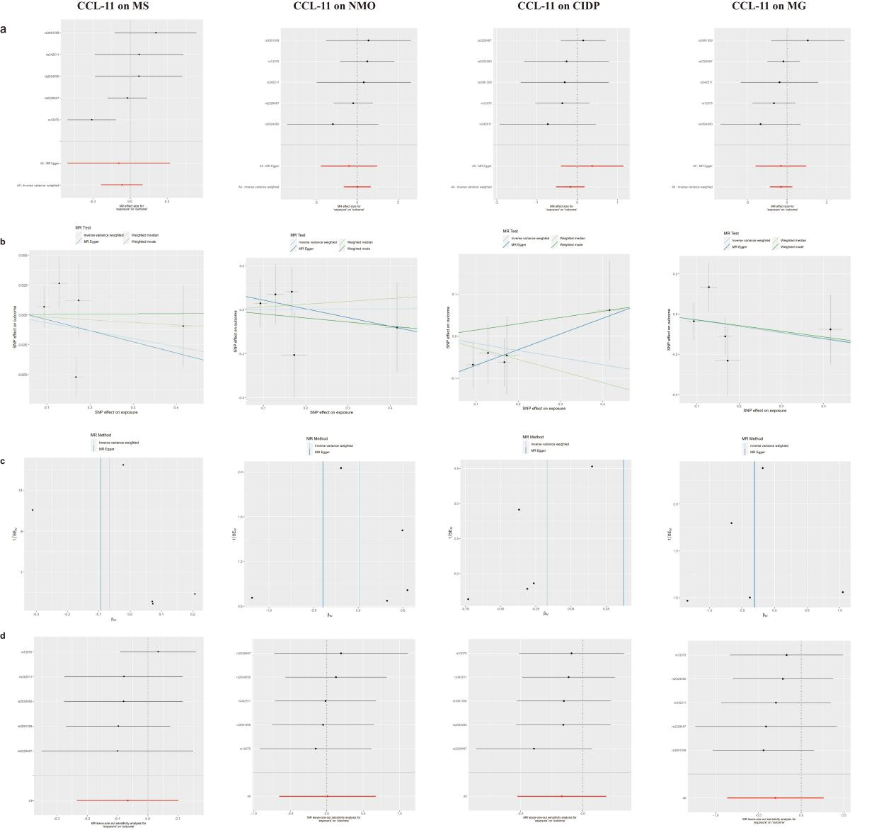
Supplementary Fig. 3 MR estimate results of CCL-11 on ANDs
Legend: a: Forest plot; b: Scatter plot; c: Funnel plot; d: Leave-one-out plot.
Abbreviations: CCL-11: Eotaxin; ANDs: autoimmune neuroinflammatory diseases; MS: multiple sclerosis; NMO: neuromyelitis optica; CIDP: chronic inflammatory demyelinating polyneuropathy; MG: myasthenia gravi.

Supplementary Fig. 4 MR estimate results of CCL-27 on ANDs
Legend: a: Forest plot; b: Scatter plot; c: Funnel plot; d: Leave-one-out plot.
Abbreviations: CCL-27: Cutaneous T-cell attracting; ANDs: autoimmune neuroinflammatory diseases; MS: multiple sclerosis; NMO: neuromyelitis optica; CIDP: chronic inflammatory demyelinating polyneuropathy; MG: myasthenia gravi.

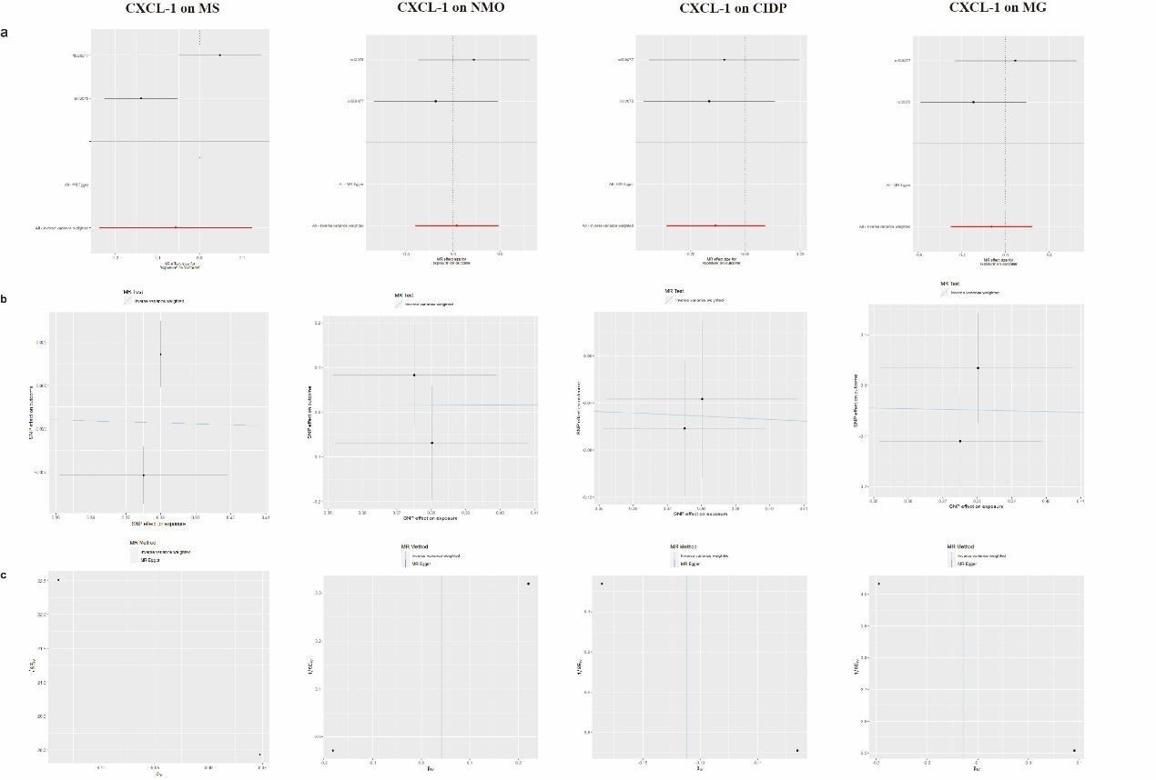
Supplementary Fig. 5 MR estimate results of CXCL-1 on ANDs
Legend: a: Forest plot; b: Scatter plot; c: Funnel plot.
Abbreviations: CXCL-1: Growth regulated oncogene-alpha; ANDs: autoimmune neuroinflammatory diseases; MS: multiple sclerosis; NMO: neuromyelitis optica; CIDP: chronic inflammatory demyelinating polyneuropathy; MG: myasthenia gravi.
Note: The number of IVs was insufficient for leave-one-out analysis.
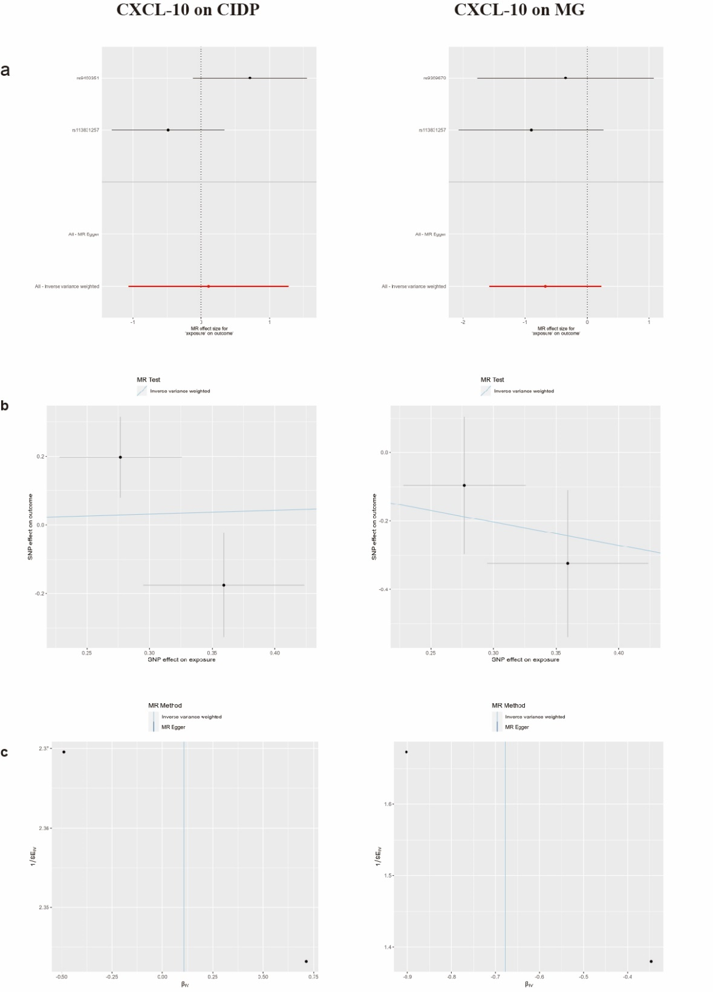
Supplementary Fig. 6 MR estimate results of CXCL-10 on ANDs
Legend: a: Forest plot; b: Scatter plot; c: Funnel plot.
Abbreviations: CXCL-10: Interferon gamma-induced protein 10; ANDs: autoimmune neuroinflammatory diseases; MS: multiple sclerosis; NMO: neuromyelitis optica; CIDP: chronic inflammatory demyelinating polyneuropathy; MG: myasthenia gravi.
Note: The number of IVs was insufficient for leave-one-out analysis, no IVs strongly associated (5*10⁻⁸) with MS and NMO were available for MR Analysis.

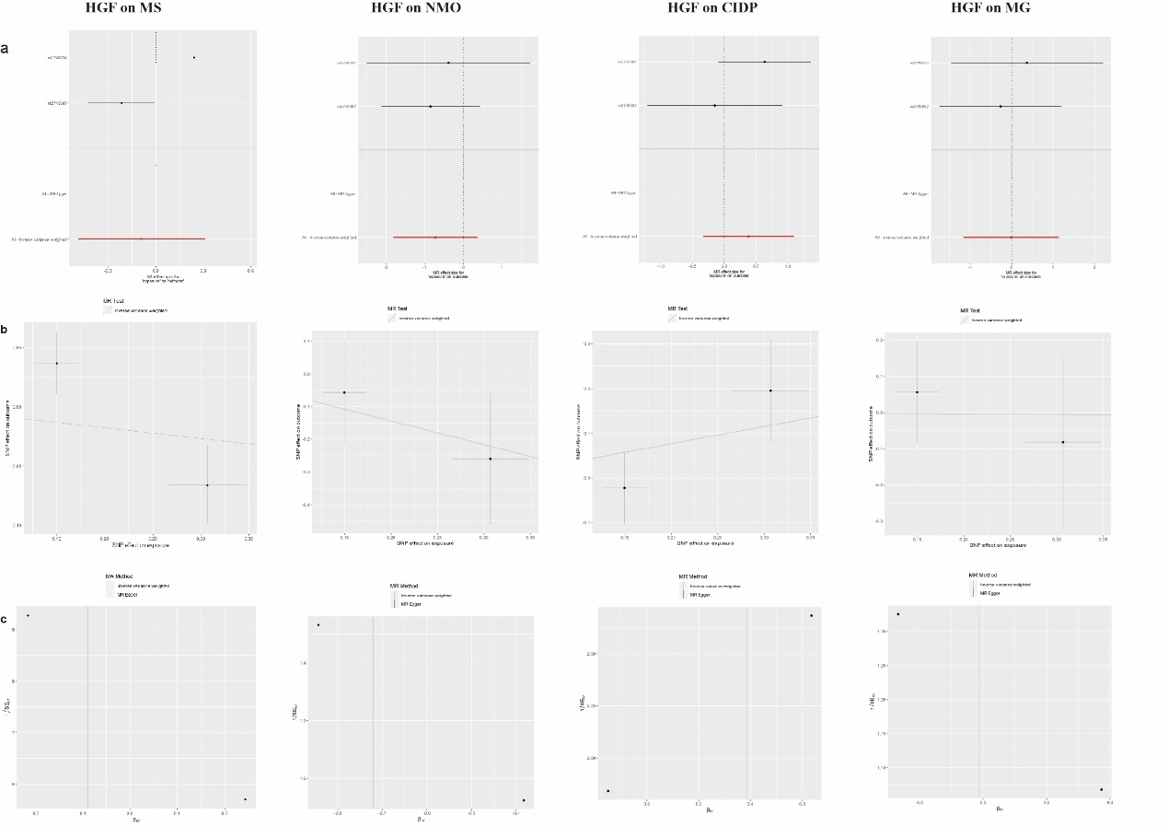
Supplementary Fig. 7 MR estimate results of HGF on ANDs
Legend: a: Forest plot; b: Scatter plot; c: Funnel plot.
Abbreviations: HGF: Hepatocyte growth factor; ANDs: autoimmune neuroinflammatory diseases; MS: multiple sclerosis; NMO: neuromyelitis optica; CIDP: chronic inflammatory demyelinating polyneuropathy; MG: myasthenia gravi.
Note: The number of IVs was insufficient for leave-one-out analysis.

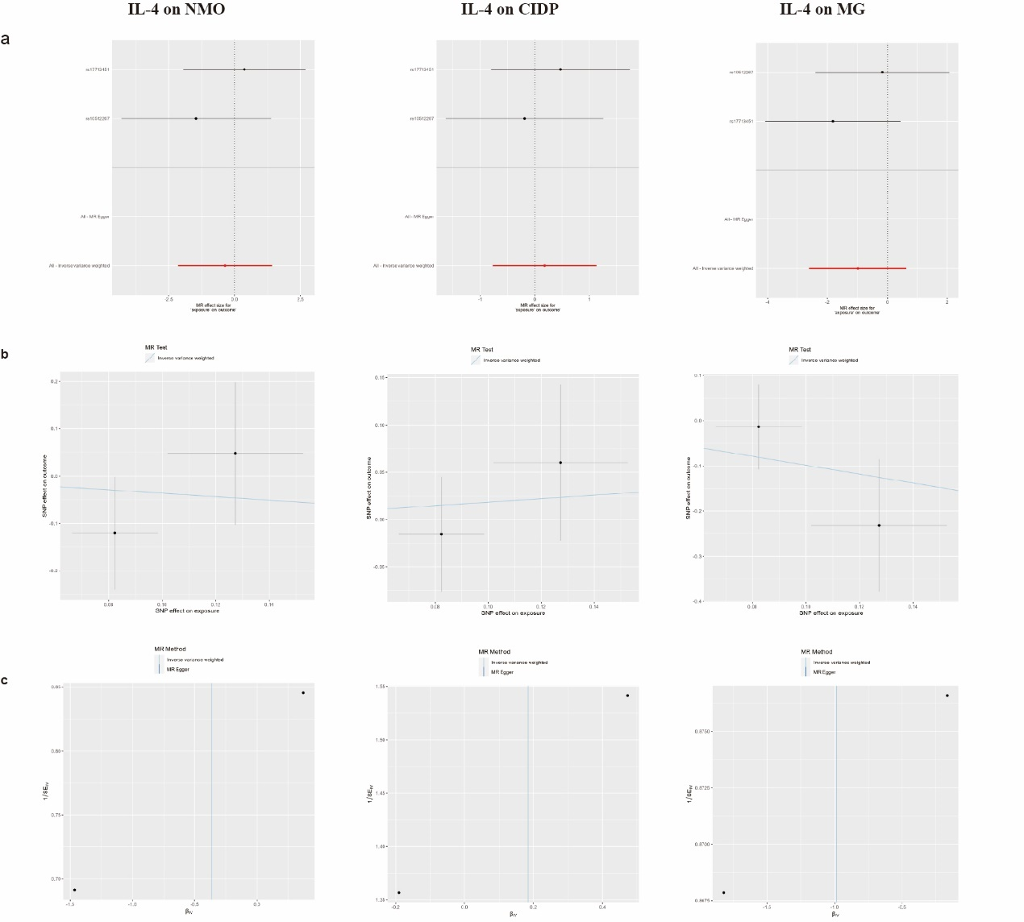
Supplementary Fig. 8 MR estimate results of IL-4 on ANDs
Legend: a: Forest plot; b: Scatter plot; c: Funnel plot.
Abbreviations: IL-4: Interleukin-4; ANDs: autoimmune neuroinflammatory diseases; MS: multiple sclerosis; NMO: neuromyelitis optica; CIDP: chronic inflammatory demyelinating polyneuropathy; MG: myasthenia gravi.
Note: The number of IVs was insufficient for leave-one-out analysis, the number of IVs was insufficient for leave-one-out analysis; no IVs strongly associated (5*10⁻⁸) with MS were available for MR Analysis.

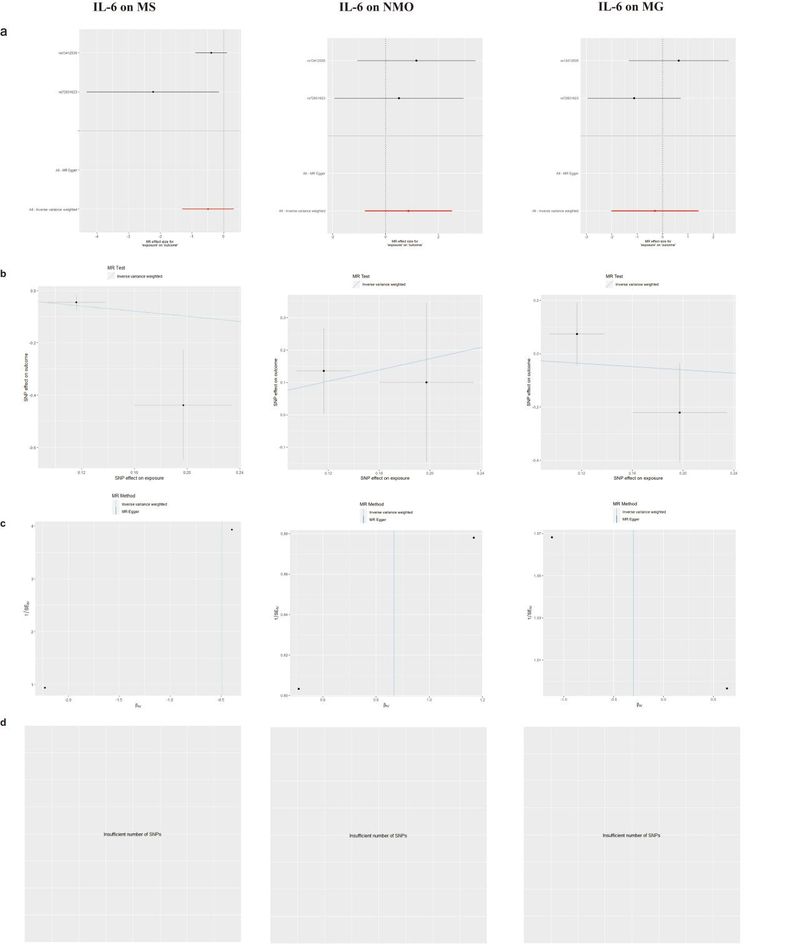
Supplementary Fig. 9 MR estimate results of IL-6 on ANDs
Legend: a: Forest plot; b: Scatter plot; c: Funnel plot; d: Leave-one-out plot; the number of IVs was insufficient for leave-one-out analysis; no IVs strongly associated (5*10⁻⁸) with CIDP were available for MR Analysis.
Abbreviations: IL-6: Interleukin-6; ANDs: autoimmune neuroinflammatory diseases; MS: multiple sclerosis; NMO: neuromyelitis optica; CIDP: chronic inflammatory demyelinating polyneuropathy; MG: myasthenia gravi.

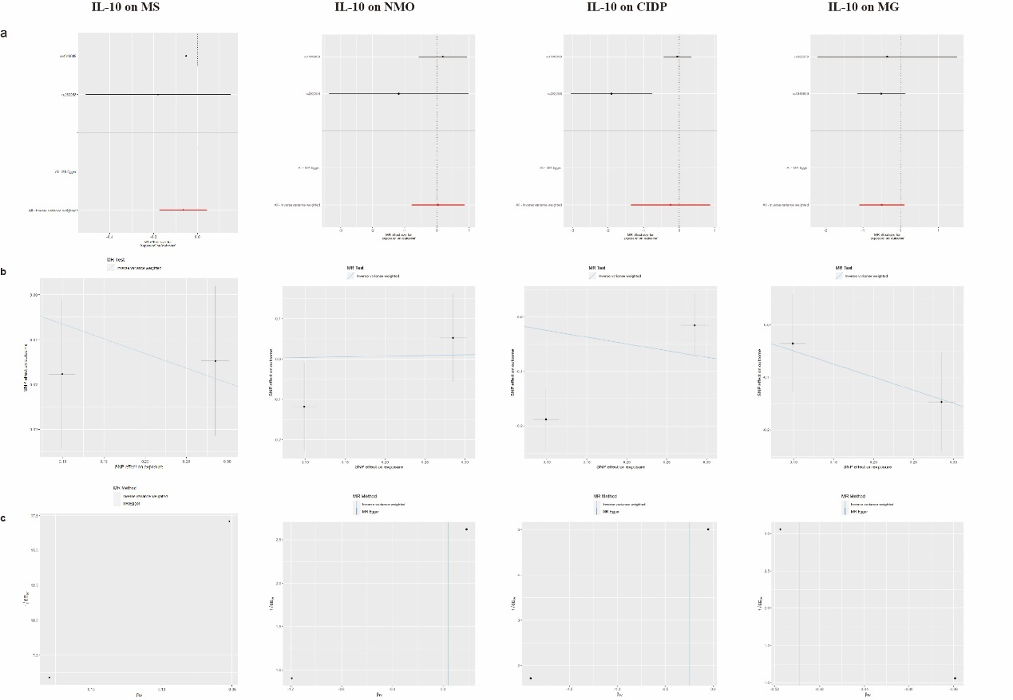
Supplementary Fig. 10 MR estimate results of IL-10 on ANDs
Legend: a: Forest plot; b: Scatter plot; c: Funnel plot.
Abbreviations: IL-10: Interleukin-10; ANDs: autoimmune neuroinflammatory diseases; MS: multiple sclerosis; NMO: neuromyelitis optica; CIDP: chronic inflammatory demyelinating polyneuropathy; MG: myasthenia gravi.
Note: The number of IVs was insufficient for leave-one-out analysis.

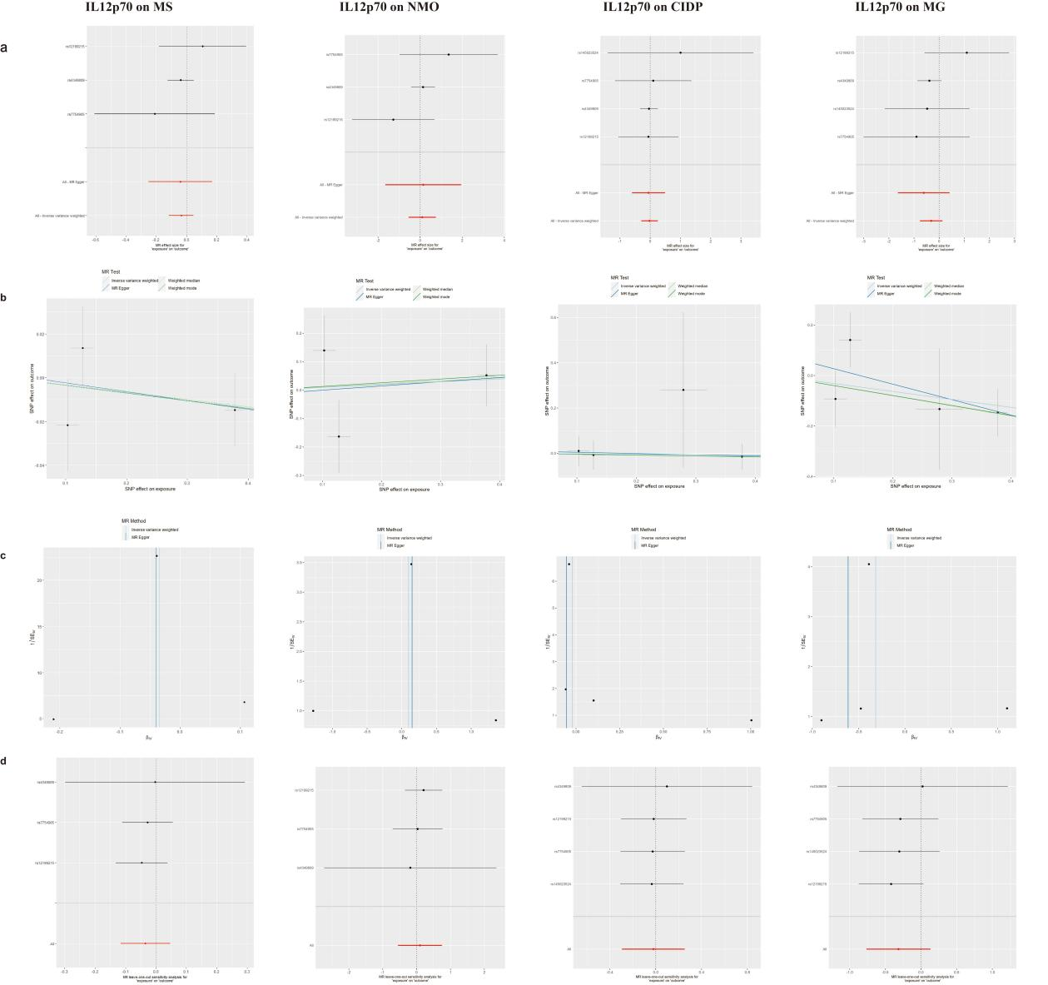
Supplementary Fig. 11 MR estimate results of IL12p70 on ANDs
Legend: a: Forest plot; b: Scatter plot; c: Funnel plot; d: Leave-one-out plot.
Abbreviations: IL12p70: Interleukin-12p70; ANDs: autoimmune neuroinflammatory diseases; MS: multiple sclerosis; NMO: neuromyelitis optica; CIDP: chronic inflammatory demyelinating polyneuropathy; MG: myasthenia gravi.

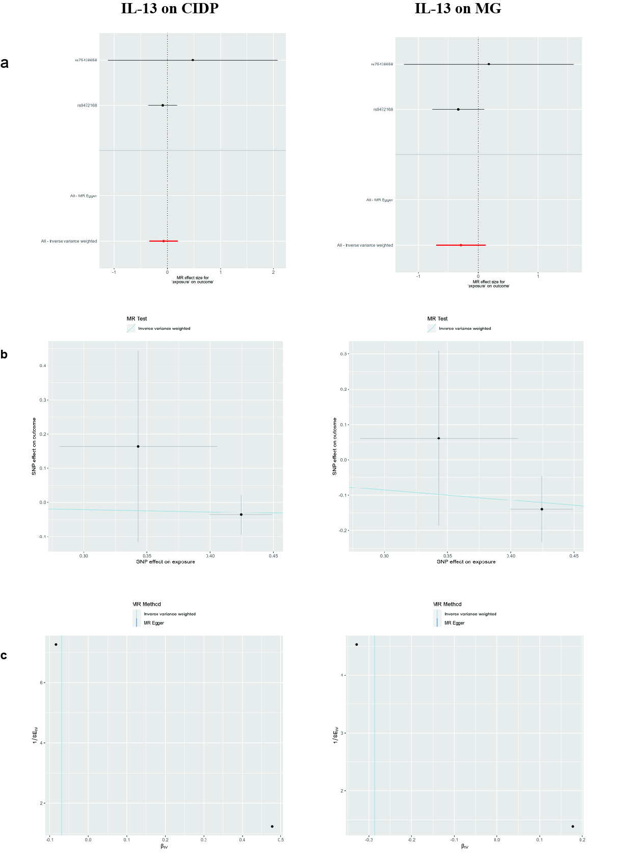
Supplementary Fig. 12 MR estimate results of IL-13 on ANDs
Legend: a: Forest plot; b: Scatter plot; c: Funnel plot.
Abbreviations: IL-13: Interleukin-13; ANDs: autoimmune neuroinflammatory diseases; MS: multiple sclerosis; NMO: neuromyelitis optica; CIDP: chronic inflammatory demyelinating polyneuropathy; MG: myasthenia gravi.
Note: The number of IVs was insufficient for leave-one-out analysis, no IVs strongly associated (5*10⁻⁸) with MS and NMO were available for MR Analysis.

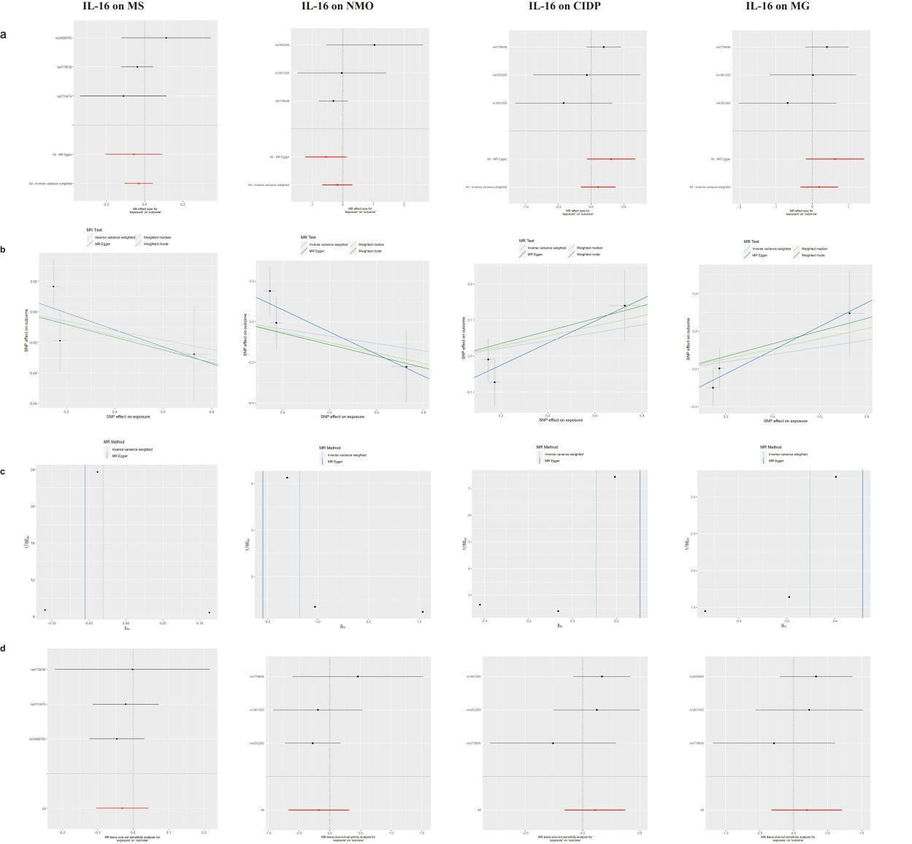
Supplementary Fig. 13 MR estimate results of IL-16 on ANDs
Legend: a: Forest plot; b: Scatter plot; c: Funnel plot; d: Leave-one-out plot.
Abbreviations: IL-16: Interleukin-16; ANDs: autoimmune neuroinflammatory diseases; MS: multiple sclerosis; NMO: neuromyelitis optica; CIDP: chronic inflammatory demyelinating polyneuropathy; MG: myasthenia gravi.

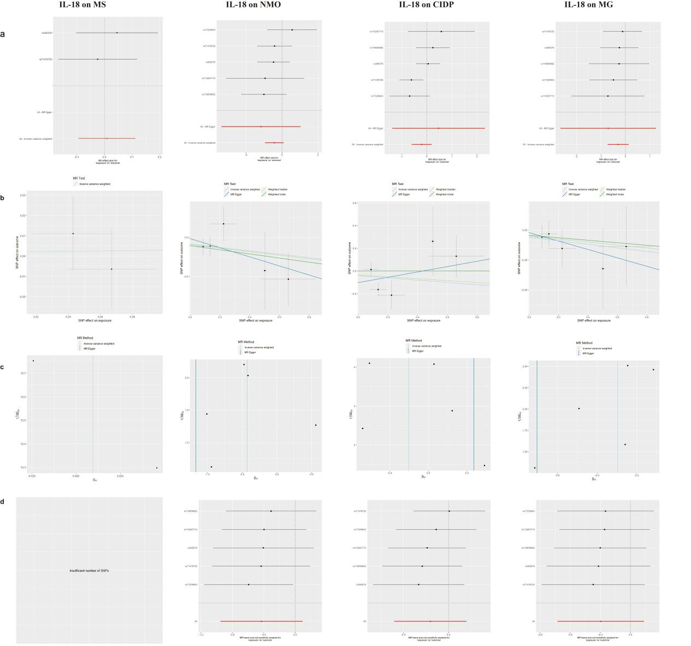
Supplementary Fig. 14 MR estimate results of IL-18 on ANDs
Legend: a: Forest plot; b: Scatter plot; c: Funnel plot; d: Leave-one-out plot; the IVs of IL-18 on MS was insufficient for leave-one-out analysis.
Abbreviations: IL-18: Interleukin-18; ANDs: autoimmune neuroinflammatory diseases; MS: multiple sclerosis; NMO: neuromyelitis optica; CIDP: chronic inflammatory demyelinating polyneuropathy; MG: myasthenia gravi.

Supplementary Fig. 15 MR estimate results of PDGFBB on ANDs
Legend: a: Forest plot; b: Scatter plot; c: Funnel plot; d: Leave-one-out plot.
Abbreviations: PDGFBB: Platelet derived growth factor BB; ANDs: autoimmune neuroinflammatory diseases; MS: multiple sclerosis; NMO: neuromyelitis optica; CIDP: chronic inflammatory demyelinating polyneuropathy; MG: myasthenia gravi.

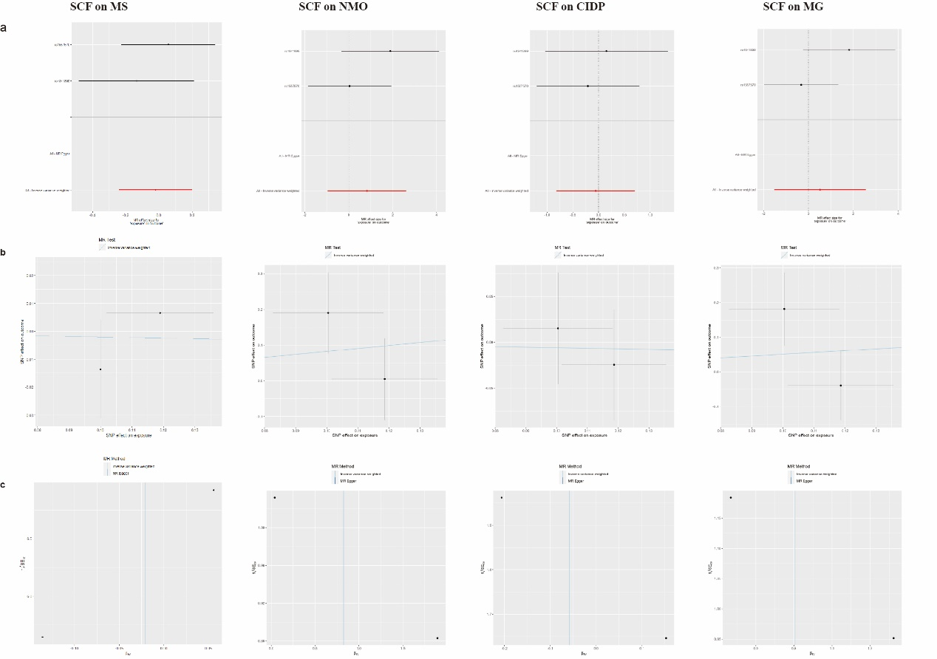
Supplementary Fig. 16 MR estimate results of SCF on ANDs
Legend: a: Forest plot; b: Scatter plot; c: Funnel plot.
Abbreviations: SCF: Stem cell factor; ANDs: autoimmune neuroinflammatory diseases; MS: multiple sclerosis; NMO: neuromyelitis optica; CIDP: chronic inflammatory demyelinating polyneuropathy; MG: myasthenia gravi.
Note: The number of IVs was insufficient for leave-one-out analysis.

Supplementary Fig. 17 MR estimate results of SCGF-β on ANDs
Legend: a: Forest plot; b: Scatter plot; c: Funnel plot; d: Leave-one-out plot.
Abbreviations: SCGF-β: Stem cell growth factor-beta; ANDs: autoimmune neuroinflammatory diseases; MS: multiple sclerosis; NMO: neuromyelitis optica; CIDP: chronic inflammatory demyelinating polyneuropathy; MG: myasthenia gravi.

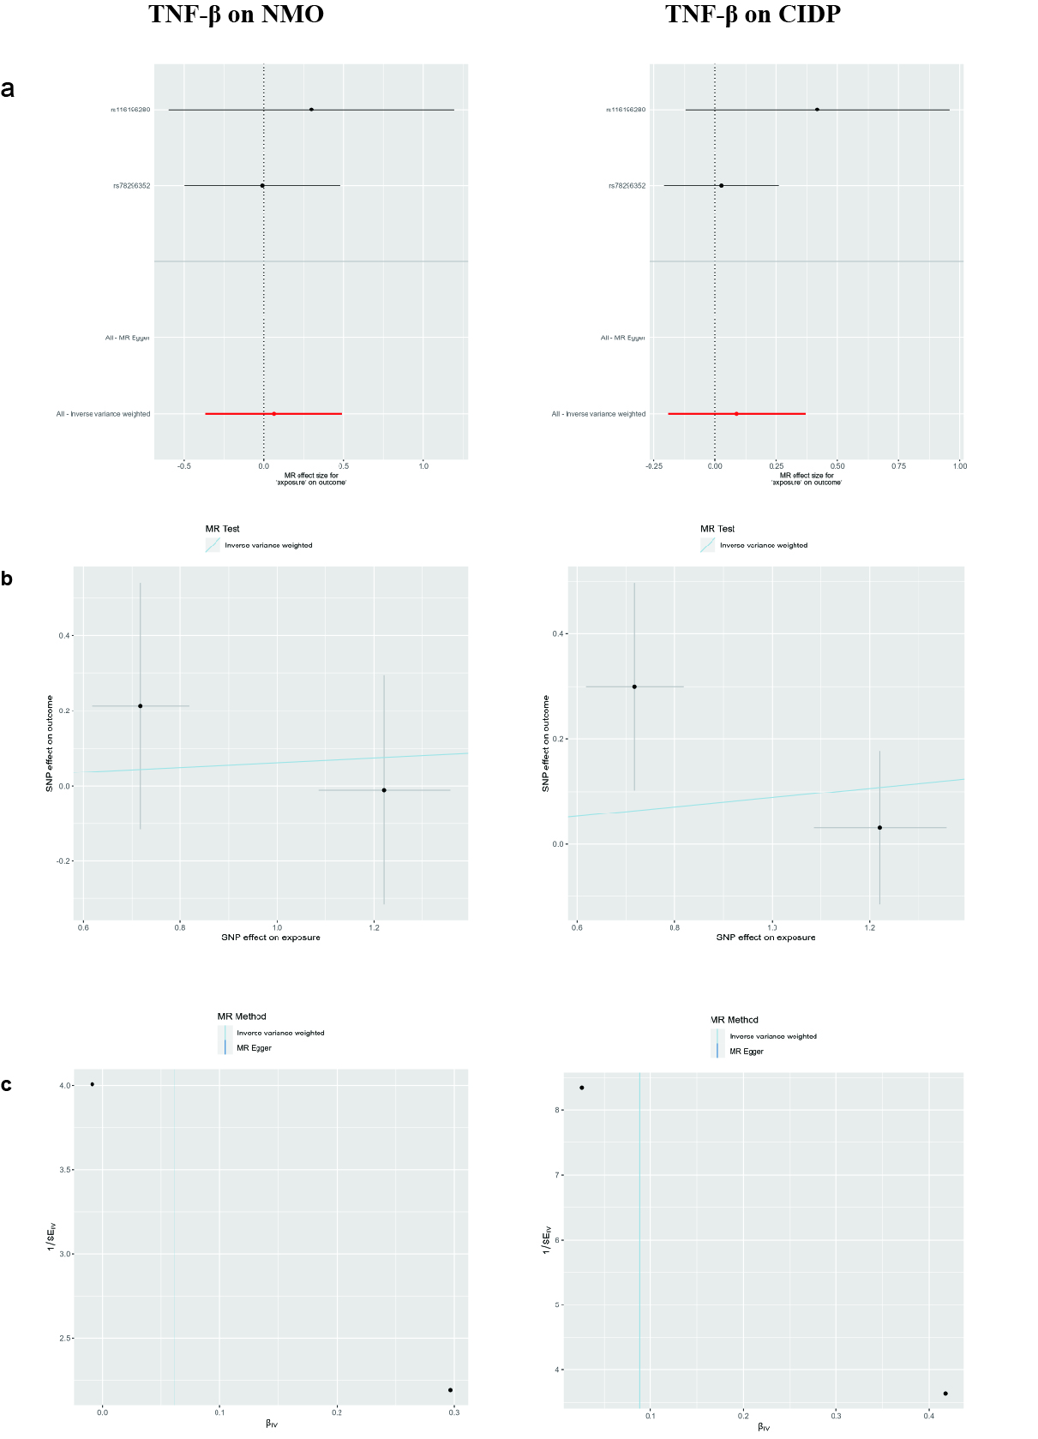
Supplementary Fig. 18 MR estimate results of TNF-β on ANDs
Legend: a: Forest plot; b: Scatter plot; c: Funnel plot.
Abbreviations: TNF-β: Tumor necrosis factor-beta; ANDs: autoimmune neuroinflammatory diseases; MS: multiple sclerosis; NMO: neuromyelitis optica; CIDP: chronic inflammatory demyelinating polyneuropathy; MG: myasthenia gravi.
Note: The number of IVs was insufficient for leave-one-out analysis; no IVs strongly associated (5*10⁻⁸) with MS and MG were available for MR Analysis.
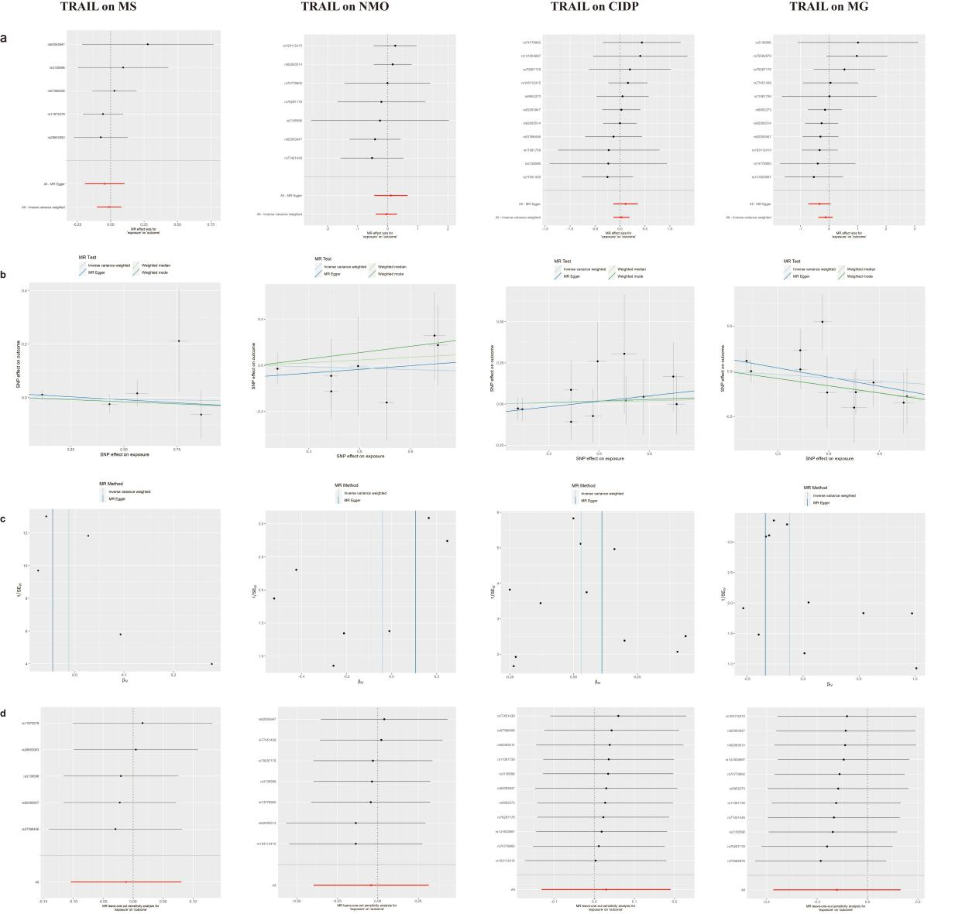
Supplementary Fig. 19 MR estimate results of TRAIL on ANDs.
Legend: a: Forest plot; b: Scatter plot; c: Funnel plot; d: Leave-one-out plot.
Abbreviations: TRAIL: TNF-related apoptosis inducing ligand; ANDs: autoimmune neuroinflammatory diseases; MS: multiple sclerosis; NMO: neuromyelitis optica; CIDP: chronic inflammatory demyelinating polyneuropathy; MG: myasthenia gravi.

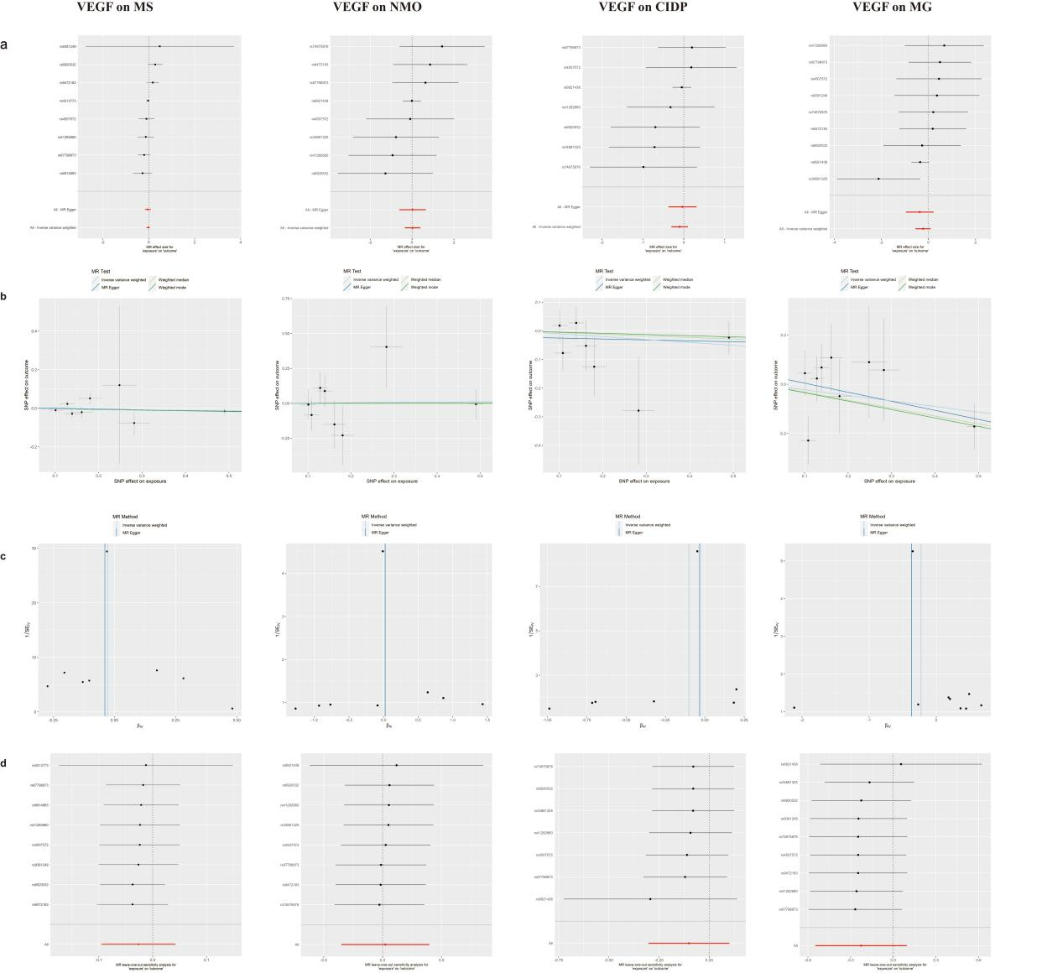
Supplementary Fig. 20 MR estimate results of VEGF on ANDs.
Legend: a: Forest plot; b: Scatter plot; c: Funnel plot; d: Leave-one-out plot.
Abbreviations: VEGF: Vascular endothelial growth factor; ANDs: autoimmune neuroinflammatory diseases; MS: multiple sclerosis; NMO: neuromyelitis optica; CIDP: chronic inflammatory demyelinating polyneuropathy; MG: myasthenia gravi.

