Table S1 The subjects included in (yes) or excluded from (no) the final sample based on the remaining tails in social comparisons and cues
 |  |  |  | Remaining trails of social comparison |  |  |  |  |  |  | Remaining trails of cues
subjects | age | sex | Included | upward (S) | equal (S) | downward (S) | upward (R) | equal (R) | downward (R) |  | Status-related | Response-related
9 | 19 | female | yes | 35 | 36 | 36 | 36 | 35 | 36 |  | 106 | 107
10 | 19 | female | yes | 36 | 32 | 34 | 35 | 36 | 36 |  | 105 | 100
11 | 21 | female | yes | 33 | 33 | 36 | 34 | 31 | 35 |  | 98 | 98
12 | 19 | female | yes | 36 | 35 | 36 | 35 | 35 | 35 |  | 103 | 105
13 | 22 | male | yes | 32 | 34 | 31 | 35 | 32 | 33 |  | 96 | 96
14 | 19 | male | yes | 36 | 36 | 36 | 36 | 36 | 36 |  | 108 | 108
15 | 21 | female | yes | 36 | 36 | 35 | 36 | 35 | 35 |  | 106 | 104
16 | 20 | female | yes | 21 | 20 | 24 | 22 | 24 | 26 |  | 82 | 87
17 | 20 | female | no | There were excessive artifacts in EEG recordings
18 | 21 | male | yes | 30 | 31 | 31 | 29 | 33 | 29 |  | 99 | 98
19 | 21 | male | yes | 36 | 36 | 36 | 35 | 36 | 36 |  | 107 | 107
20 | 18 | female | yes | 32 | 33 | 31 | 33 | 29 | 31 |  | 97 | 93
21 | 19 | female | yes | 32 | 32 | 33 | 30 | 30 | 32 |  | 81 | 89
22 | 19 | male | yes | 36 | 36 | 34 | 36 | 35 | 36 |  | 107 | 107
23 | 19 | male | yes | 32 | 34 | 32 | 30 | 30 | 31 |  | 87 | 89
24 | 20 | male | yes | 30 | 28 | 28 | 28 | 25 | 25 |  | 87 | 85
25 | 19 | male | yes | 36 | 36 | 36 | 36 | 36 | 36 |  | 108 | 107
26 | 18 | female | yes | 29 | 29 | 32 | 30 | 30 | 29 |  | 89 | 91
27 | 21 | male | yes | 31 | 34 | 30 | 34 | 35 | 32 |  | 106 | 107
28 | 18 | female | yes | 29 | 30 | 30 | 33 | 32 | 27 |  | 98 | 100
29 | 20 | male | yes | 33 | 36 | 34 | 35 | 34 | 34 |  | 100 | 103
30 | 19 | female | yes | 36 | 33 | 33 | 35 | 33 | 32 |  | 103 | 106
31 | 20 | female | yes | 35 | 35 | 33 | 34 | 34 | 31 |  | 107 | 107
32 | 20 | male | yes | 34 | 33 | 35 | 29 | 34 | 32 |  | 97 | 99
33 | 18 | male | yes | 35 | 36 | 36 | 36 | 35 | 35 |  | 104 | 101
34 | 21 | male | yes | 34 | 35 | 36 | 36 | 35 | 36 |  | 105 | 103
35 | 21 | female | yes | 23 | 22 | 26 | 26 | 25 | 23 |  | 69 | 72
36 | 20 | female | yes | 33 | 36 | 33 | 34 | 33 | 35 |  | 100 | 101
37 | 19 | male | yes | 34 | 35 | 32 | 30 | 35 | 35 |  | 105 | 94
38 | 20 | male | yes | 36 | 36 | 36 | 36 | 36 | 35 |  | 108 | 107

The collapsed localizers
According to previous studies (Luck & Gaspelin, 2016; Sui et al., 2023; Sima et al., 2024), the collapsed localizers were used to identify the time windows and the electrode sites of the ERP components of P3 and LPP according to the following steps.
- The collapsed waveform for each electrode site was calculated by averaging the six conditions;
- The peak latency of each ERP component was found by eyeballing the collapsed waveforms;
- We drew the topographic map of the collapsed waveforms in the time windows of 60 ms for P3 and 100 ms for LPP around the peek latency to find the most active areas of each ERP component.
Based on above steps, the P3 and LPP were analyzed in the time windows of 336~396ms and 450~550ms respectively.
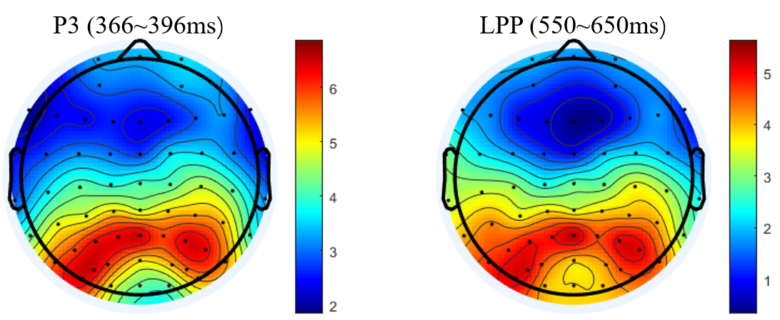
Figure S1 The topographic maps for the P3 (336~396 ms) and LPP (450~550 ms) based on the collapsed waveforms

