Supplementary Table 1. A summary table of the studies that were retrieved to determine the impact of depression on treatment response to drugs for inflammatory arthritis and mechanisms for this influence.
Author | Title | Disease | Objective | Sample size | Main findings
Parkinson et al.¹ | Depression in patients with spondyloarthritis: prevalence, incidence, risk factors, mechanisms and management | PsA and AS | A review of risk factors and potential mechanisms for pathogenesis of depression in PsA and AS patients. | Review | 15% of patients with PsA or AS have depression, a far higher proportion than the general population. Depression may manifest in arthritis patients in four key ways, summarized in the discussion section of the review.
De Lorenzis et al.² | Depression and Endothelial Dysfunction in Psoriatic Arthritis: Is There Any Possible Relationship? | PsA | To determine whether there is a relationship between depression and endothelial dysfunction | 50 | Depressive symptoms in PsA patients are correlated to increased endothelial dysfunction.
Callhoff et al.³ | Depression is a stronger predictor of the risk to consider work disability in early arthritis than disease activity or response to therapy | Early IA | To determine the factors which may influence patients with early IA to consider applying for disability pension | 528 | Early IA patients with depressive symptoms, are significantly more likely to have a work disability compared to RA patients with no mood symptoms (33% vs. 5%). Depression is a stronger predictor of work disability risk than disease activity.
Deb et al.⁴ | Tumor Necrosis Factor Inhibitor Therapy and the Risk for Depression Among Working-Age Adults with Rheumatoid Arthritis | RA | To determine the association between TNF-α inhibitor therapy and the risk of developing depression in RA patients | 4222 | RA patients who respond to TNF-α inhibitor therapy have a 20% lower chance of developing depression.
Kwiatkowska et al.⁵ | Factors of depression among patients with rheumatoid arthritis | RA | Evaluate the association between depression and RA symptoms | 120 | Patients with depression had higher HAQ, pain and DAS-28 scores
Peterson et al.⁶ | The multifaceted impact of anxiety and depression on patients with rheumatoid arthritis | RA | Assess the impact of anxiety/depression on patients with RA | 1015 | Patients with anxiety or depression had higher DAS-28 scores and work impairment
Matcham et al.⁷ | Symptoms of depression and anxiety predict treatment response and long-term physical health outcomes in rheumatoid arthritis: secondary analysis of a randomized controlled trial | RA | Examine the impact of depression/anxiety on treatment response, disease activity and disability | 379 | Patients with depression/anxiety had increased DAS-28, HAQ scores and reduced odds of clinical remission
Pinho et al.⁸ | Anxiety, depression and suicidal ideation in patients with rheumatoid arthritis in use of methotrexate, hydroxychloroquine, leflunomide and biological drugs | RA | Investigate the prevalence of anxiety and depression in patients with RA | 105 | Patients prescribed bDMARDs had higher rates of depression and anxiety
Matcham et al.⁹ | The relationship between depression and biologic treatment response in rheumatoid arthritis: An analysis of the British Society for Rheumatology Biologics Register | RA | Investigate the association between symptoms of depression and treatment response over 1 year follow-up in patients receiving bDMARDs | 18421 | Symptoms of depression at baseline reduced the odds of achieving a good treatment response
Rathbun et al.¹⁰ | A Prospective Evaluation of the Effects of Prevalent Depressive Symptoms on Disease Activity in Rheumatoid Arthritis Patients Treated With Biologic Response Modifiers | RA | Evaluate the association between symptoms of depression and bDMARD response | 2551 | Symptoms of depression were associated with decreased likelihood of remission at 6 but not 12 months
Hider et al.¹¹ | Depression in RA patients treated with anti-TNF is common and under-recognized in the rheumatology clinic | RA | Investigate the association between baseline depression and TNFi response | 159 | Patients with depression has smaller improvements in DAS-28
Zhao et al.¹² | Depression and anxiety symptoms at TNF inhibitor initiation are associated with impaired treatment response in axial spondyloarthritis | AxSpA | Investigate the association between baseline depression/anxiety symptoms and TNFi response | 742 | Depression/anxiety symptoms are associated with poorer treatment outcomes
Manning-Bennett et al.¹³ | The association of depression and anxiety with treatment outcomes in patients with rheumatoid arthritis - a pooled analysis of five randomised controlled trials | RA | Investigate the association of depression and anxiety with remission | 5502 | Depression, but not anxiety, was associated with reduced remission

PsA: Psoriatic arthritis; AS: Ankylosing spondylitis; RA: Rheumatoid arthritis; IA: Inflammatory arthritis; TNF-α: Tumor Necrosis Factor-α; HAQ: Health Assessment Questionnaire; DAS-28: Disease Activity Score-28; bDMARD: biologic disease modifying anti-rheumatic drug; AxSpA: Axial spondyloarthropathy.

1. Parkinson JT, Foley EM, Jadon DR, Khandaker GM. Depression in patients with spondyloarthritis: prevalence, incidence, risk factors, mechanisms and management. Ther Adv Musculoskelet Dis. 2020;12:1759720X20970028. doi:10.1177/1759720X20970028
2. De Lorenzis E, Di Giorgio A, Natalello G, et al. Depression and Endothelial Dysfunction in Psoriatic Arthritis: Is There Any Possible Relationship? Front Med (Lausanne). 2021;8:669397. doi:10.3389/fmed.2021.669397
3. Callhoff J, Albrecht K, Schett G, Zink A, Westhoff G. Depression is a stronger predictor of the risk to consider work disability in early arthritis than disease activity or response to therapy. RMD Open. 2015;1(1):e000020. doi:10.1136/rmdopen-2014-000020
4. Deb A, Dwibedi N, LeMasters T, Hornsby JA, Wei W, Sambamoorthi U. Tumor Necrosis Factor Inhibitor Therapy and the Risk for Depression Among Working-Age Adults with Rheumatoid Arthritis. Am Health Drug Benefits. Feb 2019;12(1):30-38.
5. Kwiatkowska B, Kłak A, Maślińska M, Mańczak M, Raciborski F. Factors of depression among patients with rheumatoid arthritis. Reumatologia. 2018;56(4):219-227. doi:10.5114/reum.2018.77973
6. Peterson S, Piercy J, Blackburn S, Sullivan E, Karyekar CS, Li N. The multifaceted impact of anxiety and depression on patients with rheumatoid arthritis. BMC Rheumatol. 2019;3:43. doi:10.1186/s41927-019-0092-5
7. Matcham F, Norton S, Scott DL, Steer S, Hotopf M. Symptoms of depression and anxiety predict treatment response and long-term physical health outcomes in rheumatoid arthritis: secondary analysis of a randomized controlled trial. Rheumatology (Oxford). Feb 2016;55(2):268-78. doi:10.1093/rheumatology/kev306
8. Pinho de Oliveira Ribeiro N, Rafael de Mello Schier A, Ornelas AC, Pinho de Oliveira CM, Nardi AE, Silva AC. Anxiety, depression and suicidal ideation in patients with rheumatoid arthritis in use of methotrexate, hydroxychloroquine, leflunomide and biological drugs. Compr Psychiatry. Nov 2013;54(8):1185-9. doi:10.1016/j.comppsych.2013.05.010
9. Matcham F, Davies R, Hotopf M, et al. The relationship between depression and biologic treatment response in rheumatoid arthritis: An analysis of the British Society for Rheumatology Biologics Register. Rheumatology (Oxford). May 1 2018;57(5):835-843. doi:10.1093/rheumatology/kex528
10. Rathbun AM, Harrold LR, Reed GW. A Prospective Evaluation of the Effects of Prevalent Depressive Symptoms on Disease Activity in Rheumatoid Arthritis Patients Treated With Biologic Response Modifiers. Clin Ther. Jul 2016;38(7):1759-1772 e3. doi:10.1016/j.clinthera.2016.06.007
11. Hider SL, Tanveer W, Brownfield A, Mattey DL, Packham JC. Depression in RA patients treated with anti-TNF is common and under-recognized in the rheumatology clinic. Rheumatology (Oxford). Sep 2009;48(9):1152-4. doi:10.1093/rheumatology/kep170
12. Zhao SS, Jones GT, Hughes DM, Moots RJ, Goodson NJ. Depression and anxiety symptoms at TNF inhibitor initiation are associated with impaired treatment response in axial spondyloarthritis. Rheumatology (Oxford). Dec 1 2021;60(12):5734-5742. doi:10.1093/rheumatology/keab242
13. Manning-Bennett AT, Hopkins AM, Sorich MJ, et al. The association of depression and anxiety with treatment outcomes in patients with rheumatoid arthritis - a pooled analysis of five randomised controlled trials. Ther Adv Musculoskelet Dis. 2022;14:1759720x221111613. doi:10.1177/1759720x221111613
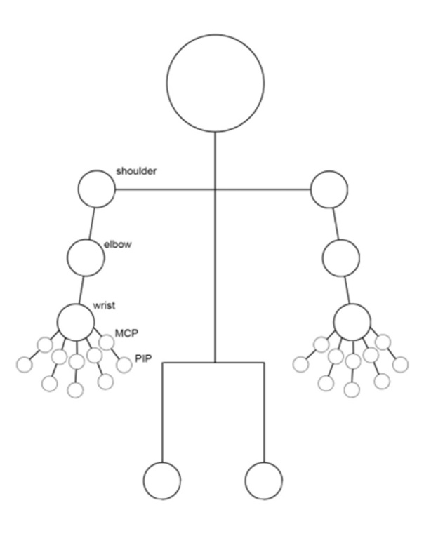
Supplementary Figure 1. The joints assessed during the DAS-28 assessment. DAS-28: Disease Activity Score; MCP: Metacarpophalangeal Joint; PIP: Proximal Interphalangeal Joint

