Supplementary information
Supplement Figure 1: Strobe diagram.
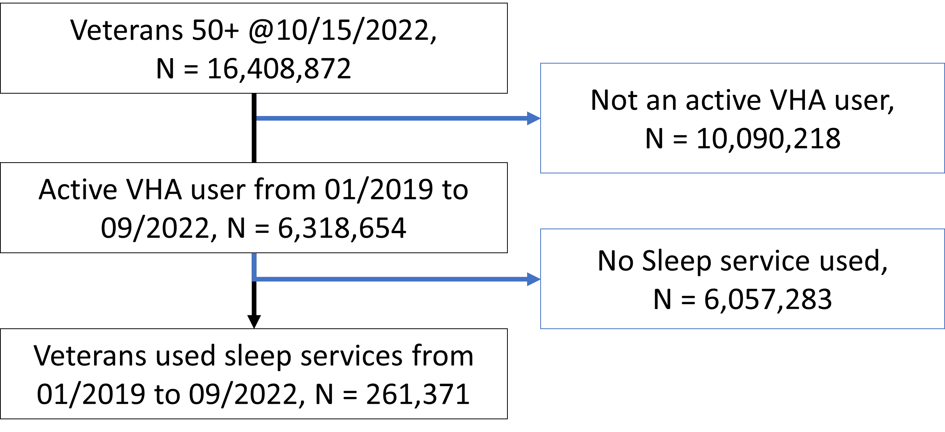

Supplement Table 1: Monthly-demographic Characteristics of Participants at Baseline
Monthly-demographic Characteristics of Participants at Baseline
Year/MM | HSAT |  | PSG |  | Number
Year/MM | REC | PTN | REC | PTN | COVID | VACCINE
2019-01 | 5287 | 4407 | 3971 | 3829 | 0 | 0
2019-02 | 4882 | 4094 | 3699 | 3590 | 0 | 0
2019-03 | 5597 | 4726 | 4304 | 4185 | 0 | 0
2019-04 | 5976 | 5098 | 4278 | 4135 | 0 | 0
2019-05 | 5858 | 4897 | 4205 | 4046 | 0 | 0
2019-06 | 5528 | 4726 | 3983 | 3870 | 0 | 0
2019-07 | 6138 | 5106 | 4242 | 4077 | 0 | 0
2019-08 | 6048 | 5033 | 4358 | 4160 | 0 | 0
2019-09 | 5696 | 4748 | 3966 | 3821 | 0 | 0
2019-10 | 6046 | 5007 | 4107 | 3939 | 0 | 0
2019-11 | 5082 | 4234 | 3506 | 3357 | 0 | 0
2019-12 | 5489 | 4510 | 3494 | 3321 | 0 | 0
2020-01 | 6022 | 4903 | 3965 | 3782 | 0 | 0
2020-02 | 5716 | 4628 | 3834 | 3656 | 1 | 0
2020-03 | 4625 | 3665 | 2225 | 2116 | 2067 | 0
2020-04 | 1127 | 941 | 91 | 86 | 6594 | 0
2020-05 | 1081 | 888 | 174 | 170 | 4419 | 0
2020-06 | 2902 | 2280 | 691 | 657 | 5785 | 0
2020-07 | 4553 | 3656 | 1086 | 1051 | 11945 | 0
2020-08 | 5494 | 4419 | 1370 | 1332 | 7248 | 0
2020-09 | 5573 | 4587 | 1752 | 1639 | 6221 | 0
2020-10 | 5590 | 4524 | 1944 | 1811 | 11362 | 583
2020-11 | 5293 | 4357 | 1708 | 1650 | 27174 | 1460
2020-12 | 5295 | 4355 | 1525 | 1463 | 37988 | 60367
2021-01 | 5279 | 4404 | 1678 | 2697 | 33287 | 996366
2021-02 | 5532 | 4523 | 1822 | 1604 | 14891 | 2061944
2021-03 | 7256 | 5800 | 2492 | 1745 | 9188 | 2986972
2021-04 | 6528 | 5278 | 2701 | 2364 | 7549 | 3281229
2021-05 | 6380 | 5160 | 2564 | 2547 | 4493 | 3392594
2021-06 | 6117 | 4952 | 2714 | 2398 | 3106 | 3450427
2021-07 | 5827 | 4746 | 2573 | 2562 | 7377 | 3508000
2021-08 | 6090 | 5017 | 2628 | 2440 | 22778 | 3574011
2021-09 | 5861 | 4789 | 2316 | 2495 | 19187 | 3610137
2021-10 | 5480 | 4419 | 2580 | 2209 | 13171 | 3638439
2021-11 | 5489 | 4459 | 2404 | 2418 | 13634 | 3659758
2021-12 | 5511 | 4414 | 2418 | 2205 | 30963 | 3677473
Note. -REC: Records-PTN: Patients-HSAT: Home Sleep Test-PSG: Polysomnography-Participant age did not differ by condition.

