Supplementary Material

Limited Generalizability of Retrospective Single-Center Cohort Study in Comparison to Multicenter Cohort Study on Prognosis of Hepatocellular Carcinoma

Kim et al.
SUPPLEMENTARY TABLE 1. Baseline characteristics of the study populationsª
Variable | Single-center cohort  (n=15,655) | Multicenter cohort  (n=16,443) | P-value
Age (years) | 57.7 ± 10.4 | 61.1 ± 11.5 | <0.001
Male | 12,690 (81.1%) | 13,045 (79.3%) | <0.001
Body mass index (kg/㎡) | 24.3 ± 3.3 | 24.0 ± 3.4 | <0.001
Diabetes mellitus | 3,314 (21.2%) | 5,779 (35.1%) | <0.001
Unknown | 615 (3.9%) | 2,002 (12.2%)
Hypertension | 4,564 (29.2%) | 4,347 (26.4%) | <0.001
Unknown | 541 (3.5%) | 3,434 (20.9%)
Hepatitis B^{b} | 10,622 (67.8%) | 9,879 (60.1%) | <0.001
Unknown | 1,125 (7.2%) | 592 (3.6%)
Hepatitis C^{c} | 1,410 (9.0%) | 1,883 (11.5%) | <0.001
Unknown | 2,126 (13.6%) | 1,622 (9.9%)
mUICC staging
Stage I | 2,626 (16.8%) | 2,532 (15.4%) | <0.001
Stage II | 6,176 (39.5%) | 6,168 (37.5%)
Stage III | 4,712 (30.1%) | 4,147 (25.2%)
Stage IVA | 1,291 (8.2%) | 1,920 (11.7%)
Stage IVB | 850 (5.4%) | 1,627 (9.9%)
Unknown | 0 (0.0%) | 49 (0.3%)
BCLC staging
Stage 0 | 2,572 (16.4%) | 1,312 (9.0%) | <0.001
Stage A | 6,719 (42.9%) | 3,655 (22.2%)
Stage B | 2,293 (14.6%) | 2,722 (16.6%)
Stage C | 3,563 (22.8%) | 5,402 (32.9%)
Stage D | 508 (3.2%) | 1,013 (6.2%)
Unknown | 0 (0.0%) | 2,339 (14.2%)
Child-Pugh class |  |  | <0.001
Class A | 12,126 (77.5%) | 11,476 (69.8%)
Class B | 2,904 (18.5%) | 3,469 (21.1%)
Class C | 510 (3.3%) | 747 (4.5%)
Unknown | 115 (0.7%) | 751 (4.6%)
MELD score | 8 (7-10) | 8 (7-11) | <0.001
Type of initial treatment
Curative^{d} | 6,586 (42.1%) | 5,282 (32.1%) | <0.001
Non-curative^{e} | 7,626 (48.7%) | 8,070 (49.1%)
Best supportive care | 1,443 (9.2%) | 3,091 (18.8%)
Initial treatment modality
Surgical resection | 5,162 (33.0%) | 3,304 (20.1%) | <0.001
Liver transplantation | 211 (1.3%) | 156 (0.9%)
LAT | 1,213 (7.7%) | 1,822 (11.1%)
TACE/TARE | 6,825 (43.6%) | 6,839 (41.6%)
Radiotherapy | 186 (1.2%) | 245 (1.5%)
Systemic therapy | 615 (3.9%) | 986 (6.0%)
Best supportive care | 1,443 (9.2%) | 3,091 (18.8%)
Note: Data are presented as mean ± standard deviation, median (interquartile range), or frequency (proportion).
Abbreviations: BCLC, Barcelona Clinic Liver Cancer; LAT, local ablation therapy; MELD, Model for End-stage Liver Disease; mUICC, modified Union for International Cancer Control; TACE, transarterial chemoembolization; TARE, transarterial radioembolization.
ª Missing data was classified as a category.
^{b} Hepatitis B was defined as any of the following: positive hepatitis B surface antigen, positive viral titer, or previous history of antiviral therapy.
^{c} Hepatitis C was defined as any of the following: positive hepatitis C antibody, positive viral titer, or previous history of antiviral therapy.
^{d} Curative treatment was defined as surgical resection, liver transplantation, and LAT.
^{e} Non-curative treatment was defined as TACE/TARE, radiotherapy, and systemic therapy.

SUPPLEMENTARY TABLE 2. Baseline characteristics of propensity score-matched populationsª
Variable | Single-center cohort  (n=9,713) | Multicenter cohort  (n=9,713) | P-value | SMD
Age (years) | 59.13 ± 10.70 | 59.19 ± 10.94 | 0.77 | 0.005
Male | 7,830 (80.6%) | 1,811 (80.4%) | 0.74 | 0.005
Body mass index (kg/㎡) | 24.08 ± 3.29 | 24.09 ± 3.37 | 0.98 | 0.003
Diabetes mellitus | 2,167 (23.2%) | 3,233 (37.5%) | <0.001 | 0.31
Hypertension | 2,993 (31.9%) | 2,426 (31.0%) | 0.24 | 0.02
Hepatitis B^{b} | 6,299 (70.0%) | 6,358 (67.3%) | <0.001 | 0.06
Hepatitis C^{c} | 993 (11.8%) | 1,030 (11.6%) | 0.75 | 0.005
mUICC staging |  |  | 0.02 | 0.05
Stage I | 1,481 (15.3%) | 1,573 (16.2%)
Stage II | 3,288 (33.9%) | 3,417 (35.2%)
Stage III | 3,048 (31.4%) | 2,847 (29.3%)
Stage IVA | 1,097 (11.3%) | 1 093 (11.3%)
Stage IVB | 799 (8.2%) | 783 (8.1%)
BCLC staging |  |  | <0.001 | 0.01
Stage 0 | 1,414 (14.6%) | 1,168 (12.0%)
Stage A | 3,312 (34.1%) | 3,261 (33.6%)
Stage B | 1,205 (12.4%) | 2,093 (21.6%)
Stage C | 3,295 (33.9%) | 2,794 (28.8%)
Stage D | 487 (5.0%) | 397 (4.1%)
Child-Pugh class |  |  | 0.001 | 0.008
Class A | 7,458 (76.8%) | 7,370 (75.9%)
Class B | 1,767 (18.2%) | 1,983 (20.4%)
Class C | 488 (5.0%) | 360 (3.7%)
MELD score | 8 (7–10) | 8 (7–11) | <0.001 | 0.05
Type of initial treatment |  |  | 0.24 | 0.02
Curative^{d} | 3,432 (35.3%) | 3,545 (36.5%)
Non-curative^{e} | 5,062 (52.1%) | 4,979 (51.3%)
Best supportive care | 1,219 (12.6%) | 1,189 (12.2%)
Initial treatment modality |  |  | 0.51 | 0.03
Surgical resection | 2314 (23.8%) | 2440 (25.1%)
Liver transplantation | 105 (1.1%) | 110 (1.1%)
LAT | 1013 (10.4%) | 995 (10.2%)
TACE/TARE | 4388 (45.2%) | 4291 (44.2%)
Radiotherapy | 144 (1.5%) | 149 (1.5%)
Systemic therapy | 530 (5.5%) | 539 (5.5%)
Best supportive care | 1219 (12.6%) | 1189 (12.2%)
Note: Data are presented as mean ± standard deviation, median (interquartile range), or frequency (proportion).
Abbreviations: BCLC, Barcelona Clinic Liver Cancer; LAT, local ablation therapy; MELD, Model for End-stage Liver Disease; mUICC, modified Union for International Cancer Control; SMD, standardized mean difference; TACE, transarterial chemoembolization; TARE, transarterial radioembolization.
ª The factors taken into account in the propensity score matching were the following: sex, age, body mass index, Child-Pugh class, BCLC staging, mUICC staging, and initial treatment modality.
^{b} Hepatitis B was defined as any of the following: positive hepatitis B surface antigen, positive viral titer, or previous history of antiviral therapy.
^{c} Hepatitis C was defined as any of the following: positive hepatitis C antibody, positive viral titer, or previous history of antiviral therapy.
^{d} Curative treatment was defined as surgical resection, liver transplantation, and local ablation therapy.
^{e} Non-curative treatment was defined as TACE/TARE, radiotherapy, and systemic therapy.

SUPPLEMENTARY TABLE 3. Distribution of liver function by initial treatmentª
Initial treatment modality  Child-Pugh class | Single-center cohort  (n=15,540) | Multicenter cohort  (n=15,692) | P-value
Surgical resection | 5,126 (33.0%) | 3,240 (20.6%) | 0.02
Class A | 4,902 (95.6%) | 3,098 (95.6%)
Class B | 208 (4.1%) | 138 (4.3%)
Class C | 16 (0.3%) | 4 (0.1%)
Liver transplantation | 210 (1.4%) | 153 (1.0%) | 0.01
Class A | 63 (30.0%) | 68 (44.4%)
Class B | 94 (44.8%) | 49 (32.0%)
Class C | 53 (25.2%) | 36 (23.5%)
LAT | 1,187 (7.6%) | 1,766 (11.2%) | 0.47
Class A | 980 (82.6%) | 1,482 (83.9%)
Class B | 186 (15.7%) | 249 (14.1%)
Class C | 21 (1.8%) | 35 (2.0%)
TACE/TARE | 6,781 (43.6%) | 6,527 (41.6%) | <0.001
Class A | 5,344 (78.8%) | 4,963 (76.0%)
Class B | 1,364 (20.1%) | 1,413 (21.7%)
Class C | 73 (1.1%) | 151 (2.3%)
Radiotherapy | 184 (1.2%) | 237 (1.5%) | <0.001
Class A | 73 (39.7%) | 138 (58.2%)
Class B | 88 (47.8%) | 90 (38.0%)
Class C | 23 (12.5%) | 9 (3.8%)
Systemic therapy | 615 (4.0%) | 946 (6.0%) | 0.002
Class A | 339 (55.1%) | 585 (61.8%)
Class B | 251 (40.8%) | 334 (35.3%)
Class C | 25 (4.1%) | 27 (2.9%)
Best supportive care | 1,437 (9.2%) | 2,823 (18.0%) | <0.001
Class A | 425 (29.6%) | 1,142 (40.5%)
Class B | 713 (49.6%) | 1,196 (42.4%)
Class C | 299 (20.8%) | 485 (17.2%)
Note: Data are presented as frequency (proportion).
Abbreviations: LAT, local ablation therapy; TACE, transarterial chemoembolization; TARE, transarterial radioembolization.
ª Missing data was excluded from the analysis.

SUPPLEMENTARY TABLE 4. Cox regression analysis of factors associated with mortality in the entire cohortsª
Variable | Univariate analysis |  | Multivariable analysis
Variable | HR (95% CI) | P-value | Adjusted HR (95% CI) | P-value
Cohort
Single-center | 1 (reference) |  | 1 (reference)
Multicenter | 1.55 (1.50–1.59) | <0.001 | 1.17 (1.13–1.20) | <0.001
Age ≥ 60 years | 1.22 (1.19–1.26) | <0.001 | 1.14 (1.10–1.18) | <0.001
Female (vs. Male) | 0.83 (0.80–0.87) | <0.001 | 0.93 (0.89–0.96) | <0.001
Hepatitis B^{b} | 0.77 (0.75–0.79) | <0.001 | 0.96 (0.92–0.99) | 0.02
Unknown | 0.70 (0.65–0.75) | <0.001 | 0.92 (0.85–0.99) | 0.03
Hepatitis C^{c} | 1.18 (1.13–1.24) | <0.001 | 1.07 (1.02–1.13) | 0.006
Unknown | 0.83 (0.79–0.87) | <0.001 | 0.98 (0.92–1.03) | 0.37
Modified UICC staging
Stage I | 1 (reference) | <0.001 | 1 (reference) | <0.001
Stage II | 1.56 (1.47–1.65) | <0.001 | 1.49 (1.41–1.58) | <0.001
Stage III | 3.81 (3.60–4.02) | <0.001 | 2.75 (2.60–2.91) | <0.001
Stage IVA | 9.31 (8.75–9.91) | <0.001 | 5.49 (5.15–5.85) | <0.001
Stage IVB | 14.57 (13.65–15.56) | <0.001 | 7.96(7.44–8.52) | <0.001
Unknown | 6.87 (5.09–9.27) | <0.001 | 3.61 (2.67–4.88) | <0.001
Child-Pugh class
Class A | 1 (reference) | <0.001 | 1 (reference) | <0.001
Class B | 3.09 (2.99–3.19) | <0.001 | 2.01 (1.94–2.08) | <0.001
Class C | 5.04 (4.73–5.37) | <0.001 | 3.18 (2.98–3.39) | <0.001
Unknown | 1.86 (1.72–2.02) | <0.001 | 1.19 (1.10–1.30) | <0.001
Type of initial treatment
Curative^{d} | 1 (reference) | <0.001 | 1 (reference) | <0.001
Non-curative^{e} | 3.64 (3.50–3.78) | <0.001 | 2.39 (2.30–2.49) | <0.001
Best supportive care | 12.89 (12.31–13.50) | <0.001 | 5.71 (5.42–6.01) | <0.001
Initial treatment modality
Surgical resection | 1 (reference) | <0.001
Liver transplantation | 0.76 (0.61–0.95) | 0.02
LAT | 1.43 (1.33–1.54) | <0.001
TACE/TARE | 3.55 (3.39–3.72) | <0.001
Radiotherapy | 8.75 (7.83–9.78) | <0.001
Systemic therapy | 14.82 (13.85–15.85) | <0.001
Best supportive care | 14.70 (13.95–15.50) | <0.001
Abbreviations: CI, Confidence interval; HR, Hazard ratio; LAT, Local ablation therapy; mUICC, Union for International Cancer Control; TACE, Transarterial chemoembolization; TARE, Transarterial radioembolization.
ª Missing data was classified as a category.
^{b} Hepatitis B was defined as any of the following: positive hepatitis B surface antigen, positive viral titer, or previous history of antiviral therapy.
^{c} Hepatitis C was defined as any of the following: positive hepatitis C antibody, positive viral titer, or previous history of antiviral therapy.
^{d} Curative treatment was defined as surgical resection, liver transplantation, and LAT.
^{e} Non-curative treatment was defined as TACE/TARE, radiotherapy, and systemic therapy.

SUPPLEMENTARY TABLE 5. Cox regression analysis of risk of mortality by initial treatment in the entire cohortsª
Initial treatment modality | Univariate analysis |  | Multivariable analysis^{b}
Initial treatment modality | HR (95% CI) | P-value | Adjusted HR (95% CI) | P-value
Surgical resection
Single-center (n=5,162) | 1 (reference) |  | 1 (reference)
Multicenter (n=3,304) | 1.38 (1.27–1.50) | <0.001 | 1.32 (1.21–1.44) | <0.001
Liver transplantation
Single-center (n=211) | 1 (reference) |  | 1 (reference)
Multicenter (n=156) | 2.22 (1.41–3.51) | <0.001 | 1.91 (1.18–3.10) | 0.009
LAT
Single-center (n=1,213) | 1 (reference) |  | 1 (reference)
Multicenter (n=1,822) | 1.64 (1.45–1.87) | <0.001 | 1.56 (1.35–1.79) | <0.001
TACE/TARE
Single-center (n=6,825) | 1 (reference) |  | 1 (reference)
Multicenter (n=6,839) | 1.25 (1.20–1.31) | <0.001 | 1.24 (1.19–1.30) | <0.001
Radiotherapy
Single-center (n=186) | 1 (reference) |  | 1 (reference)
Multicenter (n=245) | 1.16 (0.94–1.43) | 0.16 | 1.14 (0.92–1.43) | 0.23
Systemic therapy
Single-center (n=615) | 1 (reference) |  | 1 (reference)
Multicenter (n=986) | 0.86 (0.78–0.96) | 0.007 | 0.82 (0.74–0.92) | 0.001
Curative treatment^{c}
Single-center (n=6,586) | 1 (reference) | <0.001 | 1 (reference) | <0.001
Multicenter (n=5,282) | 1.54 (1.44–1.65) | <0.001 | 1.50 (1.40–1.60) | <0.001
Non-curative treatment^{d}
Single-center (n=7,626) | 1 (reference) | <0.001 | 1 (reference) | <0.001
Multicenter (n=8,070) | 1.28 (1.23–1.33) | <0.001 | 1.22 (1.18–1.27) | <0.001
Best supportive care
Single-center (n=1,443) | 1 (reference) | <0.001 | 1 (reference) | <0.001
Multicenter (n=3,091) | 0.85 (0.80–0.91) | <0.001 | 0.86 (0.80–0.92) | <0.001
Abbreviations: CI, confidence interval; HR, hazard ratio; LAT, local ablation therapy ablation; TACE, transarterial chemoembolization; TARE, transarterial radioembolization.
ª Missing data was classified as a category.
^{b} Adjusted for sex, age, hepatitis B, hepatitis C, Child-Pugh class, and modified Union for International Cancer Control (mUICC) staging.
^{c} Curative treatment was defined as surgical resection, liver transplantation, and LAT.
^{d} Non-curative treatment was defined as TACE/TARE, radiotherapy, and systemic therapy.

SUPPLEMENTARY TABLE 6. Cox regression analysis of risk of mortality by initial treatment in BCLC-guided subcohortsª
Initial treatment modality | Univariate analysis |  | Multivariable analysis^{b}
Initial treatment modality | HR (95% CI) | P-value | Adjusted HR (95% CI) | P-value
Surgical resection
Single-center (n=3,771) | 1 (reference) |  | 1 (reference)
Multicenter (n=1,481) | 1.10 (0.96–1.26) | 0.17 | 1.06 (0.93–1.22) | 0.38
Liver transplantation
Single-center (n=146) | 1 (reference) |  | 1 (reference)
Multicenter (n=90) | 1.35 (0.69–2.66) | 0.38 | 1.09 (0.54–2.18) | 0.82
LAT
Single-center (n=280) | 1 (reference) |  | 1 (reference)
Multicenter (n=346) | 1.42 (1.07–1.90) | 0.02 | 1.45 (1.08–1.95) | 0.01
TACE
Single-center (n=661) | 1 (reference) |  | 1 (reference)
Multicenter (n=366) | 1.74 (1.50–2.02) | <0.001 | 1.73 (1.49–2.02) | <0.001
Systemic therapy
Single-center (n=293) | 1 (reference) |  | 1 (reference)
Multicenter (n=514) | 0.93 (0.80–1.08) | 0.33 | 0.94 (0.81–1.10) | 0.46
Abbreviations: BCLC, Barcelona Clinic Liver Cancer; CI, confidence interval; HR, hazard ratio; LAT, local ablation therapy; TACE, transarterial chemoembolization.
ª Missing data was classified as a category.
^{b} Adjusted for sex, age, hepatitis B, hepatitis C, Child-Pugh class, and modified Union for International Cancer Control (mUICC) staging.

SUPPLEMENTARY TABLE 7. Cox regression analysis of risk of mortality by initial treatment in Child-Pugh Class B subcohortsª
Initial treatment modality | Univariate analysis |  | Multivariable analysis^{b}
Initial treatment modality | HR (95% CI) | P-value | Adjusted HR (95% CI) | P-value
Surgical resection
Single-center (n=208) | 1 (reference) |  | 1 (reference)
Multicenter (n=138) | 1.16 (0.85–1.58) | 0.34 | 1.14 (0.83–1.55) | 0.42
Liver transplantation
Single-center (n=94) | 1 (reference) |  | 1 (reference)
Multicenter (n=49) | 2.02 (0.95–4.31) | 0.07 | 2.03 (0.94–4.39) | 0.07
LAT
Single-center (n=186) | 1 (reference) |  | 1 (reference)
Multicenter (n=249) | 1.53 (1.19–1.98) | <0.001 | 1.26 (0.97–1.64) | 0.09
TACE
Single-center (n=1364) | 1 (reference) |  | 1 (reference)
Multicenter (n=1413) | 1.07 (0.98–1.16) | 0.14 | 1.10 (1.01–1.20) | 0.03
Systemic therapy
Single-center (n=251) | 1 (reference) |  | 1 (reference)
Multicenter (n=334) | 0.86 (0.72–1.01) | 0.07 | 0.72 (0.60–0.86) | <0.001
Abbreviations: CI, confidence interval; HR, hazard ratio; LAT, local ablation therapy; TACE, transarterial chemoembolization.
ª Missing data was classified as a category.
^{b} Adjusted for sex, age, hepatitis B, hepatitis C, Child-Pugh class, and modified Union for International Cancer Control (mUICC) staging.

SUPPLEMENTARY TABLE 8. Subgroup analysisª
Subgroup | Single-center cohort |  | Multicenter cohort
Subgroup | Cases | Events (%) | Cases | Events (%) | Crude HR (95% CI)^{b} | P-value | P for interaction
Sex |  |  |  |  |  |  | 0.013
Male | 12,690 | 6,126 (48.3%) | 13,045 | 8,893 (68.2%) | 1.52 (1.48–1.58) | <0.001
Female | 2,965 | 1,190 (40.1%) | 3,398 | 2,142 (63.0%) | 1.68 (1.57–1.81) | <0.001
mUICC staging |  |  |  |  |  |  | <0.001
Stage I | 2,626 | 527 (20.1%) | 2,532 | 1,058 (41.8%) | 2.13 (1.91–2.36) | <0.001
Stage II | 6,176 | 1,991 (32.2%) | 6,168 | 3,273 (53.1%) | 1.65 (1.56–1.74) | <0.001
Stage III | 4,712 | 2,954 (62.7%) | 4,147 | 3,267 (78.8%) | 1.29 (1.23–1.36) | <0.001
Stage IVA | 1,291 | 1,100 (85.2%) | 1,920 | 1,807 (94.1%) | 1.32 (1.23–1.42) | <0.001
Stage IVB | 850 | 744 (87.5%) | 1,627 | 1,586 (97.5%) | 1.34 (1.23–1.46) | <0.001
Unknown | 0 | 0 (0.0%) | 49 | 44 (89.8%) | 2.13 (1.91–2.36) | <0.001
Child-Pugh class |  |  |  |  |  |  | <0.001
Class A | 12,126 | 4,738 (39.1%) | 11,476 | 6,717 (58.5%) | 1.55 (1.49–1.61) | <0.001
Class B | 2,904 | 2,156 (74.2%) | 3,469 | 3,039 (87.6%) | 1.26 (1.19–1.33) | <0.001
Class C | 510 | 391 (76.7%) | 747 | 686 (91.8%) | 1.53 (1.35–1.73) | <0.001
Unknown | 115 | 31 (27.0%) | 751 | 593 (79.0%) | 4.50 (3.14–6.46) | <0.001
Type of initial treatment |  |  |  |  |  |  | <0.001
Curative^{c} | 6,586 | 1,523 (23.1%) | 5,282 | 1,945 (36.8%) | 1.58 (1.47–1.69) | <0.001
Non-curative^{d} | 7,626 | 4,533 (59.4%) | 8,070 | 6,222 (77.1%) | 1.27 (1.22–1.32) | <0.001
Best supportive care | 1,443 | 1,260 (87.3%) | 3,091 | 2,868 (92.8%) | 0.75 (0.70–0.80) | <0.001
Abbreviations: CI, confidence interval; HR, hazard ratio; mUICC, modified Union for International Cancer Control.
ª Missing data was classified as a category.
^{b} Crude hazard ratio for multicenter vs. single-center cohort.
^{c} Curative treatment was defined as surgical resection, liver transplantation, and local ablation therapy.
^{d} Non-curative treatment was defined as TACE/TARE, radiotherapy, and systemic therapy.

SUPPLEMENTARY TABLE 9. Overview of differences in overall survivalª
Overall survival of entire cohorts |  | Risk of mortality^{b} |  | Reference
 |  | Adjusted HR (95% CI) | P-value | Reference
Entire cohorts
Single-center (n=15,655) |  | 1 (reference) |  | - Larger treatment effect estimates in single-center trials ¹⁻³  - Center variability in qualitative factors undetected by current staging systems and methods of statistical analysis employed
Multicenter (n=16,443) |  | 1.16 (1.13–1.20) | <0.001
Curative treatment^{c}
Single-center (n=6,586) |  | 1 (reference) |  | - Relatively homogeneous treatment indications and standardized interventions with expertise in high-volume single-centers ^{1,2,4}  - Treatment outcomes of small-volume centers with higher mortality included in multicenter series ^{5,6}
Multicenter (n=5,282) |  | 1.48 (1.39–1.59) | <0.001
Non-curative treatment^{d}
Single-center (n=7,626) |  | 1 (reference)
Multicenter (n=8,070) |  | 1.22 (1.17–1.27) | <0.001
Best supportive care
Single-center (n=1,443) |  | 1 (reference) |  | - Poorer liver function in single-center cohort patients who received best supportive care (refer to Supplementary table 3, ⁷)  - Improved outcomes in patients with early incorporation of palliative care ^{8,9}
Multicenter (n=3,091) |  | 0.85 (0.80–0.91) | <0.001
Overall survival of BCLC-guided subcohorts |  | Risk of mortality^{b} |  | Reference
 |  | Adjusted HR (95% CI) | P-value | Reference
Surgical resection
Single-center (n=3,771) |  | 1 (reference) |  | - Decreased gap in treatment outcomes due to advances in surgical technique and perioperative care ¹⁰  - No significant association between center type or volume and surgical outcomes ¹¹⁻¹³
Multicenter (n=1,481) |  | 1.07 (0.93–1.23) | 0.33
Liver transplantation
Single-center (n=146) |  | 1 (reference) |  | - Post-transplant survival associated with donor age, patient age, MELD score than center volume ¹⁴
Multicenter (n=90) |  | 1.30 (0.65–2.60) | 0.45
LAT
Single-center (n=280) |  | 1 (reference) |  | - Specialized nature of interventional radiology ¹⁵⁻¹⁷  - Impact of level of expertise upon efficacy of non-pharmacologic interventions ¹⁸⁻²⁰
Multicenter (n=346) |  | 1.44 (1.08–1.92) | 0.01
TACE
Single-center (n=661) |  | 1 (reference)
Multicenter (n=366) |  | 1.72 (1.48–2.00) | <0.001
Systemic therapy
 | Single-center (n=293) | 1 (reference) |  | - Limited options of approved systemic therapy for advanced HCC within study period ²¹
 | Multicenter (n=514) | 0.94 (0.81–1.10) | 0.44
Note: Bolded text indicates statistically significant results (two-sided P-values≤0.05)
Abbreviations: CI, confidence interval; HR, hazard ratio; LAT, local ablation therapy ablation; TACE, transarterial chemoembolization
ª Missing data was imputed.
^{b} Risk of mortality was assessed using multivariable analysis adjusted for sex, age, hepatitis B, hepatitis C, Child-Pugh class, and modified Union for International Cancer Control (mUICC) staging.
^{c} Curative treatment was defined as surgical resection, liver transplantation, and LAT.
^{d} Non-curative treatment was defined as TACE/TARE, radiotherapy, and systemic therapy.

SUPPLEMENTARY FIGURES
SUPPLEMENTARY FIGURE 1. Kaplan-Meier estimates of overall survival in PS-matched cohorts

SUPPLEMENTARY FIGURE 2. Kaplan-Meier estimates of overall survival according to (A) male and (B) female sex

SUPPLEMENTARY FIGURE 3. Kaplan-Meier estimates of overall survival according to liver function of (A) Child-Pugh class A, (B) Child-Pugh class B, and (C) Child-Pugh class C
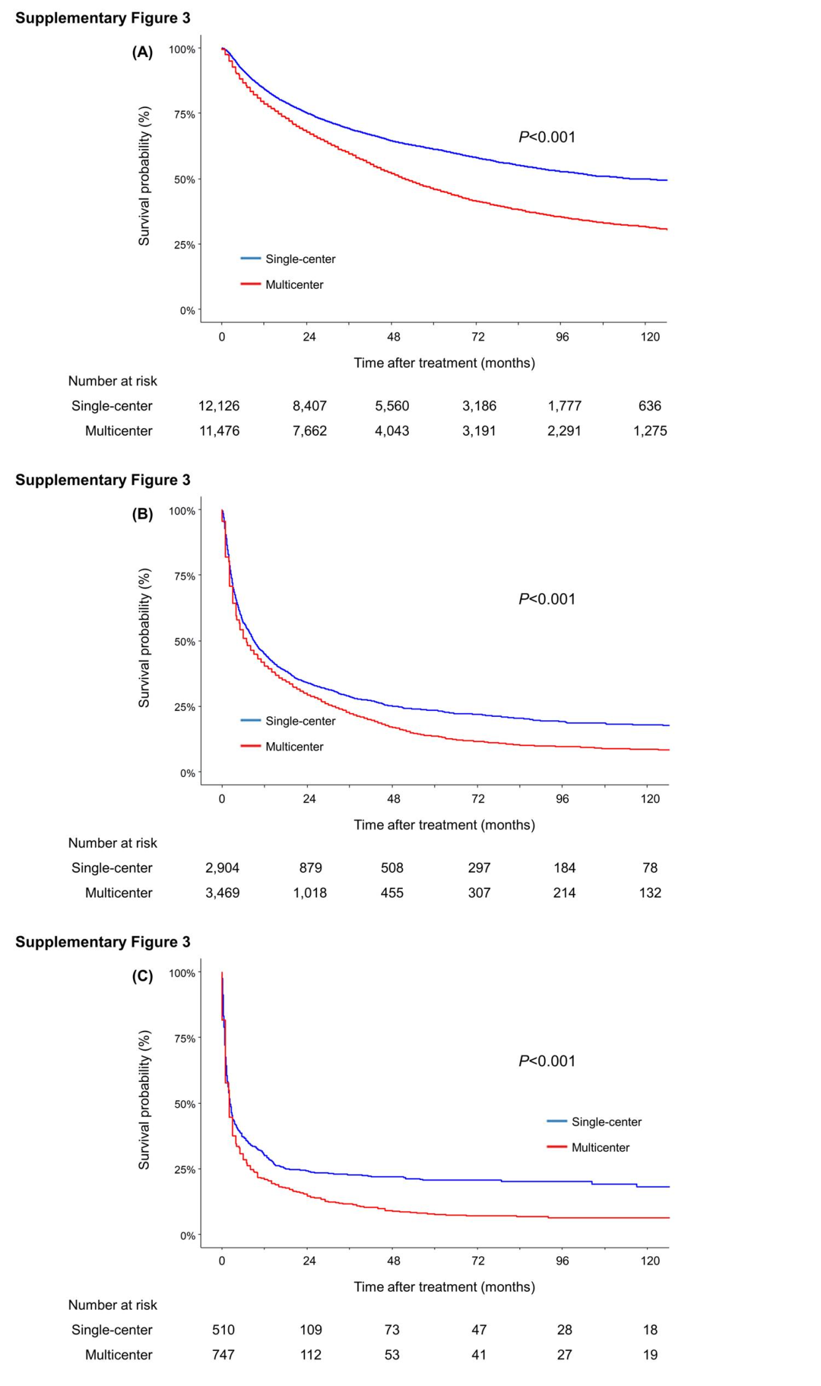
SUPPLEMENTARY FIGURE 4. Kaplan–Meier estimates of overall survival according to mUICC stage (A) I, (B) II, (C) III, (D) IVA, and (E) IVB
Abbreviations: mUICC, modified Union for International Cancer Control (mUICC) staging
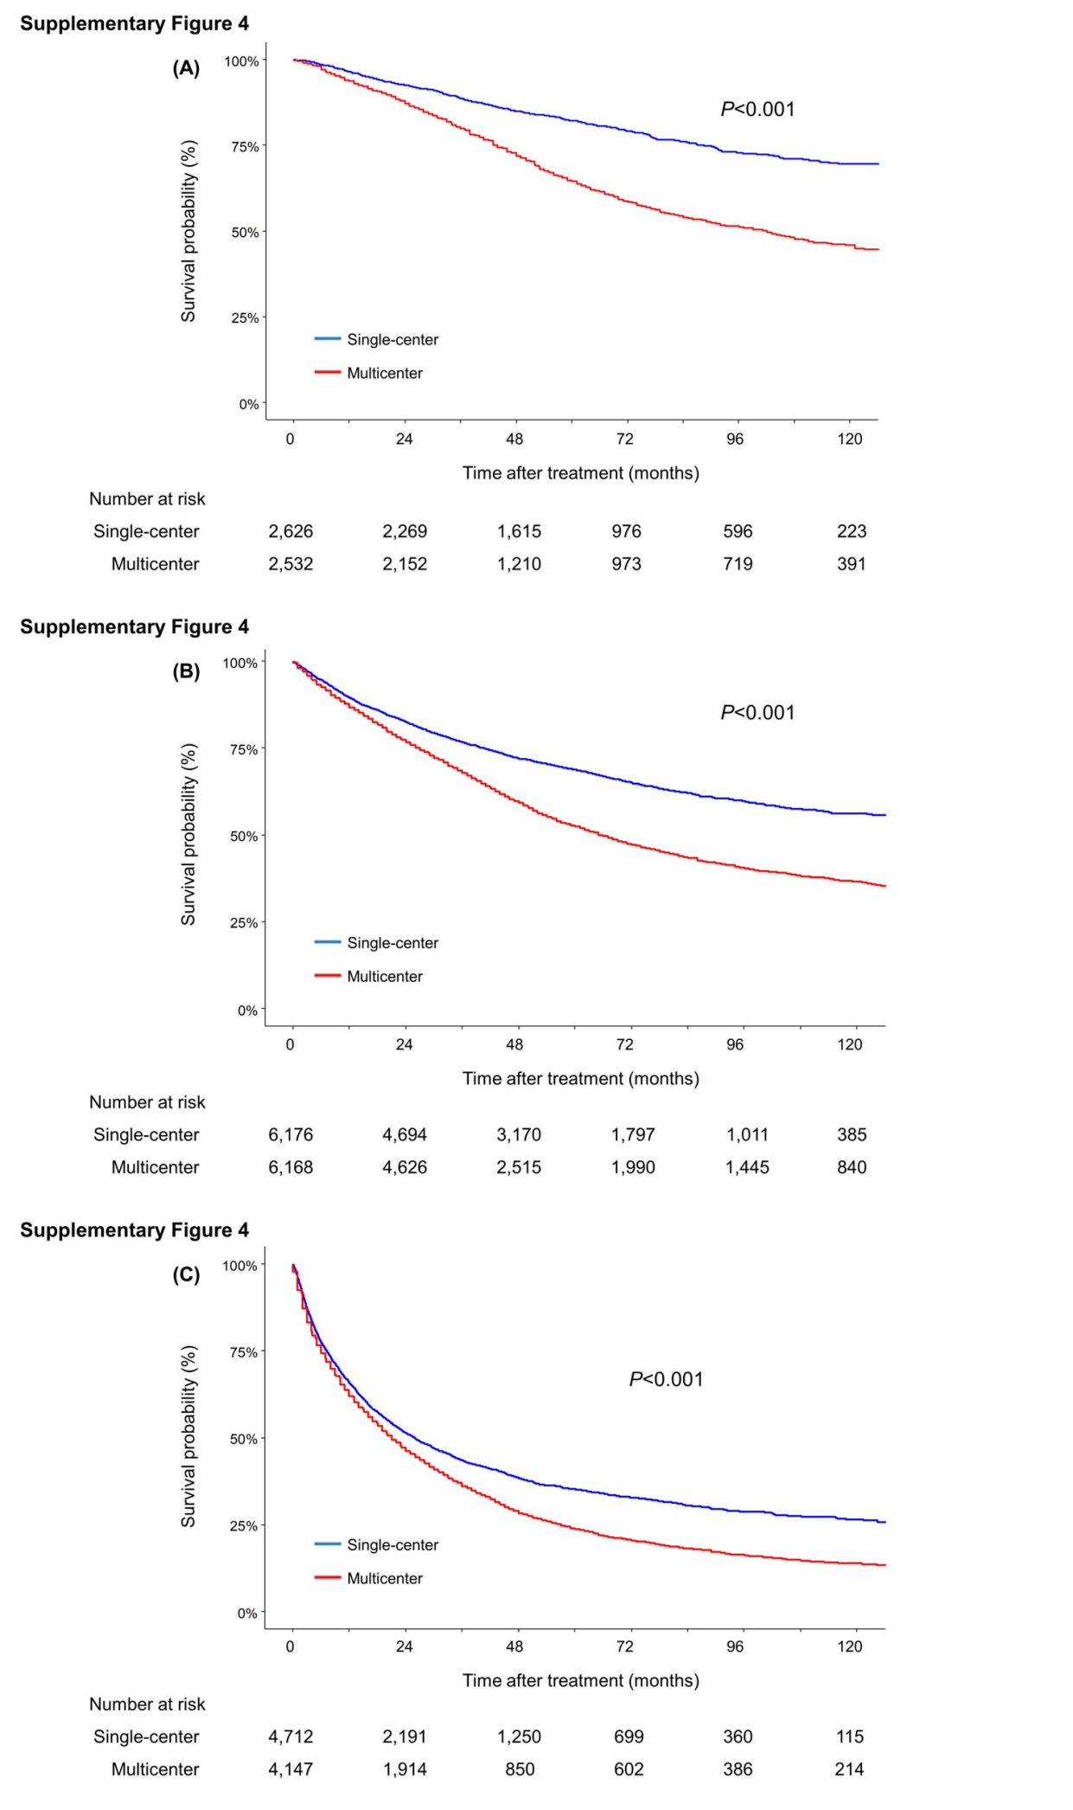
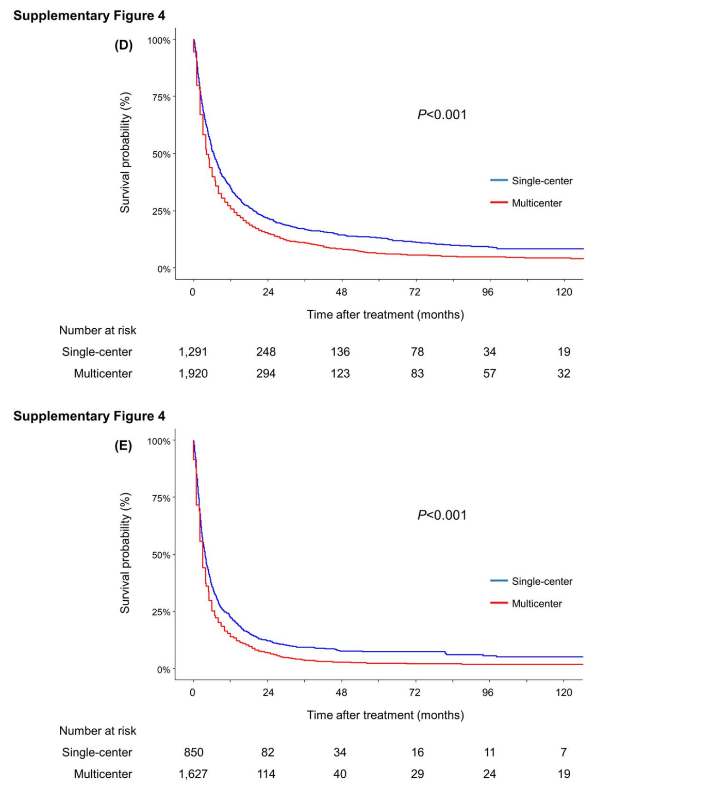

SUPPLEMENTARY FIGURE 5. Kaplan–Meier estimates of overall survival of patients who received (A) surgical resection, (B) liver transplants, (C) LAT, (D) TACE, (E) systemic therapy, and (F) radiotherapy
Abbreviations: LAT, local ablation therapy; TACE, transarterial chemoembolization; TARE, transarterial radioembolization.
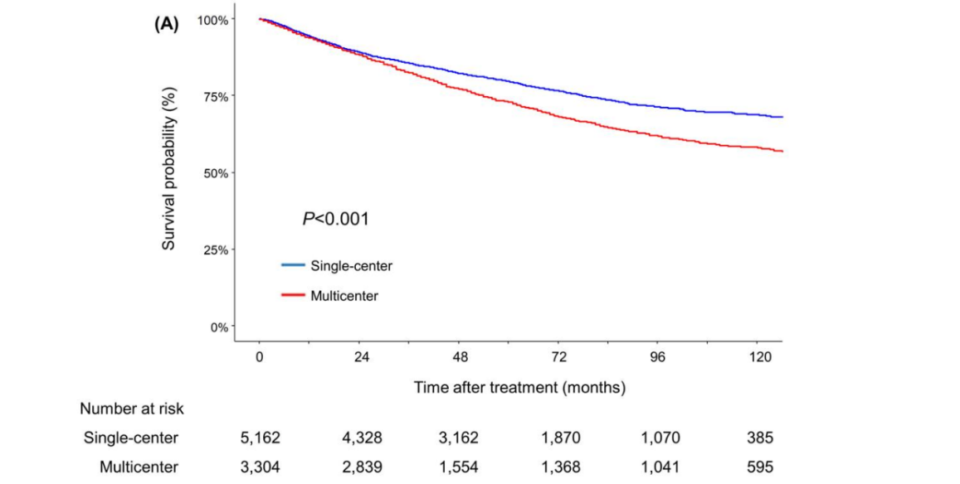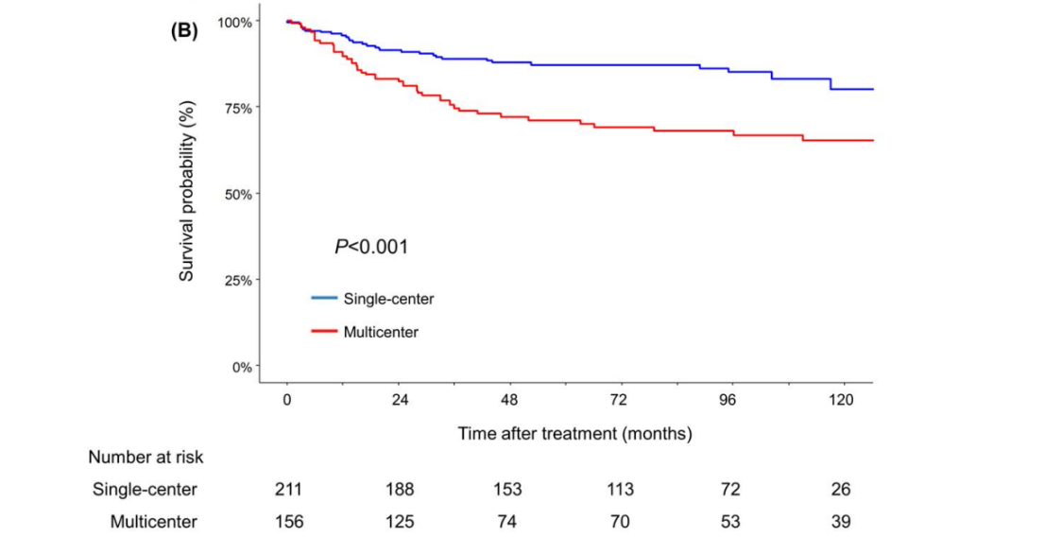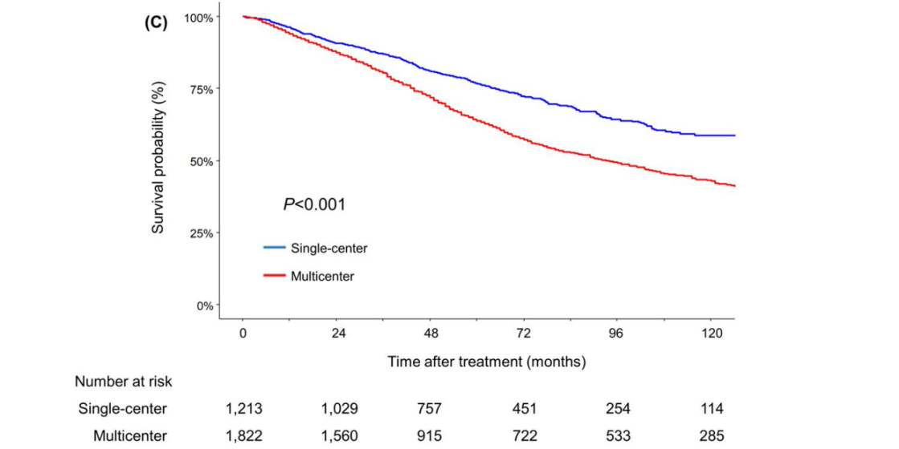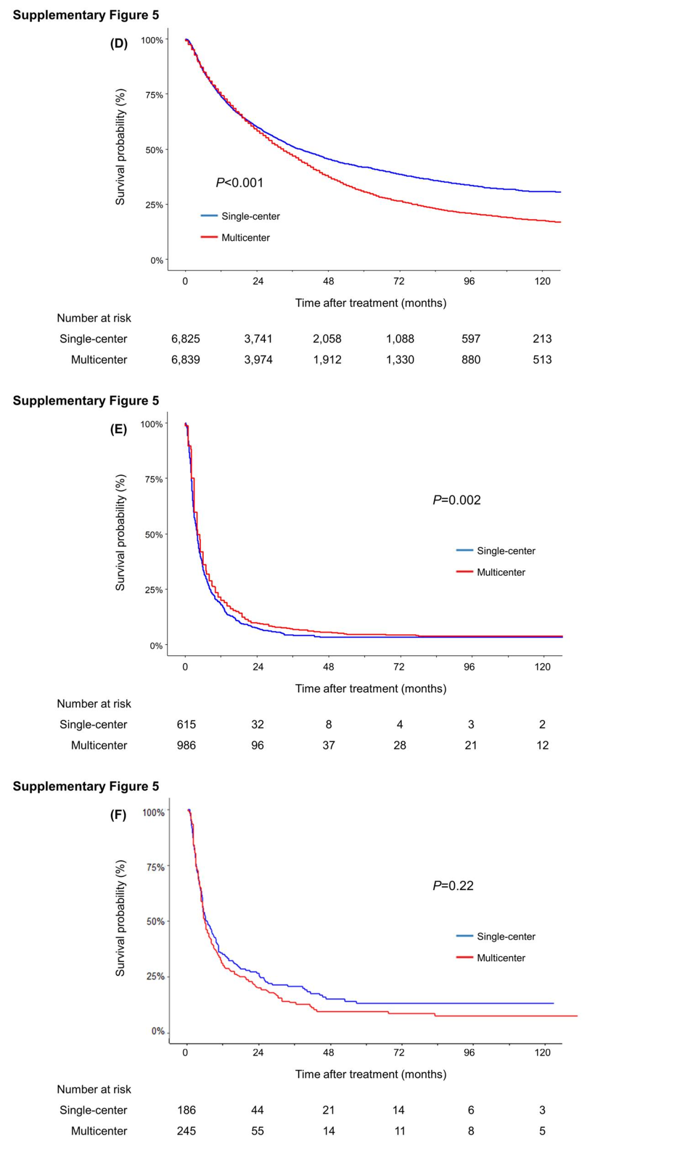

SUPPLEMENTARY FIGURE 6. Kaplan-Meier estimates of overall survival following (A) curative treatment, (B) non-curative treatment, (C) best supportive care
Curative treatment was defined as surgical resection, liver transplantation, and local ablation therapy.
Non-curative treatment was defined as transarterial chemoembolization/transarterial radioembolization, radiotherapy, and systemic therapy.
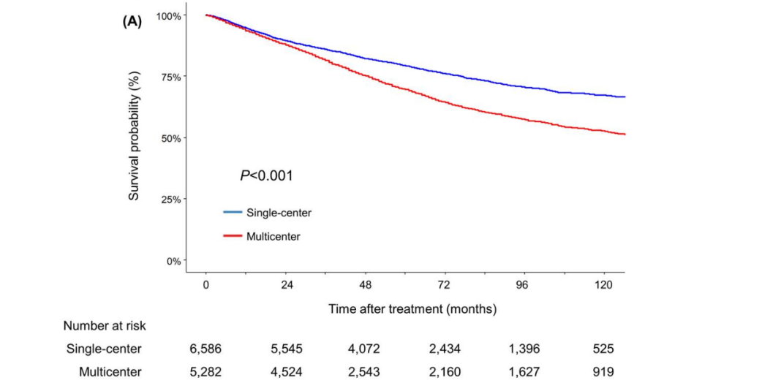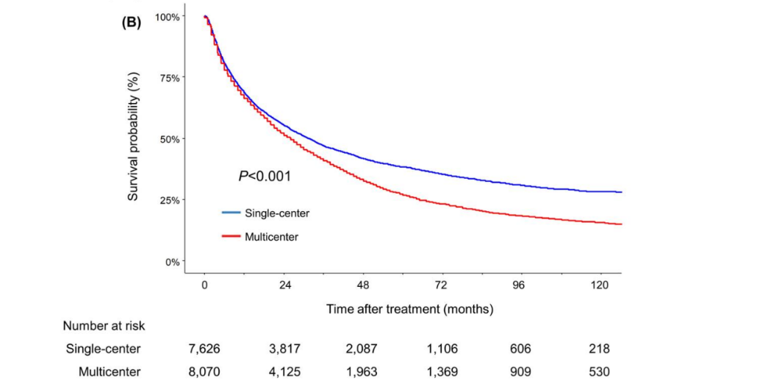
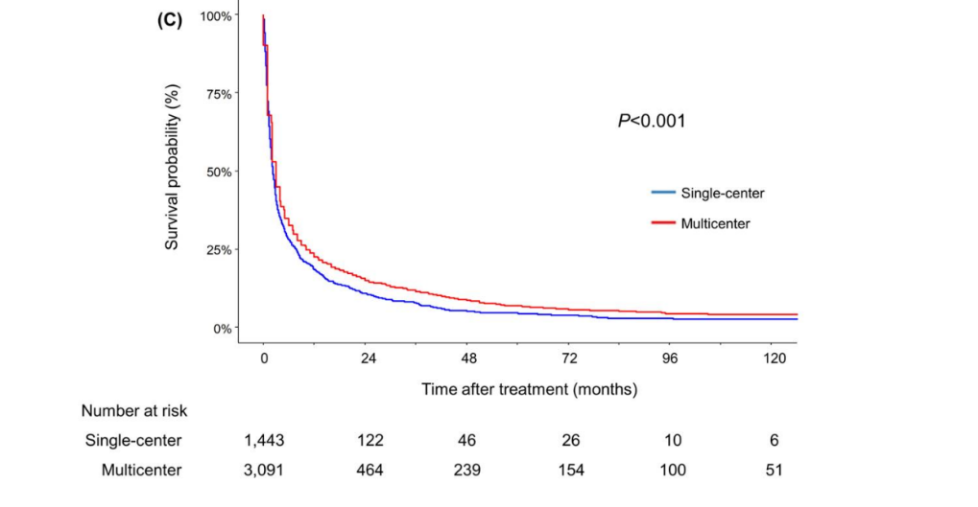
References

1. Dechartres A, Boutron I, Trinquart L, Charles P, Ravaud P. Single-center trials show larger treatment effects than multicenter trials: evidence from a meta-epidemiologic study. Annals of internal medicine. 2011;155(1):39-51.
2. Bafeta A, Dechartres A, Trinquart L, Yavchitz A, Boutron I, Ravaud P. Impact of single centre status on estimates of intervention effects in trials with continuous outcomes: meta-epidemiological study. Bmj. 2012;344.
3. Unverzagt S, Prondzinsky R, Peinemann F. Single-center trials tend to provide larger treatment effects than multicenter trials: a systematic review. Journal of clinical epidemiology. 2013;66(11):1271-1280.
4. Samaga D, Hornung R, Braselmann H, et al. Single-center versus multi-center data sets for molecular prognostic modeling: a simulation study. Radiation Oncology. 2020;15:1-14.
5. McCarthy JF, McCarthy PM, Massad MG, et al. Risk factors for death after heart transplantation: does a single-center experience correlate with multicenter registries? The Annals of thoracic surgery. 1998;65(6):1574-1578.
6. Senn SJ, Lewis RJ. Treatment effects in multicenter randomized clinical trials. Jama. 2019;321(12):1211-1212.
7. Park JW, Chen M, Colombo M, et al. Global patterns of hepatocellular carcinoma management from diagnosis to death: the BRIDGE Study. Liver International. 2015;35(9):2155-2166.
8. Laube R, Sabih AH, Strasser SI, Lim L, Cigolini M, Liu K. Palliative care in hepatocellular carcinoma. Journal of Gastroenterology and Hepatology. 2021;36(3):618-628.
9. Woodrell CD, Hansen L, Schiano TD, Goldstein NE. Palliative care for people with hepatocellular carcinoma, and specific benefits for older adults. Clinical therapeutics. 2018;40(4):512-525.
10. Do You D, Kim DG, Seo CH, Choi HJ, Yoo YK, Park YG. Prognostic factors after curative resection hepatocellular carcinoma and the surgeon's role. Annals of Surgical Treatment and Research. 2017;93(5):252.
11. Berger NG, Silva JP, Mogal H, et al. Overall survival after resection of retroperitoneal sarcoma at academic cancer centers versus community cancer centers: an analysis of the National Cancer Data Base. Surgery. 2018;163(2):318-323.
12. Meyerhardt JA, Tepper JE, Niedzwiecki D, et al. Impact of hospital procedure volume on surgical operation and long-term outcomes in high-risk curatively resected rectal cancer: findings from the Intergroup 0114 Study. Journal of clinical oncology. 2004;22(1):166-174.
13. Kozower BD, Stukenborg GJ. Hospital esophageal cancer resection volume does not predict patient mortality risk. The Annals of thoracic surgery. 2012;93(5):1690-1698.
14. Northup P, Pruett T, Stukenborg G, Berg C. Survival after adult liver transplantation does not correlate with transplant center case volume in the MELD era. American journal of transplantation. 2006;6(10):2455-2462.
15. Lee T-Y, Lin J-T, Ho HJ, Wu M-S, Wu C-Y. Evaluation of the effect of cumulative operator experience on hepatocellular carcinoma recurrence after primary treatment with radiofrequency ablation. Radiology. 2015;276(1):294-301.
16. Poon RT, Ng KK, Lam CM, et al. Learning curve for radiofrequency ablation of liver tumors: prospective analysis of initial 100 patients in a tertiary institution. Annals of surgery. 2004;239(4):441-449.
17. Raoul J-L, Sangro B, Forner A, et al. Evolving strategies for the management of intermediate-stage hepatocellular carcinoma: available evidence and expert opinion on the use of transarterial chemoembolization. Cancer treatment reviews. 2011;37(3):212-220.
18. Biau DJ, Halm JA, Ahmadieh H, et al. Provider and center effect in multicenter randomized controlled trials of surgical specialties: an analysis on patient-level data. Annals of surgery. 2008;247(5):892-898.
19. Boutron I, Tubach F, Giraudeau B, Ravaud P. Methodological differences in clinical trials evaluating nonpharmacological and pharmacological treatments of hip and knee osteoarthritis. Jama. 2003;290(8):1062-1070.
20. Jo D. The interpretation bias and trap of multicenter clinical research. The Korean Journal of Pain. 2020;33(3):199.
21. Llovet JM, Ricci S, Mazzaferro V, et al. Sorafenib in advanced hepatocellular carcinoma. New England journal of medicine. 2008;359(4):378-390.

