Supplementary materials

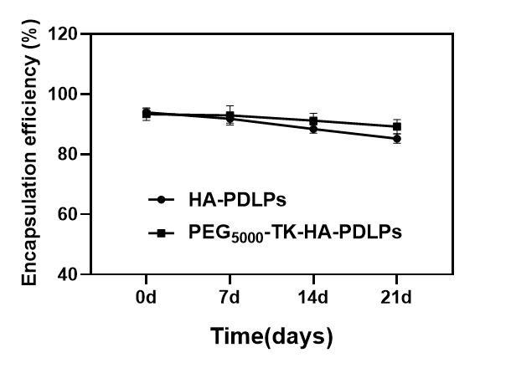
Figure S1 Stability results of different formulations.

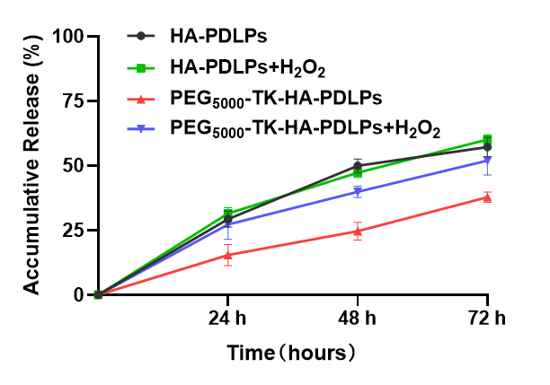
Figure S2 In vitro cumulative release results of different formulations.

