Supporting Information
Chemodynamic PtMn nanocubes for effective photothermal ROS storm a key anti-tumor therapy In-vivo
Chen Wang^{1*}, Hongmei Zhou^{1*}, Mekhrdod S. Kurboniyon², Yanping Tang¹, Zhengmin Cai¹, Shufang Ning¹, Litu Zhang¹ and Xinqiang Liang¹

¹Department of Research & Guangxi Cancer Molecular Medicine Engineering Research Center & Guangxi Key Laboratory of Basic and Translational Research for Colorectal Cancer, Guangxi Medical University Cancer Hospital, Nanning, China; ²National Academy of Sciences of Tajikistan, Dushanbe, Tajikistan

*These authors contributed equally to this work

Correspondence: Litu Zhang and Xinqiang Liang
Department of Research and Guangxi Cancer Molecular Medicine Engineering Research Center and Guangxi Key Laboratory of Basic and Translational Research for Colorectal Cancer, Guangxi Medical University Cancer Hospital, Nanning, China
Email: zhanglitu@gmail.com and xx03716@163.com

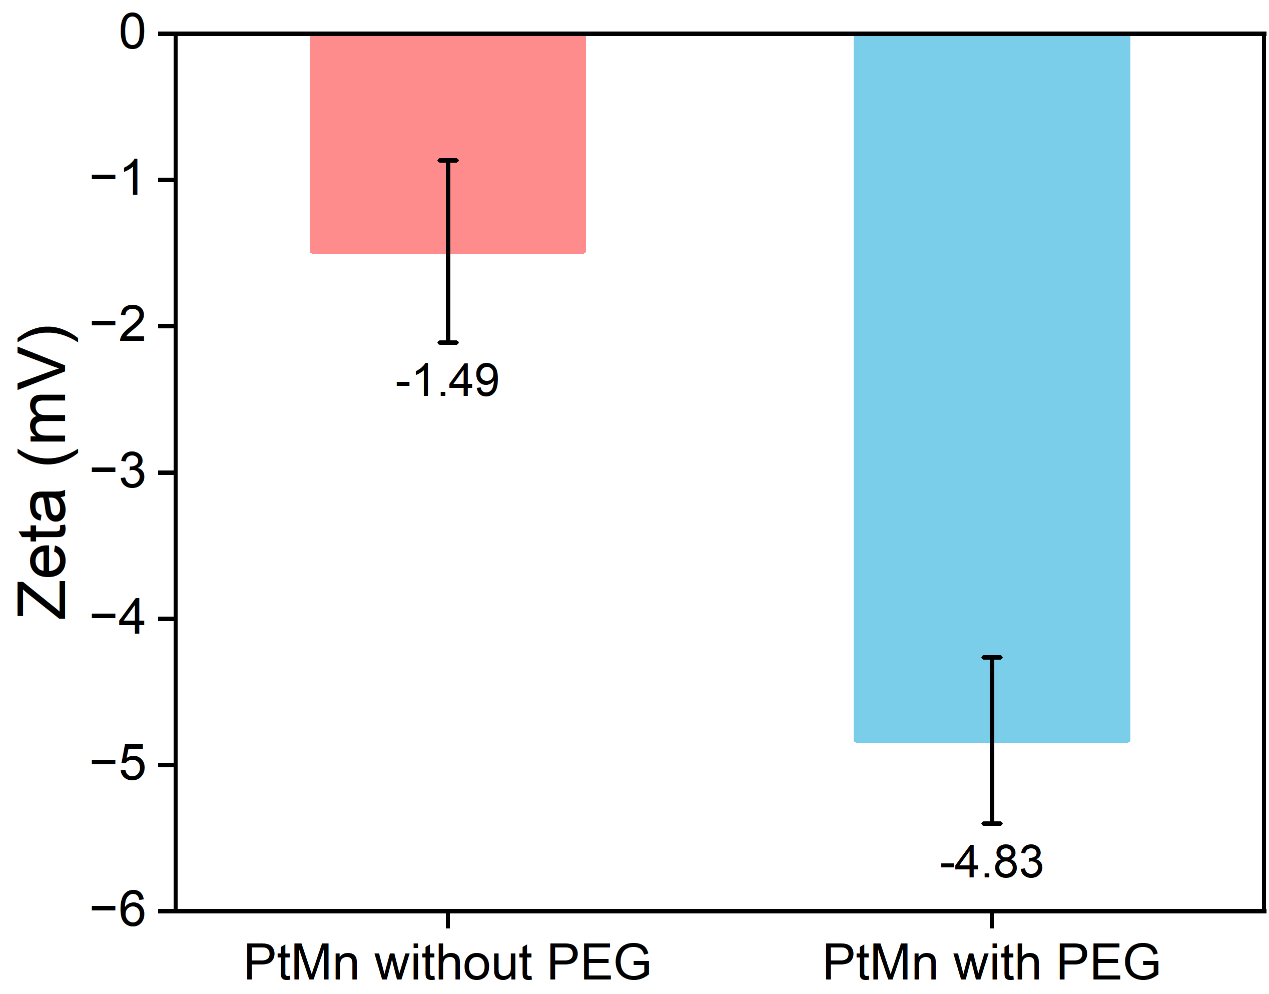
Figure S1. The zeta potentials of PtMn without PEG modification and PtMn with PEG modification.

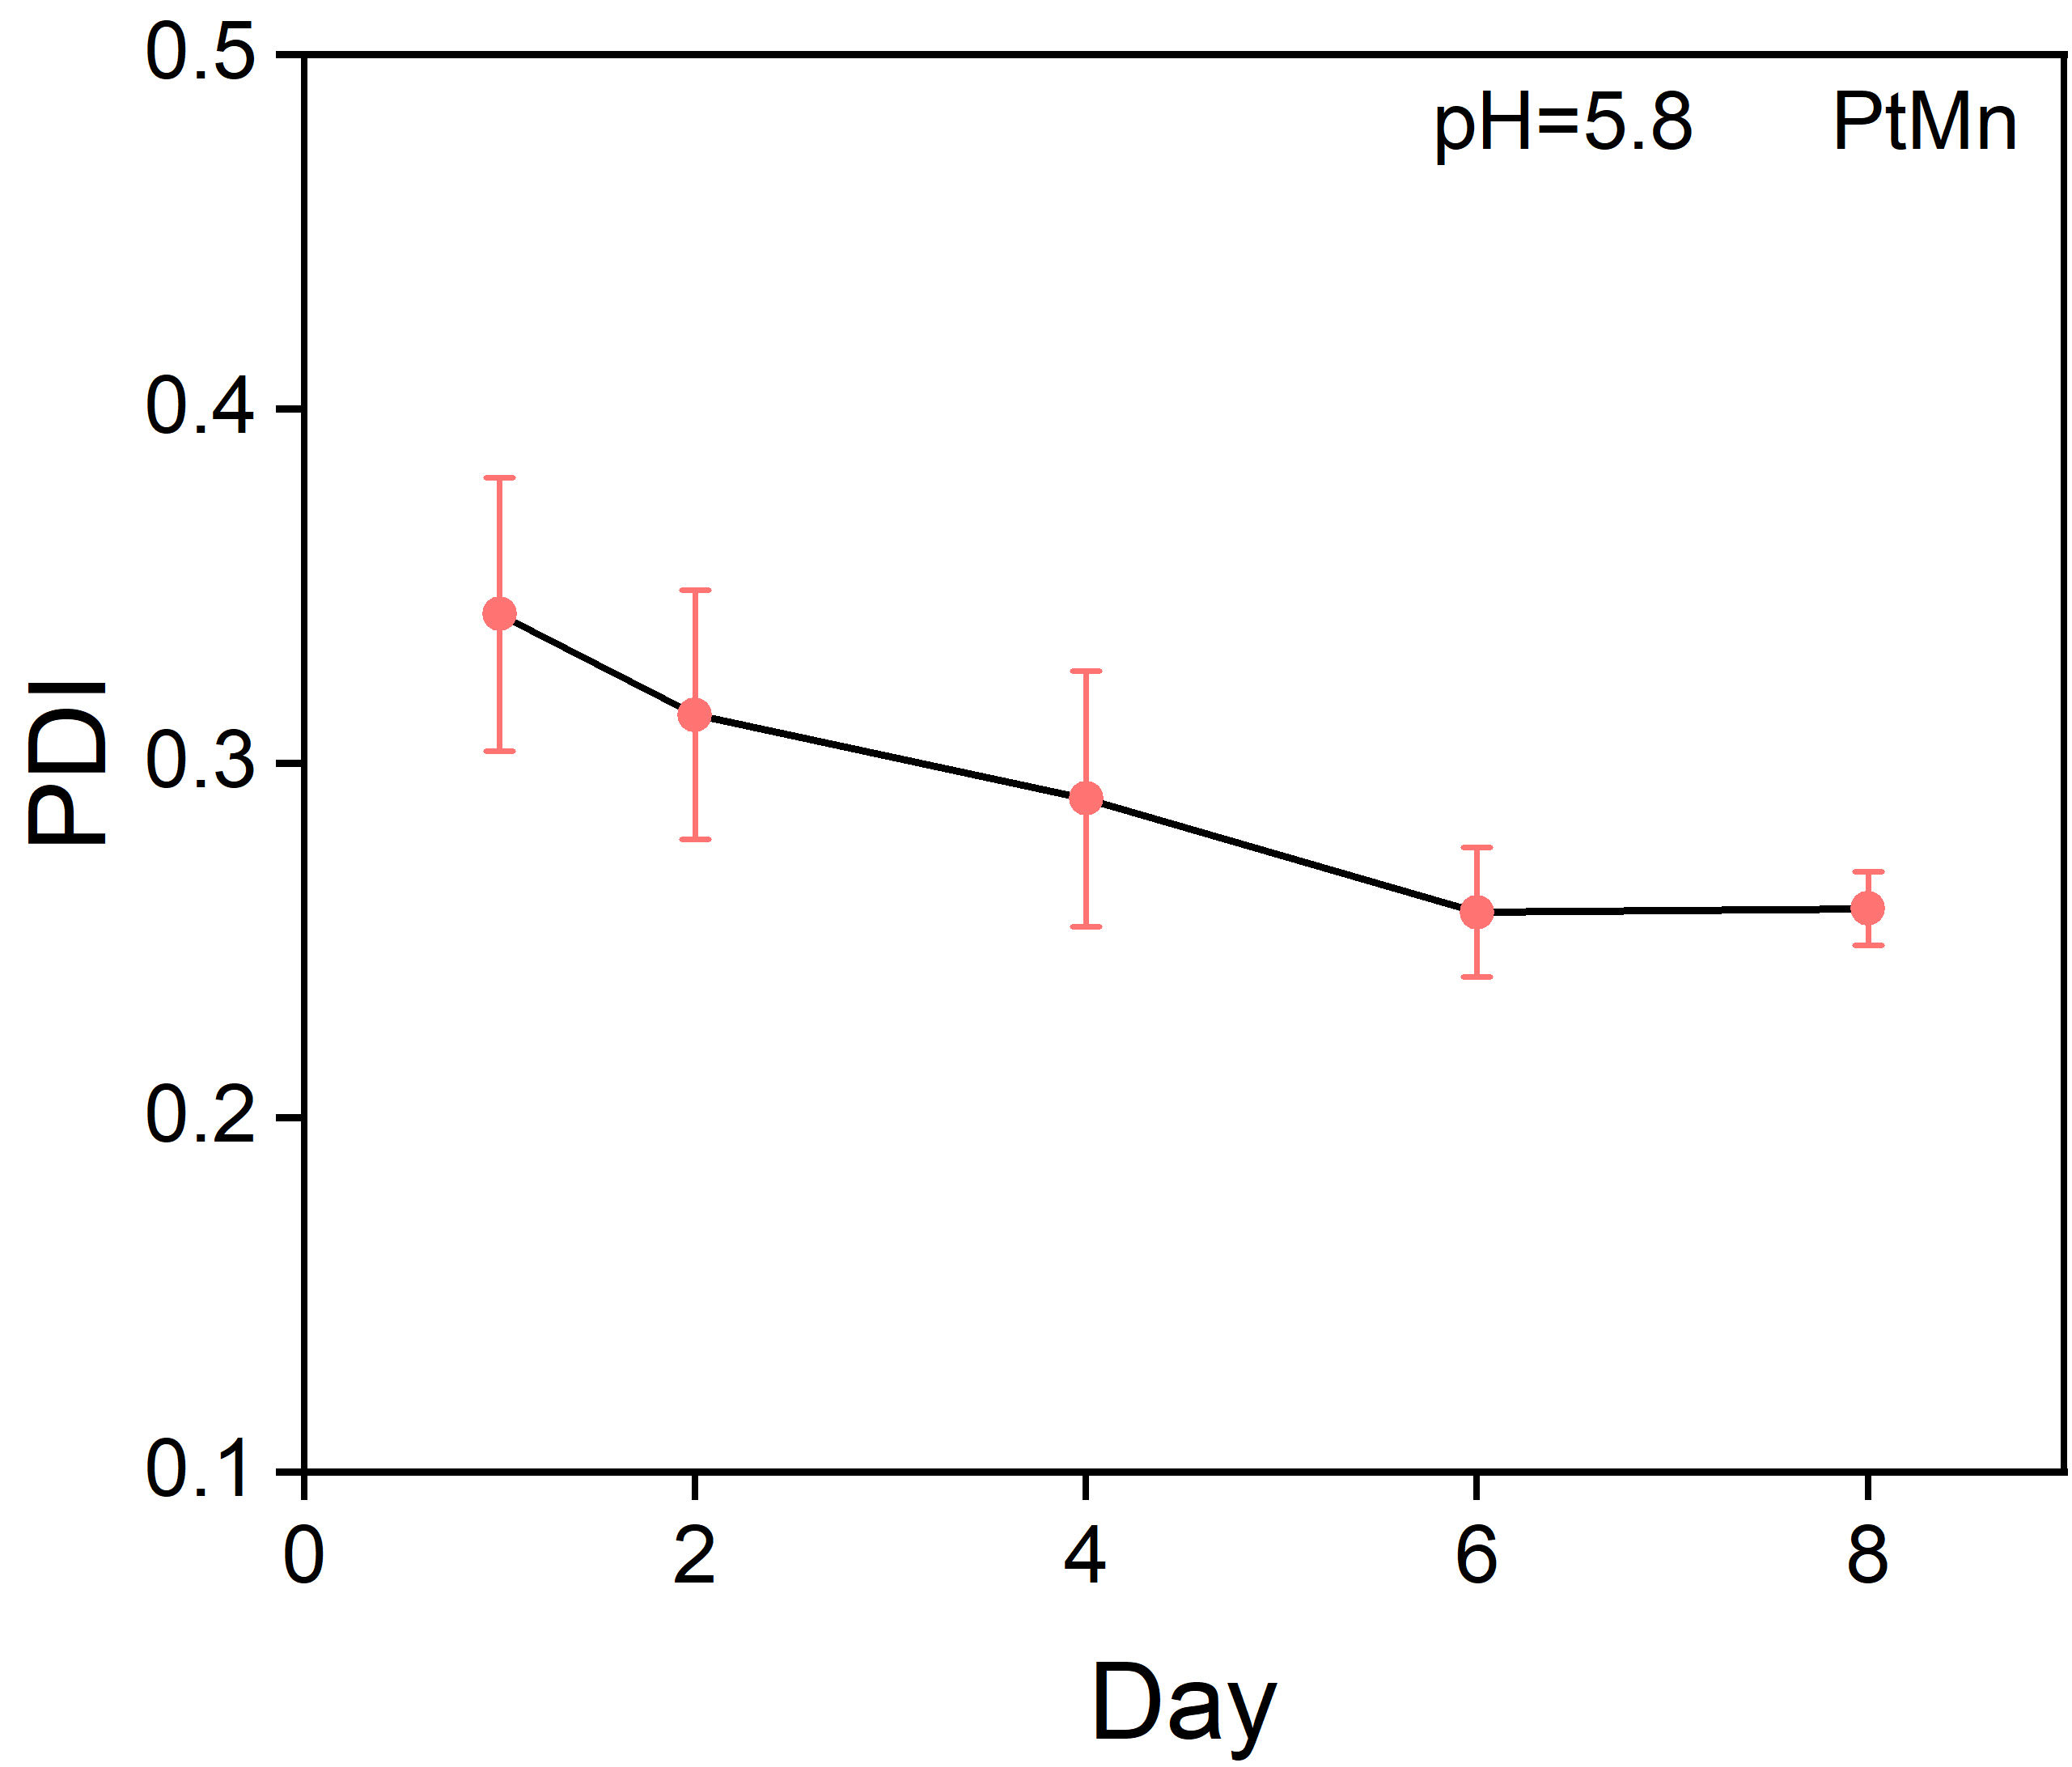
Figure S2. PDI of PtMn nanocubes at different times in an acidic condition.

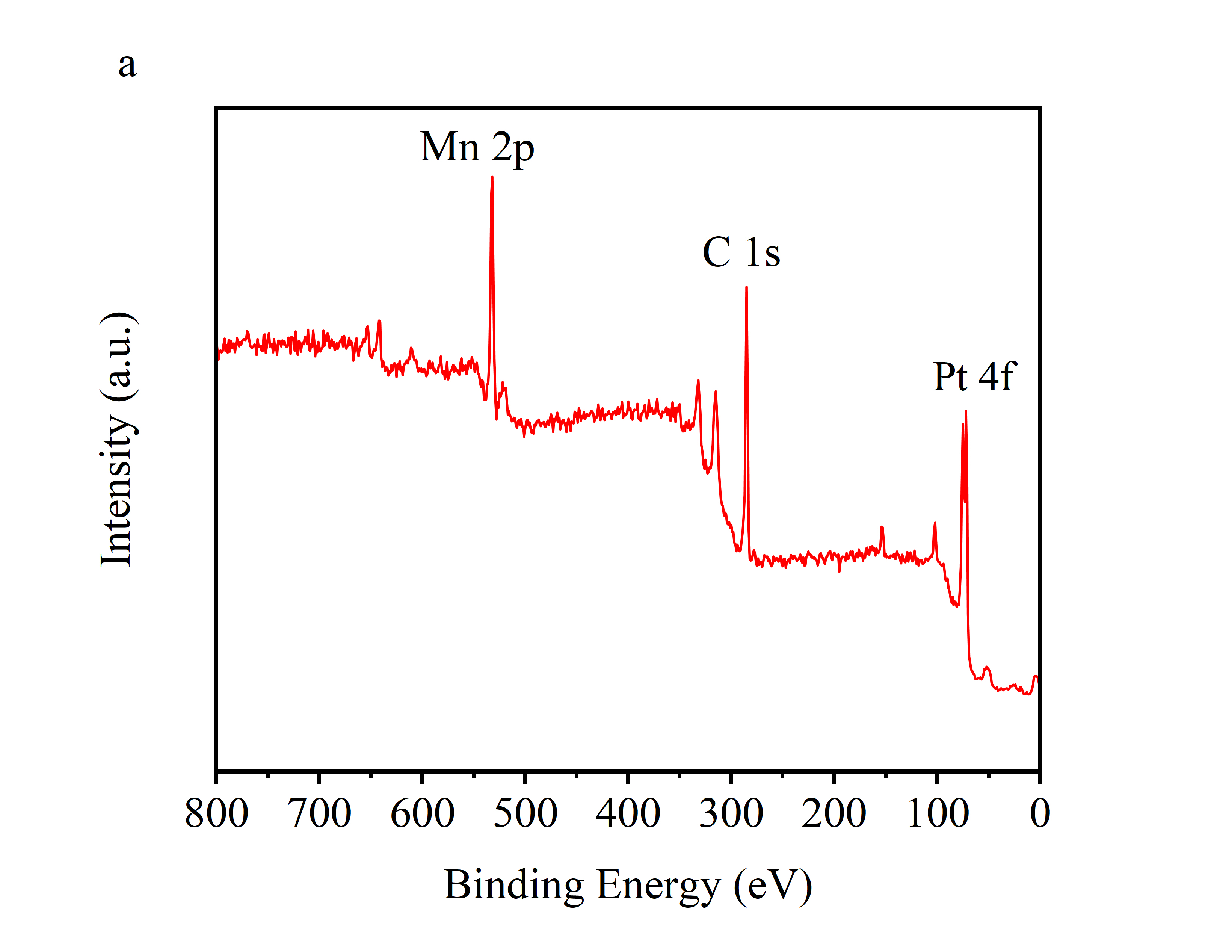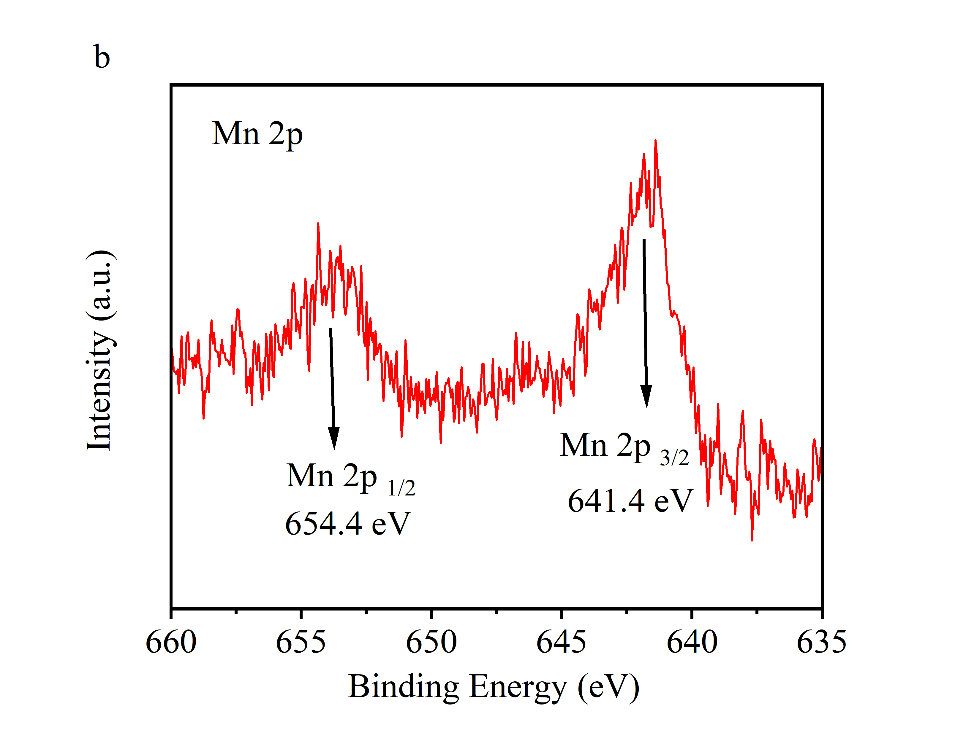
Figure S3. (a) Full XPS spectrum of PtMn nanocubes. (b) High-resolution XPS spectra of Mn 2p in PtMn nanocubes.
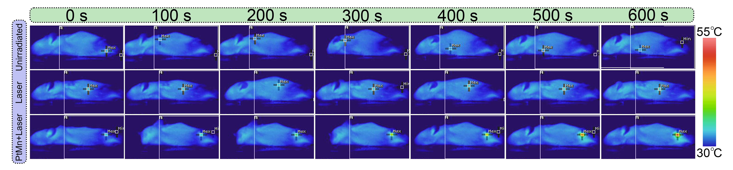
Figure S4. The photothermal images in vivo under different conditions.
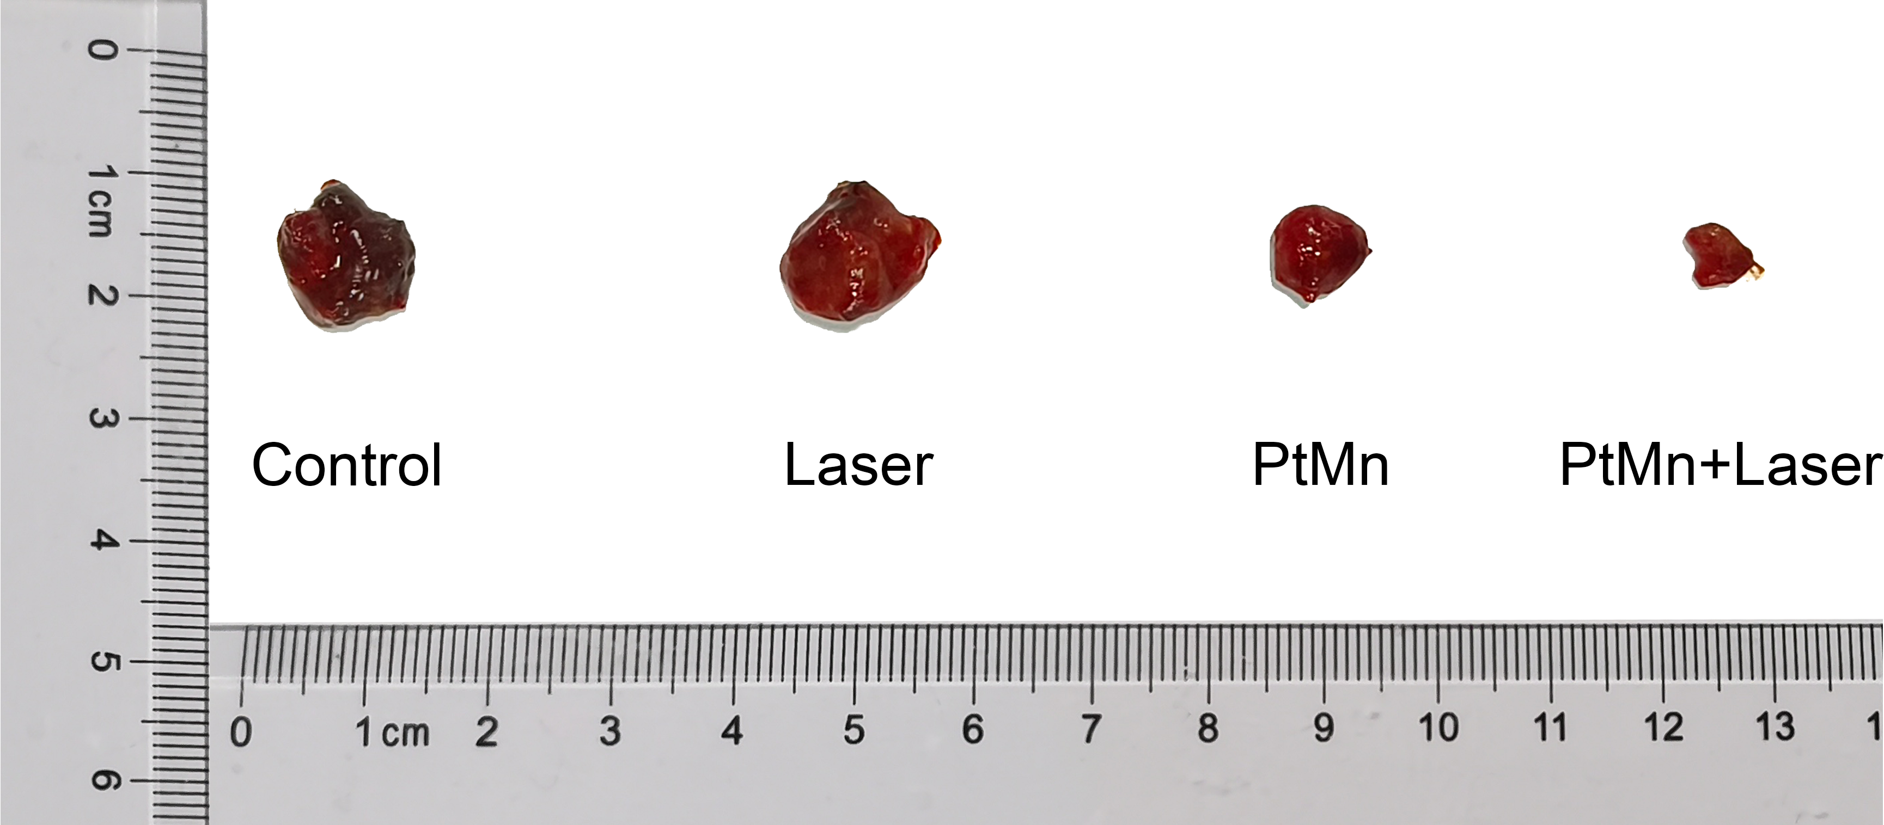
Figure S5. Representative photographs of tumors from each treatment group.

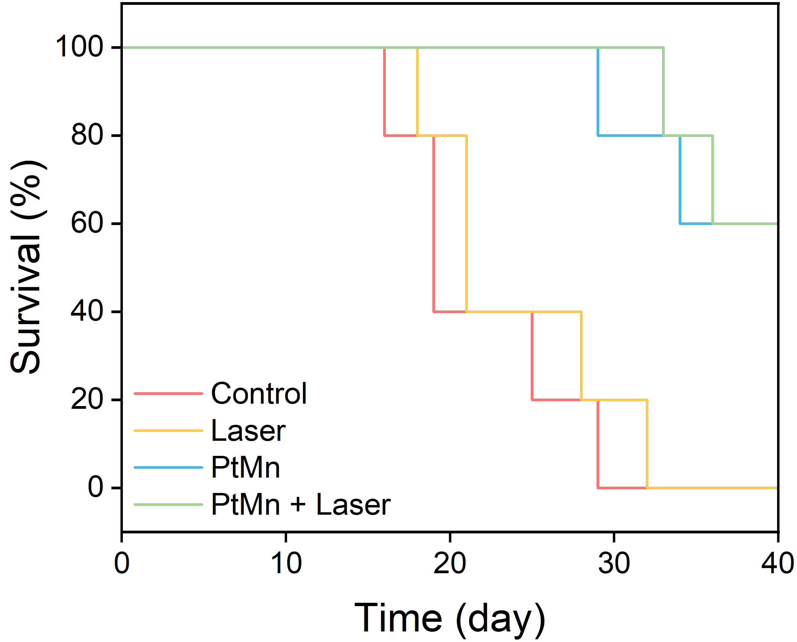
Figure S6. The survival rates of tumor-bearing mice with different treatments.

