Supplementary material

Supplementary Table 1: Laboratory values at HCC diagnosis (Damietta, 2007-2019), overall and by etiology

 |  | Etiology
 |  | Viral | Non viral
Labratory values |  | N = 4,510 | N= 204 |  | P-value
ALT (UI/L) | Median [Q25-Q75] | 48.00 [32.00-70.00] | 45.00 [31.00-70.00] |  | 0.3106
 | Missing | 570 | 10
AST (UI/L) | Median [Q25-Q75] | 75.00 [50.00-103.50] | 71.50 [49.00-110.75] |  | 0.3543
 | Missing | 631 | 14
AFP (UI/mL) | Median [Q25-Q75] | 210.00 [32.00-1000.00] | 273.00 [26.45-1174.00] |  | 0.6591
 | Missing | 499 | 21
Albumin (g/dL) | Median [Q25-Q75] | 2.90 [2.50-3.50] | 3.00 [2.50-3.40] |  | 0.6831
 | Missing | 310 | 10
Total bilirubin (mg/dL) | Median [Q25-Q75] | 1.80 [1.12-3.20] | 1.80 [1.10-3.30] |  | 0.1774
 | Missing | 177 | 4
Prothrombine concentration (%) | Median [Q25-Q75] | 65.00 [50.00-78.00] | 60.00 [45.00-75.00] |  | 0.0305
 | Missing | 787 | 39
Platelets (10³/mm³) | Median [Q25-Q75] | 100.00 [78.00-142.00] | 103.50 [79.25-141.50] |  | 0.0682
 | Missing | 491 | 14

Supplementary Figure 1: HCC recurrence-free survival after curative therapy, per etiology
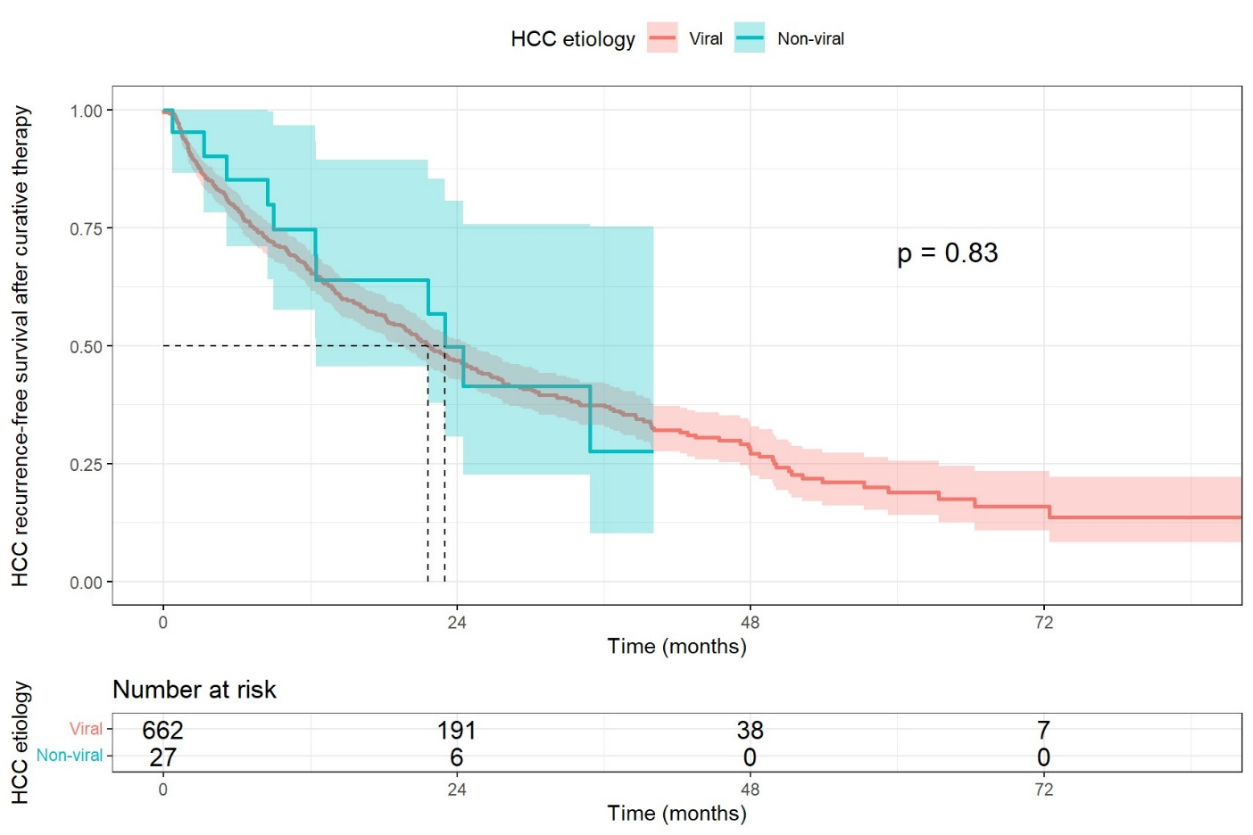

Recurrence-free survival was assessed among patients who underwent curative therapy for hepatocellular carcinoma (HCC), which included either surgical liver resection or curative locoregional therapy. Recurrence-free survival was defined as the period starting from the date of treatment completion and continuing until the recorded date of HCC recurrence or until the patient's data was censored.
Median HCC-recurrence free survival : 21.7 (95% CI: 19.7-24.8) months.

