Supplementary Table 1
Baseline patient clinicopathological characteristics
Variable | Total  (n = 562) | NER High  (n = 68) | NER Low  (n = 494) | P
Gender |  |  |  | 0.192
Female | 93 (16.55) | 15 (22.06) | 78 (15.79)
Male | 469 (83.45) | 53 (77.94) | 416 (84.21)
Age (years) |  |  |  | 0.559
≤47 | 78 (13.88) | 11 (16.18) | 67 (13.56)
＞47 | 484 (86.12) | 57 (83.82) | 427 (86.44)
HbsAg (ng/ml) |  |  |  | 0.968
Negative | 42 (7.47) | 5 (7.35) | 37 (7.49)
Positive | 520 (92.53) | 63 (92.65) | 457 (92.51)
AFP (ng/ml) |  |  |  | 0.125
≤400 | 415 (73.84) | 45 (66.18) | 370 (74.90)
＞400 | 147 (26.16) | 23 (33.82) | 124 (25.10)
Neutrophil count (10^9/L) |  |  |  | <0.001
≤4.7 | 503 (89.5) | 44 (64.71) | 459 (92.91)
＞4.7 | 59 (10.5) | 24 (35.29) | 35 (7.09)
Lymphocyte count (10^9/L) |  |  |  | 0.006
≤1.01 | 73 (12.99) | 16 (23.53) | 57 (11.54)
＞1.01 | 489 (87.01) | 52 (76.47) | 437 (88.46)
Monocyte count (10^9/L) |  |  |  | 0.233
≤0.59 | 474 (84.34) | 54 (79.41) | 420 (85.02)
＞0.59 | 88 (15.66) | 14 (20.59) | 74 (14.98)
Basophil count (10^9/L) |  |  |  | 0.024
≤0.01 | 219 (38.97) | 35 (51.47) | 184 (37.25)
＞0.01 | 343 (61.03) | 33 (48.53) | 310 (62.75)
Eosinophil count (10^9/L) |  |  |  | <0.001
≤0.03 | 80 (14.23) | 54 (79.41) | 26 (5.26)
＞0.03 | 482 (85.77) | 14 (20.59) | 468 (94.74)
WBC count (10^9/L) |  |  |  | <0.001
≤4.02 | 114 (20.28) | 1 (1.47) | 113 (22.87)
＞4.02 | 448 (79.72) | 67 (98.53) | 381 (77.13)
RBC count (10^12/L) |  |  |  | 0.724
≤4.74 | 317 (56.41) | 37 (54.41) | 280 (56.68)
＞4.74 | 245 (43.59) | 31 (45.59) | 214 (43.32)
HB (g/L) |  |  |  | 0.763
≤149 | 340 (60.5) | 40 (58.82) | 300 (60.73)
＞149 | 222 (39.5) | 28 (41.18) | 194 (39.27)
PLT (10^9/L) |  |  |  | 0.136
≤134 | 194 (34.52) | 18 (26.47) | 176 (35.63)
＞134 | 368 (65.48) | 50 (73.53) | 318 (64.37)
NLR |  |  |  | <0.001
≤3.32 | 496 (88.26) | 38 (55.88) | 458 (92.71)
＞3.32 | 66 (11.74) | 30 (44.12) | 36 (7.29)
PLR |  |  |  | <0.001
≤158.76 | 505 (89.86) | 51 (75.00) | 454 (91.90)
≥158.76 | 57 (10.14) | 17 (25.00) | 40 (8.10)
LMR |  |  |  | <0.001
≤2.51 | 68 (12.1) | 22 (32.35) | 46 (9.31)
＞2.51 | 494 (87.9) | 46 (67.65) | 448 (90.69)
ALB (g/L) |  |  |  | 0.034
≤49.9 | 504 (89.68) | 56 (82.35) | 448 (90.69)
＞49.9 | 58 (10.32) | 12 (17.65) | 46 (9.31)
TBIL (μmol/L) |  |  |  | 0.263
≤13.57 | 156 (27.76) | 15 (22.06) | 141 (28.54)
＞13.57 | 406 (72.24) | 53 (77.94) | 353 (71.46)
DBIL (μmol/L) |  |  |  | 0.111
≤7.79 | 424 (75.44) | 46 (67.65) | 378 (76.52)
＞7.79 | 138 (24.56) | 22 (32.35) | 116 (23.48)
IBIL (μmol/L) |  |  |  | 0.114
≤9.8 | 197 (35.05) | 18 (26.47) | 179 (36.23)
＞9.8 | 365 (64.95) | 50 (73.53) | 315 (63.77)
ALP (μmol/L) |  |  |  | 0.358
≤115 | 498 (88.61) | 58 (85.29) | 440 (89.07)
＞115 | 64 (11.39) | 10 (14.71) | 54 (10.93)
GGT (μmol/L) |  |  |  | 0.091
≤42.7 | 326 (58.01) | 33 (48.53) | 293 (59.31)
＞42.7 | 236 (41.99) | 35 (51.47) | 201 (40.69)
ALT (U/L) |  |  |  | 0.636
≤40 | 505 (89.86) | 60 (88.24) | 445 (90.08)
＞40 | 57 (10.14) | 8 (11.76) | 49 (9.92)
AST (U/L) |  |  |  | 0.373
≤32.04 | 366 (65.12) | 41 (60.29) | 325 (65.79)
＞32.04 | 196 (34.88) | 27 (39.71) | 169 (34.21)
Largest tumor size (cm) |  |  |  | 0.009
≤4.5 | 361 (64.23) | 34 (50.00) | 327 (66.19)
＞4.5 | 201 (35.77) | 34 (50.00) | 167 (33.81)
Tumor number |  |  |  | 0.691
Single | 523 (93.06) | 62 (91.18) | 461 (93.32)
Multiple | 39 (6.94) | 6 (8.82) | 33 (6.68)
Differentiation |  |  |  | 0.074
I-Ⅱ | 313 (55.69) | 31 (45.59) | 282 (57.09)
Ⅲ-Ⅳ | 249 (44.31) | 37 (54.41) | 212 (42.91)
Microvascular invasion |  |  |  | 0.367
No | 285 (50.71) | 31 (45.59) | 254 (51.42)
Yes | 277 (49.29) | 37 (54.41) | 240 (48.58)
Capsular invasion |  |  |  | 0.714
No | 319 (56.76) | 40 (58.82) | 279 (56.48)
Yes | 243 (43.24) | 28 (41.18) | 215 (43.52)
Satellite nodules |  |  |  | 0.296
No | 493 (87.72) | 57 (83.82) | 436 (88.26)
Yes | 69 (12.28) | 11 (16.18) | 58 (11.74)
Cirrhosis |  |  |  | 0.073
No | 217 (38.61) | 33 (48.53) | 184 (37.25)
Yes | 345 (61.39) | 35 (51.47) | 310 (62.75)
TNM stage |  |  |  | 0.023
Ⅰ | 271 (48.22) | 246 (49.80) | 25 (36.76)
Ⅱ | 264 (46.98) | 228 (46.15) | 36 (52.94)
Ⅲ | 27 (4.8) | 20 (4.05) | 7 (10.29)
BCLC stage |  |  |  | 0.267
0 | 81 (14.41) | 74 (14.98) | 7 (10.29)
A | 457 (81.32) | 401 (81.17) | 56 (82.35)
B | 24 (4.27) | 19 (3.85) | 5 (7.35)
CNLC stage |  |  |  | 0.118
Ⅰ | 279 (49.64) | 252 (51.01) | 27 (39.71)
Ⅱ | 6 (1.07) | 6 (1.21) | 0 (0.00)
Ⅲ | 277 (49.29) | 236 (47.77) | 41 (60.29)
Note: Results are presented as n (%) for qualitative data.
Abbreviations: P, p value; HbsAg, Hepatitis B surface antigen; AFP, alpha-fetoprotein; WBC, white blood cell; RBC, red blood cell; HB, Hemoglobin; PLT, platelet count; NER,neutrophil-to-eosinophil ratio; NLR, neutrophil-to-lymphocyte ratio;
PLR, platelet-to-lymphocyte ratio; LMR, lymphocyte-to-monocyte ratio; Alb, albumin; TBIL,total bilirubin; DBIL, direct bilirubin; IBIL, indirect Bilirubin; ALP, alkaline phosphatase;
GGT, γ‐glutamyl transpeptidase; ALT, alanine aminotransferase;
AST, aspartate aminotransferase; TNM, American Joint Committee on Cancer tumor-node-metastasis; BCLC, Barcelona Clinic Liver Cancer; CNLC, China liver cancer staging.

Supplementary Table 2
Univariate and multivariate Cox regression analyses of risk factors associated with progression-free survival (PFS) after surgery in the total cohort
Variables | Univariate analysis |  | Multivariate analysis
 | HR (95%CI) | P | HR (95%CI) | P
Gender
Female
Male | 0.81 (0.62 - 1.07) | 0.134
Age (years)
≤47
＞47 | 1.35 (1.03 - 1.78) | 0.033 | 1.46 (1.09 - 1.95) | 0.011
HbsAg (ng/ml)
Negative
Positive | 1.09 (0.75 - 1.58) | 0.659
AFP (ng/ml)
≤400
＞400 | 1.56 (1.26 - 1.95) | <0.001 | 1.22 (0.97 - 1.54) | 0.094
Neutrophil count (10^9/L)
≤4.7
＞4.7 | 1.73 (1.28 - 2.34) | <0.001 | 1.08 (0.74 - 1.58) | 0.676
Lymphocyte count (10^9/L)
≤1.01
＞1.01 | 1.49 (1.12 - 1.97) | 0.006 | 1.15 (0.79 - 1.68) | 0.454
Monocyte count (10^9/L)
≤0.59
＞0.59 | 1.48 (1.14 - 1.91) | 0.003 | 1.07 (0.79 - 1.45) | 0.675
Basophil count (10^9/L)
≤0.01
＞0.01 | 1.04 (0.85 - 1.28) | 0.672
Eosinophil count (10^9/L)
≤0.03
＞0.03 | 1.36 (1.03 - 1.78) | 0.029 | 0.70 (0.46 - 1.06) | 0.091
WBC count (10^9/L)
≤4.02
＞4.02 | 0.78 (0.60 - 1.00) | 0.051
RBC count (10^12/L)
≤4.74
＞4.74 | 1.34 (1.10 - 1.65) | 0.005 | 1.26 (0.91 - 1.75) | 0.158
HB (g/L)
≤149
＞149 | 1.31 (1.06 - 1.61) | 0.011 | 1.12 (0.80 - 1.56) | 0.521
PLT (10^9/L)
≤134
＞134 | 0.81 (0.65 - 0.99) | 0.044 | 0.81 (0.64 - 1.03) | 0.091
NER
≤102.00
＞102.00 | 1.93 (1.46 - 2.55) | <0.001 | 2.05 (1.30 - 3.22) | 0.002
NLR
≤3.32
＞3.32 | 2.17 (1.65 - 2.87) | <0.001 | 1.21 (0.80 - 1.83) | 0.356
PLR
≤158.76
≥158.76 | 1.75 (1.29 - 2.38) | <0.001 | 0.91 (0.63 - 1.30) | 0.592
LMR
≤2.51
＞2.51 | 1.72 (1.30 - 2.27) | <0.001 | 1.05 (0.72 - 1.52) | 0.797
ALB (g/L)
≤49.9
＞49.9 | 0.77 (0.56 - 1.05) | 0.100
TBIL (μmol/L)
≤13.57
＞13.57 | 1.21 (0.97 - 1.50) | 0.084
DBIL (μmol/L)
≤7.79
＞7.79 | 0.83 (0.66 - 1.05) | 0.126
IBIL (μmol/L)
≤9.8
＞9.8 | 1.18 (0.96 - 1.45) | 0.112
ALP (μmol/L)
≤115
＞115 | 0.69 (0.51 - 0.92) | 0.011 | 1.04 (0.76 - 1.42) | 0.813
GGT (μmol/L)
≤42.7
＞42.7 | 1.66 (1.36 - 2.02) | <0.001 | 1.37 (1.10 - 1.72) | 0.006
ALT (U/L)
≤40
＞40 | 0.76 (0.53 - 1.08) | 0.126
AST (U/L)
≤32.04
＞32.04 | 1.49 (1.22 - 1.83) | <0.001 | 1.15 (0.91 - 1.44) | 0.244
Largest tumor size (cm)
≤4.5
＞4.5 | 1.88 (1.53 - 2.30) | <0.001 | 1.44 (1.13 - 1.82) | 0.003
Tumor number
Single
Multiple | 2.10 (1.49 - 2.97) | <0.001 | 1.73 (1.20 - 2.50) | 0.003
Differentiation
I-Ⅱ
Ⅲ-Ⅳ | 1.45 (1.19 - 1.78) | <0.001 | 1.01 (0.80 - 1.27) | 0.957
Microvascular invasion
No
Yes | 0.59 (0.48 - 0.72) | <0.001 | 0.75 (0.60 - 0.96) | 0.019
Capsular invasion
No
Yes | 0.67 (0.55 - 0.82) | <0.001 | 0.87 (0.70 - 1.09) | 0.219
Satellite nodules
No
Yes | 2.03 (1.54 - 2.69) | <0.001 | 1.40 (1.02 - 1.92) | 0.035
Cirrhosis
No
Yes | 1.04 (0.85 - 1.28) | 0.675
TNM
Ⅰ
Ⅱ | 1.63 (1.33 - 2.01) | <0.001 | 1.71 (0.76 - 3.88) | 0.196
Ⅲ | 2.84 (1.83 - 4.40) | <0.001 | 1.23 (0.39 - 3.95) | 0.723
BCLC
0
A | 0.85 (0.64 - 1.14) | 0.286 | 0.97 (0.72 - 1.31) | 0.862
B | 2.73 (1.75 - 4.26) | <0.001 | 5.00 (1.94 - 12.92) | <0.001
CNLC
Ⅰ
Ⅱ | 1.69 (1.38 - 2.07) | <0.001 | 0.95 (0.42 - 2.15) | 0.906
Ⅲ | 1.31 (0.49 - 3.54) | 0.591 | 0.17 (0.04 - 0.75) | 0.020
Note: Results are presented as n (%) for qualitative data.
Abbreviations: HR, hazard ratio; CI, confidence interval; P, p value; HbsAg, Hepatitis B surface antigen; AFP, alpha-fetoprotein; WBC, white blood cell; RBC, red blood cell; HB, Hemoglobin; PLT, platelet count; NER, neutrophil-to-eosinophil ratio; NLR, neutrophil-to-lymphocyte ratio; PLR, platelet-to-lymphocyte ratio; LMR,
lymphocyte-to-monocyte ratio; Alb, albumin; TBIL, total bilirubin; DBIL, direct bilirubin; IBIL, indirect bilirubin; ALP, alkaline phosphatase; GGT, γ‐glutamyl transpeptidase;
ALT, alanine aminotransferase; AST, aspartate aminotransferase;
TNM, American Joint Committee on Cancer tumor-node-metastasis; BCLC, Barcelona Clinic Liver Cancer; CNLC, China liver cancer staging.

Supplementary Table 3
The clinicopathologic characteristics of patients in the training and validation cohorts
Variable | Total  (n = 562) | Training cohort  (n = 393) | Validation cohort  (n = 169) | P
Gender |  |  |  | 0.453
Female | 93 (16.55) | 62 (15.78) | 31 (18.34)
Male | 469 (83.45) | 331 (84.22) | 138 (81.66)
Age (years) |  |  |  | 0.498
≤47 | 78 (13.88) | 52 (13.23) | 26 (15.38)
＞47 | 484 (86.12) | 341 (86.77) | 143 (84.62)
HbsAg (ng/ml) |  |  |  | 0.569
Negative | 42 (7.47) | 31 (7.89) | 11 (6.51)
Positive | 520 (92.53) | 362 (92.11) | 158 (93.49)
AFP (ng/ml) |  |  |  | 0.066
≤400 | 415 (73.84) | 299 (76.08) | 116 (68.64)
＞400 | 147 (26.16) | 94 (23.92) | 53 (31.36)
Neutrophil count (10^9/L) |  |  |  | 0.706
≤4.7 | 503 (89.5) | 353 (89.82) | 150 (88.76)
＞4.7 | 59 (10.5) | 40 (10.18) | 19 (11.24)
Lymphocyte count (10^9/L) |  |  |  | 0.575
≤1.01 | 73 (12.99) | 49 (12.47) | 24 (14.20)
＞1.01 | 489 (87.01) | 344 (87.53) | 145 (85.80)
Monocyte count (10^9/L) |  |  |  | 0.371
≤0.59 | 474 (84.34) | 335 (85.24) | 139 (82.25)
＞0.59 | 88 (15.66) | 58 (14.76) | 30 (17.75)
Basophil count (10^9/L) |  |  |  | 0.063
≤0.01 | 219 (38.97) | 163 (41.48) | 56 (33.14)
＞0.01 | 343 (61.03) | 230 (58.52) | 113 (66.86)
Eosinophil count (10^9/L) |  |  |  | 0.781
≤0.03 | 80 (14.23) | 57 (14.50) | 23 (13.61)
＞0.03 | 482 (85.77) | 336 (85.50) | 146 (86.39)
WBC count (10^9/L) |  |  |  | 0.453
≤4.02 | 114 (20.28) | 83 (21.12) | 31 (18.34)
＞4.02 | 448 (79.72) | 310 (78.88) | 138 (81.66)
RBC count (10^12/L) |  |  |  | 0.537
≤4.74 | 317 (56.41) | 225 (57.25) | 92 (54.44)
＞4.74 | 245 (43.59) | 168 (42.75) | 77 (45.56)
HB (g/L) |  |  |  | 0.964
≤149 | 340 (60.5) | 238 (60.56) | 102 (60.36)
＞149 | 222 (39.5) | 155 (39.44) | 67 (39.64)
PLT (10^9/L) |  |  |  | 0.479
≤134 | 194 (34.52) | 132 (33.59) | 62 (36.69)
＞134 | 368 (65.48) | 261 (66.41) | 107 (63.31)
NER |  |  |  | 0.472
≤102.00 | 494 (87.9) | 348 (88.55) | 146 (86.39)
＞102.00 | 68 (12.1) | 45 (11.45) | 23 (13.61)
NLR |  |  |  | 0.235
≤3.32 | 496 (88.26) | 351 (89.31) | 145 (85.80)
＞3.32 | 66 (11.74) | 42 (10.69) | 24 (14.20)
PLR |  |  |  | 0.571
≤158.76 | 505 (89.86) | 355 (90.33) | 150 (88.76)
≥158.76 | 57 (10.14) | 38 (9.67) | 19 (11.24)
LMR |  |  |  | 0.662
≤2.51 | 68 (12.1) | 46 (11.70) | 22 (13.02)
＞2.51 | 494 (87.9) | 347 (88.30) | 147 (86.98)
ALB (g/L) |  |  |  | 0.051
≤49.9 | 504 (89.68) | 346 (88.04) | 158 (93.49)
＞49.9 | 58 (10.32) | 47 (11.96) | 11 (6.51)
TBIL (μmol/L) |  |  |  | 0.526
≤13.57 | 156 (27.76) | 106 (26.97) | 50 (29.59)
＞13.57 | 406 (72.24) | 287 (73.03) | 119 (70.41)
DBIL (μmol/L) |  |  |  | 0.593
≤7.79 | 424 (75.44) | 294 (74.81) | 130 (76.92)
＞7.79 | 138 (24.56) | 99 (25.19) | 39 (23.08)
IBIL (μmol/L) |  |  |  | 0.359
≤9.8 | 197 (35.05) | 133 (33.84) | 64 (37.87)
＞9.8 | 365 (64.95) | 260 (66.16) | 105 (62.13)
ALP (μmol/L) |  |  |  | 0.943
≤115 | 498 (88.61) | 348 (88.55) | 150 (88.76)
＞115 | 64 (11.39) | 45 (11.45) | 19 (11.24)
GGT (μmol/L) |  |  |  | 0.261
≤42.7 | 326 (58.01) | 234 (59.54) | 92 (54.44)
＞42.7 | 236 (41.99) | 159 (40.46) | 77 (45.56)
ALT (U/L) |  |  |  | 0.793
≤40 | 505 (89.86) | 354 (90.08) | 151 (89.35)
＞40 | 57 (10.14) | 39 (9.92) | 18 (10.65)
AST (U/L) |  |  |  | 0.447
≤32.04 | 366 (65.12) | 252 (64.12) | 114 (67.46)
＞32.04 | 196 (34.88) | 141 (35.88) | 55 (32.54)
Largest tumor size (cm) |  |  |  | 0.067
≤4.5 | 361 (64.23) | 262 (66.67) | 99 (58.58)
＞4.5 | 201 (35.77) | 131 (33.33) | 70 (41.42)
Tumor number |  |  |  | 0.532
Single | 523 (93.06) | 364 (92.62) | 159 (94.08)
Multiple | 39 (6.94) | 29 (7.38) | 10 (5.92)
Differentiation |  |  |  | 0.563
I-Ⅱ | 313 (55.69) | 222 (56.49) | 91 (53.85)
Ⅲ-Ⅳ | 249 (44.31) | 171 (43.51) | 78 (46.15)
Microvascular invasion |  |  |  | 0.294
No | 285 (50.71) | 205 (52.16) | 80 (47.34)
Yes | 277 (49.29) | 188 (47.84) | 89 (52.66)
Capsular invasion |  |  |  | 0.720
No | 319 (56.76) | 225 (57.25) | 94 (55.62)
Yes | 243 (43.24) | 168 (42.75) | 75 (44.38)
Satellite nodules |  |  |  | 0.528
No | 493 (87.72) | 347 (88.30) | 146 (86.39)
Yes | 69 (12.28) | 46 (11.70) | 23 (13.61)
Cirrhosis |  |  |  | 0.421
No | 217 (38.61) | 156 (39.69) | 61 (36.09)
Yes | 345 (61.39) | 237 (60.31) | 108 (63.91)

Note: Results are presented as n (%) for qualitative data.
Abbreviations: P, p value; HbsAg, Hepatitis B surface antigen;
AFP, alpha-fetoprotein; WBC, white blood cell; RBC, red blood cell;
HB, Hemoglobin; PLT, platelet count; NER, neutrophil-to-eosinophil ratio;
NLR, neutrophil-to-lymphocyte ratio; PLR, platelet-to-lymphocyte ratio;
LMR, lymphocyte-to-monocyte ratio; Alb, albumin; TBIL, total bilirubin;
DBIL, direct bilirubin; IBIL, indirect Bilirubin;ALP, alkaline phosphatase;
GGT, γ‐glutamyl transpeptidase; ALT, alanine aminotransferase;
AST, aspartate aminotransferase.

Supplementary Figure 1
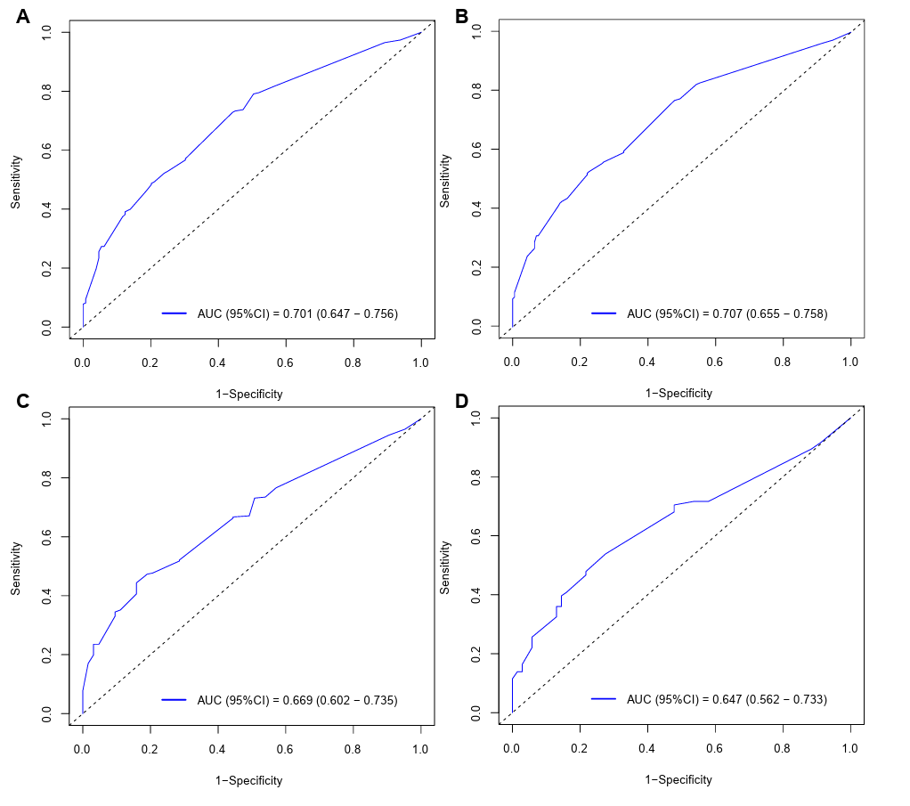
Supplementary Fig. 1 Receiver operating characteristic (ROC) curve for NER (A), NLR(B), PLR(C), and LMR (D).

