Supplemental file
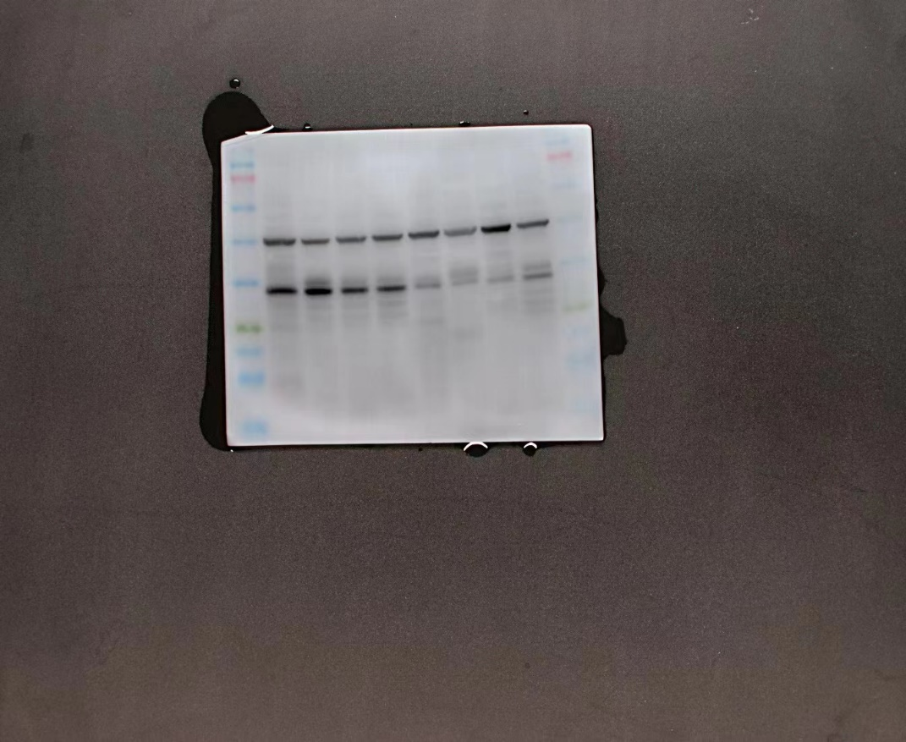
Figure S1 The blot image of NAT1.

