Supplementary table 1. Correlation analysis between smoking behavior and pulmonary function indexes
Pulmonary function | Age | P-value | BMI | P-value | Respiratory symptoms | P-value | Initial smoking age | P-value | Cigarettes /day | P-value | Smoking duration | P-value | Pack-years | P-value
VC%pre | -0.352 | ＜0.001 | 0.031 | 0.616 | -0.316 | ＜0.001 | 0.342 | ＜0.001 | -0.058 | 0.343 | -0.39 | ＜0.001 | -0.216 | ＜0.001
TLC%pre | -0.352 | ＜0.001 | 0.015 | 0.864 | -0.173 | 0.041 | 0.233 | 0.005 | -0.075 | 0.374 | -0.294 | ＜0.001 | -0.172 | 0.042
RV/TLC%pre | -0.094 | ＜0.001 | 0.133 | 0.117 | 0.132 | 0.12 | -0.279 | 0.001 | -0.055 | 0.517 | 0.06 | 0.479 | -0.029 | 0.733
FVC%pre | -0.359 | ＜0.001 | 0.022 | 0.724 | -0.352 | ＜0.001 | 0.396 | ＜0.001 | -0.052 | 0.394 | -0.417 | ＜0.001 | -0.229 | ＜0.001
FEV1%pre | -0.333 | ＜0.001 | 0.181 | 0.003 | -0.388 | ＜0.001 | 0.458 | ＜0.001 | -0.05 | 0.416 | -0.454 | ＜0.001 | -0.25 | ＜0.001
FEV1/FVC% | -0.317 | ＜0.001 | 0.338 | ＜0.001 | -0.367 | ＜0.001 | 0.412 | ＜0.001 | -0.01 | 0.865 | -0.427 | ＜0.001 | -0.215 | ＜0.001
FEV1/FVC%pre | -0.199 | ＜0.001 | 0.384 | ＜0.001 | -0.349 | ＜0.001 | 0.419 | ＜0.001 | -0.027 | 0.654 | -0.363 | ＜0.001 | -0.2 | 0.001
MMEF%pre | -0.35 | ＜0.001 | 0.186 | 0.002 | -0.354 | ＜0.001 | 0.405 | ＜0.001 | -0.106 | 0.081 | -0.454 | ＜0.001 | -0.299 | ＜0.001
DLCO%pre | -0.418 | ＜0.001 | 0.239 | 0.004 | -0.182 | 0.031 | 0.183 | 0.03 | 0.036 | 0.668 | -0.363 | ＜0.001 | -0.139 | 0.099
KCO%pre | -0.314 | ＜0.001 | 0.223 | 0.008 | -0.082 | 0.334 | 0.125 | 0.14 | 0.093 | 0.271 | -0.304 | ＜0.001 | -0.083 | 0.325
Types of pulmonary ventilation dysfuction | 0.373 | ＜0.001 | -0.092 | 0.13 | 0.283 | ＜0.001 | -0.495 | ＜0.001 | 0.038 | 0.529 | 0.406 | ＜0.001 | 0.237 | ＜0.001
GOLD stage | 0.264 | ＜0.001 | -0.218 | ＜0.001 | 0.365 | ＜0.001 | -0.571 | ＜0.001 | 0.011 | 0.861 | 0.434 | ＜0.001 | 0.231 | ＜0.001
Abbreviations: BMI, body mass index; GOLD, Global Initiative for Obstructive Lung Disease

Supplementary table 2. Regression analysis on influencing factors of pulmonary function indexes in COPD patients
PFTs | Variables | β | std.error | statistic | P-value | 95%CI
FEV1%pre | Age (years old) | -0.779 | 0.134 | -5.806 | ＜0.001 | (-1.043,-0.515)
FEV1%pre | BMI (kg/m²) | 1.243 | 0.412 | 3.018 | 0.003 | (0.432,2.054)
FEV1%pre | Presence of respiratory symptoms | -19.151 | 2.729 | -7.016 | ＜0.001 | (-24.524,-13.777)
FEV1%pre | No/one/≥two symptoms | -10.341 | 1.553 | -6.661 | ＜0.001 | (-13.398,-7.284)
FEV1%pre | Duration of respiratory symptoms (years) | -1.375 | 0.235 | -5.853 | ＜0.001 | (-1.837,-0.912)
FEV1%pre | Initial smoking age (years old) | 1.166 | 0.138 | 8.47 | ＜0.001 | (0.895,1.437)
FEV1%pre | Cigarettes/day | -0.077 | 0.095 | -0.815 | 0.416 | (-0.264,0.11)
FEV1%pre | Smoking duration (years) | -0.82 | 0.098 | -8.375 | ＜0.001 | (-1.013,-0.628)
FEV1%pre | Pack-years | -0.155 | 0.037 | -4.241 | ＜0.001 | (-0.227,-0.083)
FEV1/FVC% | Age (years old) | -0.41 | 0.074 | -5.501 | ＜0.001 | (-0.556,-0.263)
FEV1/FVC% | BMI (kg/m²) | 1.282 | 0.218 | 5.893 | ＜0.001 | (0.854,1.71)
FEV1/FVC% | Presence of respiratory symptoms | -9.837 | 1.525 | -6.451 | ＜0.001 | (-12.839,-6.835)
FEV1/FVC% | No/one/≥two symptoms | -5.076 | 0.872 | -5.824 | ＜0.001 | (-6.792,-3.36)
FEV1/FVC% | Duration of respiratory symptoms (years) | -0.641 | 0.132 | -4.854 | ＜0.001 | (-0.901,-0.381)
FEV1/FVC% | Initial smoking age (years old) | 0.579 | 0.078 | 7.424 | ＜0.001 | (0.425,0.732)
FEV1/FVC% | Cigarettes/day | -0.009 | 0.052 | -0.17 | 0.865 | (-0.112,0.094)
FEV1/FVC% | Smoking duration (years) | -0.426 | 0.055 | -7.763 | ＜0.001 | (-0.534,-0.318)
FEV1/FVC% | Pack-years | -0.074 | 0.02 | -3.616 | ＜0.001 | (-0.114,-0.034)
FEV1/FVC%pre | Age (years old) | -0.32 | 0.096 | -3.338 | 0.001 | (-0.508,-0.131)
FEV1/FVC%pre | BMI (kg/m²) | 1.815 | 0.266 | 6.833 | ＜0.001 | (1.292,2.338)
FEV1/FVC%pre | Presence of respiratory symptoms | -11.817 | 1.908 | -6.194 | ＜0.001 | (-15.573,-8.061)
FEV1/FVC%pre | No/one/≥two symptoms | -6.147 | 1.088 | -5.648 | ＜0.001 | (-8.29,-4.004)
FEV1/FVC%pre | Duration of respiratory symptoms (years) | -0.753 | 0.165 | -4.559 | ＜0.001 | (-1.078,-0.428)
FEV1/FVC%pre | Initial smoking age (years old) | 0.733 | 0.097 | 7.581 | ＜0.001 | (0.542,0.923)
FEV1/FVC%pre | Cigarettes/day | -0.029 | 0.065 | -0.449 | 0.654 | (-0.158,0.099)
FEV1/FVC%pre | Smoking duration (years) | -0.45 | 0.07 | -6.397 | ＜0.001 | (-0.589,-0.312)
FEV1/FVC%pre | Pack-years | -0.085 | 0.025 | -3.359 | 0.001 | (-0.135,-0.035)
MMEF%  pre | Age (years old) | -0.559 | 0.091 | -6.111 | ＜0.001 | (-0.739,-0.379)
MMEF%  pre | BMI (kg/m²) | 0.875 | 0.283 | 3.086 | 0.002 | (0.317,1.433)
MMEF%  pre | Presence of respiratory symptoms | -11.778 | 1.909 | -6.171 | ＜0.001 | (-15.536,-8.02)
MMEF%  pre | No/one/≥two symptoms | -6.138 | 1.087 | -5.645 | ＜0.001 | (-8.278,-3.997)
MMEF%  pre | Duration of respiratory symptoms (years) | -0.819 | 0.165 | -4.951 | ＜0.001 | (-1.145,-0.493)
MMEF%  pre | Initial smoking age (years old) | 0.703 | 0.097 | 7.248 | ＜0.001 | (0.512,0.893)
MMEF%  pre | Cigarettes/day | -0.113 | 0.065 | -1.75 | 0.081 | (-0.24,0.014)
MMEF%  pre | Smoking duration (years) | -0.558 | 0.067 | -8.33 | ＜0.001 | (-0.69,-0.426)
MMEF%  pre | Pack-years | -0.126 | 0.025 | -5.114 | ＜0.001 | (-0.175,-0.078)
TLC%pre | Age (years old) | -0.469 | 0.106 | -4.437 | ＜0.001 | (-0.679,-0.26)
TLC%pre | BMI (kg/m²) | 0.056 | 0.326 | 0.171 | 0.864 | (-0.588,0.7)
TLC%pre | Presence of respiratory symptoms | -5.159 | 2.243 | -2.3 | 0.023 | (-9.593,-0.724)
TLC%pre | No/one/≥two symptoms | -2.522 | 1.272 | -1.983 | 0.049 | (-5.036,-0.007)
TLC%pre | Duration of respiratory symptoms (years) | -0.443 | 0.172 | -2.577 | 0.011 | (-0.784,-0.103)
TLC%pre | Initial smoking age (years old) | 0.315 | 0.112 | 2.822 | 0.005 | (0.094,0.536)
TLC%pre | Cigarettes/day | -0.061 | 0.068 | -0.892 | 0.374 | (-0.196,0.074)
TLC%pre | Smoking duration (years) | -0.295 | 0.081 | -3.631 | ＜0.001 | (-0.456,-0.134)
TLC%pre | Pack-years | -0.057 | 0.028 | -2.053 | 0.042 | (-0.112,-0.002)
RV/TLC%pre | Age (years old) | -0.215 | 0.194 | -1.11 | 0.269 | (-0.598,0.168)
RV/TLC%pre | BMI (kg/m²) | 0.878 | 0.556 | 1.579 | 0.117 | (-0.222,1.977)
RV/TLC%pre | Presence of respiratory symptoms | 6.592 | 3.895 | 1.693 | 0.093 | (-1.108,14.292)
RV/TLC%pre | No/one/≥two symptoms | 3.618 | 2.199 | 1.645 | 0.102 | (-0.73,7.967)
RV/TLC%pre | Duration of respiratory symptoms (years) | 0.42 | 0.301 | 1.396 | 0.165 | (-0.175,1.016)
RV/TLC%pre | Initial smoking age (years old) | -0.649 | 0.19 | -3.419 | 0.001 | (-1.024,-0.274)
RV/TLC%pre | Cigarettes/day | -0.077 | 0.118 | -0.649 | 0.517 | (-0.31,0.157)
RV/TLC%pre | Smoking duration (years) | 0.104 | 0.146 | 0.71 | 0.479 | (-0.185,0.393)
RV/TLC%pre | Pack-years | -0.017 | 0.049 | -0.342 | 0.733 | (-0.113,0.08)
DLCO%  pre | Age (years old) | -0.976 | 0.18 | -5.427 | 0 | (-1.332,-0.62)
DLCO%  pre | BMI (kg/m²) | 1.61 | 0.554 | 2.907 | 0.004 | (0.515,2.706)
DLCO%  pre | Presence of respiratory symptoms | -7.347 | 3.953 | -1.859 | 0.065 | (-15.163,0.468)
DLCO%  pre | No/one/≥two symptoms | -5.305 | 2.213 | -2.397 | 0.018 | (-9.681,-0.929)
DLCO%  pre | Duration of respiratory symptoms (years) | -0.533 | 0.305 | -1.748 | 0.083 | (-1.137,0.07)
DLCO%  pre | Initial smoking age (years old) | 0.433 | 0.198 | 2.189 | 0.03 | (0.042,0.823)
DLCO%  pre | Cigarettes/day | 0.052 | 0.12 | 0.43 | 0.668 | (-0.186,0.289)
DLCO%  pre | Smoking duration (years) | -0.637 | 0.139 | -4.587 | 0 | (-0.911,-0.362)
DLCO%  pre | Pack-years | -0.081 | 0.049 | -1.659 | 0.099 | (-0.178,0.016)
Abbreviations: COPD, chronic obstructive pulmonary disease; PFTs, pulmonary function tests; BMI, body mass index; CI, confidence interval

Supplementary table 3: Regression analysis on influencing factors of GOLD stage in COPD patients
GOLD stage | I | II | III | IV | statistic | P-value
Age (years old) | 60.86±11.41 | 64.01±10.3 | 69.27±8.52 | 67.61±7.44 | 10.042 | ＜0.001
BMI (kg/m2) | 22.78±2.75 | 23.1±3.34 | 22.38±3.43 | 20.55±3.73 | 6.256 | ＜0.001
With/without symptoms |  |  |  |  | 14.38 | ＜0.001
No | 48(85.7) | 66(75.9) | 40(48.2) | 18(39.1)
Yes | 8(14.3) | 21(24.1) | 43(51.8) | 28(60.9)
No/one/≥two symptoms |  |  |  |  | 13.631 | ＜0.001
0 | 48(85.7) | 66(75.9) | 40(48.2) | 18(39.1)
1 | 3(5.4) | 7(8) | 17(20.5) | 6(13)
≥2 | 5(8.9) | 14(16.1) | 26(31.3) | 22(47.8)
Duration of respiratory symptoms (years) | 1.04±3.09 | 2.38±5.91 | 4.66±6.12 | 6.11±5.74 | 9.648 | ＜0.001
Initial smoking age (years old) | 29±11.28 | 25±8.52 | 18.72±6.03 | 17.17±5.94 | 27.062 | ＜0.001
Cigarettes/day | 26.88±11.78 | 29.85±15.48 | 28.55±14.26 | 29.46±19.07 | 0.478 | 0.698
Smoking duration (years) | 32.07±12.09 | 37.53±11.31 | 46.87±12.58 | 46.83±9.59 | 24.52 | ＜0.001
Pack-years | 43.79±25.39 | 55.5±34.34 | 67.9±40.62 | 67.85±45.79 | 5.899 | 0.001
Abbreviations: GOLD, Global Initiative for Obstructive Lung Disease; COPD, chronic obstructive pulmonary disease; BMI, body mass index

Supplementary table 4. Comparison of clinical characteristics between COPD patients with and without PH
Clinical features, PFTs and echocardiographic data | All（n=272） | Pulmonary hypertension |  | Statistic | P-value
Clinical features, PFTs and echocardiographic data | All（n=272） | No（n=101） | Yes（n=54） | Statistic | P-value
Age (years old) | 66.88±9.91 | 64.94±9.54 | 70.5±9.66 | -3.442 | 0.001
BMI (kg/m2) | 22.67±3.54 | 23.24±3.39 | 21.61±3.61 | 2.79 | 0.006
Respiratory symptoms |  |  |  | 13.615 | ＜0.001
No | 83(53.5) | 65(64.4) | 18(33.3)
Yes | 72(46.5) | 36(35.6) | 36(66.7)
Number of respiratory symptoms |  |  |  | 13.615 | 0.001
0 | 83(53.5) | 65(64.4) | 18(33.3)
1 | 24(15.5) | 12(11.9) | 12(22.2)
≥ 2 | 48(31) | 24(23.8) | 24(44.4)
Duration of respiratory symptoms (years) | 4.51±6.38 | 3.2±5.33 | 6.96±7.42 | -3.3 | 0.001
Initial smoking age (years old) | 21.98±9.43 | 22.79±9.27 | 20.46±9.62 | 1.471 | 0.143
Cigarettes/day | 28.88±15.79 | 29.71±13.78 | 27.31±19.03 | 0.9 | 0.369
Smoking duration (years) | 42.51±13.18 | 40.01±12.59 | 47.19±13.09 | -3.334 | 0.001
Pack-years | 62.15±41.87 | 61.21±37.04 | 63.91±50.02 | -0.382 | 0.703
VC (L) | 2.75±0.83 | 2.94±0.84 | 2.39±0.7 | 4.098 | ＜0.001
VC%pre | 72.7±18.63 | 75.38±18.15 | 67.67±18.65 | 2.497 | 0.014
RV%pre | 116.45±28.81 | 117.47±27.09 | 114.78±31.72 | 0.457 | 0.648
TLC%pre | 83.19±13.78 | 85.52±13.13 | 79.44±14.16 | 2.204 | 0.03
RV/TLC%pre | 138.22±23.15 | 137.6±22.25 | 139.22±24.82 | -0.343 | 0.732
FVC (L) | 2.58±0.87 | 2.79±0.87 | 2.19±0.7 | 4.667 | ＜0.001
FVC%pre | 71.35±20.49 | 74.7±20.16 | 65.06±19.78 | 2.855 | 0.005
FEV1 (L) | 1.48±0.77 | 1.67±0.79 | 1.13±0.6 | 4.762 | ＜0.001
FEV1%pre | 51.63±23.31 | 56.15±23.2 | 43.19±21.25 | 3.41 | 0.001
FEV1/FVC% | 54.59±12.28 | 57.29±12 | 49.55±11.26 | 3.906 | ＜0.001
FEV1/FVC%pre | 70.59±15.62 | 73.93±15.08 | 64.32±14.78 | 3.806 | ＜0.001
PEF%pre | 48.47±22.36 | 51.42±22.78 | 42.95±20.63 | 2.276 | 0.024
PEF25%pre | 31.78±23.27 | 35.8±24.85 | 24.25±17.85 | 3.334 | 0.001
PEF50%pre | 24.62±18.59 | 28.77±19.99 | 16.85±12.49 | 4.559 | ＜0.001
PEF75%pre | 29.35±16.65 | 30.72±15.26 | 26.75±18.9 | 1.41 | 0.161
MMEF%pre | 25.7±15.3 | 28.14±16.25 | 21.1±12.21 | 3.013 | 0.003
DLCO%pre | 69.31±23.69 | 77.09±22.36 | 56.74±20.34 | 4.622 | ＜0.001
KCO%pre | 77.22±21.39 | 83.39±20.66 | 67.25±18.84 | 3.963 | ＜0.001
Bronchodilator reversibility |  |  |  | 1.267 | 0.737
Suspicious positive | 16(10.3) | 10(9.9) | 6(11.1)
Positive | 13(8.4) | 9(8.9) | 4(7.4)
Negative | 81(52.3) | 50(49.5) | 31(57.4)
Types of pulmonary ventilation dysfuction |  |  |  | 5.158 | 0.023
Obstructive | 62(40) | 47(46.5) | 15(27.8)
Mixed | 93(60) | 54(53.5) | 39(72.2)
GOLD stage |  |  |  | 13.749 | 0.003
I | 26(16.8) | 21(20.8) | 5(9.3)
II | 42(27.1) | 31(30.7) | 11(20.4)
III | 56(36.1) | 37(36.6) | 19(35.2)
IV | 31(20) | 12(11.9) | 19(35.2)
Left atrium diameter (mm) | 35.03±4.67 | 35.09±4.06 | 34.91±5.67 | 0.208 | 0.835
Interventricular septal thickness (mm) | 9.88±1.69 | 9.86±1.6 | 9.91±1.86 | -0.161 | 0.872
Systolic pulmonary artery pressure (mmHg) | 36.28±12.97 | 29.16±4.36 | 49.61±13.24 | -11.038 | ＜0.001
Left ventricular ejection fractions (%) | 0.65±0.05 | 0.65±0.04 | 0.65±0.06 | 0.517 | 0.606
Abbreviations: COPD, chronic obstructive pulmonary disease; PH, pulmonary hypertention; PFTs, pulmonary function tests; BMI, body mass index; GOLD, Global Initiative for Obstructive Lung Disease

Supplementary table 5. Correlation analysis between clinical variables or smoking behavior and echocardiographic data
Echocardiographic data | Age | P-value | Respiratory symptoms | P-value | Duration of symptoms | P-value | Smoking duration | P-value | GOLD stage | P-value
Left atrium diameter (mm) | 0.108 | 0.183 | -0.245 | 0.002 | -0.125 | 0.122 | 0.018 | 0.822 | -0.187 | 0.02
Interventricular septal thickness (mm) | 0.113 | 0.161 | -0.116 | 0.152 | -0.038 | 0.637 | 0.056 | 0.489 | -0.135 | 0.094
Systolic pulmonary artery pressure (mmHg) | 0.261 | 0.001 | 0.312 | ＜0.001 | 0.377 | ＜0.001 | 0.223 | 0.005 | 0.248 | 0.002
Left ventricular ejection fractions (%) | -0.106 | 0.188 | -0.103 | 0.2 | 0.032 | 0.697 | -0.04 | 0.624 | -0.07 | 0.385
 | VC%pre | P-value | FVC%pre | P-value | FEV1%pre | P-value | FEV1/FVC% | P-value | FEV1/FVC%pre | P-value
Left atrium diameter (mm) | 0.102 | 0.205 | 0.077 | 0.339 | 0.195 | 0.015 | 0.277 | ＜0.001 | 0.337 | ＜0.001
Interventricular septal thickness (mm) | 0.03 | 0.709 | 0.022 | 0.782 | 0.125 | 0.121 | 0.211 | 0.008 | 0.262 | 0.001
Systolic pulmonary artery pressure (mmHg) | -0.248 | 0.002 | -0.237 | 0.003 | -0.278 | ＜0.001 | -0.335 | ＜0.001 | -0.327 | ＜0.001
Left ventricular ejection fractions (%) | 0.106 | 0.188 | 0.159 | 0.049 | 0.123 | 0.128 | 0.056 | 0.49 | 0.03 | 0.711
Abbreviations: GOLD, Global Initiative for Obstructive Lung Disease

Supplementary table 6. Regression analysis on influencing factors of systolic pulmonary artery pressure in COPD patients
Systolic pulmonary artery pressure | β | std.error | Statistic | P-value | 95%CI
Age (years old) | 0.341 | 0.102 | 3.339 | 0.001 | (0.139,0.543)
BMI (kg/m²) | -0.963 | 0.285 | -3.373 | 0.001 | (-1.527,-0.399)
Presence of respiratory symptoms | 8.626 | 1.976 | 4.364 | ＜0.001 | (4.721,12.53)
No/one/≥two symptoms | 4.687 | 1.11 | 4.222 | ＜0.001 | (2.494,6.88)
Duration of respiratory symptoms (years) | 0.767 | 0.152 | 5.032 | ＜0.001 | (0.466,1.068)
Initial smoking age (years old) | -0.136 | 0.111 | -1.228 | 0.221 | (-0.355,0.083)
Cigarettes/day | 0.018 | 0.066 | 0.274 | 0.784 | (-0.113,0.149)
Smoking duration (years) | 0.219 | 0.078 | 2.825 | 0.005 | (0.066,0.372)
Pack-years | 0.033 | 0.025 | 1.322 | 0.188 | (-0.016,0.082)
VC%pre | -0.173 | 0.055 | -3.166 | 0.002 | (-0.28,-0.065)
TLC%pre | -0.114 | 0.086 | -1.332 | 0.186 | (-0.285,0.056)
RV/TLC%pre | 0.038 | 0.051 | 0.748 | 0.456 | (-0.064,0.14)
FVC%pre | -0.15 | 0.05 | -3.022 | 0.003 | (-0.248,-0.052)
FEV1%pre | -0.155 | 0.043 | -3.575 | ＜0.001 | (-0.24,-0.069)
FEV1/FVC% | -0.353 | 0.08 | -4.393 | ＜0.001 | (-0.512,-0.194)
FEV1/FVC%pre | -0.272 | 0.063 | -4.279 | ＜0.001 | (-0.397,-0.146)
MMEF%pre | -0.216 | 0.067 | -3.223 | 0.002 | (-0.349,-0.084)
DLCO%pre | -0.189 | 0.047 | -4.038 | ＜0.001 | (-0.281,-0.096)
Types of pulmonary ventilation dysfuction | 4.855 | 2.097 | 2.315 | 0.022 | (0.712,8.998)
GOLD stage | 3.877 | 1.01 | 3.838 | ＜0.001 | (1.881,5.872)
Abbreviations: COPD, chronic obstructive pulmonary disease; BMI, body mass index; GOLD, Global Initiative for Obstructive Lung Disease; CI, confidence interval

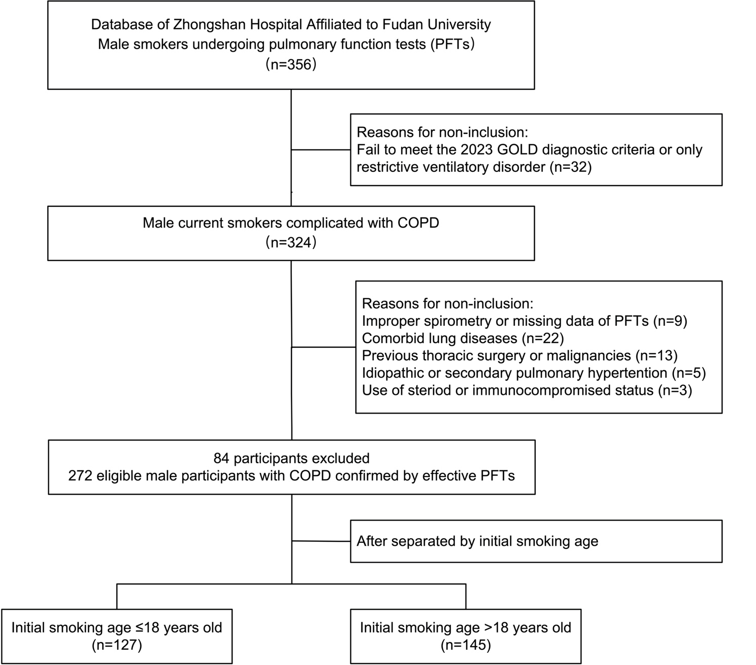
Supplementary figure 1. Patient enrollment.
Abbreviations: PFTs, pulmonary function tests; GOLD, Global Initiative for Obstructive Lung Disease; COPD, chronic obstructive pulmonary disease

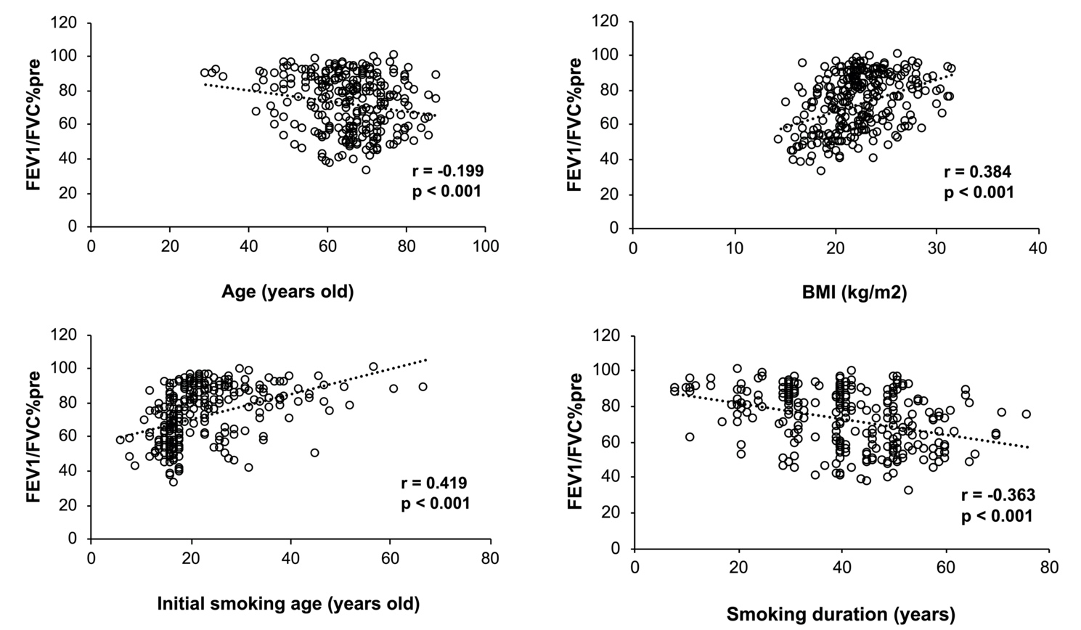
Supplementary figure 2. The correlations between FEV1/FVC%pre and clinical characteristics.
Abbreviations: BMI, body mass index

