Supplementary Material

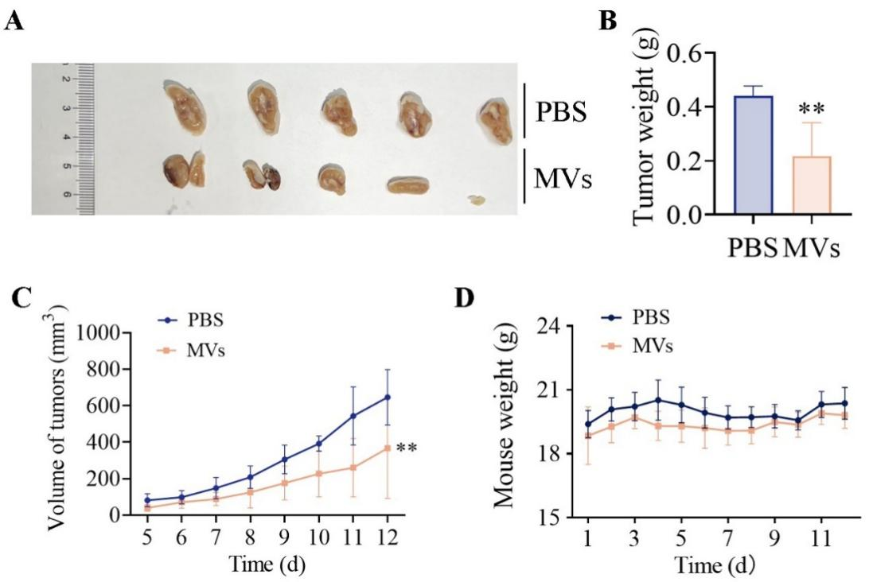
Supplementary Figure 1. Antitumor activity of S. aureus MVs in vivo. BALB/c female mice were subcutaneously injected with CT26 cells at day 0, and intravenously injected with 5 μg of bacterial MVs at day 1, then MV-treatment was performed once every other day up to 11 days. (A) Tumor images and (B) weights harvested at day 11 posttreatment with MVs. (C) Tumor volumes of mice bearing CT26 tumor measured after tumor formation. (D) Variation of body weight of tumor-bearing mice during MV-treatment. Data in B–D are presented as mean ± SD. Statistical significance was calculated via t-test or two-way ANOVA. **p < 0.01.

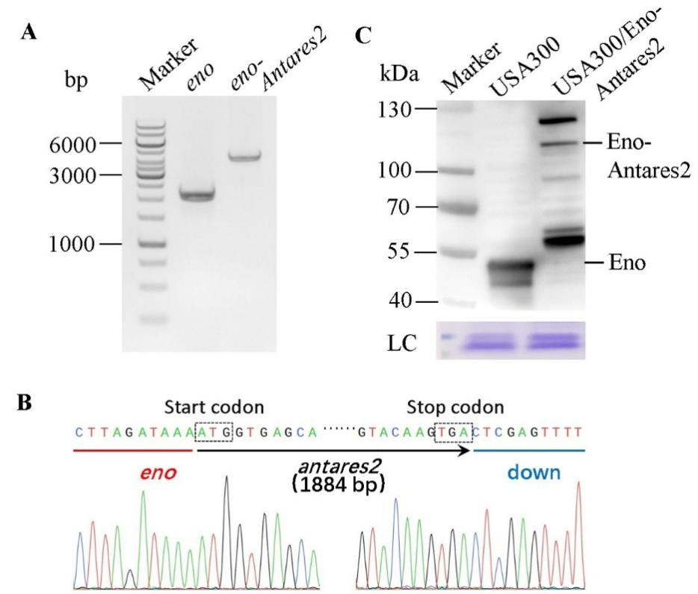
Supplementary Figure 2. Construction of luciferase Antares2–MV-produced S. aureus strain. (A) PCR products of eno and eno-Antares2 analyzed with 1% (w/v) agarose gel electrophoresis. (B) Identification of USA300/Eno-Antares2 strain by DNA sequencing. The target Antares2 gene was in-frame fused with eno in the chromosome of S. aureus USA300. (C) Western blot analysis of Eno–Antares2 produced by USA300/Eno-Antares2. SDS-PAGE gel stained with Coomassie brilliant blue was used as loading control (LC). The size of protein marker is presented on the left.

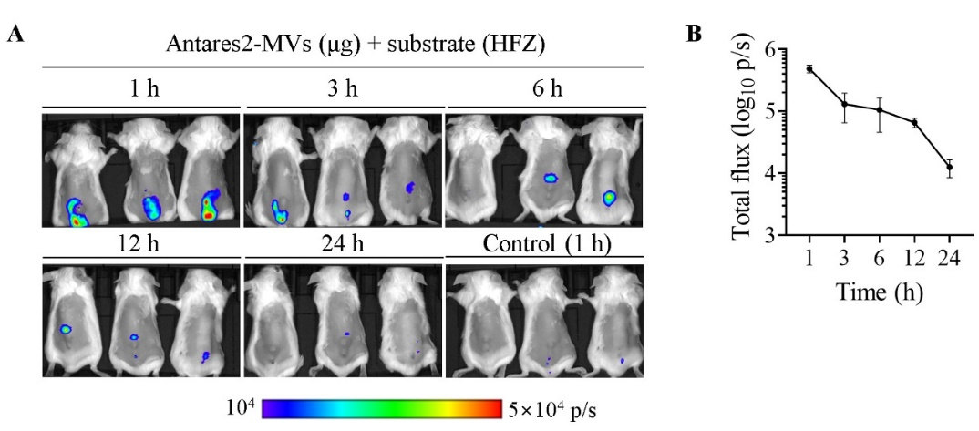
Supplementary Figure 3. Accumulation of MVs in tumor tissues. (A) Bioluminescence signals of the treated mice. CT26 tumor-bearing mice (n = 3) were intravenously injected with 5 μg Antares2–MVs and 100 μmol HFZ substrate. Injection of PBS served as controls. The bioluminescence signals from mice were detected at the time indicated. (B) Total photon flux changed over time. Data are presented as mean ± SEM. HFZ, hydrofurimazine.

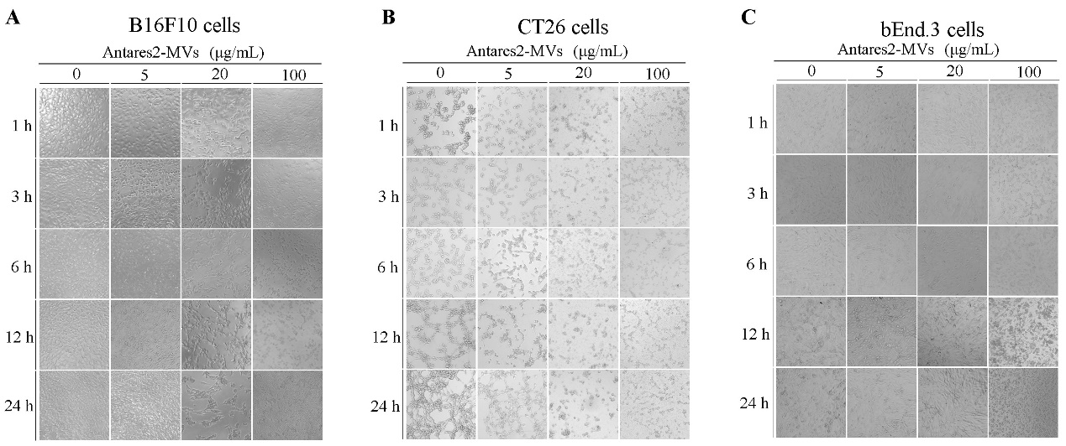
Supplementary Figure 4. S. aureus MVs killed tumor cells in vitro. The viability of (A) B16F10, (B) CT26, and (C) bEnd.3 cells. Cells were treated with various concentrations of MVs (0, 5, 20, and 100 μg/mL) for 1, 3, 6, 12, and 24 h, respectively (n = 3 for each group). PBS treatment served as controls (0).

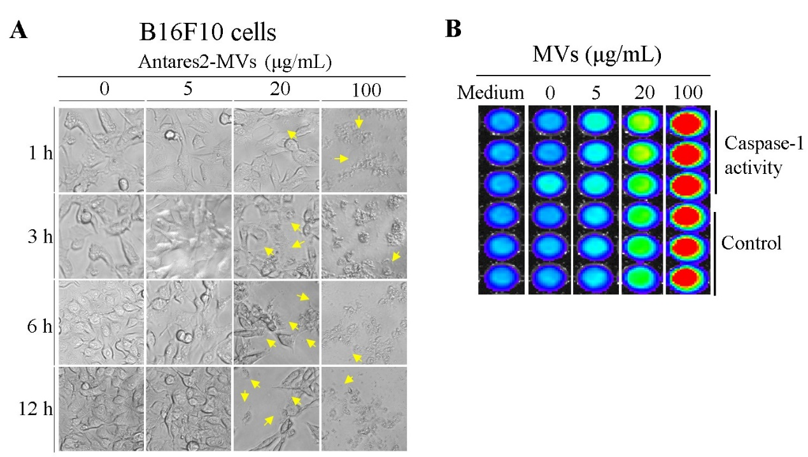
Supplementary Figure 5. Antitumor activity of S. aureus MVs depended on caspase-1 activation. (A) The pyrogenic cells observed after treatment with S. aureus MVs. B16F10 cells were treated with increasing concentrations of S. aureus MVs for the indicated time, and the photographs were taken. The pyrogenic cells were indicated with yellow arrows. (B) Detection of caspase-1 activity. B16F10 cells were incubated with 0, 5, 20 and 100 µg/mL of S. aureus MVs for 8 h, and the active caspase-1 in culture supernatant was detected with a kit of Caspase-Glo® 1 Inflammasome Assay. PBS was used as control.

