Supplementary Appendix

HMGB1 expression levels correlate with response to immunotherapy in non-small cell lung cancer levels
Maria González-Cao¹, Xueting Cai², Jillian Wilhelmina Paulina Bracht³, Xuan Han², Yang Yang², Carlos Pedraz-Valdunciel⁴, Teresa Morán⁵, Javier García-Corbacho⁶, Andrés Aguilar¹, Reyes Bernabé⁷, Pedro De Marchi^{8,9}, Luciane Sussuchi da Silva¹⁰, Leticia Ferro Leal^{8,9}, Rui Manuel Reis^{10,11}, Jordi Codony-Servat⁴, Eloisa Jantus-Lewintre^{12,13,14}, Miguel Angel Molina-Vila⁴, Peng Cao^{2,15}*, Rafael Rosell1^{1,16,17}*

¹Translational Cancer Research Unit, Instituto Oncológico Dr Rosell, Dexeus University Hospital, Barcelona, Spain; ²Integrated Traditional Chinese and Western Medicine Department of Affiliated Hospital, Nanjing University of Chinese Medicine, Nanjing, Jiangsu, China; ³Amsterdam University Medical Center (UMC), Amsterdam, The Netherlands; ⁴Laboratory of Oncology, Pangaea Oncology, Quirón Dexeus University Hospital, Barcelona, Spain; ⁵Medical Oncology Department, Catalan Institute of Oncology (ICO), Germans Trias i Pujol Hospital, Badalona, Spain; ⁶Medical Oncology Department (Hospital Clinic)/Translational Genomics and Targeted Therapies in Solid Tumors (IDIBAPs), Barcelona, Spain; ⁷Medical Oncology Department, Hospital Universitario Virgen del Rocío, Sevilla, Spain; ⁸Molecular Oncology Research Center; Barretos Cancer Hospital, Barretos, Brazil; ⁹Oncoclinicas, Rio de Janeiro, Brazil; ¹⁰Life and Health Sciences Research Institute (ICVS), School of Medicine, University of Minho, Braga, Portugal; ¹¹ICVS/3B’s – PT Government Associate Laboratory, Braga/Guimarães, Portugal; ¹²Valencian Community Foundation Principe Felipe Research Center, Laboratory of Molecular Oncology, Valencia, Spain; ¹³Centro de Investigación Biomédica en Red (CIBERONC), Madrid, Spain; ¹⁴Universitat Politècnica de Valencia, Biotechnology Department, Valencia, Spain; ¹⁵College of Pharmacy, Nanjing Univ. of Chinese Medicine, Nanjing, Jiangsu, China; ¹⁶Germans Trias i Pujol Health Sciences Institute and Hospital (IGTP), Badalona, Spain; ¹⁷Catalan Institute of Oncology, Badalona, Spain

*Co-corresponding authors:
Rafael Rosell, MD, PhD. Laboratory of Molecular Biology, Germans Trias i Pujol Health Sciences Institute and Hospital (IGTP). Camí de les Escoles, s/n, 08916 Badalona, Barcelona, Spain. Phone: +34 930330520; Email: rrosell@iconcologia.net

Peng Cao, PhD. College of Pharmacy, Nanjing University of Chinese Medicine, Nanjing 210023, China. Phone: +86 85608666; Email: cao_peng@njucm.edu.cn

Background and Rationale
The DURVAST trial demonstrated a good safety profile and feasibility of durvalumab, an anti PD-L1 antibody, in the treatment of patients with solid tumors and HIV-1 infection. In the study most patients included had lung cancer (14 from 20 patients included). All patients had basal undetectable viral plasma load and all continued their antiretroviral (ART) treatment without toxicity. The study demonstrated a cancer control rate of 50% despite the fact that 60% of patients were previously pretreated.¹ Fourteen patients were on treatment with ART that included an INSTIs, and six patients were on treatment with ART combinations without INSTIs. An exploratory analysis demonstrated a significant longer duration of clinical benefit in patients that were under treatment with ART including an INSTI (median NR vs 2.3 months, p=0.036) (Table S1).

Methods
Ethical approval for this study was obtained from the ethics committee “CEIm Grupo Hospitalario Quirónsalud” (acta nº17/2020; 2020/123-ONC-DEX). The study includes clinical data and samples retrospectively obtained from cancer patients treated with anti PD-1/ PD-L1 antibodies. The cohort of patients with HIV-1 infection had been treated into a multicenter prospective phase 2 trial (DURVAST trial, NCT03094286). The cohort of cancer patients non –HIV infected includes patients treated at Hospital Universitari Dexeus (Barcelona, Spain) from April 2016 to May 2020. Samples consisted of tumor tissue archival paraffin-embedded slides and blood samples obtained before treatment initiation. Written informed consent was obtained from each patient.
Data about patient characteristics, tumor type, molecular sub-classification, and response to therapy according to RECIST 1.1 criteria was recorded from 45 patients (15 with HIV-1 infection and 30 non-HIV infected). All HIV-1 infected patients comprised HIV-1 infected persons under effective cART with advanced solid tumors in which anti PD-1/PD-L1 antibodies had an approved indication or data of antitumoral activity. They were treated with durvalumab at the fixed-dose of 1500 mg every four weeks until disease progression or unacceptable toxicity. Non-HIV-1 infected patients were treated with currently approved anti PD-1/PD-L1 antibodies according to standard of care. An external validation cohort included patients with metastatic NSCLC treated with anti PD-1/PD-L1 antibodies from Barretos Cancer Hospital, Barretos, Brazil. The study was conducted in accordance with the declaration of Helsinki and international conference on harmonization guidelines for good clinical practice.

Table S1. Molecular classification of tumors by NGS/qRT-PCR. NE: non evaluable (untested); ¹Germline mutation; ²Variant of unknown significance; ³Variant unknown; amp: amplification; transl: translocation; CNV: copy number variation.
Patient Nr | Tumor | Mutations |  |  |  |  |  | CNVs
Patient Nr | Tumor | KRAS | EGFR | BRAF | NRAS | STK11 | TP53
1 | Lung | G12C | WT | WT | WT | splicing | R248L | -
2 | Lung | WT | WT | WT | WT | WT | R273L | HER2 amp
3 | Lung | WT | WT | WT | WT | E165* | K132* | -
4 | Lung | G12C | WT | G596R | WT | WT | R248L | -
5 | Lung | G12V | WT | WT | WT | WT | C177F | -
6 | Lung | NE | NE | NE | NE | NE | NE | -
7 | Lung | Q61H | WT | WT | WT | P281fs*6 | WT | -
8 | Lung | G12F | WT | WT | WT | WT | WT | -
9 | Lung | WT | WT | WT | WT | WT | WT | -
10 | Lung | WT | WT | WT | NE | NE | NE | -
11 | Lung | WT | WT | WT | WT | WT | WT | -
12 | Lung | G12V | WT | WT | WT | WT | G245C  /V157I¹ | -
13 | Bladder | WT | WT | WT | NE | NE | NE | -
14 | Melanoma | WT | WT | WT | WT | WT | WT | -
15 | Melanoma | WT | WT | V600E | WT | WT | WT | -
16 | Lung | WT | WT | WT | NE | NE | NE | -
17 | Lung | WT | WT | WT | WT | WT | WT | -
18 | Lung | NE | NE | NE | NE | NE | NE | -
19 | Lung | WT | WT | WT | WT | WT | WT | FGFR1 amp
20 | Lung | WT | WT | WT | WT | WT | WT | EGFR amp, HER2 amp
21 | Mesothelioma | WT | WT | V600E | WT | WT | WT | -
22 | Lung | G12D | WT | WT | WT | WT | WT | -
23 | Lung | WT | WT | NE | NE | NE | NE | -
24 | Lung | G12C | WT | NE | NE | NE | WT | -
25 | Lung | WT | WT | WT | WT | WT | WT | MET amp
26 | Lung | WT | WT | WT | WT | WT | WT | RET amp
27 | Lung | NE | WT | WT | WT | WT | WT | -
28 | Lung | NE | NE | NE | NE | NE | NE | -
29 | Lung | WT | NE | WT | WT | WT | WT | -
30 | Lung | NE | NE | NE | NE | NE | NE | -
31 | Lung | NE | NE | NE | NE | NE | NE | -
32 | Lung | WT | WT | WT | WT | WT | R273C | -
33 | Lung | NE | WT | NE | NE | NE | NE | -
34 | Lung | G12A | NE | NE | NE | NE | NE | MET amp
35 | Lung | G12C | WT | WT | WT | WT | WT | -
36 | Lung | WT | WT | WT | NE | NE | NE | -
37 | Lung | G12V | WT | NE | NE | NE | NE | -
38 | Lung | NE | WT | WT | NE | NE | NE | -
39 | Lung | WT | WT | NE | NE | NE | NE | MET amp
40 | Lung | WT | WT | WT | WT | WT | WT | EGFR amp  ROS1 transl
41 | Lung | G12A/  G12D | WT | NE | NE | NE | NE | -
42 | Lung | G12C | WT | WT | NE | NE | NE | -
43 | Lung | WT | WT | NE | NE | NE | NE | -
44 | Lung | NE | WT | NE | NE | NE | NE | -
45 | Lung | WT | WT | K601N  /P632S² | WT | WT | WT | -

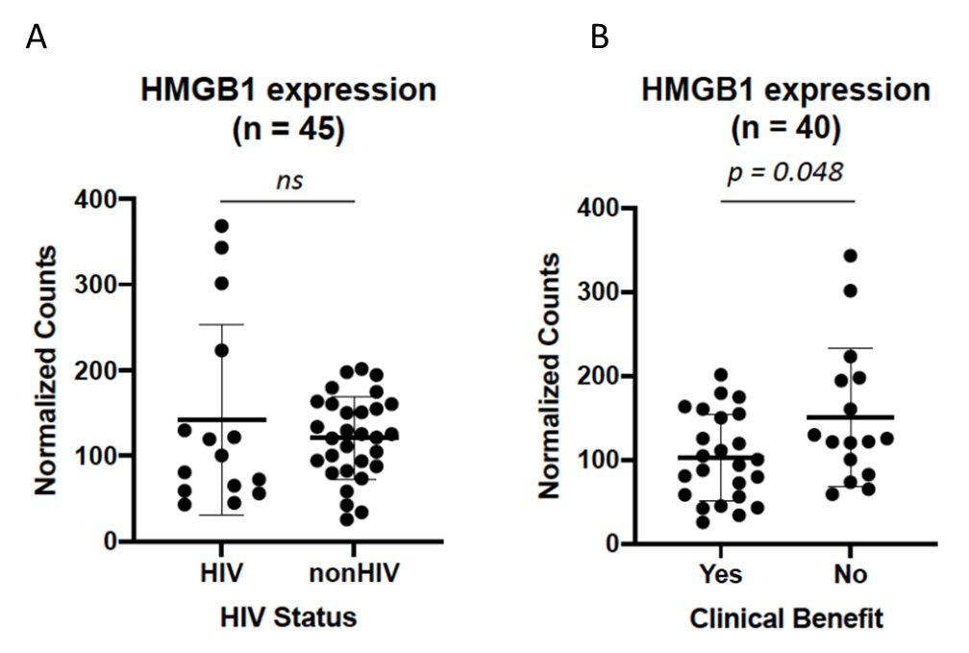

Figure S1. A) Normalized HMGB1 mRNA counts in patients with and without HIV-1 infection (n=45, Mann-Whitney U test, p = 0.609). B) Normalized HMGB1 mRNA counts in patients with and without clinical benefit (objective response or stable disease for more than 24 weeks by RECISTS 1.1 criteria) from ICI-treatment (n = 40, Mann-Whitney U test, p = 0.048).

Figure. S2. Differential expression of HMGB1 in pre-ICI-treatment FFPE tumor tissue samples in patients with and without clinical benefit. A) Normalized HMGB1 mRNA counts in nonHIV-1 infected patients with and without clinical benefit (objective response or stable disease for more than 24 weeks by RECISTS 1.1 criteria) from ICI-treatment (n = 26). B) Normalized HMGB1 mRNA counts in HIV-1 infected patients with and without clinical benefit from ICI-treatment (n = 14). CB:clinical benefit; ns: not significant.

Figure. S3. Transcriptomic analysis of plasma extracellular vesicles (EV) from cancer patients indicates no exosomal expression of the HMGB1 gene. A) Total number of genes detected in EVs isolated from cancer patients (min = 16; max = 313). B) Expression of control genes (UBB, SF3A1, OAZ1, G6PD and ERCC3) compared to HMGB1. No expression was found for HGMB1, while different expression rates were found for the control genes, validating the performance of the nCounter runs.

Figure. S4. HMGB1 concentration in plasma from cancer patients measured by enzyme-linked immunosorbent assay (ELISA). A) HMGB1 levels were measured in patients with and without clinical benefit from ICI treatment. No statistical significant difference on HMGB1 expression was found between cohorts (Mann Witney test). B) Table showing the different statistical parameters of the Mann Whitney test applied to our dataset.

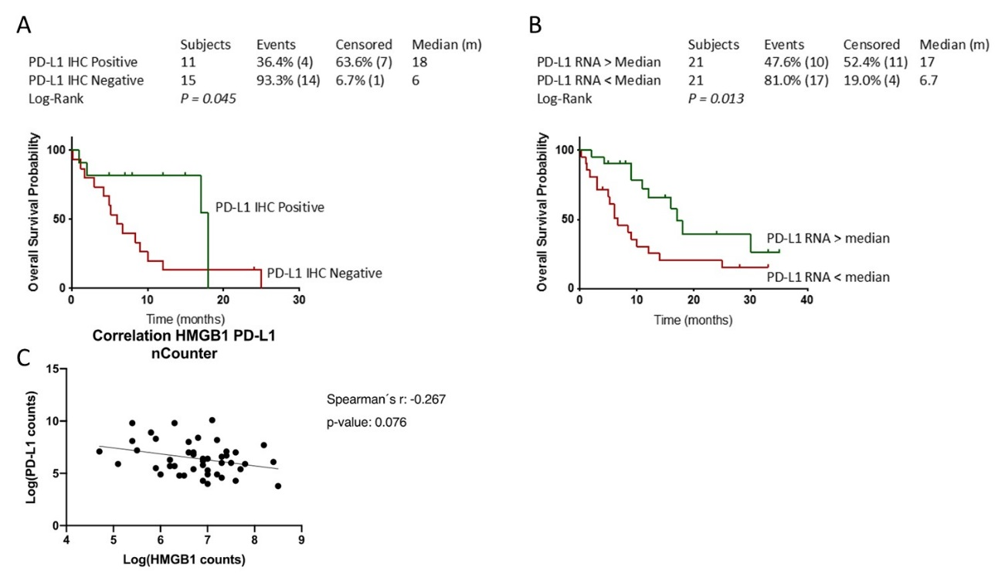

Figure. S5. A) Kaplan Meier analysis of the overall survival (OS) based on PD-L1 expression by IHC (left, n = 26, log-rank p = 0.045) and B) PD-L1 mRNA expression higher or lower than the median (right, n = 42, log-rank p = 0.013). C) Correlation between PD-L1 and HMGB1 RNA expression levels (log₂ normalized counts). Spearman´s correlation coefficient and p-value are indicated.

