Table S1. Material composition of all prepared transdermal nanocarriers formulation.
Group | Tween 80 (wt%) | Limonene (wt%) | D.D Water (wt%)
TD-71 | 70 | 10 | 20
TD-41 | 40 | 10 | 50
TD-11 | 10 | 10 | 80
TD-12 | 10 | 20 | 70
TD-13 | 10 | 30 | 60
TD-14 | 10 | 40 | 50
TD-15 | 10 | 50 | 40
TD-16 | 10 | 60 | 30
TD-18 | 10 | 80 | 10
Abbreviations: TD = transdermal nanocarriers

Table S2 Nano emulsion system of transdermal nanocarrier formula.
Group | Size (nm) |  |  | PDI |  | Zeta (mV) |  | T:L (wt%) |  | Appearance
TD-71 | X |  |  | X |  | X |  | 1:0.14 |  | Precipitate
TD-41 | 94.6 $±$ 0.79 |  |  | 0.547 $±$ 0.01 |  | -7.13 $±$ 0.32 |  | 1:0.25 |  | Light milky
TD-11 | 202.7 $±$ 6.79 |  |  | 0.452 $±$ 0.02 |  | -12.7 $±$ 0.40 |  | 1:1 |  | Light milky
TD-12 | 187.5 $±$ 4.01 |  |  | 0.282 $±$ 0.03 |  | -14.8 $±$ 0.30 |  | 1:2 |  | Milky
TD-13 | 415.8 $±$ 7.25 |  |  | 0.492 $±$ 0.01 |  | -13.5 $±$ 0.57 |  | 1:3 |  | Light milky
TD-14 | 333.0 $±$ 16.55 |  |  | 0.448 $±$ 0.01 |  | -11.1 $±$ 0.51 |  | 1:4 |  | Milky
TD-15 | 334.5 $±$ 8.10 |  |  | 0.591 $±$ 0.03 |  | -13.6 $±$ 0.61 |  | 1:5 |  | Turbidity
TD-16 | 294.0 $±$ 12.05 |  |  | 0.399 $±$ 0.02 |  | -14.6 $±$ 0.42 |  | 1:6 |  | Turbidity
TD-18 | 275.1 $±$ 64.83 |  |  | 0.453 $±$ 0.11 |  | -12.8 $±$ 0.44 |  | 1:8 |  | Turbidity
Group |  | Tween80 : Limonene (wt%) | CBD (mg) | Size (nm) | PDI |  | Zeta (mV) |  | EE (%) |  | DL (%)
CTD-41 |  | 1 : 0.25 | 200 | 174.1 $±$ 0.87 | 0.195 $±$ 0.01 |  | -18.9 $±$ 0.47 |  | 87.83 $±$ 3.24 |  | 30.25 $±$ 1.12
CTD-12 |  | 1 : 2 | 200 | 333.4 $±$ 0.26 | 0.234 $±$ 0.02 |  | -44.2 $±$ 0.27 |  | 89.01 $±$ 1.02 |  | - $±$ 3.44
Abbreviations: PDI, Polydiseperse Index; EE%, Encapsulation Efficiency; DL%, Drug Loaded ratio; TD = Transdermal nanocarriers; CTD = Cannabidiol loaded transdermal nanocarriers; CBD = Cannabidiol.

Table S3. Comparison CTD-12 with other studies CBD formulation system transdermal ability.
Formulation system | Performance | Ref
Micellar vesicular nanocarriers | CTD-12  0-24 hr: 3521.45 ± 200.86 mcg = 11918.26 ± 638.74 nmol  Flux: 83.07 ± 4.74 mcg/hr∙${\text{cm}}^{2}$ = 264.16 ± 15.07 nmol/${\text{hr∙cm}}^{2}$
Gel + Penetration enhancer | Twice dosage(12hr/times) 4 % CBD gel  0-24 hr: 87.5 ± 19.5 nmol  Flux: 2.9 ± 0.6 nmol/${\text{hr∙cm}}^{2}$ | US20100273895A1⁷⁴  CA2760460C⁷⁵
CBD + Penetration enhancer | CBD  0-48 hr: 193.21 ± 22.77 nmol  Flux: 6.13 ± 0.43 nmol/${\text{hr∙cm}}^{2}$  CBD + transcutol hp (TC-HP)  0-48 hr: 503.98 ± 109.94 nmol  Flux: 14.81 ± 1.08 nmol/${\text{hr∙cm}}^{2}$  CBD + super refined® novol nf(OA)  0-48 hr: 688.09 ± 154.27 nmol  Flux: 14.69 ± 1.7 nmol/${\text{hr∙cm}}^{2}$  CBD + labrafil® m1944 cs (LF)  0-48 hr: 670.54 ± 184.73 nmol  Flux: 614.9 ± 3.02 nmol/${\text{hr∙cm}}^{2}$ | US8435556B2⁷⁶
Microneedle drug delivery system | CBD  0-48 hr: 0 ± 0 nmol  Flux: 0 ± 0 nmol/${\text{hr∙cm}}^{2}$  ALL00179  0-48 hr: 3110.7 ± 686.0 nmol  Flux: 63.2 ± 11.4 nmol/${\text{hr∙cm}}^{2}$ | US9533942B2⁷⁷
NLC | CBD-NLC1  Flux: 15.56 ± 1.22 mcg/${\text{hr∙cm}}^{2}$  CBD-NLC2  Flux: 16.47 ± 1.81 mcg/${\text{hr∙cm}}^{2}$  CBD-NLC3  Flux: 11.00 ± 1.02 mcg/${\text{hr∙cm}}^{2}$  CBD-NLC4  Flux: 12.52 ± 2.71 mcg/${\text{hr∙cm}}^{2}$ | 78
Transfersome and Micelle system | Transfersome  Flux: 0.07 ± 0.02 mcg/${\text{hr∙cm}}^{2}$  Micelle system  Flux: 0.19 ± 0.10 mcg/${\text{hr∙cm}}^{2}$ | 79
Micelles-in-Liposome Systems | DiMiL system  0-24 hr: < 1.8 mcg/cm²  24 hr in skin: 4.67 ± 1.23 mcg/cm² | 80
Oil-in-water nano emulsions | Oil-in-water nanoemulsions  0-30 hr: 572.56 ± 211.11 mcg/cm  steady-state flux: 403.37 ± 130.09 mcg/${\text{hr∙cm}}^{2}$  Oil-in-water nano emulsion-filled hydrogels  0-30 hr: 709.22 ± 220.62 mcg/cm  steady-state flux: 475.68 ± 162.57 mcg/${\text{hr∙cm}}^{2}$ | 81
Pickering emulsion | Formulation 1 - olive oil  24 hr Stratum corneum: 105.92 ± 12.95 mcg/cm²  viable epidermis and dermis: 38.06 ± 8.05 mcg/cm²  Receptor fluid: 4.06 ± 1.01 mcg/cm²  Residual sample (skin surface): 2846.02 ± 104.41 mcg/cm²  Formulation 2 - liquid paraffin  24 hr Stratum corneum: 123.11 ± 17.59 mcg/cm²  viable epidermis and dermis: 35.67 ± 7.50 mcg/cm²  Receptor fluid: 3.78 ± 1.00 mcg/cm²  Residual sample (skin surface): 2785.30 ± 139.75 mcg/cm²  Formulation 3 - olive oil  24 hr Stratum corneum: 77.47 ± 12.33 mcg/cm²  viable epidermis and dermis: 19.79 ± 4.67 mcg/cm²  Receptor fluid: 0.80 ± 1.03 mcg/cm²  Residual sample (skin surface): 2579.72 ± 55.07 mcg/cm²  Formulation 4 - liquid paraffin  24 hr Stratum corneum: 64.82 ± 9.770 mcg/cm²  viable epidermis and dermis: 15.34 ± 5.37 mcg/cm²  Receptor fluid: 0.64 ± 0.77 mcg/cm²  Residual sample (skin surface): 2546.36 ± 104.93 mcg/cm² | 82
Abbreviations: CTD = Cannabidiol loaded transdermal nanocarriers; CBD = Cannabidiol.

Table S4. Comparison of CBD pharmacokinetics of PCTD-12 and other studies.
Method | Performance | Ref
Self-assembled Nanoparticle | PK- PCTD-12  C max: 189.16 ± 4.46 ng/ml  T max: 4 hr  AUC 0-8 hr : 1338.8 $±$ 69.22 ng/ml∙hr  AUC 0-24 hr : 3522.81 $±$ 191.25 ng/ml∙hr
Zein and Whey Protein  Co-solvent with anti-solvent precipitation | PK- Oral 12mg  C max: 0.47 mcg/ml = 470 ng/ml  T max: 2 hr  AUC 0-12 hr : 2.42 mcg/ml∙hr = 2420 ng/ml∙hr  AUC 0-limit hr : 2.91 mcg/ml∙hr = 2910 ng/ml∙hr | 50
transdermal delivery formulation | PK- AEM.CBD006 (78.69 mg/kg)  C max: 427.149 ng/ml  T max: 2 hr  AUC 0-8 hr : 1758 ng/ml∙hr  PK- AEM.CBD007 (76.61 mg/kg)  C max: 360.351 ng/ml  T max: 2 hr  AUC 0-8 hr : 1563 ng/ml∙hr  PK- AEM.CBD010 (155.24 mg/kg)  C max: 602.168 ng/ml  T max: 4 hr  AUC 0-8 hr : 3067 ng/ml∙hr  PK- AEM.CBD011 (75.76 mg/kg)  C max: 331.560 ng/ml  T max: 1 hr  AUC 0-8 hr : 1410 ng/ml∙hr | US10842758B1⁹⁰  US11026896B2⁹¹  US20230038462A1⁹²
Abbreviations: AUC_{0-t hr} = area under the curve-time curve from 0 to the time point; CBD = Cannabidiol; PCTD = patch of cannabidiol loaded transdermal nanocarriers.

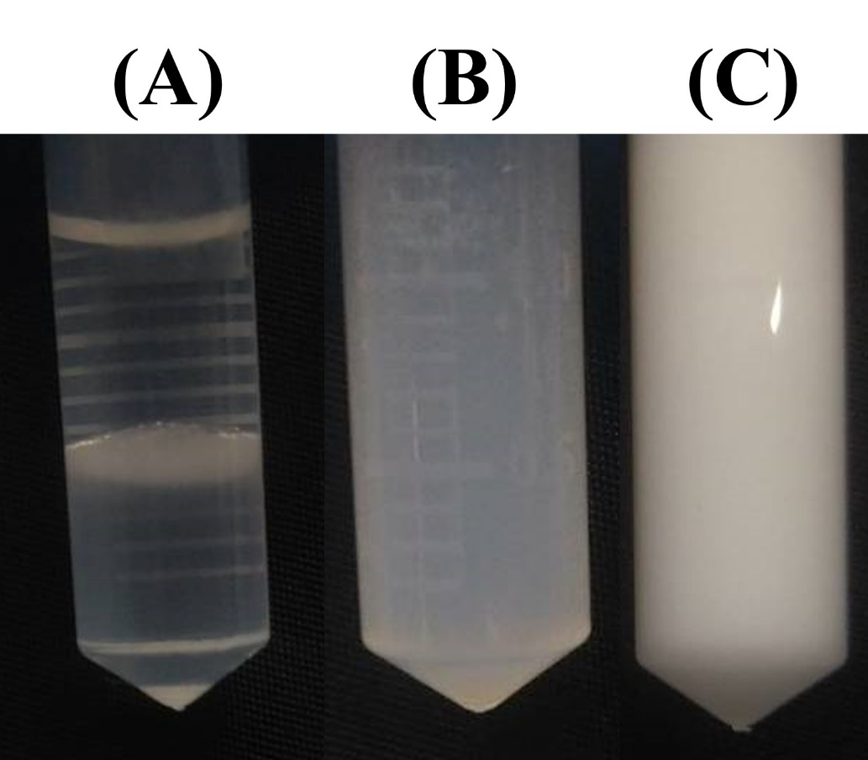
Figure S1 Appearance of TD series (A)precipitate, (B)turbidity, (C)Milky.
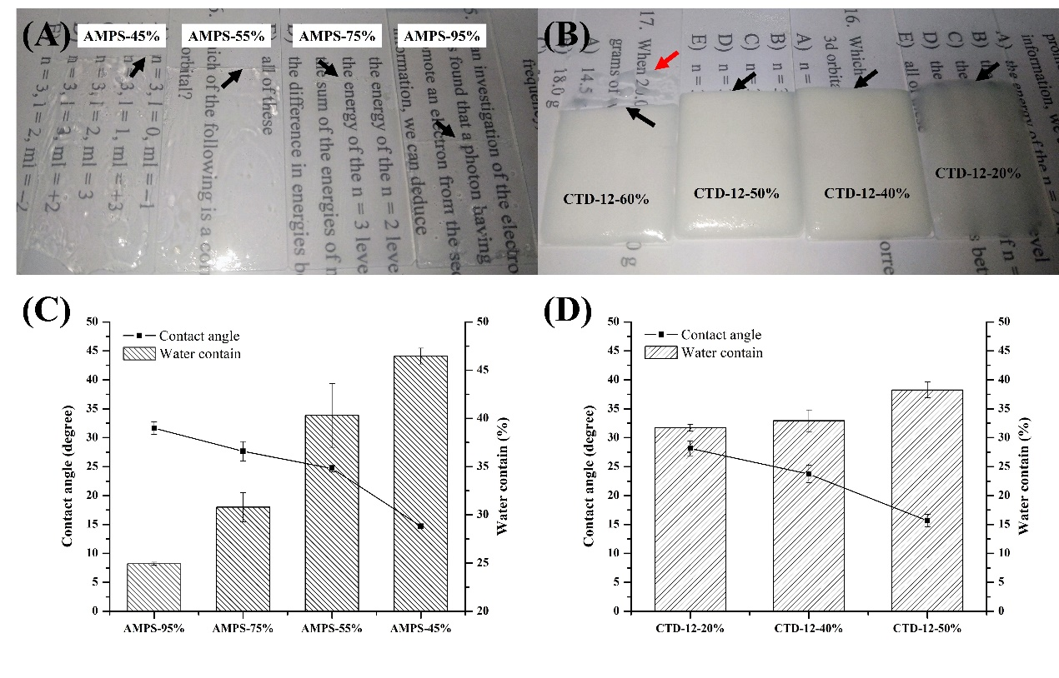
Figure S2 the properties of the prototype CTD-NCs AMPS gel. The appearance of (A) AMPS-gel (B) CTD-NCs-AMPS gel. The contact angle and water contain of (C) AMPS-series gel (D) CTD-NCs-AMPS gel. The black arrow indicates the gel boundary position, which used to cut to confirm whether curing is complete. Red arrow indicates incomplete curing part of the gel.

