 | All participants |  | Participants at both timepoints
 | n = 93 | n = 109 | n = 34
 | n (%) |  | n (%)
Gender | 2020 | 2022 | 2020 | 2022
Woman | 45 (48) | 66 (61) | 16 (47) | 16 (47)
Men | 43 (46) | 39 (36) | 16 (47) | 14 (41)
(non)-binary | 0 (0) | 1 (1) | 0 (0) | 1 (3)
Rather not say | 3 (3) | 3 (3) | 1 (3) | 2 (6)
Unknown | 2 (2) | 0 (0) | 1 (3) | 1 (3)
Numbers of years in current job
< 1 | 8 (9) | 8 (7) | 0 (0) | 0 (0)
1 to 5 | 24 (26) | 22 (20) | 4 (12) | 2 (6)
6 to 10 | 23 (25) | 28 (26) | 9 (26) | 9 (26)
11 to 15 | 12 (13) | 16 (15) | 5 (15) | 9 (26)
16 to 20 | 15 (16) | 14 (13) | 8 (24) | 7 (21)
≥ 21 | 8 (9) | 17 (16) | 5 (15) | 6 (18)
Rather not say | 1 (1) | 3 (3) | 1 (3) | 0 (0)
Unknown | 2 (2) | 1 (1) | 2 (6) | 1 (3)
Numbers of years worked in hospital
< 1 | 3 (3) | 13 (12) | 0 (0) | 0 (0)
1 to 5 | 17 (18) | 27 (25) | 6 (18) | 3 (9)
6 to 10 | 25 (27) | 24 (22) | 9 (26) | 11 (32)
11 to 15 | 10 (11) | 16 (15) | 7 (21) | 7 (21)
16 to 20 | 21 (23) | 13 (12) | 6 (18) | 6 (18)
≥ 21 | 12 (13) | 12 (11) | 4 (12) | 6 (18)
Rather not say | 1 (1) | 3 (3) | 1 (3) | 0 (0)
Unknown | 3 (3) | 1 (1) | 1 (3) | 1 (3)
Function
Medical specialist | 73 (78) | 85 (78) | 29 (85) | 32 (94)
Resident | 8 (9) | 16 (15) | 0 (0) | 1 (3)
Intern | 5 (5) | 7 (6) | 0 (0) | 0 (0)
Rather not say | 3 (3) | 0 (0) | 2 (6) | 0 (0)
Unknown | 4 (4) | 1 (1) | 3 (9) | 1 (3)
Organization principle
Patient-oriented | 52 (56) | 57 (52) | 21 (62) | 21 (62)
Process-oriented | 41 (44) | 47 (43) | 13 (38) | 13 (38)
Unknown | 0 (0) | 5 (5) | 0 | 0
Table S1. Characteristics of the participating physicians in 2020 and 2022

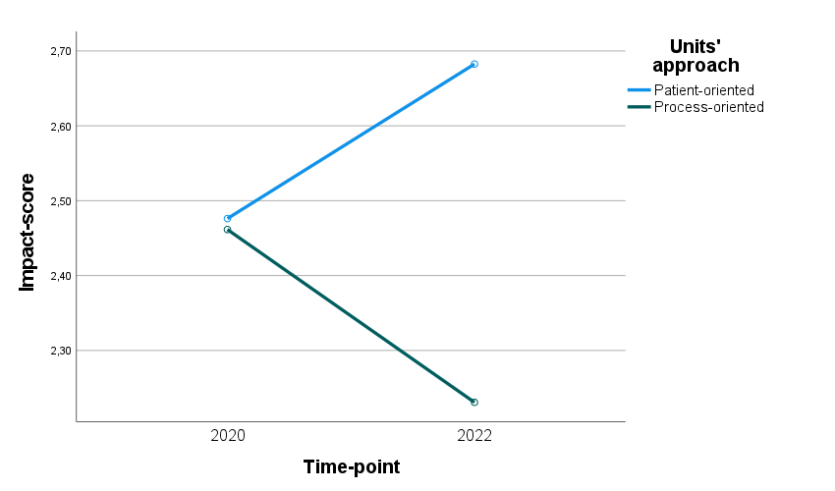
Figure S1. Mixed between-within subjects ANOVA (Impact _{x} Time).

