Supplementary Material:
Supplemental Figure 1. The diagnostic criteria of SJS/TEN by the RegiSCAR study group [1]
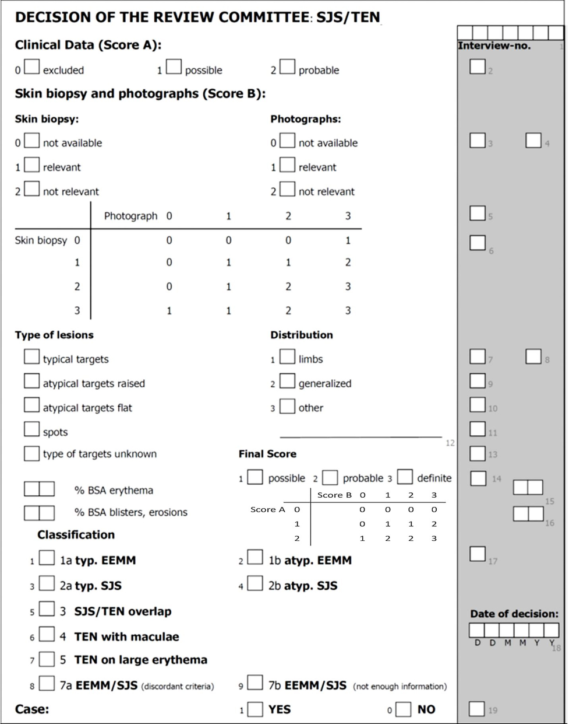
Supplemental Figure 2. Study protocol. Two independent groups were enrolled in this study
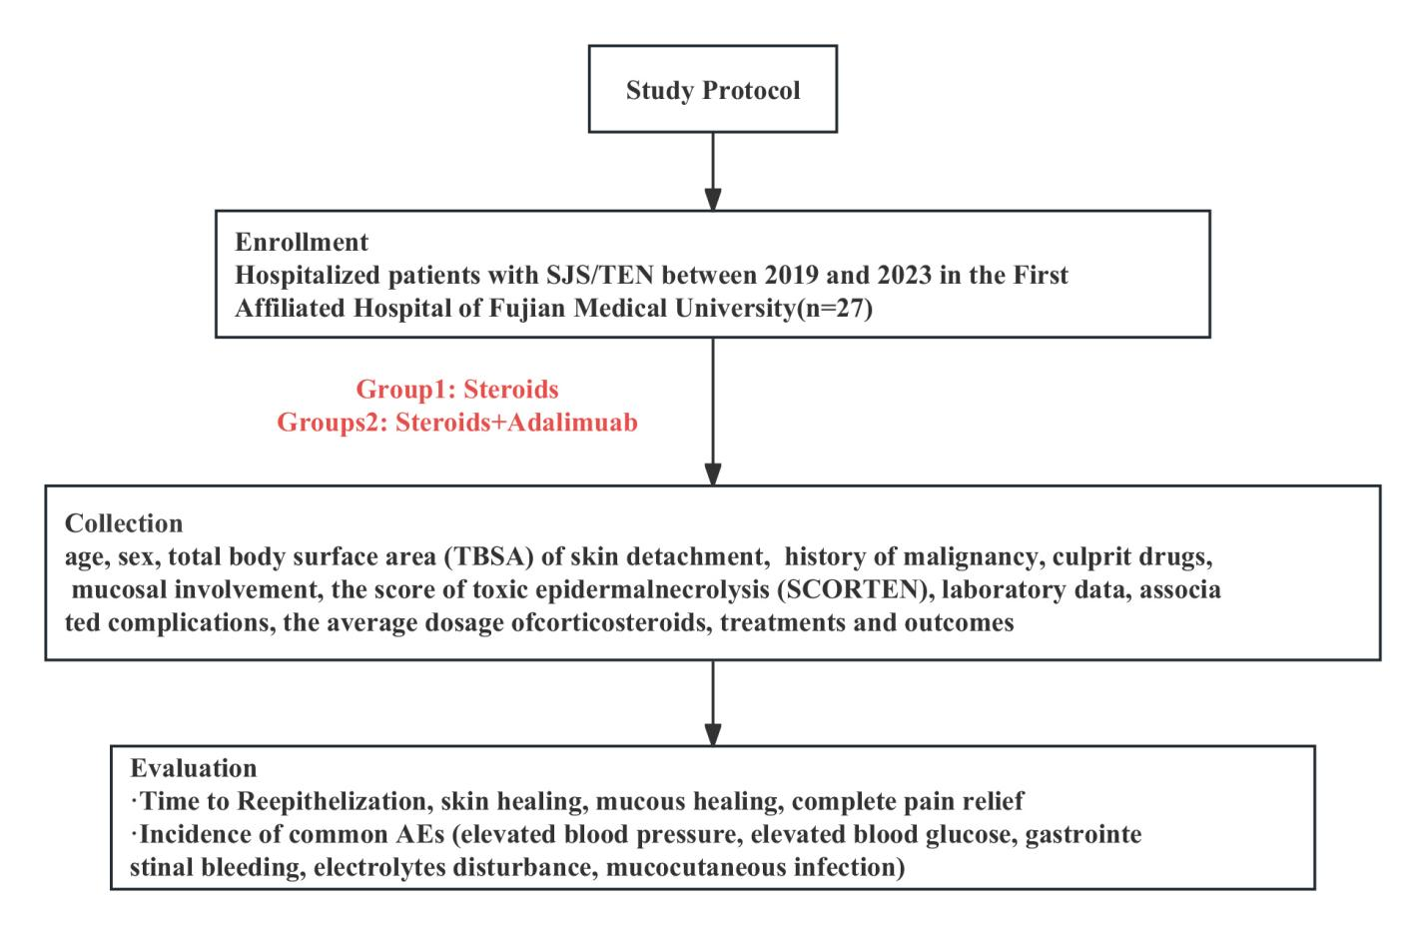

Supplemental Table 1. Naranjo adverse drug reaction probability scale
Question | Yes | No | Don’t know
1. Are there previous conclusive reports on this reaction? | 1 | 0 | 0
2. Did the adverse reaction appear after the suspected drug was administered? | 2 | -1 | 0
3. Did the adverse reaction improve when the drug was discontinued or a specific antagonist was administered? | 1 | 0 | 0
4. Did the adverse reaction reappear when the drug was readministered? | 2 | -1 | 0
5. Are there alternative causes that could on their own have caused the reaction? | -1 | 2 | 0
6. Did the reaction reappear when a placebo was given? | -1 | 1 | 0
7. Was the drug detected in the blood (or other fluids) in concentrations known to be toxic? | 1 | 0 | 0
8. Was the reaction more severe when the dose was increased or less severe when the dose was decreased? | 1 | 0 | 0
9. Did the patient have a similar reaction to the same or similar drug in any previous exposure? | 1 | 0 | 0
10. Was the adverse event confirmed by any objective evidence? | 1 | 0 | 0
Scoring: 9, definite; 5 8, probable; 1 4, possible; 0, doubtful.

Supplemental Table 2. The clinical scoring system, “SCORTEN”, for predicting mortality in SJS/TEN
Criteria  (Individual score) | Cut-off value | SCORTEN  (Sum of individual scores) | Predicted Mortality (%)
Age | ≥40 yrs | 0 | 3.2
History of malignancy | + | 1 | 3.2
Heart rate | ≥120/min | 2 | 12.1
Initial % TBSA detachment | >10% | 3 | 35.3
Serum urea nitrogen | >10 mmol/L (or >28 mg/dL) | 4 | 58.3
Serum bicarbonate | <20 mmol/L (mEq/L) | >5 | >90
Serum glucose | >14 mmol/L (or >252 mg/dL)

Supplemental Table 3. The distribution of tumor types in SJS/TEN patients induced by targeted anticancer therapies and immunotherapies
Tumor types | SJS  (n=58) | SJS-TEN  (n=8) | TEN  (n=46) | Total, n (%)  (n=112)
Melanoma | 5 | 1 | 15 | 21 (18.75)
Lung cancer | 11 | 2 | 7 | 20 (17.86)
Chronic myelogenous leukemia | 17 |  |  | 17 (15.18)
Gastrointestinal tumors | 6 | 2 | 6 | 14 (12.50)
Liver cancer | 5 | 1 | 6 | 12 (10.72)
Lymphoma | 3 | 1 | 4 | 8 (7.14)
Squamous cell carcinoma | 3 | 1 | 3 | 7 (6.25)
Renal cell carcinoma | 2 |  | 2 | 4 (3.57)
Myeloma |  |  | 2 | 2 (1.79)
Nasopharyngeal carcinoma | 2 |  |  | 2 (1.79)
Prostate cancer | 1 |  |  | 1 (0.89)
Malignant tumor of the tonsil | 1 |  |  | 1 (0.89)
Glioblastoma |  |  | 1 | 1 (0.89)
Urothelium carcinoma | 1 |  |  | 1 (0.89)
Breast carcinoma | 1 |  |  | 1 (0.89)

Supplemental Table 4. Tolerability follow-up for rechallenge or alternatives in patients with SJS/TEN induced by anticancer drugs (n=14)
Anticancer drugs | Disease | Tumor type | Rechallenge | Tolerance
Imatinib | SJS | CML | / | Dasatinib (new rash)  Nilotinib (tolerance) [2]
Imatinib | SJS | CML | Pruritic eruption after reinitiation at a lower dose of 200 mg/day; tolerated with a slow titration (100–300 mg/day), including 100 mg together with prednisolone (1 mg/kg) [3] | /
Imatinib | SJS | CML | Tolerance was achieved with a slow titration, starting at 100 mg/day and gradually escalating to 400 mg/day[4] | /
Imatinib | SJS | CML | Reinitiated Imatinib at a dose of 600mg/d and multiple blisters appeared [5] | /
Imatinib | SJS | CML | Imatinib was administered at a dose of 100 mg/day along with prednisolone 40 mg/day, and prednisolone was gradually tapered and discontinued while the Imatinib dose was increased to 300 mg[6] | /
Imatinib | SJS | CML | Imatinib 100 mg/d in combination with prednisolone 30 mg/d was administered. Later, Imatinib was increased to 400 mg/d, and prednisolone was decreased to 10 mg/d[7] | /
Imatinib | SJS | CML | The dose of 300 mg/d of Imatinib, in combination with steroids, did not result in a rash. Subsequently, the steroids were tapered[8] | /
Imatinib | SJS | Gastrointestinal stromal tumor | At 300 mg/day of imatinib, 25 mg/day of prednisone, and 5 mg/day of desloratadine, eyelid and lip swelling occurred after 24 hours, accompanied by a rash all over the body[9] | /
Afatinib | SJS | Lung adenocarcinoma | / | Erlotinib (liver damage)  Gefitinib (liver damage) [10]
Cetuximab | SJS | Colon adenocarcinoma | / | Panitumumab (SJS) [11]
Sorafenib | SJS | Hepatocellular carcinoma | Resumed the administration of sorafenib, but discontinued it the following day due to rash and high fever [12]
Vemurafenib | SJS | Melanoma | Started with dexamethasone and gradually increased the dose of vemurafenib, with no recurrence of the rash[13] | /
vemurafenib | TEN | Melanoma | / | Dabrafenib and trametinib (tolerance) [14]
vemurafenib | TEN | Melanoma | / | Dabrafenib (tolerance) [15]

Supplemental Table 5. Culprit drugs of SJS/TEN patients induced by anticancer drugs in our hospital
Class of meditation |  | Combination therapy  (n=14) | Conventional therapy  (n=13)
PD-1 inhibitors, n (%) | Pembrolizumab | 4
17 (63.00) | Camrelizumab | 3 | 1
 | Sintilimab | 2 | 1
 | Pembrolizumab | 1
 | Serplulimab | 1 | 1
 | Tislelizumab |  | 2
 | Treprinumab |  | 1
Multikinase inhibitors, n (%) | Imatinib | 1
2 (7.40) | Sorafenib |  | 1
EGFR inhibitor, n (%) | Apatinib Mesylate Tablets | 1
2 (7.40) | Osimertinib |  | 1
CD20, n (%)  2 (7.40) | Rituximab |  | 2
Other drugs, n (%) | Abiraterone |  | 1
4 (14.80) | Gemcitabine |  | 1
 | Paclitaxel | 1
 | Docetaxel |  | 1

Supplemental Table 6. Common adverse events of SJS/TEN patients in two groups
 | Combination therapy | Conventional therapy | P Value
Total SJS/TEN patients, n | 14 | 13
Common adverse events
Elevated blood pressureª, n (%) |  |  | 0.303
+ | 2(14.29) | 4 (30.77)
- | 12 (85.71) | 9 (69.23)
Elevated blood glucose^{b}, n (%) |  |  | 0.686
+ | 3 (21.43) | 2 (15.38)
- | 11 (78.57) | 11 (84.62)
GI hemorrhage^{c}, n (%)
+ | 1 (7.14) | 1 (7.69) | 0.957
- | 13 (92.86) | 11 (92.31)
Electrolyte disturbance^{d}, n (%) |  |  | 0.034
+ | 3 (21.43) | 8 (61.54)
- | 11 (78.57) | 5 (38.46)
Mucocutaneous infection^{e}, n (%) |  |  | 0.580
+ | 3 (21.43) | 4 (30.77)
- | 11 (78.57) | 9 (69.23)
All P-values were determined using the Chi-squared test/Fisher's exact test for each category.
ªElevated blood pressure was defined as an increase of 20 mmHg or more in either systolic or diastolic blood pressure compared to the pre-steroid treatment baseline.
^{b}Elevated blood glucose was defined as a postprandial blood glucose level exceeding 20 mmol/L.
^{c}Gastrointestinal (GI) bleeding was defined as the presence of multiple positive outcomes in stool occult blood (OB) testing subsequent to the administration of steroid treatment, or the confirmation of a positive result in upper endoscopy. Notably, false-positive results from OB testing arising due to ulceration in perianal regions and hemorrhoids were excluded. The assessment of the severity of GI bleeding was established in accordance with the Common Terminology Criteria for Adverse Events (CTCAE) in its fifth version.
^{d}Electrolyte disturbance was defined as the identification of one or more positive findings related to hypocalcemia, hypokalemia, and hyponatremia.
^{e}Mucocutaneous infection was defined as the presence of one or more infections involving specific pathogens affecting both the skin and mucous membranes.

Supplemental Table 7. Deceased SJS/TEN patients in two groups (n=5)
Case no./age (y)/sex | Causative drug | Severity  of disease | Causes of death | Kind of therapy | SCORTEN | Comorbidities
1/69/M | Serplulimab | TEN | Pulmonary fungal infection | Corticosteroid+  Adalimumab | 3 | Malignant lung tumor with metastasis, Extensive pleural effusion in the right lung, Pulmonary collapse, Pneumothorax, Left kidney stone
2/68/M | Pembrolizumab | TEN | Sepsis, Infectious shock, Cardiopulmonary failure, Metabolic acidosis, Coagulation dysfunction | Corticosteroid+  Adalimumab | 3 | Malignant liver tumor with metastasis, Hepatitis B-related cirrhosis, Chronic myeloid leukemia, Hypertension, Left kidney stone (with hydronephrosis)
3/55/M | Rituximab | TEN | Sepsis | Corticosteroid | 4 | Diabetes, Renal Dysfunction, Coagulation Abnormalities, Bilateral Pleural Effusion, Hepatic Cyst
4/45/M | Sintilimab | TEN | Respiratory failure, Sepsis, Infectious shock | Corticosteroid | 3 | Pulmonary squamous cell Carcinoma
5/81/F | Osimertinib | TEN | Respiratory failure, Sepsis, Infectious shock | Corticosteroid | 3 | Malignant non-small cell lung cancer with metastasis, Hypertension, Urinary tract infection, Cerebral infarction

References
1. Gong, T.; Zhang, P.; Ruan, S. F.; Xiao, Z.; Chen, W.; Lin, M.; Zhong, Q.; Luo, R.; Xu, Q.; Peng, J.; Cheng, B.; Chen, F.; Chen, L.; Chung, W. H.; Ji, C., APOA4 as a novel predictor of prognosis in Stevens-Johnson syndrome/toxic epidermal necrolysis: A proteomics analysis from two prospective cohorts. J Am Acad Dermatol 2023, 89 (1), 45-52.
2. Bois, E.; Holle, L. M.; Farooq, U., Late onset imatinib-induced Stevens-Johnson syndrome. J. Oncol Pharm Pract 2014, 20 (6), 476-8.
3. Jha, P.; Himanshu, D.; Jain, N.; Singh, A. K., Imatinib-induced Stevens-Johnsons syndrome. BMJ Case Rep 2013, 2013.
4. Pavithran, K.; Thomas, M., Imatinib induced Stevens-Johnson syndrome: lack of recurrence. following re-challenge with a lower dose. Indian J Dermatol Venereol Leprol 2005, 71 (4), 288-9.
5. Hsiao, L. T.; Chung, H. M.; Lin, J. T.; Chiou, T. J.; Liu, J. H.; Fan, F. S.; Wang, W. S.; Yen, C. C.; Chen, P. M., Stevens-Johnson syndrome after treatment with STI571: a case report. Br J Haematol 2002, 117 (3), 620-2.
6. Mahapatra, M.; Mishra, P.; Kumar, R., Imatinib-induced Stevens-Johnson syndrome: recurrence after re-challenge with a lower dose. Ann Hematol 2007, 86 (7), 537-8.
7. Sanchez-Gonzalez, B.; Pascual-Ramirez, J. C.; Fernandez-Abellan, P.; Belinchon-Romero, I.; Rivas, C.; Vegara-Aguilera, G., Severe skin reaction to imatinib in a case of Philadelphia-positive acute lymphoblastic leukemia. Blood 2003, 101 (6), 2446.
8. Rule, S. A.; O'Brien, S. G.; Crossman, L. C., Managing cutaneous reactions to imatinib therapy. Blood 2002, 100 (9), 3434-5.
9. Severino, G.; Chillotti, C.; De Lisa, R.; Del Zompo, M.; Ardau, R., Adverse reactions during. imatinib and lansoprazole treatment in gastrointestinal stromal tumors. Ann Pharmacother 2005, 39 (1), 162-4.
10. Honda, Y.; Hattori, Y.; Katsura, S.; Terashima, T.; Manabe, T.; Otsuka, A.; Miyachi, Y., Stevens-Johnson syndrome-like erosive dermatitis possibly related to afatinib. Eur J Dermatol 2016, 26 (4), 413-4.
11. Pantano, F.; Silletta, M.; Iovieno, A.; Vincenzi, B.; Santini, D.; Galluzzo, S.; Bonini, S.; Tonini, G., Stevens-Johnson syndrome associated with reduced tear production complicating the use of cetuximab and panitunumab. Int J Colorectal Dis 2009, 24 (10), 1247-8.
12. Sohn, K. H.; Oh, S. Y.; Lim, K. W.; Kim, M. Y.; Lee, S. Y.; Kang, H. R., Sorafenib induces. delayed-onset cutaneous hypersensitivity: a case series. Allergy Asthma Immunol Res 2015, 7 (3), 304-7.
13. Minor, D. R.; Rodvien, R.; Kashani-Sabet, M., Successful desensitization in a case of Stevens-Johnson syndrome due to vemurafenib. Melanoma Res 2012, 22 (5), 410-1.
14. Bellón, T.; Lerma, V.; González-Valle, O.; González Herrada, C.; de Abajo, F. J., Vemurafenib-induced toxic epidermal necrolysis: possible cross-reactivity with other sulfonamide compounds. Br J Dermatol 2016, 174 (3), 621-4.
15. Jeudy, G.; Dalac-Rat, S.; Bonniaud, B.; Hervieu, A.; Petrella, T.; Collet, E.; Vabres, P., Successful switch to dabrafenib after vemurafenib-induced toxic epidermal necrolysis. Br J Dermatol 2015, 172 (5), 1454-5.

