Table S1. Thrombus resolution rates used in the model
 | NOAC |  | VKA
1-6 weeks | Base | 0.111925 | Base | 0.040030
1-6 weeks | α | 27 | α | 20
1-6 weeks | β | 26 | β | 72
6-12 weeks | Base | 0.039651 | Base | 0.023689
6-12 weeks | α | 10 | α | 18
6-12 weeks | β | 16 | β | 54
12-26 weeks | Base | 0.021886 | Base | 0.023627
12-26 weeks | α | 7 | α | 25
12-26 weeks | β | 9 | β | 29
26-52 weeks | Base | 0.004821 | Base | 0.006188
26-52 weeks | α | 2 | α | 8
26-52 weeks | β | 7 | β | 21
Notes:
- The data presented in this table are derived from the E-DISSOLVE study¹.
- Resolution rates within this table were calculated using a beta distribution based on calculated baseline values for each cycle's resolution rate, which have been rounded to six decimal places.
- In the PSA, the resolution rates were determined using the beta distribution values obtained from the specified α and β parameters.

Table S2. Transition probabilities between health states used in the model
 | NOAC |  | VKA
LVT to SE/stroke | Base | 0.004258 | Base | 0.005247
LVT to SE/stroke | α | 109 | α | 386
LVT to SE/stroke | β | 509 | β | 1428
LVT to all case bleed*  (1-12 weeks) | Base | 0.001164 | Base | 0.001830
LVT to all case bleed*  (1-12 weeks) | α | 94 | α | 290
LVT to all case bleed*  (1-12 weeks) | β | 1704 | β | 3293
Bleed to major bleed*  (1-12 weeks) | Base | 0.001838 | Base | 0.002323
Bleed to major bleed*  (1-12 weeks) | α | 46 | α | 175
Bleed to major bleed*  (1-12 weeks) | β | 525 | β | 1562
TR to LVT# | Base | 0.048000 | Base | 0.048000
TR to LVT# | Low value | 0.010000 | Low value | 0.010000
TR to LVT# | High value | 0.135000 | High value | 0.135000
SE/stroke to death# | Base | 0.622000 | Base | 0.622000
SE/stroke to death# | Low value | 0.533000 | Low value | 0.533000
SE/stroke to death# | High value | 0.707000 | High value | 0.707000
Major bleed to death# | Base | 0.601000 | Base | 0.601000
Major bleed to death# | Low value | 0.523000 | Low value | 0.523000
Major bleed to death# | High value | 0.690000 | High value | 0.690000
Minor bleed to TR# | Base | 0.571429 | Base | 0.571429
Minor bleed to TR# | Low value | 0.428571 | Low value | 0.428571
Minor bleed to TR# | High value | 0.714286 | High value | 0.714286
Notes:
- The transition probabilities between health states presented in this table are sourced from publicly available meta-analyses² and national-level studies on cardiovascular event mortality rates³.
- The base values for each cycle's transition rate have been calculated and rounded to six decimal places.
- Rates without a distribution have been assigned upper and lower limits based on the available data due to the lack of a specific distribution.
- *According to the E-DISSOLVE study, the incidence rate of bleeding events approaches zero after 12 weeks; therefore, those rate for the first 12 weeks.
- # Probabilities specific to those events are challenging to obtain. Based on expert consensus, these rates have a minimal impact on the final outcomes, hence a single value available has been used for both NOACs and VKAs. The DSA results also reflect that.

Table S3. Utility Values for Health States
Health State | ICD-10 Code | Utility Value
Health State | ICD-10 Code | Base Value | Low value | High value
LVT | I23.6 | 0.011596 | 0.007000 | 0.015308
TR | I74 | 0.014058 | 0.013288 | 0.019231
SE/stroke | I63-I64 | 0.012327 | 0.009923 | 0.016308
Major bleed | I65-68 | 0.011615 | 0.008327 | 0.015308
CRNMB | D68.303 | 0.014173 | 0.013250 | 0.015308
Death | - | 0 | 0 | 0
Notes:
- The utility values presented in this table were derived from an EQ-5D-3L study⁴, which included values from both the UK and the US. For our analysis, we have selected the UK values.
- The utility values in the referenced study were originally calculated on an annual basis. The values in this table have been converted to reflect a weekly basis to align with the time frame of our model.

Table S4. DRG Payment Standards for Disease States
Disease State | ICD-10 Code | DRG Code* | Average (CNY) | Low value (CNY) | High value (CNY)
Disease State | ICD-10 Code | DRG Code* | Average length of stay  (days) | Shortest length of stay  (days) | Longest length of stay  (days)
LVT | I23 | FR13 | 11429.00 | 7616.00 | 30699.00
LVT | I23 | FR13 | 8.44 | 5.76 | 12.67
TR | I74 | FZ15 | 5631.00 | 2829.00 | 10753.00
TR | I74 | FZ15 | 5.71 | 2.29 | 9.00
SE/stroke | I63-I64 | BR2 | 8859.00 | 6206.00 | 19656.00
SE/stroke | I63-I64 | BR2 | 9.25 | 6.91 | 13.35
Major bleed | I65-68 | BR15 | 15979.00 | 5345.00 | 33677.00
Major bleed | I65-68 | BR15 | 12.76 | 8.35 | 18.31
CRNMB | D68.303 | QT19 | 6068.00 | 1579.00 | 15624.00
CRNMB | D68.303 | QT19 | 7.12 | 4.76 | 10.26
Notes:
- *DRG codes as defined by China's DRG policy, which correspond to the ICD-10 codes for different disease conditions. These codes can be found on the official government website.
- The DRG payment standards are presented as average, upper limit, and lower limit, which correspond to the average length of hospital stay, the shortest average length of stay, and the longest length of stay, respectively.
- Given that our model operates on a weekly cycle (7 days), which aligns closely with the average length of stay for these conditions, we have not converted the costs to a standard 7-day hospital stay rate.

Table S5. Drug Prices
Drug | BND (CNY) |  |  | VBP (CNY)
Drug | Base value | Low value | High value | Base value | Low value | High value
Rivaroxaban | 270.48 | 169.40 | 386.26 | 18.27 | 16.80 | 19.74
Apixaban | 487.20 | 438.48 | 535.92 | 47.32 | 13.72 | 59.52
Edoxaban | 175.28 | 126.77 | 448.00 | 104.30 | 93.87 | 114.73
Dabigatran | 258.30 | 241.92 | 317.48 | 152.18 | 56.51 | 207.62
Warfarin | - | - | - | 3.06 | 1.26 | 14.00
Notes:
- All prices listed in this table are calculated based on the cost of a one-week course of treatment according to the dosing regimen.
- The 'base value' in the table represents the typical market price for the predominant variety of each drug. This is reflective of the most commonly purchased options in the market.
- The 'low value' and 'high value' indicate the lowest and highest prices available domestically for these typical varieties. For drugs with a single listed price, we have chosen to represent the lowest and highest prices as ±10% of the base value to provide a range for potential price variations.

Table S6. Cost of INR Monitoring for Warfarin Therapy
One-time | Base value | Low value | High value
CNY | 35.00 | 16.00 | 80.00
Notes:
- The cost of a single INR monitoring session for warfarin therapy is based on local pricing, ensuring representation of the current expenses.
- The frequency of INR monitoring for the warfarin group was determined based on information from a Chinese study, indicating an average of 13 INR tests per year for individuals on warfarin⁵, equivalent to approximately 0.25 tests per week.

Figure S1. Scatter plot for rivaroxaban (95.0%)
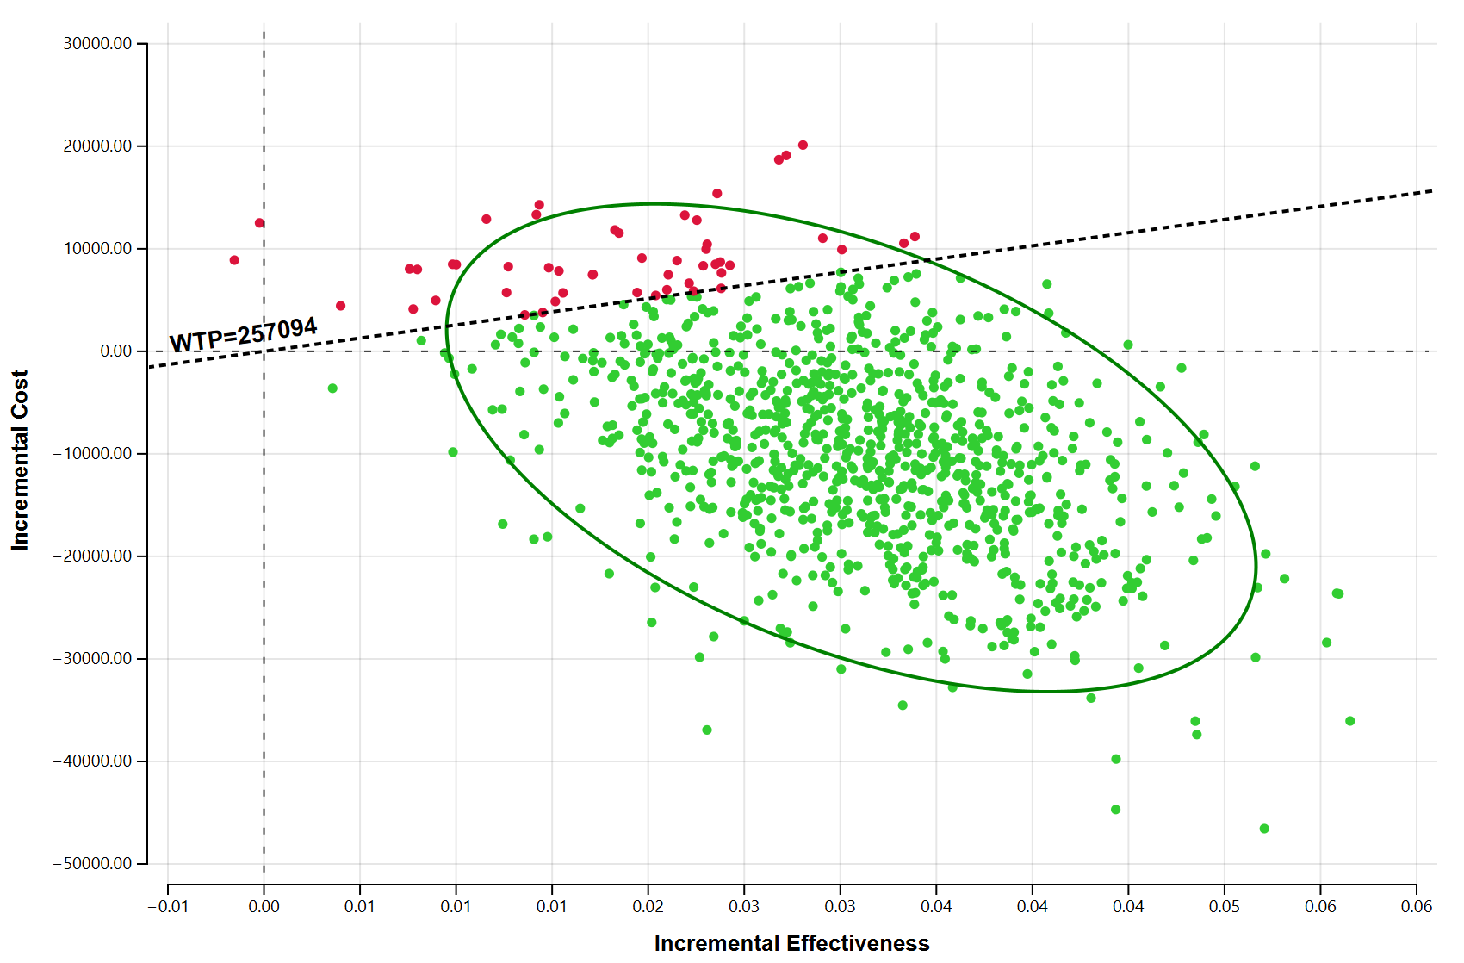
Abbreviations: WTP, Willingness-to-pay.

Figure. S2 Scatter plot for apixaban (93.1%)
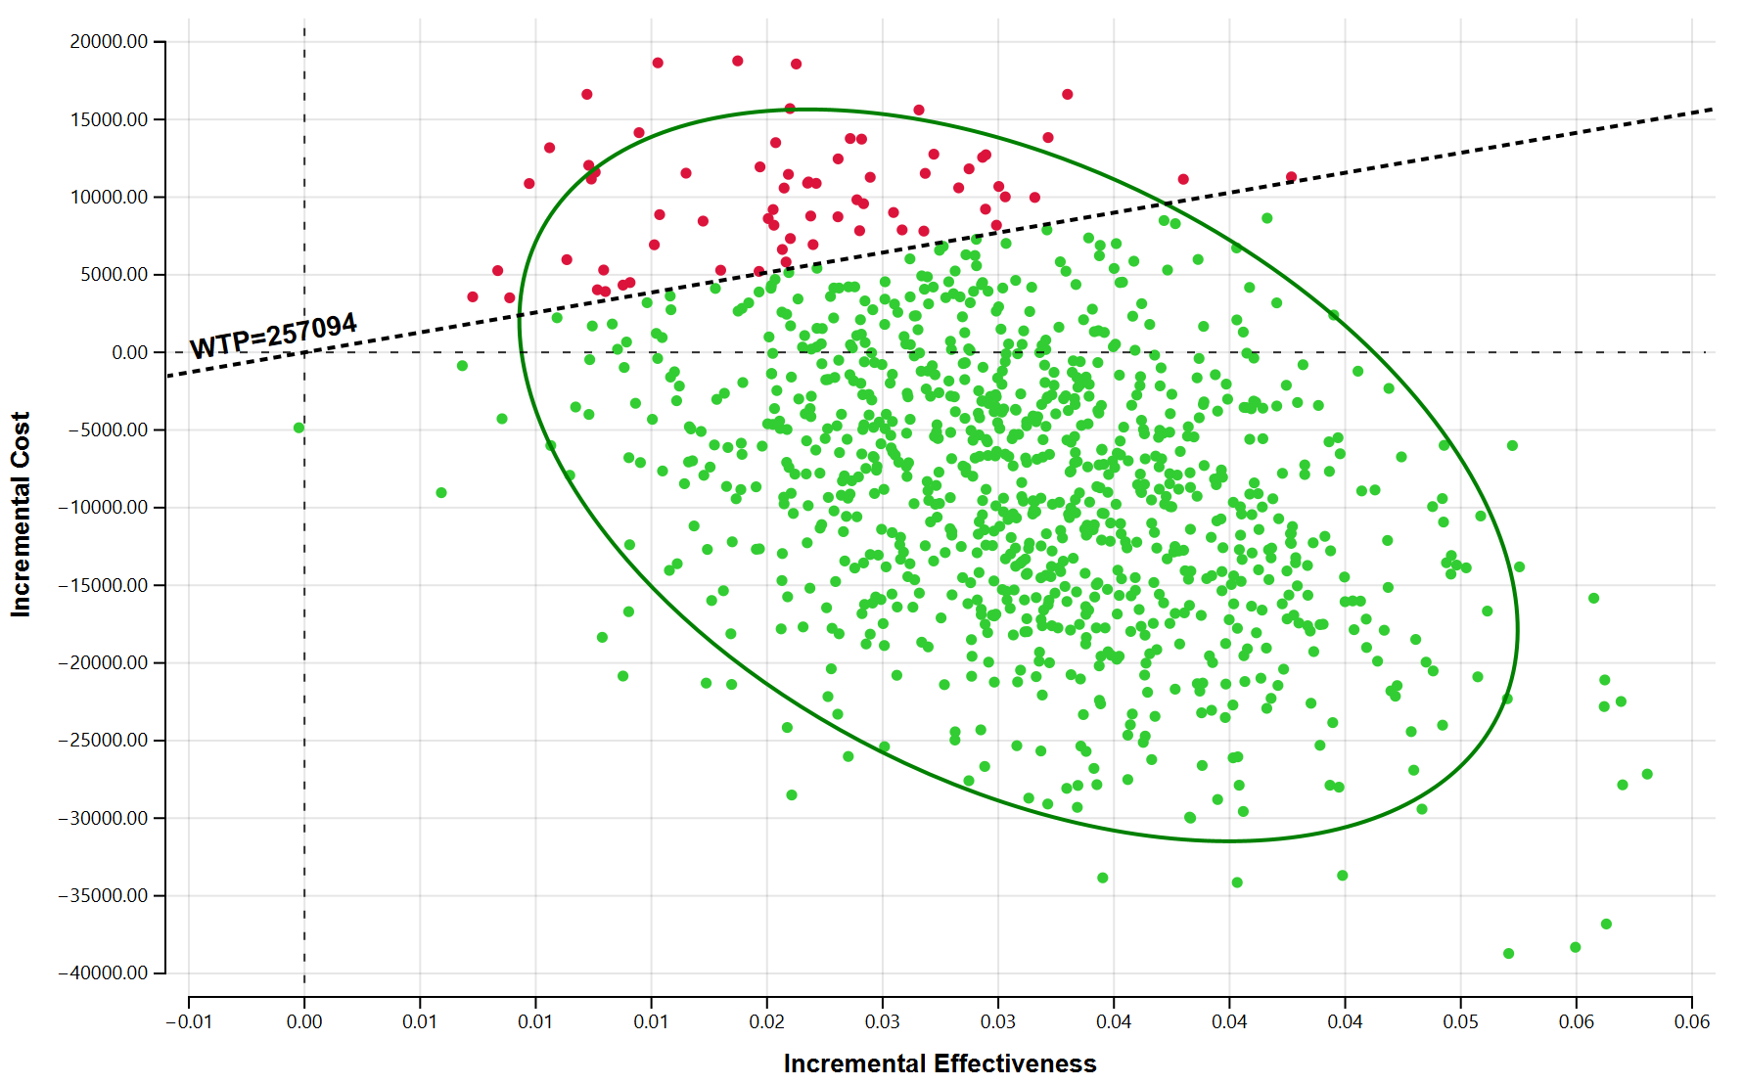
Abbreviations: WTP, Willingness-to-pay.

Figure. S3 Scatter plot for edoxaban (89.1%)
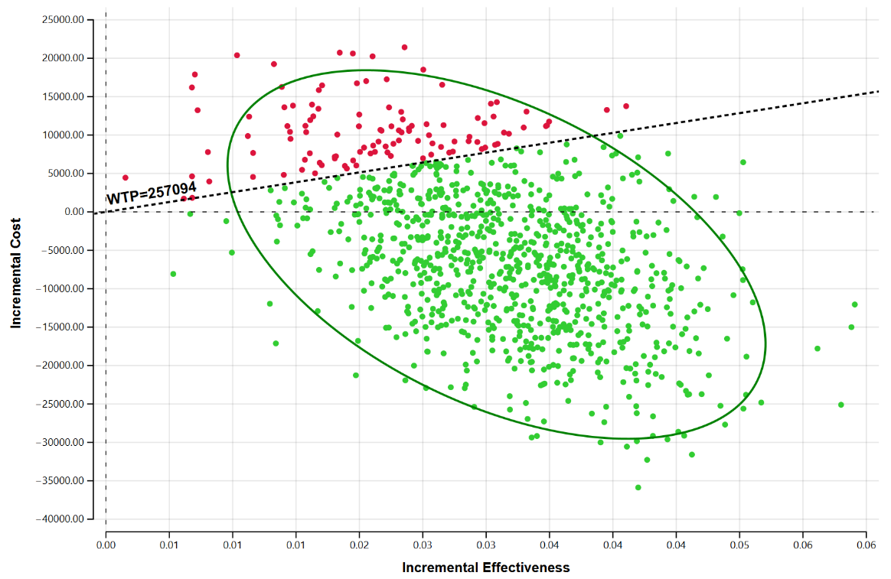
Abbreviations: WTP, Willingness-to-pay.
Figure. S4 Scatter plot for dabigatran (82.5%)
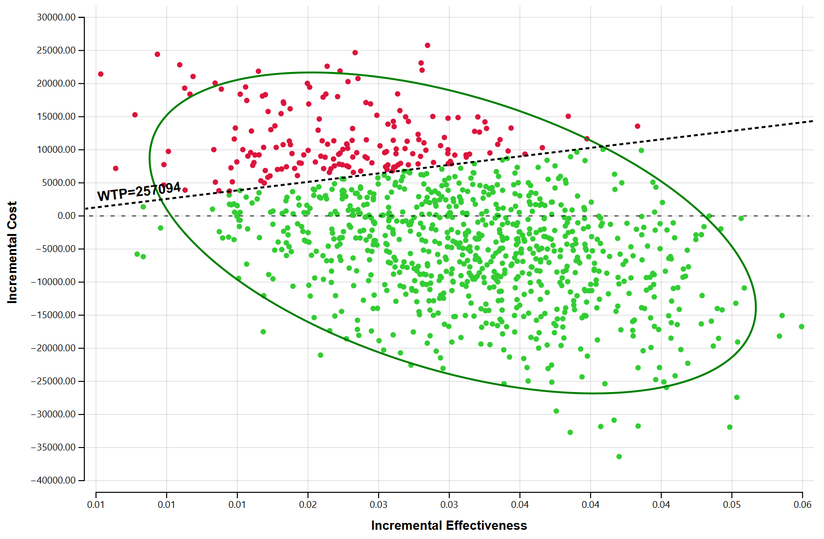

Abbreviations: WTP, Willingness-to-pay.
References
1. Yang Q, Lang X, Quan X, Gong Z, Liang Y. Different Oral Antithrombotic Therapy for the Treatment of Ventricular Thrombus: An Observational Study from 2010 to 2019. International journal of clinical practice. 2022;2022:7400860.
2. da Silva Ferreira H, Lima Lopes J, Augusto J, et al. Effect of direct oral anticoagulants versus vitamin K antagonists or warfarin in patients with left ventricular thrombus outcomes: A systematic review and meta-analysis. Revista portuguesa de cardiologia : orgao oficial da Sociedade Portuguesa de Cardiologia = Portuguese journal of cardiology : an official journal of the Portuguese Society of Cardiology. 2023;42(1):63-70.
3. Ma Q, Li R, Wang L, et al. Temporal trend and attributable risk factors of stroke burden in China, 1990-2019: an analysis for the Global Burden of Disease Study 2019. The Lancet Public health. 2021;6(12):e897-e906.
4. Falk Hvidberg M, Hernández Alava M. Catalogues of EQ-5D-3L Health-Related Quality of Life Scores for 199 Chronic Conditions and Health Risks for Use in the UK and the USA. PharmacoEconomics. 2023;41(10):1287-1388.
5. Huang Y, Lu X, Chen W, Meng X. Economic Evaluation of Oral Anticoagulation Therapies. Chinese Journal of Clinical Thoracic and Cardiovascular Surgery. 2016;23(09):859-863.

