Supplementary Table 1. Laboratory Test Names and Criteria for Adverse Events of Special Interest
Category | Laboratory Test Name | Criteria
Hyperglycemia | Glucose [Mass/volume] in Serum or Plasma | ≥200 mg/dL
Hyperglycemia | Glucose [Mass/volume] in Capillary blood by Glucometer | ≥200 mg/dL
Liver dysfunction | Alanine aminotransferase [Enzymatic activity/volume] in Serum or Plasma | >120 IU/L  (>3 × ULN)
Liver dysfunction | Aspartate aminotransferase [Enzymatic activity/volume] in Serum or Plasma | >120 IU/L  (>3 × ULN)
Hyperbilirubinemia | Total Bilirubin [Mass/volume] in Serum or Plasma | >1.8 mg/dL  (>1.5 × ULN)
Hyperbilirubinemia | Direct Bilirubin [Mass/volume] in Serum or Plasma | >0.75 mg/dL  (>1.5 × ULN)
Hyperlipidemia | Triglyceride [Mass/volume] in Serum or Plasma | >300 mg/dL
Pancreatitis | Amylase [Enzymatic activity/volume] in Serum or Plasma | >150 IU/L  (>1.5 × ULN)
Pancreatitis | Lipase [Enzymatic activity/volume] in Serum or Plasma | >90 IU/L  (>1.5 × ULN)

Supplementary Table 2. Odds Ratios for Tumor Lysis Syndrome Based on Selected Covariates from Reduced Logistic Regression Model after Backward Elimination
 | Odds ratio (95% confidence interval) | p-value
Age at ALL diagnosis | 1.18 (0.98, 1.43) | 0.088
Sex: Male | 4.46 (1.46, 13.61) | 0.01
WBC | 1.01 (1, 1.02) | 0.001
Hemoglobin | 0.75 (0.57, 0.98) | 0.04
Platelet | 0.99 (0.98, 0.99) | 0.006
Phosphorous | 1.33 (0.84, 2.11) | 0.224
Potassium | 0.41 (0.21, 0.81) | 0.006
BUN | 0.88 (0.79, 0.99) | 0.042
Creatinine | 14.97 (1.32, 169.8) | 0.027
Risk: Standard Risk | 0.04 (<0.01, 0.31) | 0.016
Risk: High Risk | 0.02 (<0.01, 0.25) | 0.018
Premedication with rasburicase: Yes | 4.62 (1.29, 16.6) | 0.02

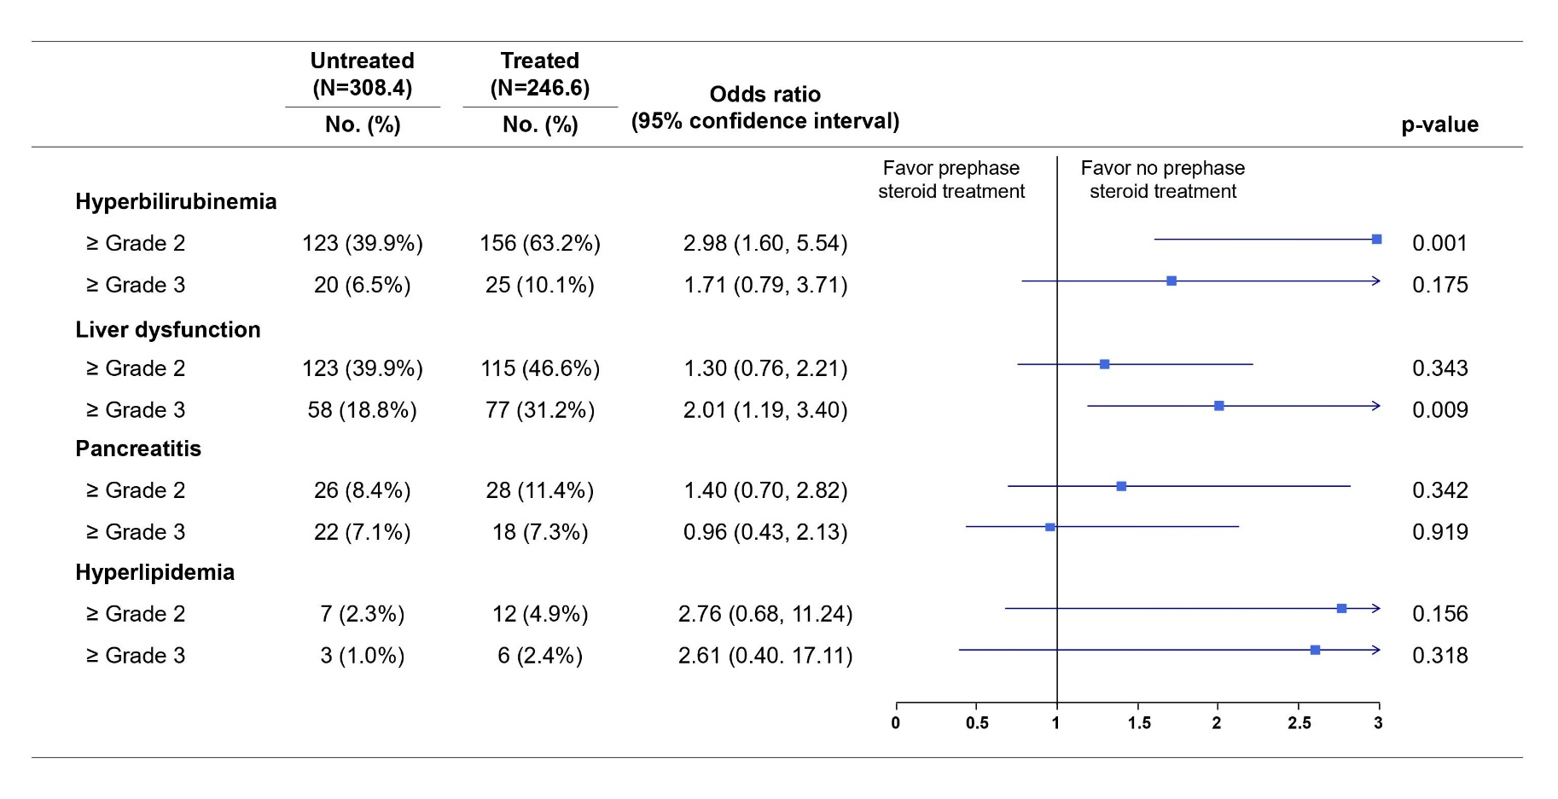
Supplementary Figure 1. Odds Ratios for Adverse Events of Special Interest Across Varying Severity Thresholds

