The therapeutic effectiveness of Laparoscopic Sleeve Gastrectomy among individuals with low BMI obesity (30-35 kg/m²) and the relationship of BMI to weight loss

Contents
Appendix Content 1: The standardized LSG protocol
Content 2: Table S1. Comparison of the percentage of total weight loss (%TWL) in the three groups after surgery
Content 3: Figure S1. Comparison of postoperative % Total Weight Loss between the three groups at 1, 3, 6, and 12 months postoperatively

Appendix Content 1: The standardized LSG protocol
In the first step, we use the ultrasonic scalpel to free the greater omentum starting from the avascular zone of the gastrocolic ligament, up to the gastroesophageal junction, and completely expose the fundus, and down to 4 cm-6 cm from the pylorus. Then, the anesthesiologist places a 36 Fr calibration bougie into the gastric cavity through the mouth, which is used as a template to perform a vertical partial gastrectomy and to aid in the intraoperative emptying of the stomach. Next, the surgeon uses an articulating endoscopic linear cutter to begin resection of the gastric wall at a distance of approximately 2–6 cm from the pylorus under the guidance of the bougie. During the procedure, we completely resected the fundus of the stomach, which is very important for LSG. At the end of the operation, we removed the bougie, added sutures to the gastric incision margin, removed the specimen, left a drainage tube in the abdomen, sutured the incisions, and completed the operation.

Content 2:
Table S1. Comparison of the percentage of total weight loss (%TWL) in the three groups after surgery
Groups | 1 month | 3 months | 6 months | 12 months
Class I (n=61) | 10.52 ± 3.42 | 16.46 ± 4.12 | 21.22 ± 4.82 | 24.10 ± 4.02
Class II (n=44) | 12.31 ± 3.47 | 20.36 ± 3.86 | 26.69 ± 3.66 | 29.92 ± 3.20
Class III (n=29) | 14.45 ± 10.48 | 23.57 ± 6.15 | 30.63 ± 7.46 | 32.89 ± 7.33
P value | 0.001 | <0.001 | <0.001 | <0.001
P₁₋₂ value | 0.104 | <0.001 | <0.001 | <0.001
P₁₋₃ value | 0.001 | <0.001 | <0.001 | <0.001
P ₂₋₃ value | 0.318 | 0.249 | 0.294 | 1.000
Note: Data are mean ± SD
Abbreviations: P₁₋₂ value are P values after comparison of %TWL for Class I and Class II obesity at postoperative follow-up time; P₁₋₃ value are P values after comparison of %TWL for Class I and Class III obesity at postoperative follow-up time; P ₂₋₃ value are P values after comparison of %TWL for Class II and Class III obesity at postoperative follow-up time.

Content 3:
Figure S1. Comparison of postoperative % Total Weight Loss between the three groups at 1, 3, 6, and 12 months postoperatively
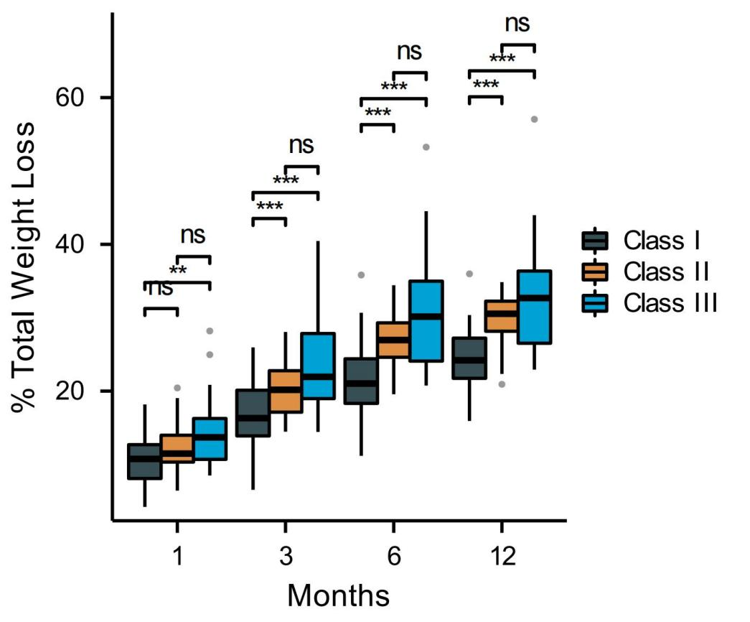

ns, P > 0.05; **, P < 0.01; ***, P < 0.001.

