Supporting Information
Multimodal Imaging-Guided Synergistic Photodynamic Therapy Using Carbonized Zn/Co Metal-Organic Framework Loaded with Cytotoxin Against Liver Cancer
Jingmei Huang^{1†}，Lianshan Guo^{1†}， Xiaoxiao Huang¹，Xiaoping Yu²，Liqiao Lin¹，Xinlin Jiang³，Zhihao Bai^{4*} and Zhengzhao Li^{1*}

Figure S1. BET of C-ZIF.
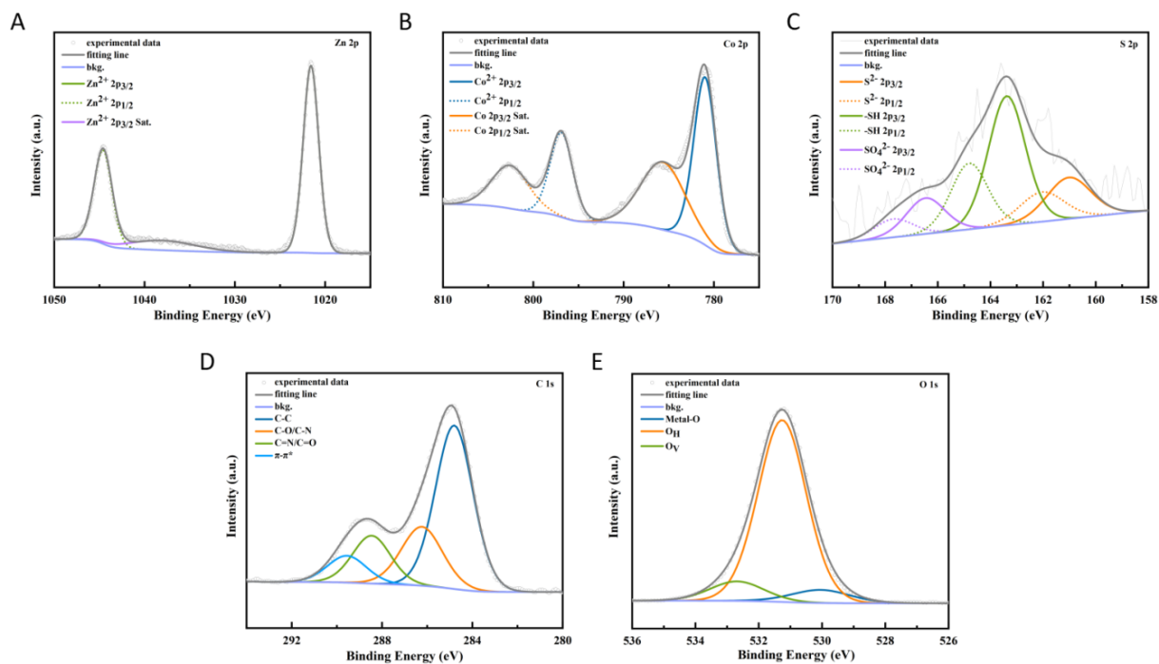
Figure S2. XPS of Zn、Co、S、C、O in RPZC NPs.
Figure S3. Fluorescence Spectrum of RZCP NPs.
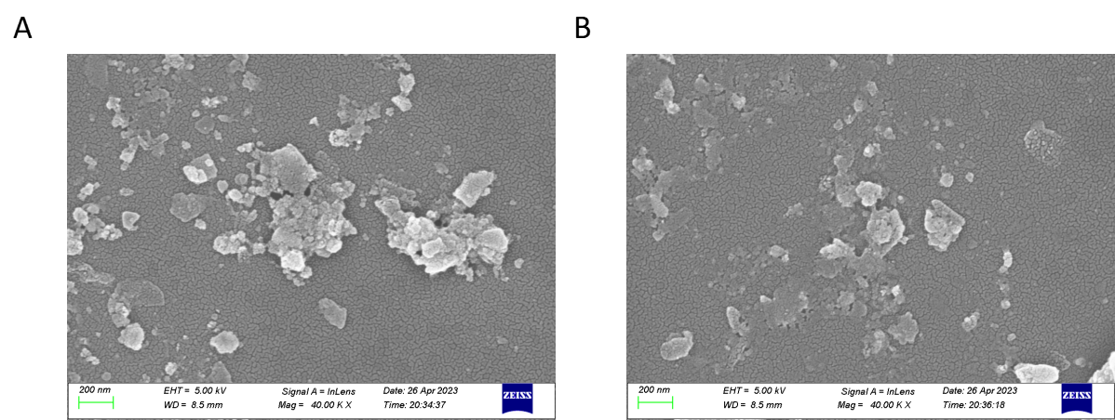
Figure S4.Disintegration of RPZC NPs in solutions with varying pH levels(A) pH 5.5; (B) pH 4.5.

