Supplemental Table 1. Clinical data of 272 older adult patients infected with Omicron sub-variants of COVID-19 in the training cohort and validation cohort.
 | Training cohort  (n=191) | Validation cohort  (n=81) | P
Age > 80 yrs | 27 (33.3%) | 83 (43.5%) | 0.155
History of malignancies | 15 (18.5%) | 36 (18.8%) | 1.000
WBC > 9.15×10⁹/L | 7 (8.64%) | 35 (18.3%) | 0.066
NEU > 7×10⁹/L | 8 (9.88%) | 43 (22.5%) | 0.023
LYM < 0.8×10⁹/L | 41 (50.6%) | 99 (51.8%) | 0.960
CRP > 10 mg/L | 38 (46.9%) | 83 (43.5%) | 0.696
PCT > 0.052 ng/mL | 34 (42.0%) | 92 (48.2%) | 0.422
IL-6 > 6.6 pg/mL | 42 (51.9%) | 117 (61.3%) | 0.192
AST > 40 U/L | 15 (18.5%) | 46 (24.1%) | 0.397
LDH > 245 U/L | 34 (42.0%) | 90 (47.1%) | 0.518
Scr > 104 μmol/L | 12 (14.8%) | 38 (19.9%) | 0.413
CD4⁺ T-LYM < 400/μL | 52 (64.2%) | 119 (62.3%) | 0.874
CD8⁺ T-LYM < 200/μL | 44 (54.3%) | 90 (47.1%) | 0.340
B-LYM < 50/μL | 15 (18.5%) | 48 (25.1%) | 0.305
PNI > 40 | 44 (54.3%) | 121 (63.4%) | 0.208
MNA-SF score ≤ 7 points | 40 (49.4%) | 99 (51.8%) | 0.813
ADL score ≤ 40 points | 28 (34.6%) | 92 (48.2%) | 0.053
FRAIL score ≥ 3 points | 56 (69.1%) | 125 (65.4%) | 0.653
COVID-19, coronavirus disease 2019; WBC, white blood cell count; NEU, neutrophils; LYM, lymphocytes; CRP, C-reactive protein; PCT, procalcitonin; IL-6, interleukin-6; LDH, lactate dehydrogenase; Scr, serum creatinine; CD4⁺ T-LYM, CD4⁺ T-lymphocyte count; CD8⁺ T-LYM, CD8⁺ T-lymphocyte count; B-LYM, B-lymphocyte count; PNI, Prognosis Nutrition Index; MNA-SF, the Mini Nutritional Assessment Scale-Short Form; ADL, the Activities of Daily Living.
The bold texts were considered the differences of statistically significant (P＜0.05).

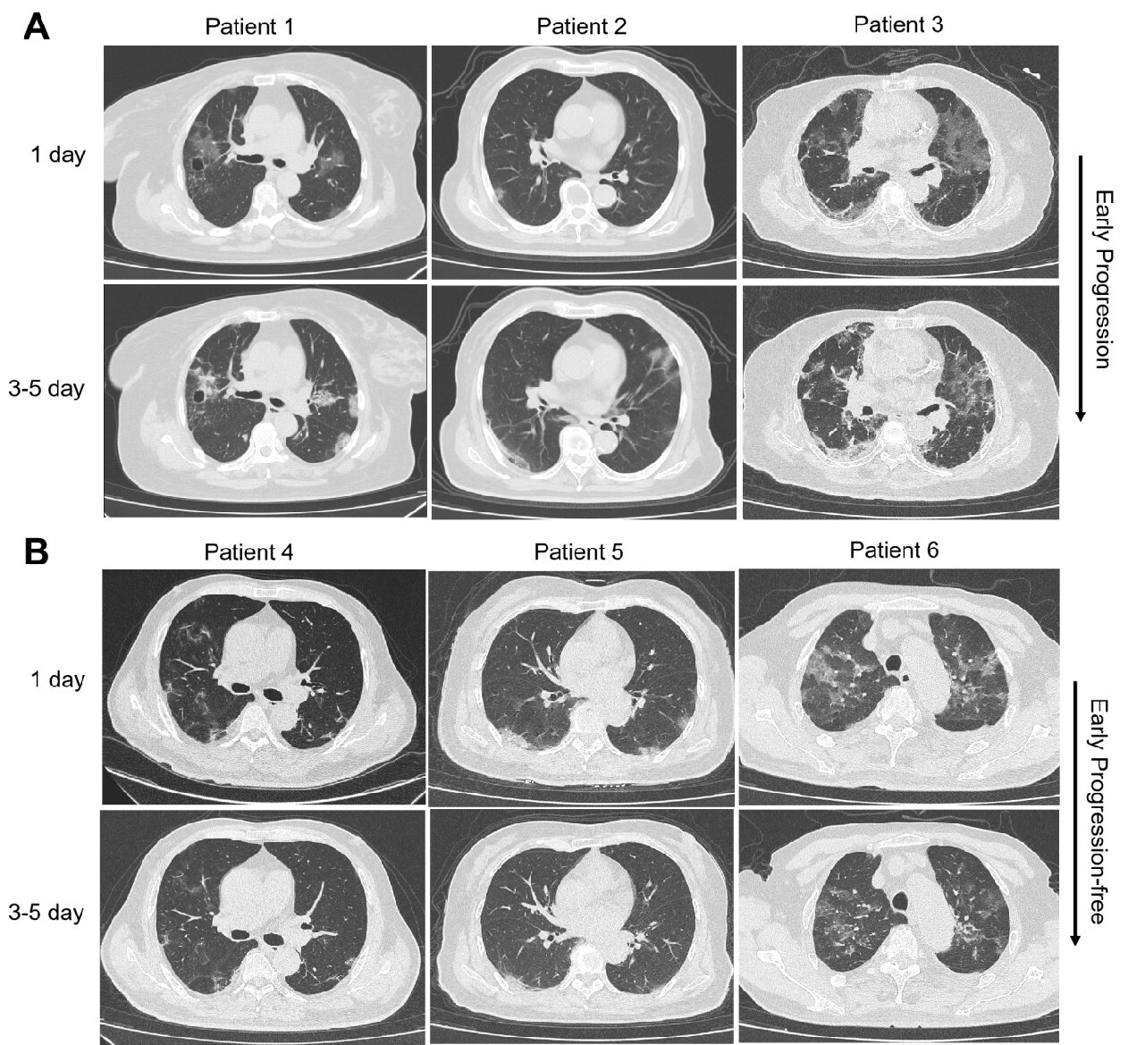

Supplemental Figure 1. Representative chest computed tomography (CT) scans on admission (day 1) and 3-5 days after treatment of older adult patients infected with Omicron sub-variants of COVID-19 who had the early-stage imaging progression (A, Patients 1-3), or progression-free on chest CT (B, Patients 4-6).

