Supplementary materials

eTable 1. Hyperparameter definition with nested 10-fold cross-validation
Models | Hyperparameter | Fixed values (All features)
XGBoost | Learning rate | 0.1
XGBoost | Max tree depth | 4
XGBoost | Min child weight | 4
XGBoost | Regularization strength | 0.5
LightGBM | Learning rate | 0.001
LightGBM | Max tree depth | 20
LightGBM | Number of estimators | 50
LightGBM | Number of leaves | 100
AdaBoost | Learning rate | 0.1
AdaBoost | Number of leaves | 100
GNB | Priors | None
GNB | Var_smoothing | 1e-07
CNB | Alpha (Laplace / Lidstone) | 0
MLP | Hidden layer sizes | (30, 30)
MLP | Max_iter | 20

Models | XGBoost | LightGBM | AdaBoost | GNB | CNB | MLP
XGBoost | NA | 0.357 | 0.569 | 0.5 | 0.347 | 0.583
LightGBM | 0.357 | NA | 0.355 | 0.336 | 0.423 | 0.427
AdaBoost | 0.569 | 0.355 | NA | 0.612 | 0.477 | 0.653
GNB | 0.5 | 0.336 | 0.612 | NA | 0.485 | 0.552
CNB | 0.347 | 0.423 | 0.477 | 0.485 | NA | 0.302
MLP | 0.583 | 0.427 | 0.653 | 0.552 | 0.302 | NA

eTable 2. The Delong test for AUC results of each machine learning model

eTable 3. The performance of XGBoost model in train, validation and test sets.
AUC | Sets | Accuracy | Sensitivity | Specificity | PPV | NPV | F1-Score
0.854 | Train | 0.779 | 0.754 | 0.810 | 0.788 | 0.773 | 0.770
0.856 | Validation | 0.778 | 0.760 | 0.846 | 0.787 | 0.776 | 0.771
0.804 | Test | 0.74 | 0.775 | 0.728 | 0.747 | 0.733 | 0.761

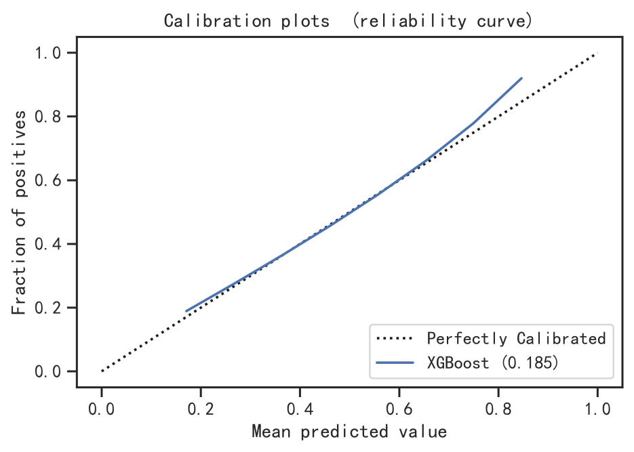
eFigure 1. The calibration plots for XGBoost model

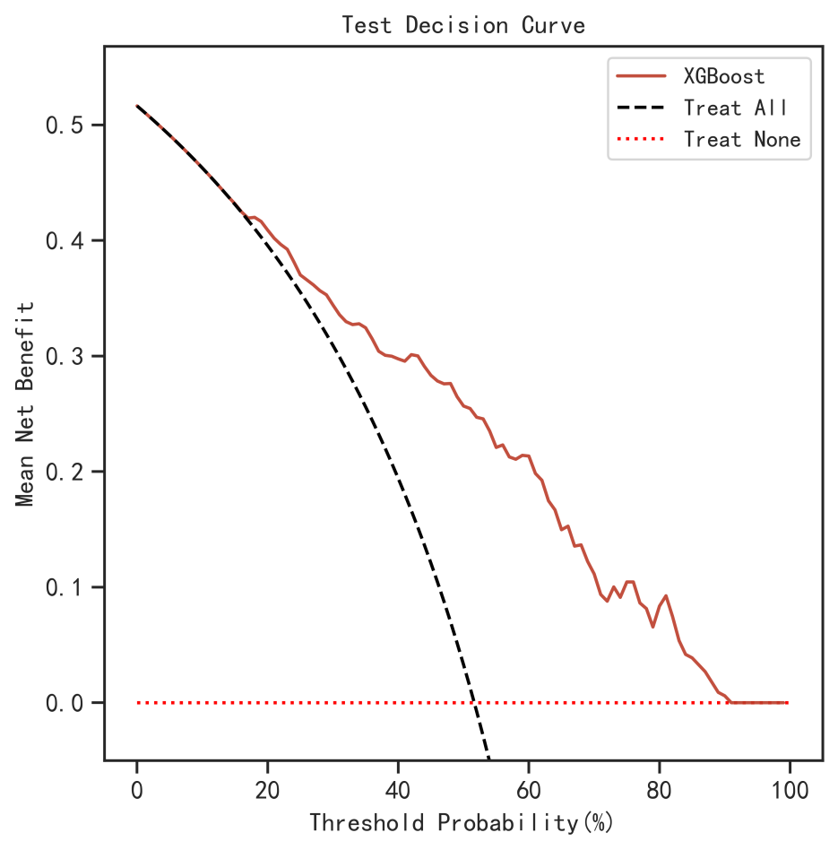
eFigure 2. The DCA curve for XGBoost model

