Supplementary Table 1 The specificity, sensitivity, and F1-score of the leave-one-subject-out cross-validations for the single thigh and single back accelerometer set-up when using accelerometry features and all feature combinations as input to the machine learning model. Values are mean (SD).
Feature  input | All participants (n=29) |  |  |  | Without sleep disorder (n=18) |  |  |  | With possible sleep disorder (n=11)
Feature  input | Specificity | Sensitivity | F1-score |  | Specificity | Sensitivity | F1-score |  | Specificity | Sensitivity | F1-score
Thigh
A | 0.51 (0.19) | 0.89 (0.12) | 0.70 (0.10) |  | 0.52 (0.16) | 0.85 (0.12) | 0.67 (0.09) |  | 0.64 (0.12) | 0.90 (0.06) | 0.76 (0.07)
A+T | 0.57 (0.20) | 0.92 (0.10) | 0.75 (0.10) |  | 0.51 (0.19) | 0.90 (0.07) | 0.71 (0.08) |  | 0.68 (0.18) | 0.88 (0.15) | 0.77 (0.12)
A+Cy | 0.70 (0.18) | 0.93 (0.06) | 0.81 (0.10) |  | 0.61 (0.21) | 0.93 (0.07) | 0.78 (0.12) |  | 0.79 (0.11) | 0.88 (0.10) | 0.82 (0.07)
A+Ci | 0.61 (0.20) | 0.93 (0.10) | 0.77 (0.12) |  | 0.57 (0.19) | 0.92 (0.08) | 0.75 (0.11) |  | 0.71 (0.12) | 0.90 (0.14) | 0.80 (0.12)
A+T+Cy | 0.67 (0.21) | 0.94 (0.06) | 0.81 (0.11) |  | 0.63 (0.20) | 0.94 (0.06) | 0.79 (0.10) |  | 0.76 (0.22) | 0.86 (0.16) | 0.79 (0.09)
A+T+Ci | 0.69 (0.20) | 0.94 (0.10) | 0.82 (0.10) |  | 0. 64(0.20) | 0.94 (0.04) | 0.80 (0.10) |  | 0.79 (0.15) | 0.88 (0.17) | 0.81 (0.11)
A+Cy+Ci | 0.70 (0.19) | 0.94 (0.06) | 0.82 (0.11) |  | 0.64 (0.21) | 0.94 (0.06) | 0.80 (0.11) |  | 0.80 (0.09) | 0.92 (0.09) | 0.84 (0.07)
A+T+Cy+CI | 0.70 (0.21) | 0.94 (0.06) | 0.82 (0.11) |  | 0.67 (0.24) | 0.95 (0.06) | 0.82 (0.10) |  | 0.78 (0.21) | 0.88 (0.14) | 0.81 (0.10)
Back
A | 0.57 (0.20) | 0.93 (0.06) | 0.75 (0.10) |  | 0.49 (0.19) | 0.93 (0.06) | 0.72 (0.08) |  | 0.65 (0.20) | 0.96 (0.03) | 0.81 (0.11)
A+T | 0.61 (0.20) | 0.93 (005.) | 0.78 (0.09) |  | 0.54 (0.21) | 0.93 (0.07) | 0.74 (0.08) |  | 0.70 (0.15) | 0.96 (0.02) | 0.84 (0.07)
A+Cy | 0.69 (0.18) | 0.94 (007.) | 0.82 (0.11) |  | 0.63 (0.24) | 0.94 (0.05) | 0.79 (0.13) |  | 0.79 (0.12) | 0.90 (0.12) | 0.84 (0.07)
A+Ci | 0.67 (0.18) | 0.93 (0.06) | 0.80 (0.09) |  | 0.63 (0.17) | 0.94 (0.04) | 0.79 (0.09) |  | 0.78 (0.10) | 0.91 (0.08) | 0.83 (0.09)
A+T+Cy | 0.68 (0.18) | 0.94 (006.) | 0.82 (0.10) |  | 0.62 (0.23) | 0.94 (0.06) | 0.78 (0.11) |  | 0.78 (0.15) | 0.93 (0.07) | 0.85 (0.06)
A+T+Ci | 0.68 (0.21) | 0.95 (0.05) | 0.82 (0.10) |  | 0.63 (0.20) | 0.96 (0.03) | 0.81 (0.09) |  | 0.76 (0.11) | 0.94 (0.05) | 0.85 (0.07)
A+Cy+Ci | 0.71 (0.18) | 0.93 (0.06) | 0.82 (0.10) |  | 0.64 (0.20) | 0.95 (0.03) | 0.80 (0.09) |  | 0.80 (0.10) | 0.93 (0.08) | 0.85 (0.06)
A+T+Cy+CI | 0.71 (0.19) | 0.95 (0.06) | 0.83 (0.11) |  | 0.64 (0.22) | 0.94 (0.05) | 0.79 (0.11) |  | 0.79 (0.13) | 0.92 (0.05) | 0.85 (0.07)
Abbreviations: A, accelerometer; T, skin temperature; Cy, cyclic time; Ci, circadian rhythm

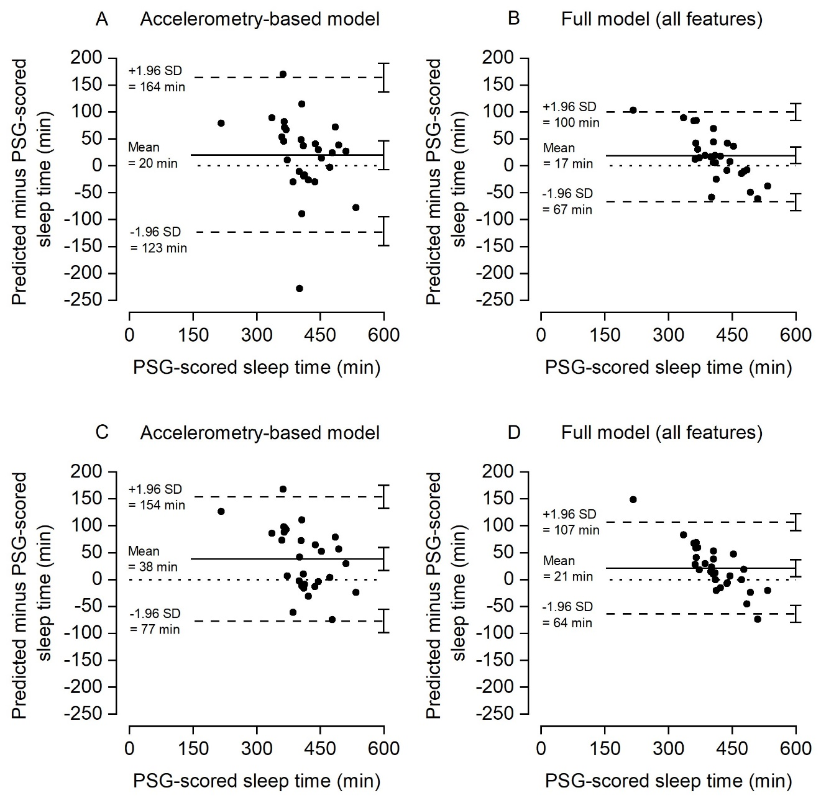
Supplementary Figure 1 Bland-Altman plots indicating the difference in total sleep time predicted by the machine learning model when including accelerometry-derived features and all features versus the PSG-scored sleep time for the thigh accelerometer data (A and B) and low back accelerometer data (C and D). The upper and lower dashed lines indicate the 95% limits of agreement and middle solid line the mean difference. The dotted horizontal line indicates zero (i.e., line of equality). The regression line is indicated by the short, dotted line. The error bars on right side indicate the 95% confidence interval for the limits of agreement and the mean difference.

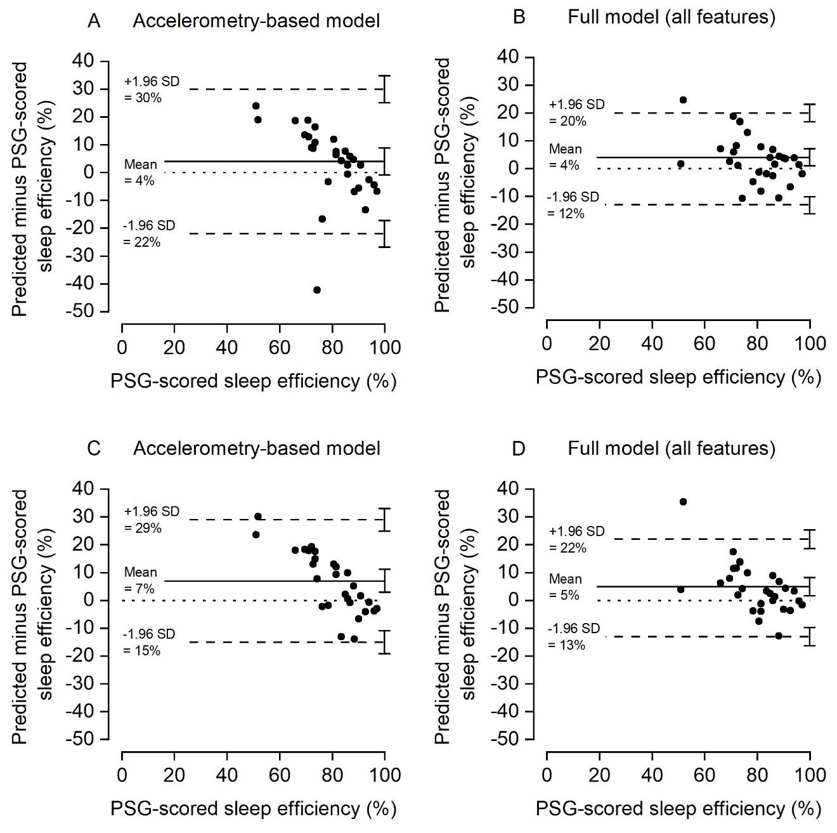
Supplementary Figure 2 Bland-Altman plots indicating the difference in sleep efficiency predicted by the machine learning model when including accelerometry-derived features and all features versus the PSG-scored sleep time for the thigh accelerometer data (A and B) and low back accelerometer data (C and D). The upper and lower dashed lines indicate the 95% limits of agreement and middle solid line the mean difference. The dotted horizontal line indicates zero (i.e., line of equality). The regression line is indicated by the short, dotted line. The error bars on the right side indicate the 95% confidence interval for the limits of agreement and the mean difference.

