The supplementary materials of results of networks

Supplementary Fig.s1 Accuracy of edge weights in item network of kinesiophobia
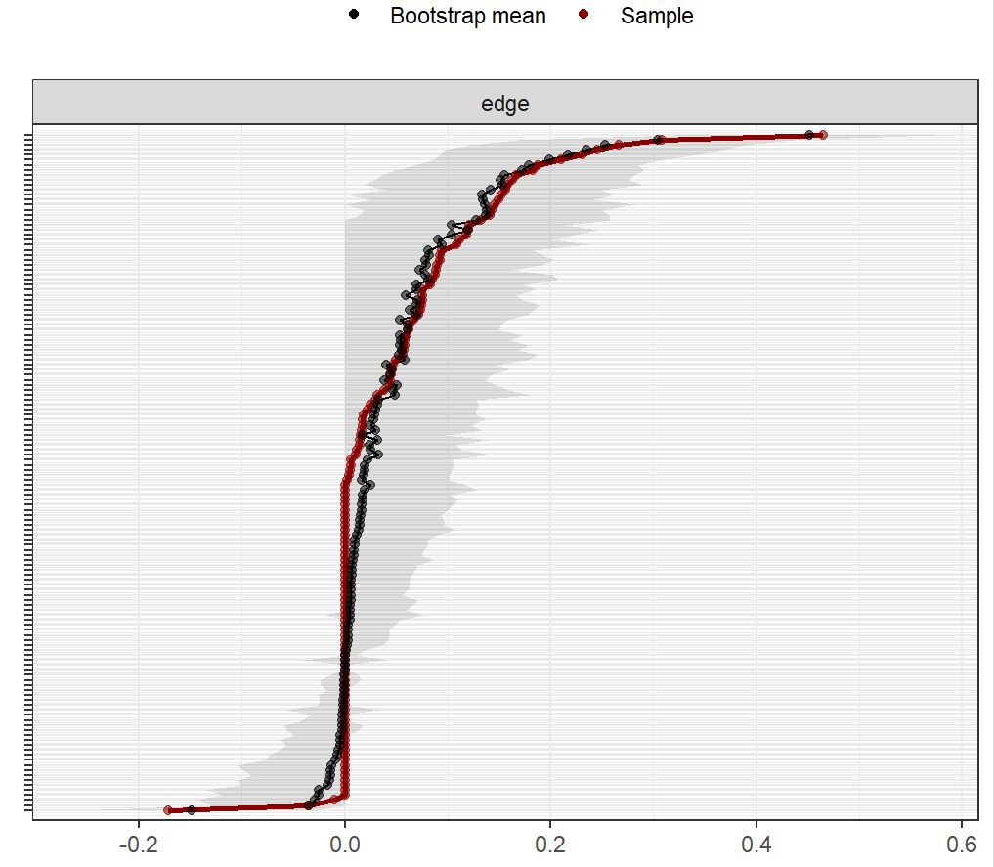

Supplementary Fig.s2 Bootstrapped difference test for edge weights in item network of kinesiophobia
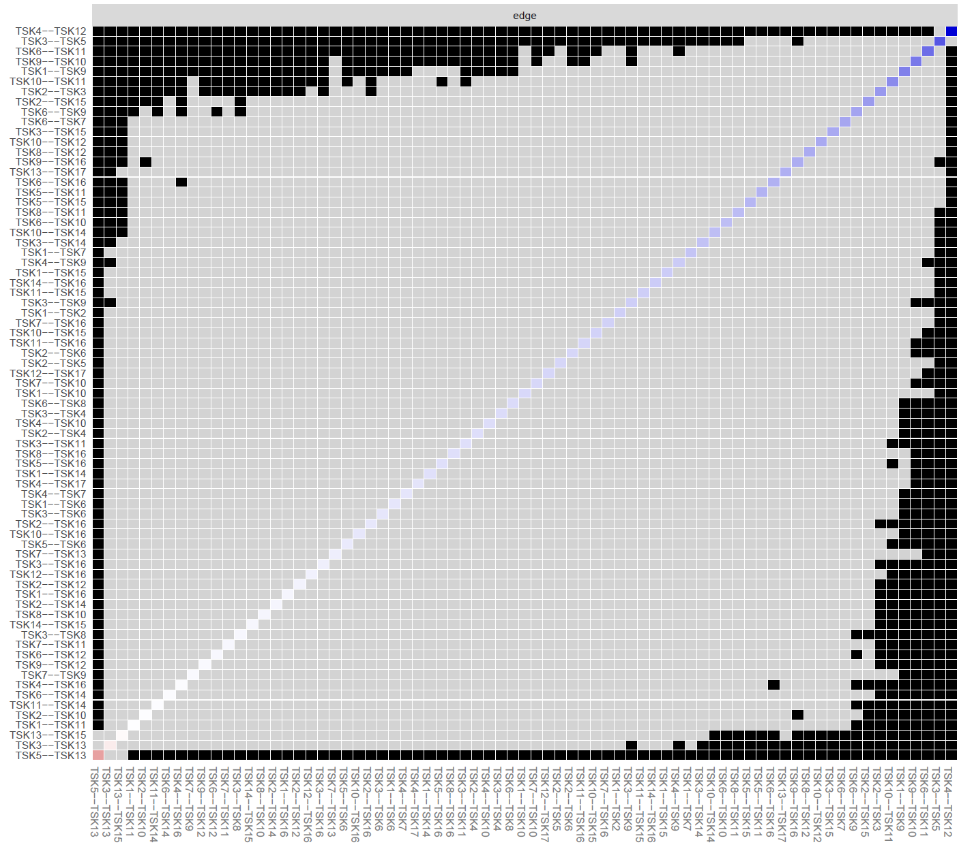

Supplementary Fig.s3 Stability of node strength in item network of kinesiophobia
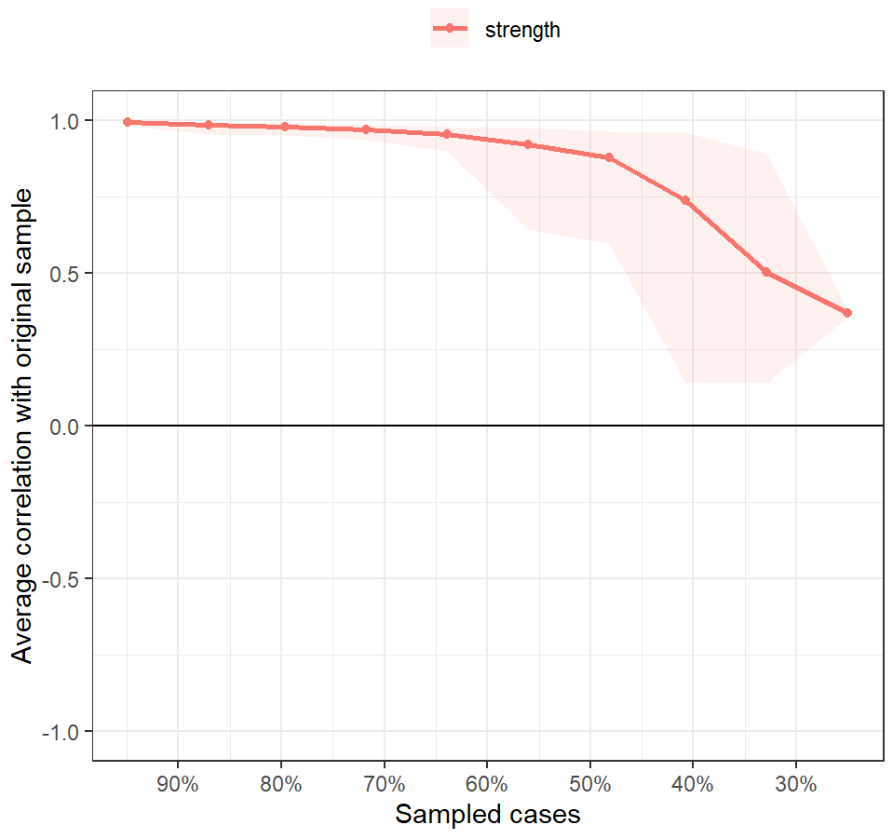

Supplementary Fig.s4 Bootstrapped difference test for node strength in item network of kinesiophobia
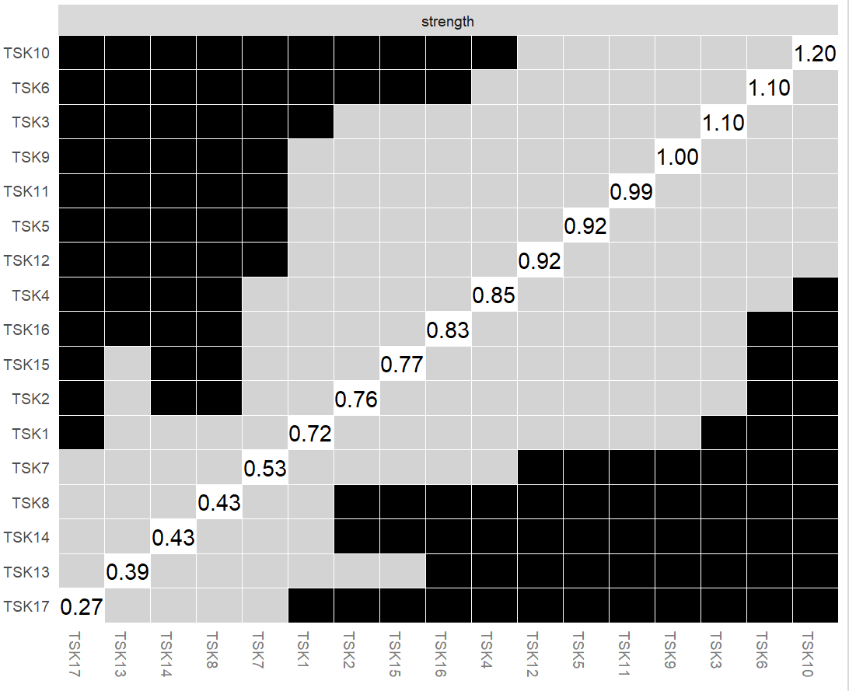

Supplementary Fig.s5 Accuracy of edge weights in pain catastrophizing/self-efficacy-kinesiophobia network
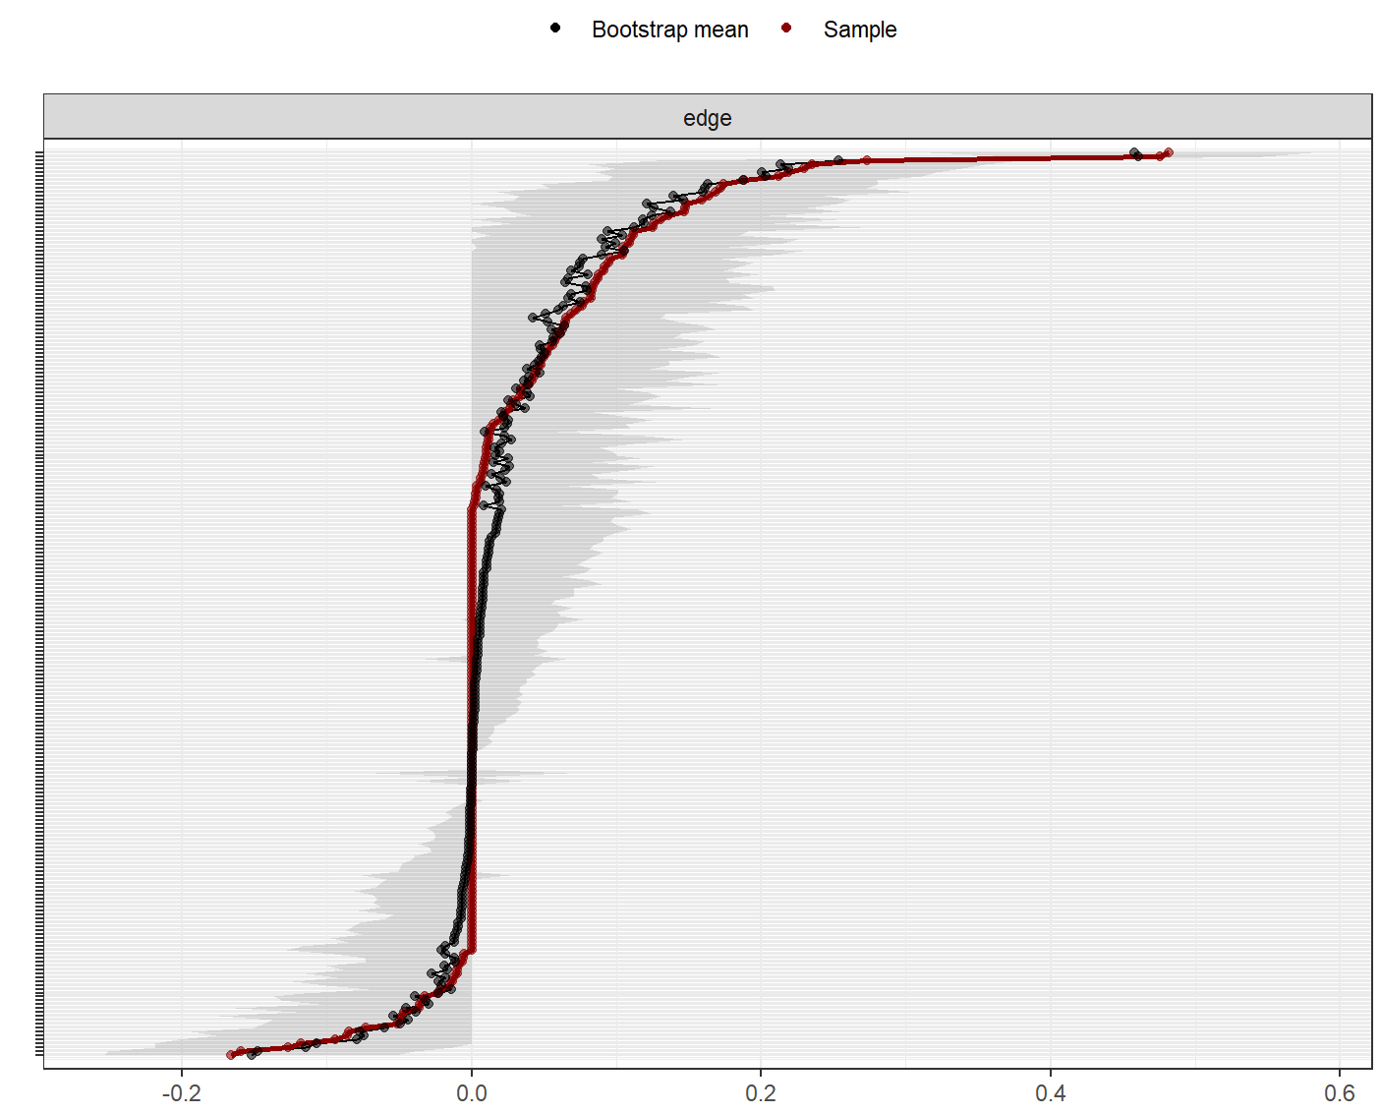

Supplementary Fig.s6 Bootstrapped difference test for edge weights in pain catastrophizing/self-efficacy-kinesiophobia network
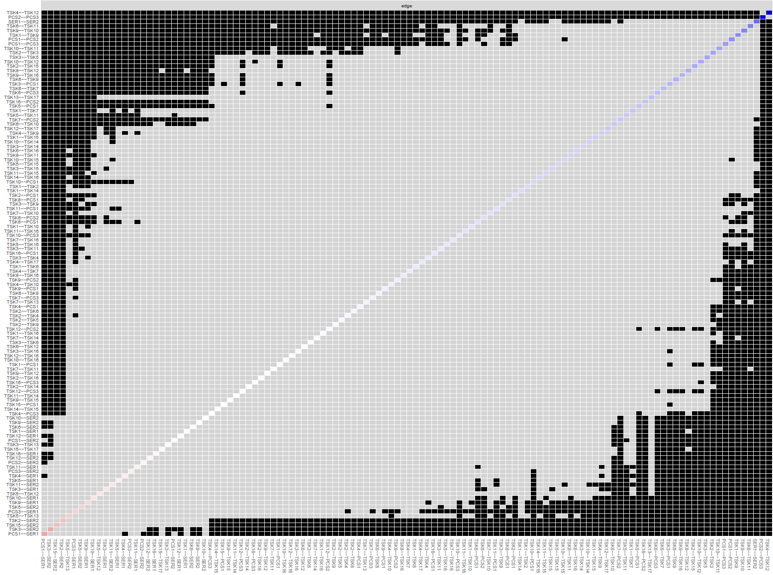

Supplementary Fig.s7 Stability of node bridge expected influences in pain catastrophizing/self-efficacy-kinesiophobia network
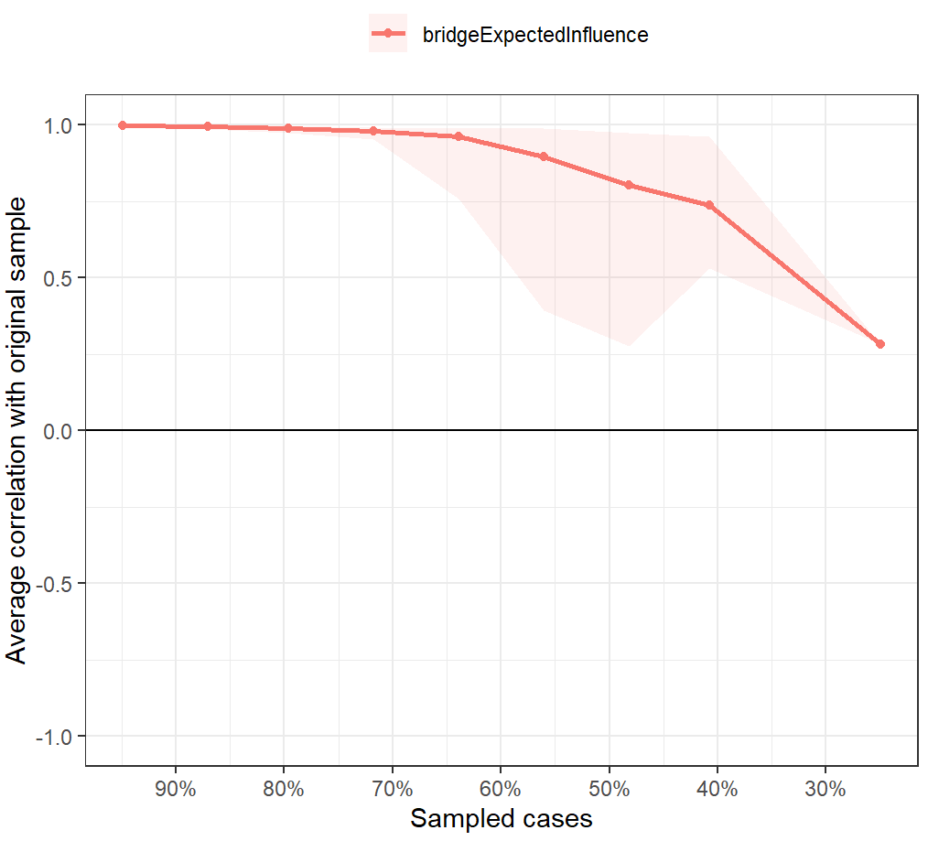
Supplementary Fig.s8 Bootstrapped difference test for node bridge expected influences in pain catastrophizing/self-efficacy-kinesiophobia network
