Supplementary Material
Increased PD-1⁺ NK cell subset in the older population

Meiju Deng^{1,2#}, Yongqin Zeng^{2,3#}, Ying Liu², Xiaolei Wang^{1,2}, Na Chen^{1,2}, Mengyuan Zhang^{1,4,5,6}, Meiqing Jiang^{1,4,5,6}, Hongxin Zhao²*, Juan Du^{1,4,5,6}*

¹Beijing Key Laboratory of Emerging Infectious Diseases, Institute of Infectious Diseases, Beijing Ditan Hospital, Capital Medical University, Beijing, 100015, People’s Republic of China.
² Clinical Center for HIV/AIDS, Beijing Ditan Hospital, Capital Medical University, Beijing, 100015, People’s Republic of China.

³Department of Nephrology, The Affiliated Hospital Guizhou Medical University, Guiyang, Guizhou, 550004, People’s Republic of China.

⁴Beijing Institute of Infectious Diseases，Beijing, 100015, People’s Republic of China.

⁵National Center for Infectious Diseases, Beijing Ditan Hospital, Capital Medical University, Beijing, 100015, People’s Republic of China.

⁶National Key Laboratory of Intelligent Tracking and Forecasting for Infectious Diseases, Beijing, 100015, People’s Republic of China.

#Equal contribution

J Du and H Zhao are co-corresponding authors

*Correspondence: Juan Du, Email: duj656@ccmu.edu.cn

Hongxin Zhao, Email: Drzhao66@ccmu.edu.cn

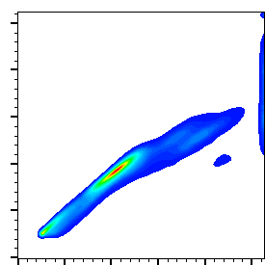
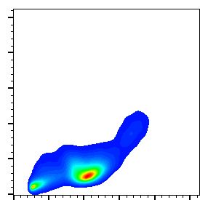
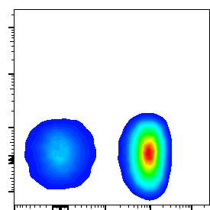
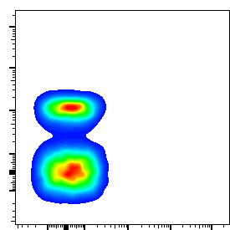
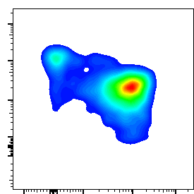
Supplementary Figures
FSC-A
FSC-H
FSC-A
SSC-A
CD3
7AAD
CD14
CD19
CD16
CD56
CD56^{neg}CD16⁺
CD56^{dim}CD16⁺
CD56^{bright}CD16⁻

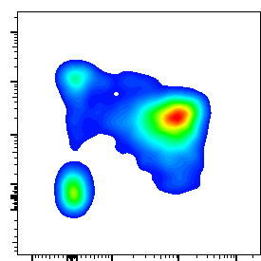
CD16
CD56

Figure S1. Flow cytometry gating strategy
Representative gating strategy for flow cytometry analysis of peripheral blood NK cells in humans.

B
Age in decades
Age in decades
*
Age in decades
A
H
C
Age in decades
Age in decades
Age in decades
D
I
Age in decades
E
Age in decades
F
Age in decades
G
*
**
***
*
****
****

Figure S2. Changes of absolute number, subset distribution and phenotype on NK cells with age
Flow cytometry analysis of NK cell absolute number, subset distribution and phenotype was performed on PBMCs collected from donors of three age groups (n = 27-37 for each group).
(A-D) Box plots of the absolute number of NK cells, CD56^{bright}CD16⁻ NK cells, CD56^{dim}CD16⁺ NK cells and CD56^{neg}CD16⁺ NK cells from donors of three age groups. (E-G) Box plots of the percentage of NK cells subset from donors of three age groups, including CD56^{bright}CD16⁻ NK cells, CD56^{dim}CD16⁺ NK cells and CD56^{neg}CD16⁺ NK cells. (H, I) Box plots of the percentage of CD57⁺ and CD69⁺ NK cells from donors of three age groups. P values were obtained by the Kruskal-Wallis test followed by Dunn’s multiple comparisons test. *P < 0.05, **P < 0.01, ***P < 0.001, ****P < 0.0001.

Age in decades
Age in decades
Age in decades
Age in decades
Age in decades
Age in decades
Age in decades
Age in decades
A
B
C
D
E
F
G
H
**
*
*
*
**

Figure S3. Expression of co-inhibitory molecules on NK cells in three age groups
Flow cytometry analysis of expression of 2B4 (A), CTLA-4 (B), TIM-3 (C), BTLA (D), CD70 (E), CD39 (F), CD160 (G) and TIGIT (H). Box plots of the positive percentage of the above receptors on NK cells from donors in three age groups (n = 27-37 for each group). P values were obtained by the Kruskal-Wallis test followed by Dunn’s multiple comparisons test. *P < 0.05, **P < 0.01.

Age in decades
Age in decades
Age in decades
B
C
D
E
****
***
****
***
Age in decades
r=0.1644
P=0.1058
A
Age in decades

F
Age in decades
F
≥60
M
F
M
M
F
20-39
40-59

Figure S4. PD-1-positive NK cells accumulated in older people and accumulation of PD-1⁺ NK cells was independent of gender.
(A) Box plots of the percentage of PD-1⁺ cells among CD56^{neg}CD16⁺ NK cells (A, left) from individuals in different age groups (n = 14-22 each group). Correlation analysis of the percentage of PD-1⁺ cells among CD56^{neg}CD16⁺ NK cells (A, right) with age on NK cells from all individuals. (B-E) Box plots of the percentage of PD-1⁺ cells among NK cells, CD56^{bright}CD16⁻ NK cells, CD56^{dim}CD16⁺ NK cells, CD56^{neg}CD16⁺ NK cells from individuals in three age groups (n = 27-37 each group). (F) Box plots of PD-1 expression on NK cells from males and females (left). Box plots of PD-1 expression on NK cells from males and females in different age groups (right). P values were obtained by the Kruskal-Wallis test followed by Dunn’s multiple comparisons test. Spearman’s non-parametric test was used to test for correlations. ***P < 0.001, ****P < 0.0001.

