Supplementary Materials for
Lymphocyte-to-C reactive protein ratio is an independent predictor of survival benefits for
hepatocellular carcinoma patients receiving radiotherapy
Zhan Shi^{1#}, Sihui Zhu^{2#}, Yuncheng Jin¹, Liang Qi¹, Mingzhen Zhou¹, Ziyan Zhou¹, Juan Zhang¹, Baorui Liu¹*, Jie Shen¹*
Corresponding authors: Jie Shen, shenjie2008nju@163.com; Baorui Liu, baoruiliu@nju.edu.cn.

This Word file includes:
Supplementary Figure 1 to 5.
Supplementary Table 1 and 2.

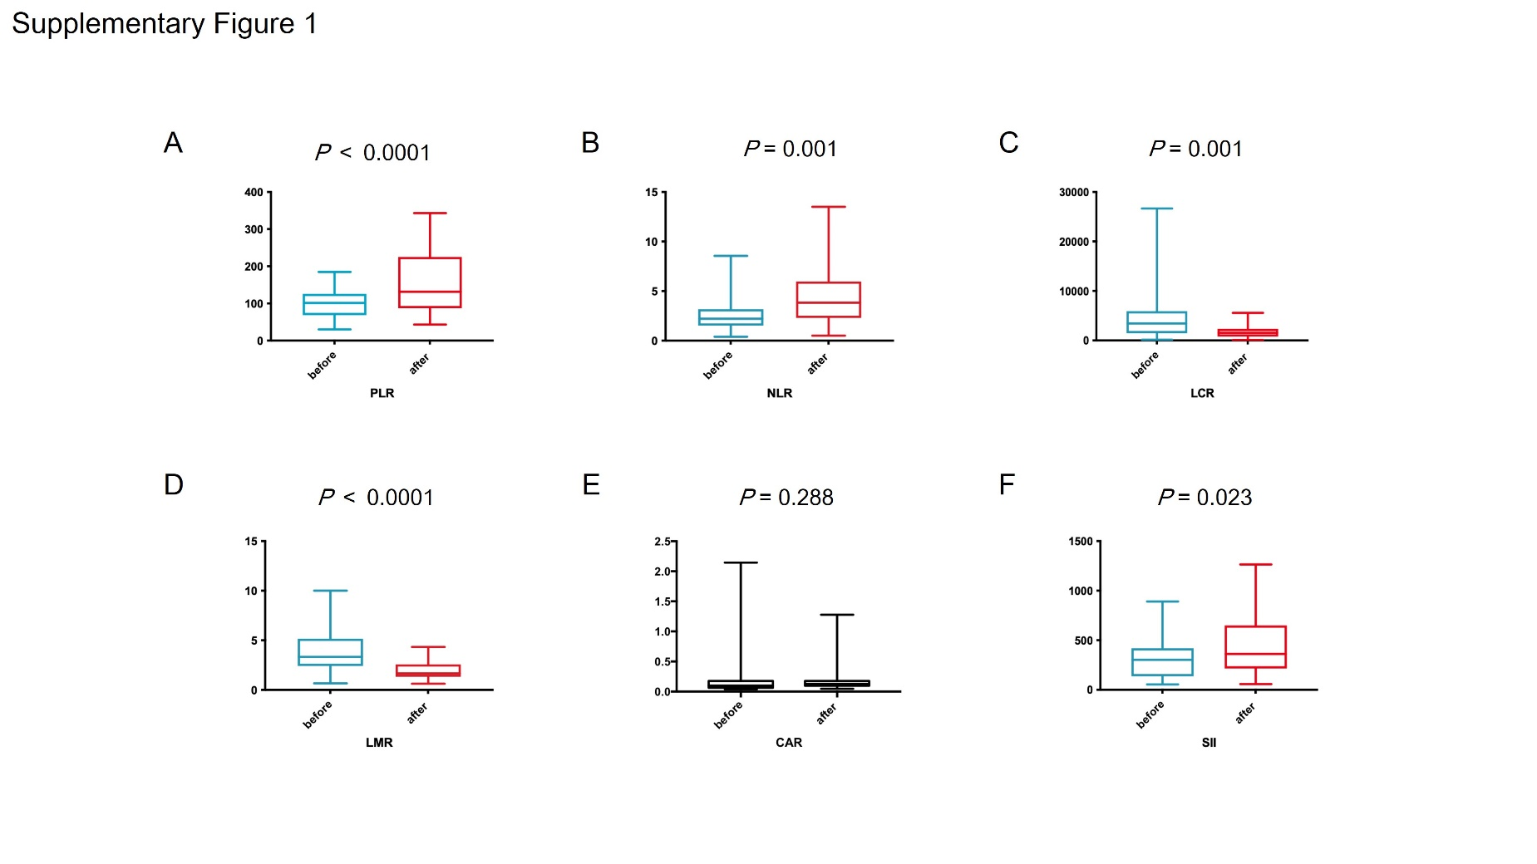
Supplementary Fig. 1. Boxplot of pre- and post-radiotherapy PLR (A), NLR (B), LCR (C), LMR (D), CAR (E) and SII (F) for primary liver lesions. Abbreviations: PLR, platelet-to-lymphocyte ratio; NLR, neutrophil-to-lymphocyte ratio; LCR, lymphocyte‐to-C reactive protein ratio; LMR, lymphocyte-to-monocyte ratio; CAR, C-reactive protein-to-albumin ratio; SII, systemic immune-inflammation index.

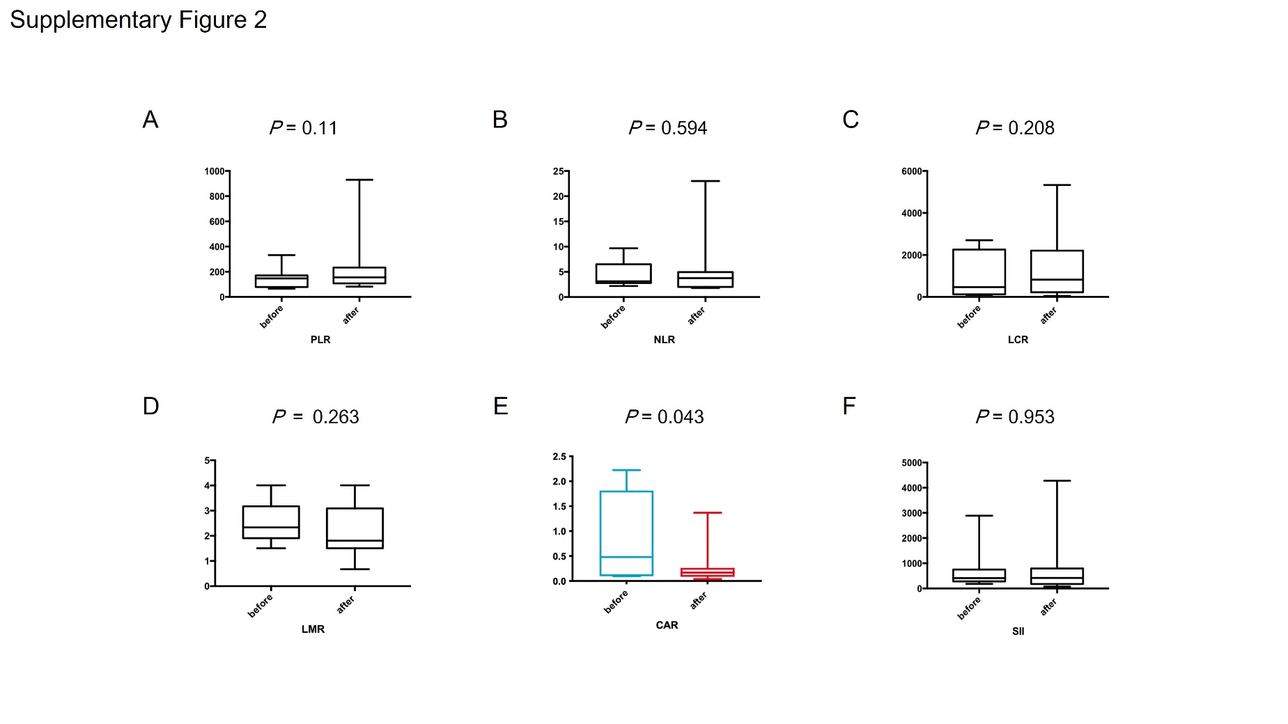
Supplementary Fig. 2. Boxplot of pre- and post-radiotherapy PLR (A), NLR (B), LCR (C), LMR (D), CAR (E) and SII (F) for metastatic bone lesions. Abbreviations: PLR, platelet-to-lymphocyte ratio; NLR, neutrophil-to-lymphocyte ratio; LCR, lymphocyte‐to-C reactive protein ratio; LMR, lymphocyte-to-monocyte ratio; CAR, C-reactive protein-to-albumin ratio; SII, systemic immune-inflammation index.

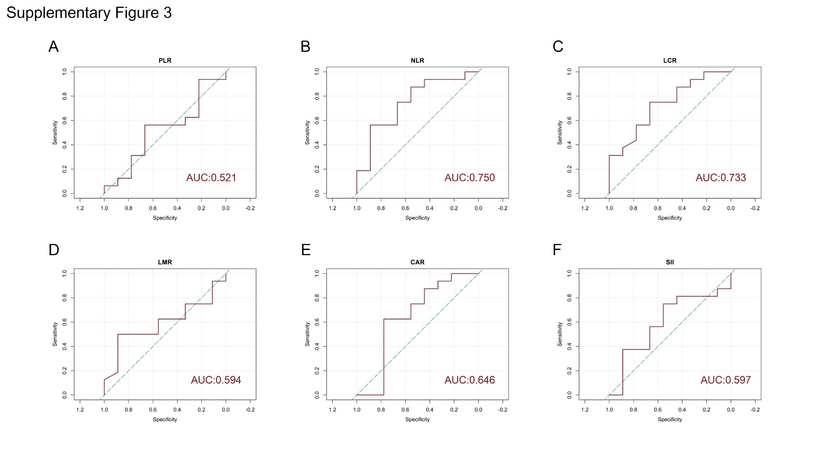
Supplementary Fig. 3. ROC results for 1-year OS of PLR (A), NLR (B), LCR (C), LMR (D), CAR (E) and SII (F). Abbreviations: ROC, receiver operating characteristic; AUC, area under the curve; OS, overall survival; PLR, platelet-to-lymphocyte ratio; NLR, neutrophil-to-lymphocyte ratio; LCR, lymphocyte‐to-C reactive protein ratio; LMR, lymphocyte-to-monocyte ratio; CAR, C-reactive protein-to-albumin ratio; SII, systemic immune-inflammation index.

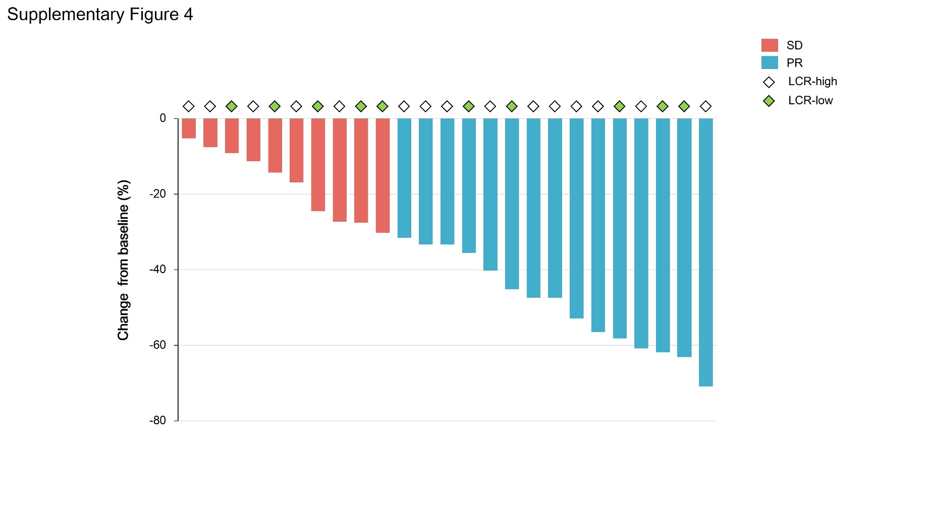
Supplementary Fig. 4. Best percentage change in tumor size from baseline of target lesions. Abbreviations: SD, stable disease; PR, partial response; LCR, lymphocyte‐to-C reactive protein ratio.

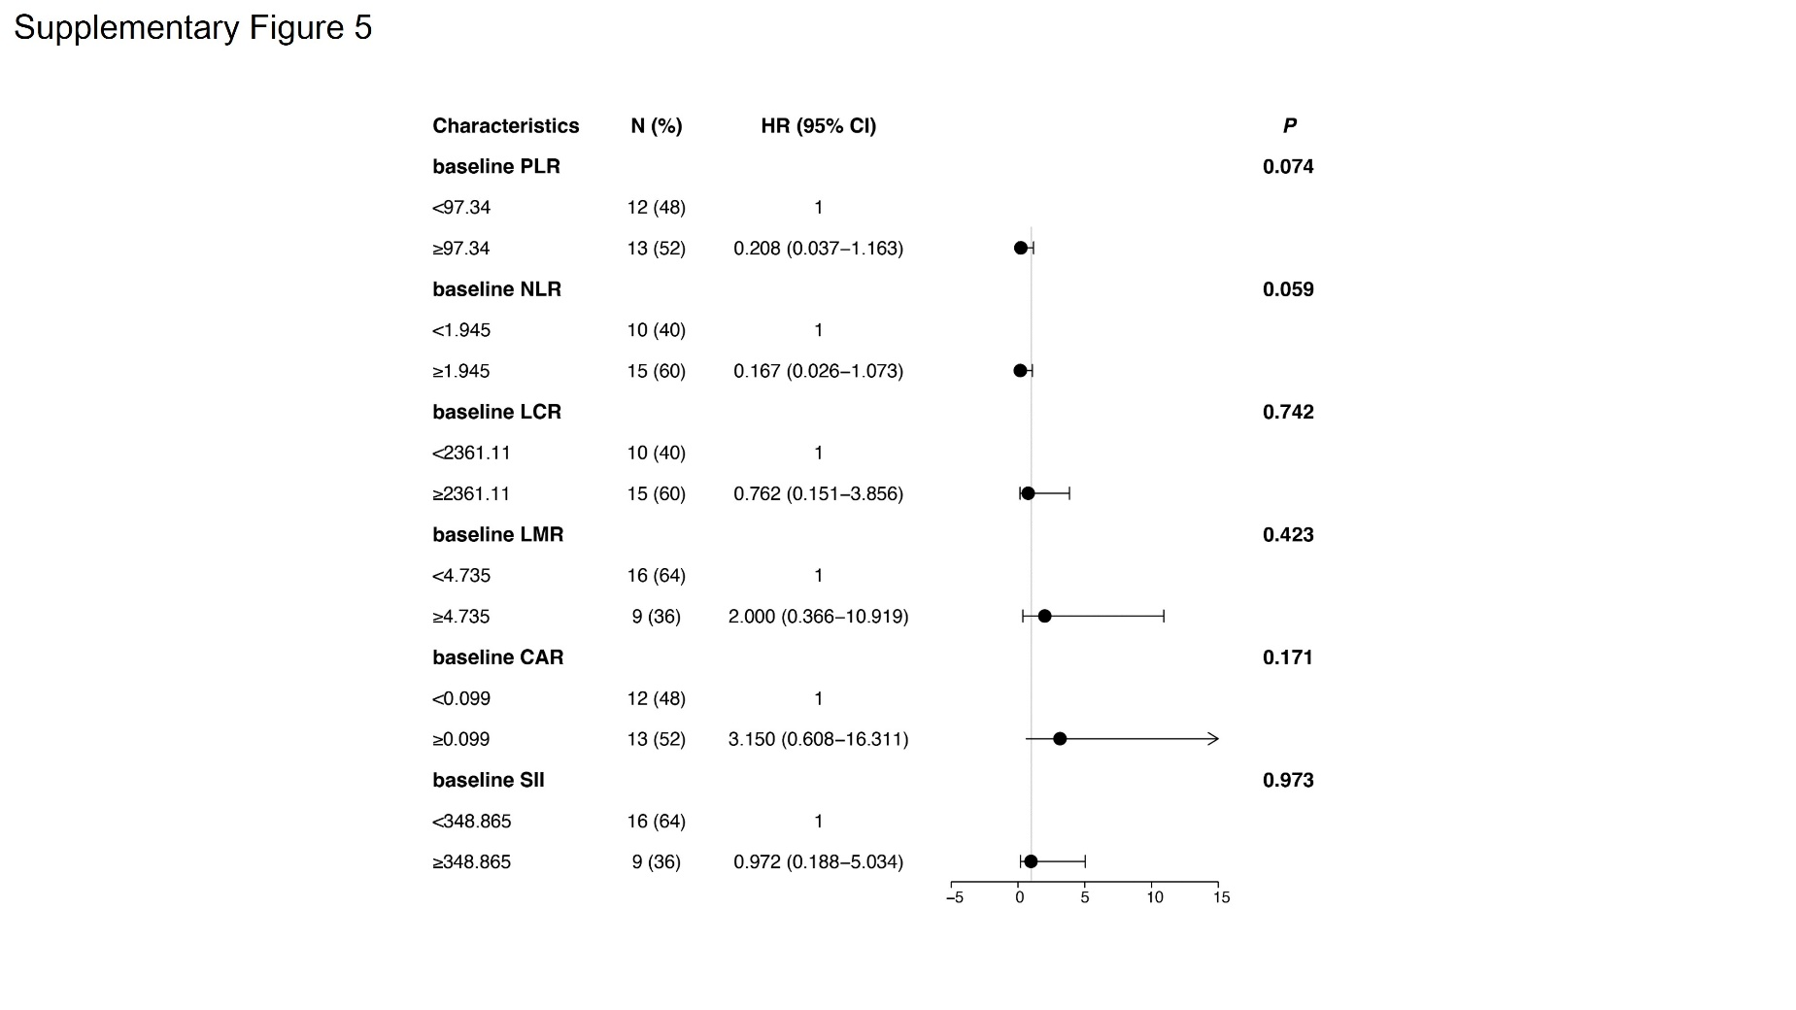
Supplementary Fig. 5. Forest plot for liver toxicity assessed by inflammatory markers. Abbreviations: HR, hazard ratio; CI, confidence interval; PLR, platelet-to-lymphocyte ratio; NLR, neutrophil-to-lymphocyte ratio; LCR, lymphocyte‐to-C reactive protein ratio; LMR, lymphocyte-to-monocyte ratio; CAR, C-reactive protein-to-albumin ratio; SII, systemic immune-inflammation index.

Supplementary Table 1. Tumor response after radiotherapy
Response | Total,  N (%) | PLR |  | P | NLR |  | P | LCR |  | P | LMR |  | P | CAR |  | P | SII |  | P
Response | Total,  N (%) | Low | High |  | Low | High |  | Low | High |  | Low | High |  | Low | High |  | Low | High
CR | 0 | 0 | 0 |  | 0 | 0 |  | 0 | 0 |  | 0 | 0 |  | 0 | 0 |  | 0 | 0
PR | 15 | 6 | 9 |  | 6 | 9 |  | 5 | 10 |  | 9 | 6 |  | 8 | 7 |  | 10 | 5
SD | 10 | 6 | 4 |  | 4 | 6 |  | 5 | 5 |  | 7 | 3 |  | 4 | 6 |  | 6 | 4
PD | 0 | 0 | 0 |  | 0 | 0 |  | 0 | 0 |  | 0 | 0 |  | 0 | 0 |  | 0 | 0
ORR | 15 (60.0) | 6 (50.0) | 9 (69.2) | 0.428 | 6 (60.0) | 9 (60.0) | 1.000 | 5 (50.0) | 10 (66.7) | 0.442 | 9 (56.3) | 6 (66.7) | 0.691 | 8 (66.7) | 7 (53.8) | 0.688 | 10 (62.5) | 5 (55.6) | 1.000
DCR | 25 (100) | 12 (100) | 13 (100) |  | 10 (100) | 15 (100) |  | 10 (100) | 15 (100) |  | 16 (100) | 9 (100) |  | 12 (100) | 13 (100) |  | 16 (100) | 9 (100)

Abbreviations: CR, complete response; PR, partial response; SD, stable disease; PD, progressive disease; ORR, objective response rate; DCR, disease control rate; PLR, platelet-to-lymphocyte ratio; NLR, neutrophil-to-lymphocyte ratio; LCR, lymphocyte-to-C reactive protein ratio; LMR, lymphocyte-to-monocyte ratio; CAR, C-reactive protein-to-albumin ratio; SII, systemic immune-inflammation index.

Supplementary Table 2. Liver toxicity within 3 months after radiotherapy
Toxicity | Grade
Toxicity | 0 | 1 | 2 | ≥3
Toxicity | Cases (%) | Cases (%) | Cases (%) | Cases (%)
Elevated ALT | 16 (64.0) | 9 (36.0) | 0 (0) | 0 (0)
Elevated AST | 16 (64.0) | 9 (36.0) | 0 (0) | 0 (0)
Hyperbilirubinemia | 23 (92.0) | 2 (8.0) | 0 (0) | 0 (0)
Elevated GGT | 4 (16.0) | 7 (28.0) | 11 (44.0) | 3 (12.0)
Hypoalbuminemia | 14 (56.0) | 11 (44.0) | 0 (0) | 0 (0)
Elevated ALP | 25 (100) | 0 (0) | 0 (0) | 0 (0)
Prolonged APTT | 20 (100) | 5 (20.0) | 0 (0) | 0 (0)
Elevated INR | 25 (100) | 0 (0) | 0 (0) | 0 (0)

Abbreviations: ALT, alanine aminotransferase; AST, aspartate aminotransferase; ALP, alkaline phosphatase; GGT, gamma-glutamyl transferase; APTT, activated partial thromboplastin time; INR, international normalized ratio.

