Supplementary material
Exploring the Multifaceted Landscape of Pediatric Obstructive Sleep Apnea: Insights into Prevalence, Severity, and Coexisting Conditions
Qin Yang^{1,2}, Xiao Huang², Yanhong Lin¹, Ke Chen¹, Qinghua Lu¹, Weinan Lin¹, Xing Wang², Yishu Teng³, Peng Jiang³, Sandip Patil^{3*}, Yuejie Zheng^{1*}
- Department of Respiratory Medicine, Shenzhen Children’s Hospital, Shenzhen, Guangdong Province, People’s Republic of China
- Department of Sleep Centre, Shenzhen Children’s Hospital, Shenzhen, Guangdong Province, People’s Republic of China
- Department of Haematology and Oncology, Shenzhen Children's Hospital, Shenzhen, Guangdong Province, People’s Republic of China

* Corresponding Author:
      - Dr Sandip Patil
Department of Haematology and Oncology,
Shenzhen Children's Hospital, Shenzhen, Guangdong Province, People’s Republic of China
E-mail: sandippatil1309@yahoo.com
Phone:+85-755-82008283
      - Professor Yuejie Zheng
Department of Respiratory Medicine,
Shenzhen Children’s Hospital, Shenzhen, Guangdong Province, People’s Republic of China E-mail: shine1990@sina.com

S1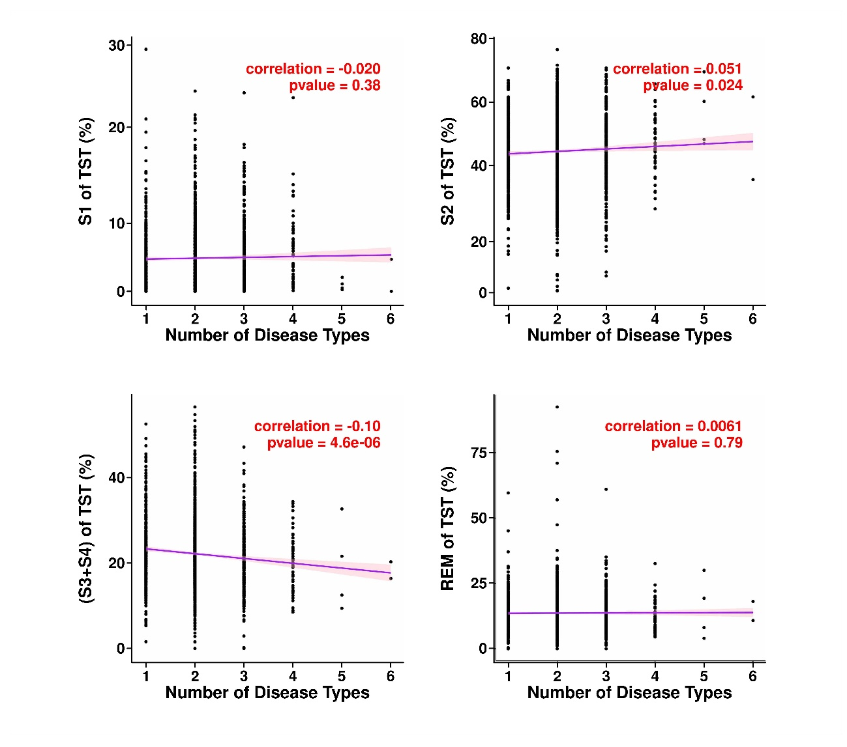
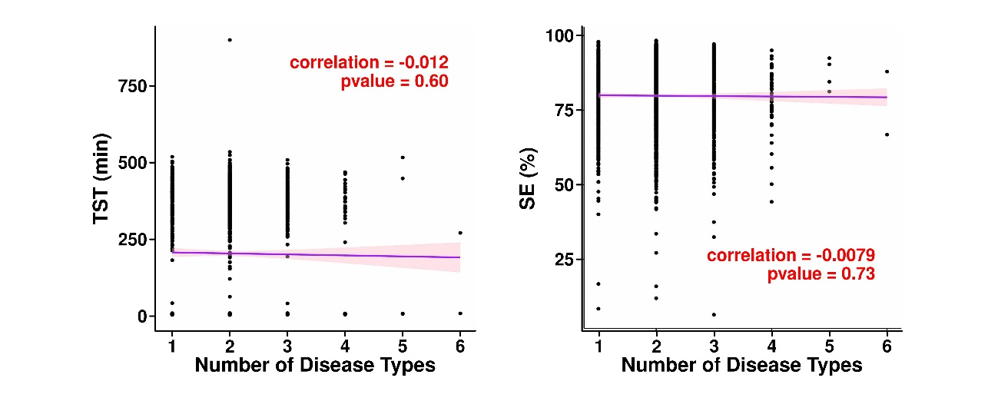
Fig S1. Analysis demonstrated several noteworthy correlations
Note: TST: Total Sleep Time; REM: Rapid Eye Movement
S2

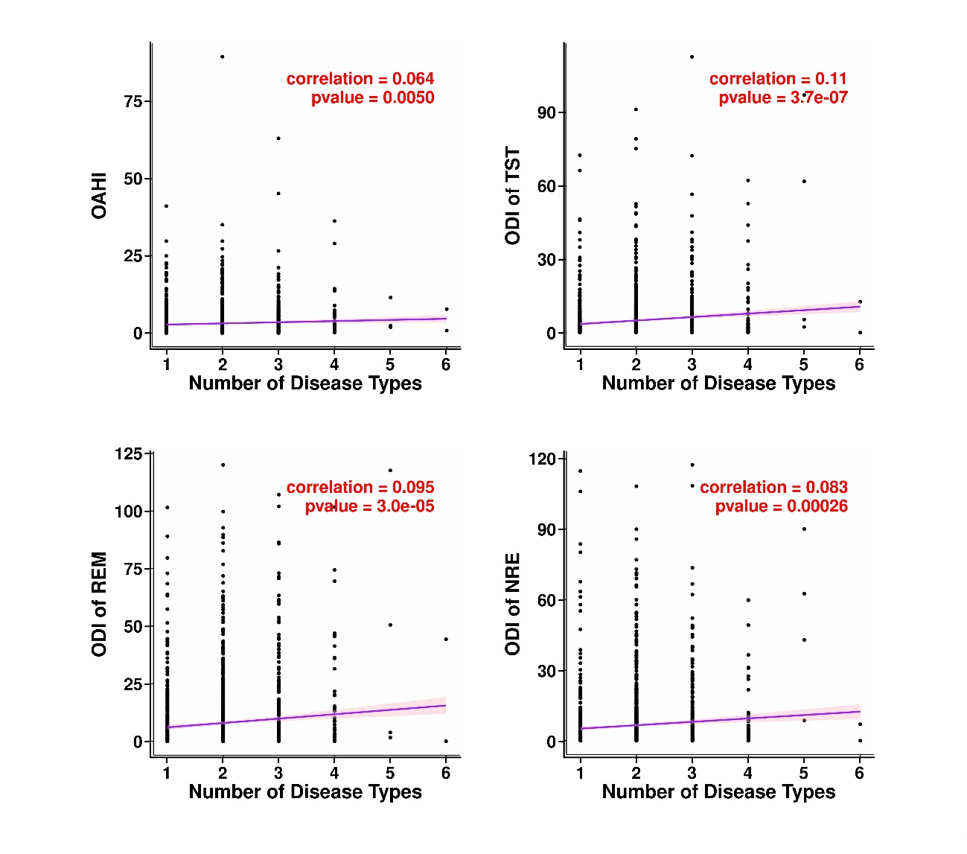
Fig S2. The Hypopnea Index (HI) exhibited positive correlations with various Oxygen Desaturation Indices (ODI) thresholds

