Supporting Information
Nanosuspension-Loaded Dissolving Microneedle Patches for Enhanced Transdermal Delivery of a Highly Lipophilic Cannabidiol
Aguo Cheng¹⁻², Suohui Zhang^{1,3}, Fanda Meng⁴, Mengzhen Xing⁵, Han Liu³, Guozhong Yang³, Yunhua Gao¹⁻³

¹Key Laboratory of Photochemical Conversion and Optoelectronic Materials, Technical Institute of Physics and Chemistry of Chinese Academy of Sciences, Beijing, People’s Republic of China; ²University of Chinese Academy of Sciences, Beijing, People’s Republic of China; ³Beijing CAS Microneedle Technology Ltd, Beijing, People’s Republic of China; ⁴School of Clinical and Basic Medical Sciences, Shandong First Medical University & Shandong Academy of Medical Sciences, Jinan, Shandong province, People’s Republic of China; ⁵Key Laboratory of New Material Research Institute, Department of Pharmaceutical Research Institute, Shandong University of Traditional Chinese Medicine, Jinan, Shandong province, People’s Republic of China.
Correspondence: Yunhua Gao, Key Laboratory of Photochemical Conversion and Optoelectronic Materials, Technical Institute of Physics and Chemistry of Chinese Academy of Sciences, Beijing, People’s Republic of China, Tel +86 (010)82543581, Email yhgao@mail.ipc.ac.cn.

Material and methods

Materials
Carboxymethyl cellulose (CMC, 38 cp) was purchased from Anhui Sunhere Pharmaceutical Excipients Co., Ltd. (Huainan, China). Polyvinylpyrrolidone (PVP K30, PVP K90) was procured from Gobekie (Shanghai, China); Polyvinyl alcohol (PVA, 3 cp) was purchased from Alpha Pharmaceutical Co. Ltd (Jiangxi, China).; Hyaluronic acid (HA, 50-100 kDa) was furnished by Freda Biotechnology Co., Ltd (Jinan, China) and trehalose was acquired from HAYASHIBARA Co., Ltd (Okayama, Japan).

The process of screening DMN formulations
The DMN was fabricated using a one-step manufacturing process. Specifically, the microneedles were prepared by adding 1 g of CBD-NS to a centrifuge tube followed by 10% (w/w) of different matrix materials (CMC, PVA, PVP and HA). Then the morphology is observed under microscope
After selecting the matrix materials, we prepared DMN of HA and PVP using the method described above, Meanwhile, assessing the impact of adding trehalose on their structure and puncture ability. The morphology of the DMN was observed and the puncture performance was evaluated after completion of the evaluation. The DMN was stained with Taipan blue to evaluate their in vitro skin insertion performance. Specifically, DMN was inserted into pig ear skin for 20 s, then, DMN was removed, and a 1% trypan blue solution was added dropwise to the pig ear skin for 20 min to observe the staining of the DMN.

Results
At a 10% concentration, PVP and HA demonstrated relatively better tip integrity. Without the addition of trehalose, issues such as DMN not flat enough and hollow needles persisted, which were significantly mitigated upon adding trehalose. In the ratio selection between HA and PVP, a mix of 11.6% HA and 5% PVP showed optimal tip formation and enhanced puncture performance. Considering biocompatibility, PVP K30 was ultimately selected as the auxiliary ingredients.

Figure S1 Appearance of DMN of a single matrix material
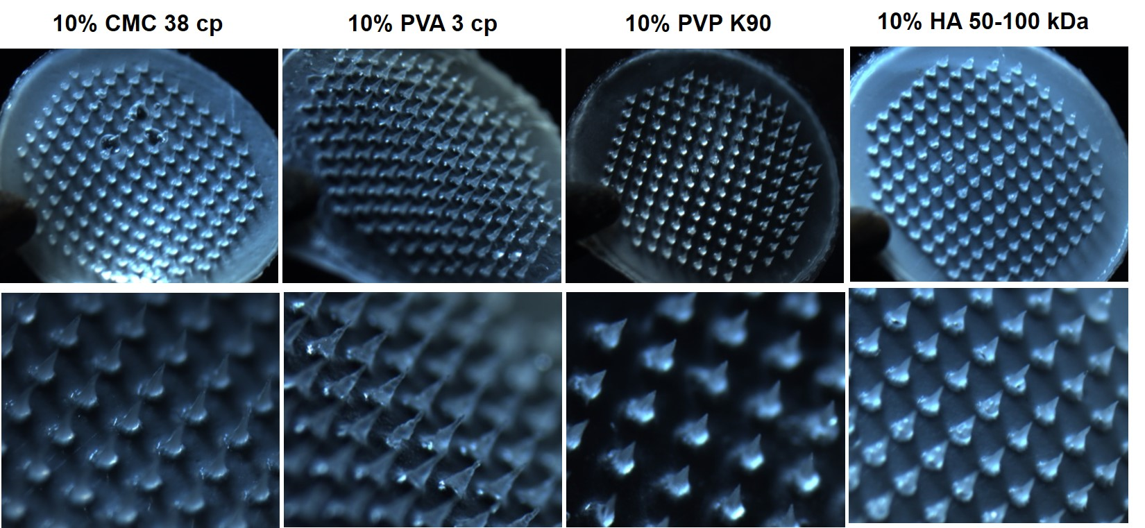

Figure S2 Appearance and skin puncture images of CBD DMN prepared from composite matrix materials
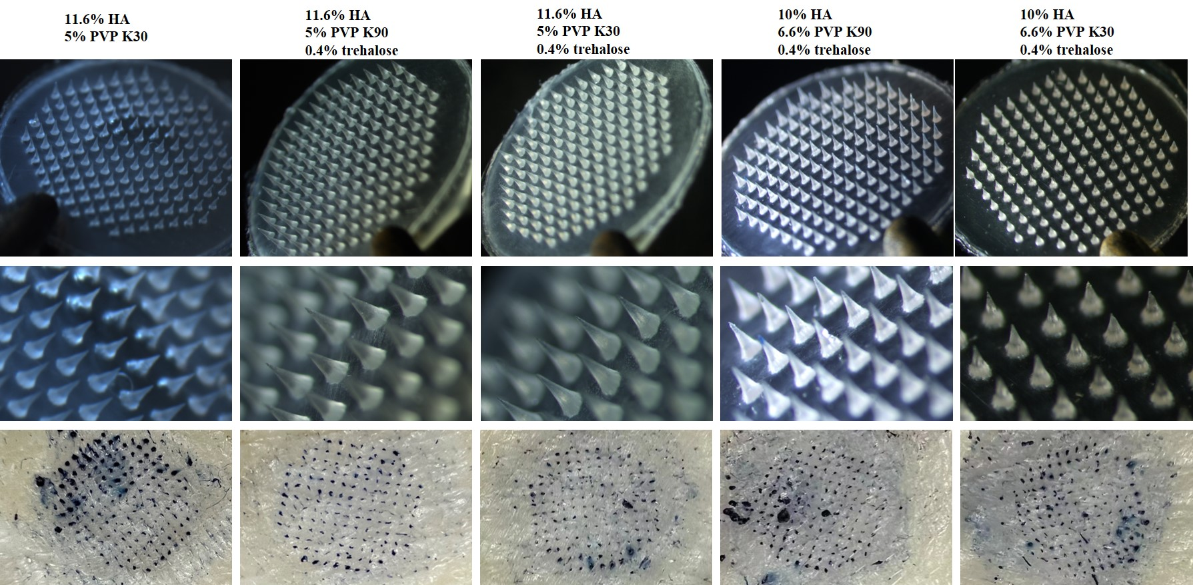

Figure S3 Schematic representation of dissolution abilities
