Microfluidic fabricated liposomes for Nutlin-3a ocular delivery as potential candidate for proliferative vitreoretinal diseases treatment
Elisabetta Esposito^{1,}*, Elena Pozza², Catia Contado¹, Walter Pula¹, Olga Bortolini³, Daniele Ragno¹, Sofia Toldo³, Fabio Casciano⁴, Agnese Bondi¹, Enrico Zauli², Paola Secchiero⁴, Giorgio Zauli³, and Elisabetta Melloni^{4,}*

Table S1. Means ± SD of ARPE-19 cell viability after treatment for 24h or 48h with LIPO_{0.5} and LIPO_{0.8}.
 | 24h |  | 48h
Treatments (μM) | LIPO_{0.5} | LIPO_{0.8} | LIPO_{0.5} | LIPO_{0.8}
0 | 100.00 ± 0.00 | 100.00 ± 0.00 | 100.00 ± 0.00 | 100.00 ± 0.00
25 | 101.80 ± 7.95 | 99.90 ± 6.69 | 105.40 ± 11.98 | 107.50 ± 5.42
10 | 102.40 ± 7.03 | 99.87 ± 6.94 | 103.70 ± 10.93 | 107.20 ± 5.48
5 | 102.20 ± 2.40 | 98.63 ± 9.61 | 104.90 ± 12.28 | 103.00 ± 4.50
1 | 101.80 ± 4.89 | 101.40 ± 7.87 | 98.64 ± 9.38 | 101.10 ± 4.02
0,5 | 97.52 ± 3.92 | 98.56 ± 6.53 | 95.25 ± 9.39 | 99.22 ± 5.38
0,1 | 98.37 ± 2.77 | 95.70 ± 9.12 | 95.50 ± 8.19 | 99.52 ± 4.79

Table S2. Means ± SD of ARPE-19 cell viability, MTT test and cell cycle S phases after treatment for 24 h or 48 h with NUT or LIPO_{0.5}-NUT.
Cell viability (%)
 | 24 h |  |  | 48 h
Treatments (μM) | NUT | LIPO_{0.5}-NUT | P value* | NUT | LIPO_{0.5}-NUT | P value*
25 | 53.60 ± 4.93 | 59.64 ± 9.87 | >0.9999 | 31.57 ± 7.71 | 38.53 ± 18.01 | >0.9999
10 | 63.45 ± 5.85 | 67.17 ± 12.17 | >0.9999 | 37.64 ± 8.04 | 49.27 ± 22.94 | >0.9999
1 | 82.07 ± 10.16 | 84.18 ± 9.16 | >0.9999 | 58.13 ± 8.92 | 72.75 ± 14.12 | 0.3572

MTT (%)
 | 24 h |  |  | 48 h
Treatments (μM) | NUT | LIPO_{0.5}-NUT | P value* | NUT | LIPO_{0.5}-NUT | P value*
25 | 61.74 ± 7.37 | 66.72 ± 16.34 | 0,9791 | 46.26 ± 6.15 | 58.48 ± 16.60 | 0.6290
10 | 71.17 ± 6.73 | 67.60 ± 15.03 | 0,9963 | 54.19 ± 11.91 | 56.42 ± 17.09 | >0.9999
1 | 85.77 ± 5.35 | 77.72 ± 15.45 | 0,8196 | 76.83 ± 13.68 | 68.37 ± 18.80 | 0.9023

S phase (%)
 | 24 h |  |  | 48 h
Treatments (μM) | NUT | LIPO_{0.5}-NUT | P value* | NUT | LIPO_{0.5}-NUT | P value*
25 | 0.55 ± 0.11 | 0.55 ± 0.11 | >0.9999 | 0.79 ± 0.42 | 0.91 ± 0.83 | >0.9999
10 | 1.15 ± 0.8 | 0.67 ± 0.12 | >0.9999 | 0.51 ± 0.33 | 0.52 ± 0.24 | >0.9999
1 | 19.61± 6.6 | 16.70 ± 0.1 | >0.9999 | 11.09 ± 2.32 | 11.39 ± 2.68 | >0.9999

*p values obtained by the statistical analysis (one-way ANOVA followed by Bonferroni post hoc test for multiple corrections) comparing NUT vs LIPO_{0.5}-NUT data sets.

Figure S1

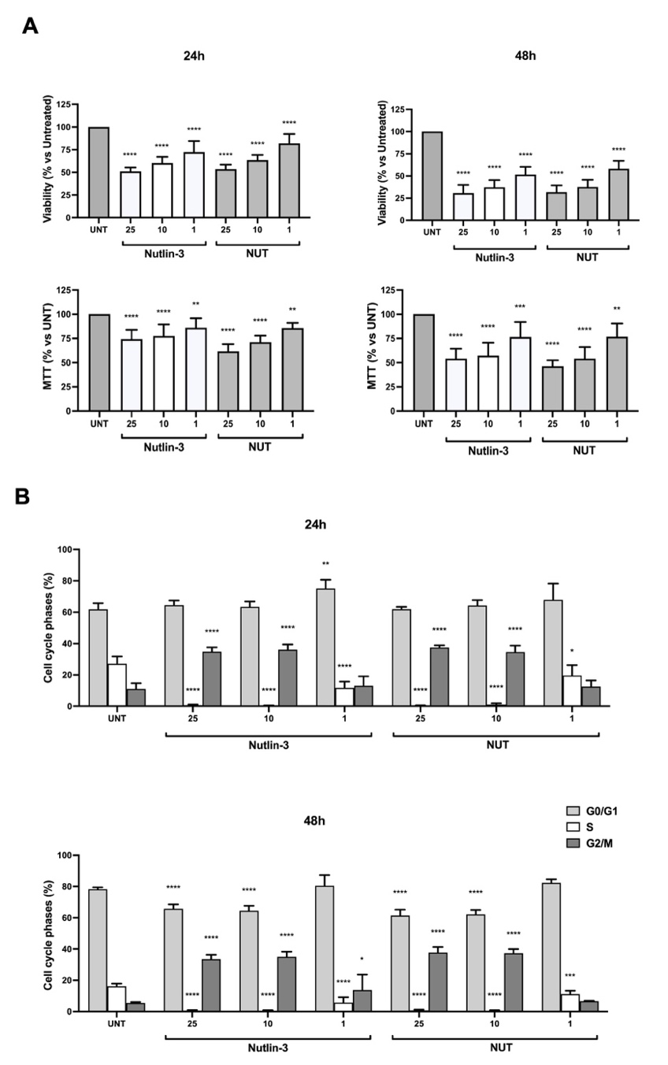

Figure S1: Nutlin-3 and NUT effects’ comparison on ARPE-19 cell line. Cell viability (A) and cell cycle (B) evaluation in ARPE-19 cells treated for 24h or 48h with three different Nutlin-3 and NUT concentrations (25-10-1 μM). Results are reported as mean ± SD of at least three independent experiments. Statistical analysis was performed by ANOVA followed by Bonferroni post hoc test for pairwise comparisons. * p < 0.1, ** p < 0.01, *** p < 0.001, **** p < 0.0001.

Figure S2
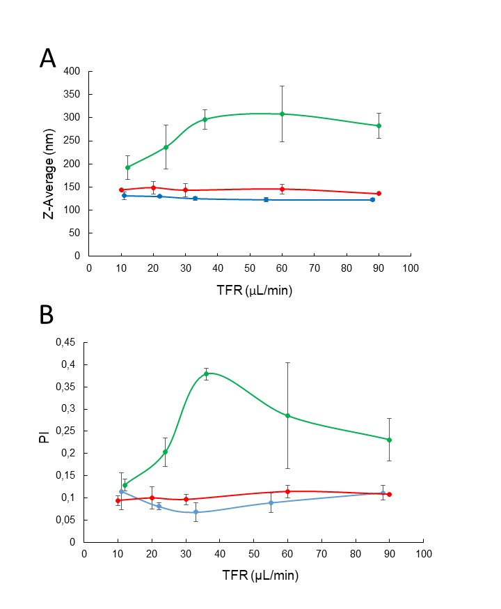
Figure S2: Size distribution parameters of vesicles obtained by microfluidics. Z-Average (A) and PI (B) were evaluated as a function of TFR, using FRR 2:1 (green), 4:1 (red) or 10:1 (blue) and PC 30 mg/ml.

Figure S3
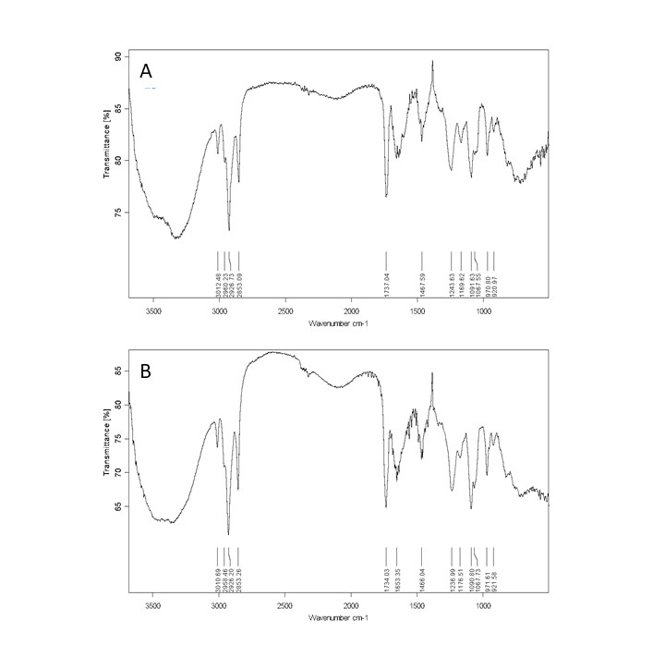
Figure S3. FTIR spectra of LIPO_{0.8} (A), LIPO_{0.8}-NUT (B).

Figure S4

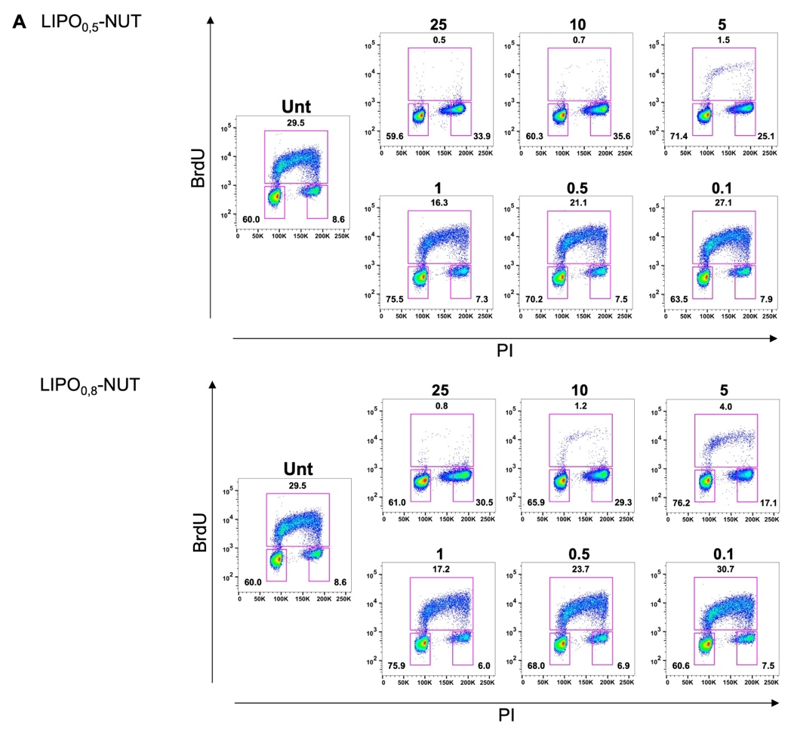
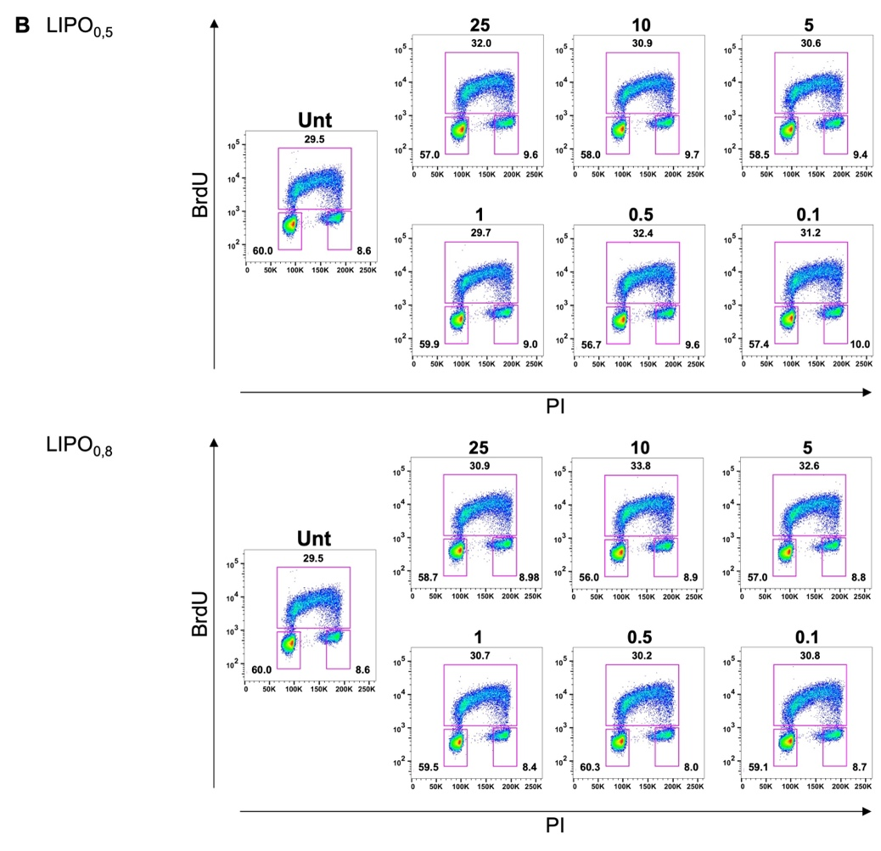
Figure S4: Representative panels of ARPE-19 cell cycle cytofluorimetric analysis after LIPO-NUT or LIPO treatment. Cell cycle evaluation in ARPE-19 cells treated for 24h or 48h with different LIPO_{0.5}-NUT, LIPO_{0.8}-NUT, LIPO_{0.5} and LIPO_{0.8} (concentration range 25-0.1 μM). In A, a panel reporting a representative experiment performed for cell cycle analysis after 24h of treatment with LIPO_{0.5}-NUT and LIPO_{0.8}-NUT, used in the range of concentration described above, is shown. In B, a panel reporting a representative experiment performed for cell cycle analysis after 24h of treatment with LIPO_{0.5} and LIPO_{0.8}, used in the range of concentration of LIPO-NUT, is reported.

