Phytochemical investigation and in vitro antimicrobial and antioxidant activities evaluation of Erianthemum aethiopicum Wiens and Polhill

Teshome Gonfaª*, Ayalew Temesgenª, Tsegu Kiros^{a*}, Sivasubramanian Muthusaravananª, and Olyad Erba Urgessa^{b}, Tadele Teklu^{b}
ªDepartment of Chemistry, College of Natural and Computational Sciences, Haramaya University, P. O. Box 138, Dire Dawa, Ethiopia
^{b}School of Biological Sciences and Biotechnology, College of Natural and Computational Sciences, Haramaya University, P. O. Box 138, Dire Dawa, Ethiopia

Correspondence: Teshome Gonfa; tashe2002@gmail.com, ORCID: https://orcid.org/0000-0001-5691-6905 and Tsegu Kiros; kirosorg@gmail.com, ORCID: https://orcid.org/0000-0002-2073-6889

Supplementary Materials

Antimicrobial Activities of Various Extracts

E. Coli
Hexane Chloroform Methanol
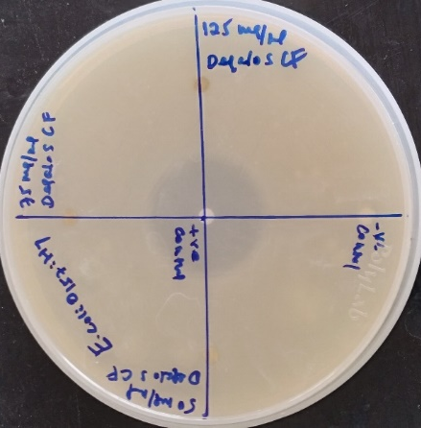
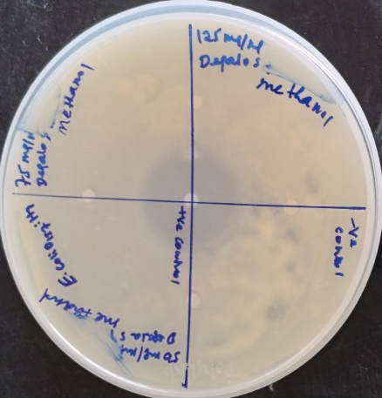
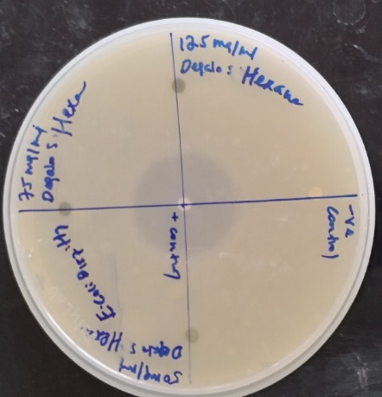

Figure S1: Antibacterial activity inhibition zone images of extracts against E. coli.

Hexane Chloroform Methanol
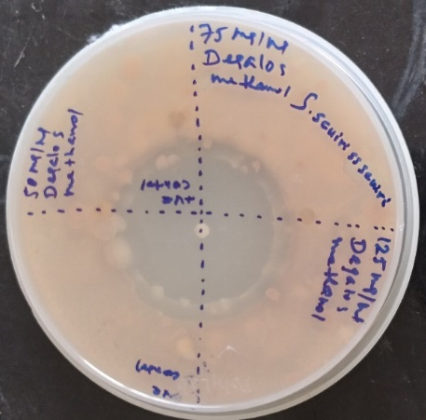
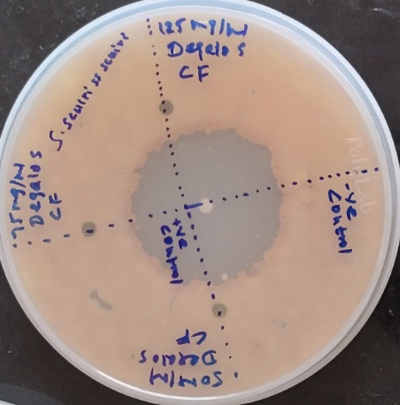
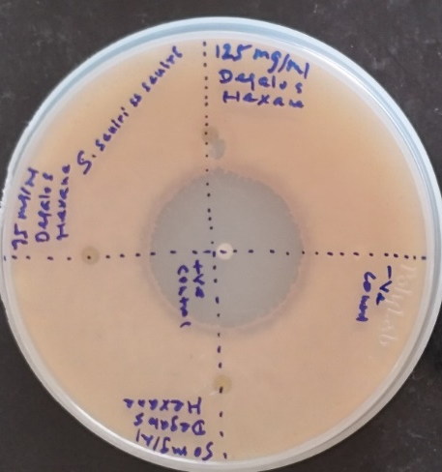

Figure S2: Antibacterial activity inhibition zone images of extracts against Staphylococcus sciuris ss sciuri

Hexane Chloroform Methanol
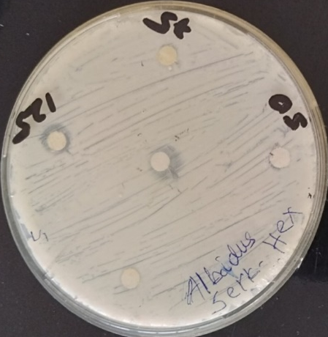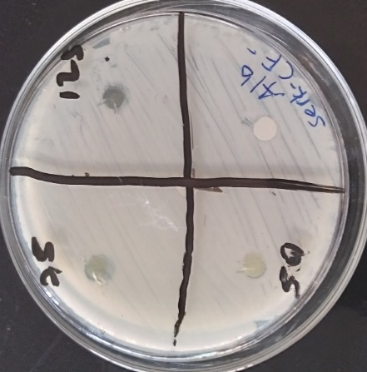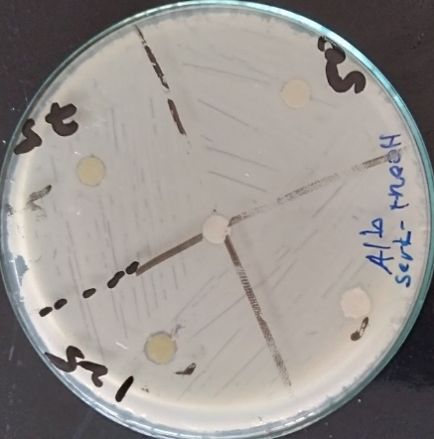

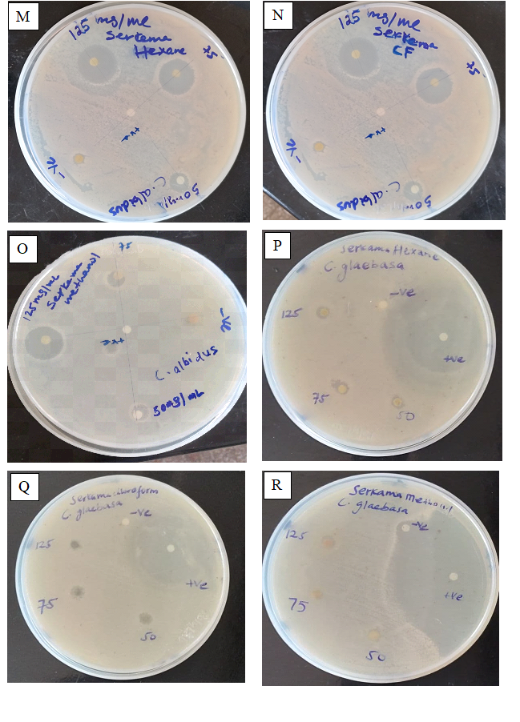
Figure S3: Antifungal activity inhibition zone images of extracts agaisnt Cryptococcus albidus

Hexane Chloroform Methanol
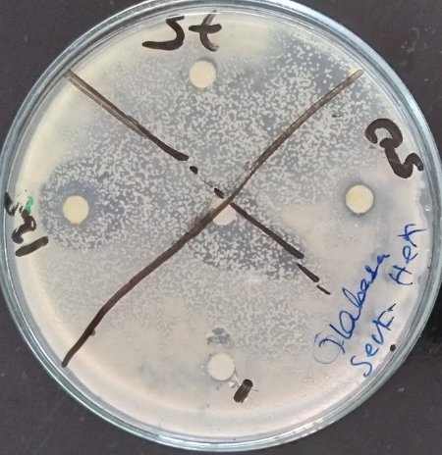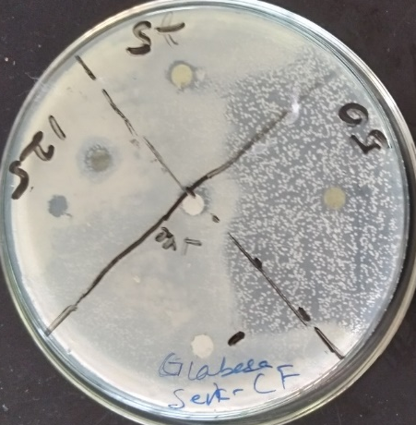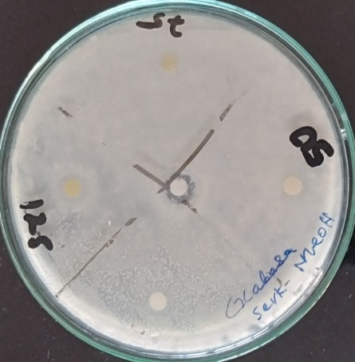
Figure S4: Antifungal activity inhibition zone images of extracts against Candida glaebosa

