Supplementary information
PDADMAC/ALGINATE-COATED GOLD NANOROD FOR ERADICATION OF STAPHYLOCOCCUS AUREUS BIOFILMS
Malarmugila Manimaran^{1,a}, , Yin Yin Teo², James Chen Yong Kah³, Adilet Beishenaliev¹, Yean Leng Loke², Yiing Yee Foo¹, Shiow-Fern Ng⁴, Chin Fei Chee⁵, Sek Peng Chin⁶, Farid Nazeer Faruqu¹, Chia-Yu Chang⁷, Misni Misran², Lip Yong Chung⁶, Bey Fen Leo^{8,a}, Shih-Hwa Chiou^{9,10}, Chia-Ching Chang^{7,11,12,13,}*, Sun Tee Tay¹⁴, Lik Voon Kiew^{1,7}*

¹Department of Pharmacology, Faculty of Medicine, Universiti Malaya, Kuala Lumpur, Malaysia
²Department of Chemistry, Faculty of Science, Universiti Malaya, Kuala Lumpur, Malaysia
³Department of Biomedical Engineering, College of Design and Engineering, National University of Singapore, Singapore, Singapore
⁴Centre for Drug Delivery Technology and Vaccine, Faculty of Pharmacy, Universiti Kebangsaan Malaysia, Kuala Lumpur, Malaysia
⁵Nanotechnology Catalysis Research Centre, Universiti Malaya, Kuala Lumpur, Malaysia
⁶Department of Pharmaceutical Chemistry, Faculty of Pharmacy, Universiti Malaya, Kuala Lumpur, Malaysia
⁷Department of Biological Science and Technology, National Yang Ming Chiao Tung University, Hsinchu, Taiwan, Republic of China
⁸Department of Molecular Medicine, Faculty of Medicine, Universiti Malaya, Kuala Lumpur, Malaysia
⁹Department of Medical Research, Taipei Veterans General Hospital, Taipei, Taiwan, Republic of China
¹⁰Institute of Pharmacology, National Yang Ming Chiao Tung University, Taipei, Taiwan, Republic of China
¹¹Department of Electrophysics, National Yang Ming Chiao Tung University, Hsinchu, Taiwan, Republic of China
¹²Center for Intelligent Drug Systems and Smart Bio-devices, National Yang Ming Chiao Tung University, Hsinchu, Taiwan, Republic of China
¹³Institute of Physics, Academia Sinica, Nankang, Taipei, Taiwan, Republic of China.
¹⁴Department of Medical Microbiology, Faculty of Medicine, Universiti Malaya, Kuala Lumpur, Malaysia
ª These authors contributed equally to this work.
* Corresponding authors:
Chia-Ching Chang, ccchang01@nycu.edu.tw
Lik-Voon Kiew, lvkiew@um.edu.my

A. Concentration of Gold Nanorods (GNR)
The concentration of the GNR was estimated from the UV-visible spectra of the GNR using a technique derived from a previous study. The extinction coefficient value of GNR was obtained through the equation:
$y=1.23×{10}^{7}x-5.02×{10}^{9}$,
where x is the wavelength in the UV-visible spectra, and y is the extinction coefficient. Thus, the concentration¹ of GNR was calculated based on the equation: nM$={Abs}/y$, where absorbance value² was obtained from the UV-visible spectrophotometer, and y is the extinction coefficient.³

B. Effects of PDADMAC on bacterial biofilms
Graph of PDADMAC solution alone without the combination of GNR doesn’t show significant biofilm eradication but poses below 35% of eradication even at a high concentration of 5 mg/mL.
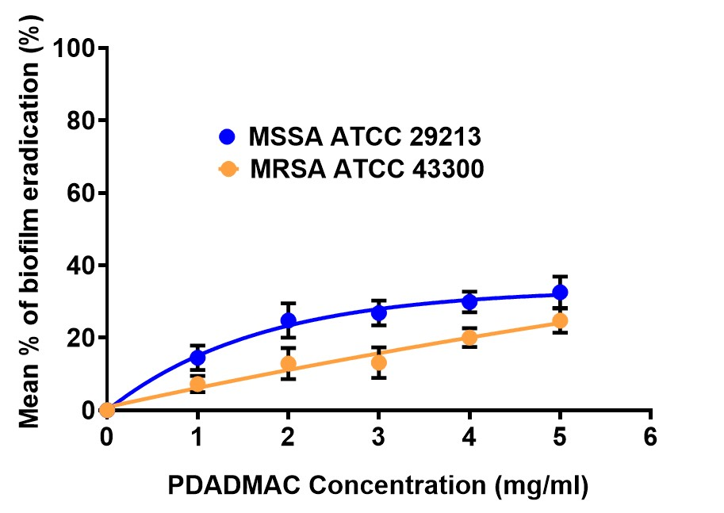
Figure S1. Poly(diallyldimethylammonium chloride) (PDADMAC) at working concentrations (5 mg/mL) did not cause a significant biofilm eradication after 24 hours of incubation, suggesting the PDADMAC/alginate-coated gold nanorods (GNR/Alg/PDADMAC)’s ability in biofilm eradication was not due to PDADMAC solely. Data are represented as mean ± SD (n = 3).

C. Calculation of the percentage of biofilm eradication
The percentage of biofilm eradication was calculated using the formula:
1. Absorbance value - Average sterility control absorbance value = Normalised absorbance value.
2. 100 $×$ (1-normalised absorbance value/Average growth control absorbance value) = % Biofilm Eradication.
3. Plot concentration (x- axis) against average value of biofilm eradication (y-axis) + standard deviation.

*MBEC 50 = Minimum biofilm eradication concentration that eradicates 50% of biofilm

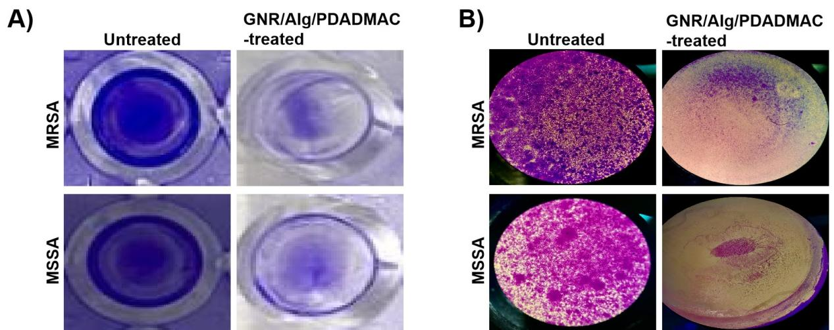
Figure S2. (A) microtiter well pictures after CV staining of untreated and GNR/Alg/PDADMAC-treated biofilms of MRSA and MSSA, showing less CV stain in both MRSA and MSSA biofilms after exactly 16.5 minutes and 17 minutes of GNR/Alg/PDADMAC treatment. (B) Microscopic picture further enhanced the ability of GNR/Alg/PDADMAC at 0.15 nM to eradicate 50% (MBEC₅₀) of MRSA and MSSA biofilm within 16.5 and 17 minutes, respectively. Pictures A and B manifest that the composition of both GNR/Alg/PDADMAC-treated MRSA and MSSA biofilms were reduced significantly at a shorter time, 16.5 minutes and 17 minutes.

D. Effects of GNR/Alg/PDADMAC on the biofilms of Gram-negative bacteria
The effects of GNR/Alg/PDADMAC on the biofilms of Gram-negative bacteria, i.e. Pseudomonas aeruginosa, Escherichia coli, and Klebsiella pneumonia was performed. Results revealed that GNR/Alg/PDADMAC was ineffective in eradicating the biofilms of the Gram-negative bacteria at the concentration range tested (0.002 – 0.3 nM) although similar concentration range was effective in eradicating Gram-positive MRSA and MSSA biofilms (Figure S3). This suggests the avenues of further improvement onto the GNR/Alg/PDADMAC to expand its biofilm eradication spectrum. Meanwhile the positive control triclosan at high concentration (345 µM) showed effective eradication of Gram-Positive MRSA and MSSA biofilms as well as the biofilms of Gram-negative Klebsiella pneumonia and Escherichia coli, but not the biofilms of Pseudomonas aeruginosa (Figure S4)

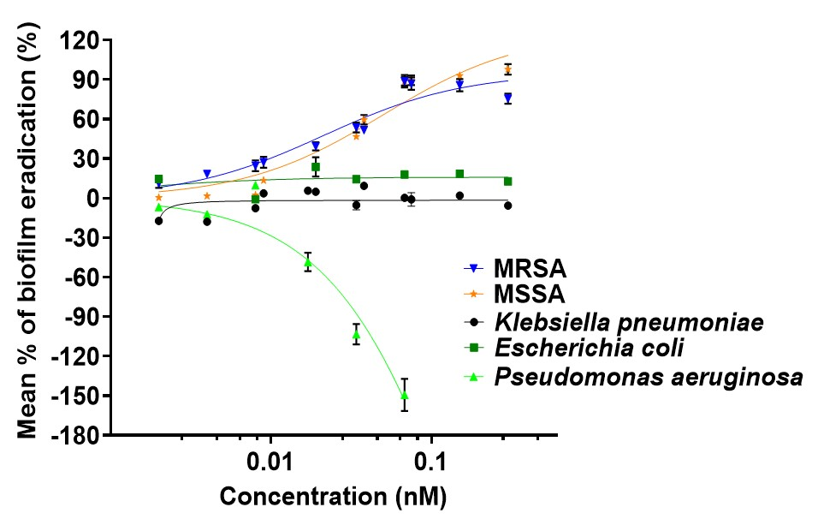
Figure S3. PDADMAC/alginate-coated gold nanorod (GNR/Alg/PDADMAC) showing inefficient Klebsiella pneumonia, Pseudomonas aeruginosa and Escherichia coli biofilm eradication but effectively remove Gram-positive bacteria (MRSA and MSSA) at increasing concentration. Data are represented as mean ± SD (n = 3).

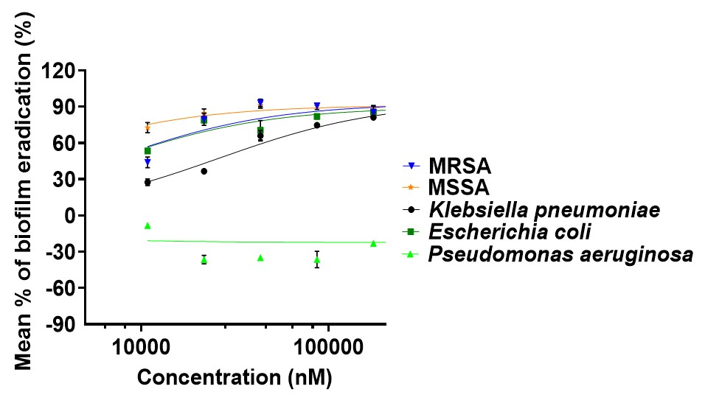
Figure S4. Triclosan at high concentration (345 µM) showed effective eradication of the biofilms of the Gram-Positive MRSA and MSSA as well as Gram-negative Klebsiella pneumonia and Escherichia coli, but not the biofilms of Gram-negative Pseudomonas aeruginosa (Figure S4).

E. Effects of GNR/Alg on the biofilms of MRSA and MSSA
The effects of GNR/Alg on the biofilms of MRSA and MSSA was performed. Results revealed that GNR/Alg was ineffective in eradicating the biofilms of the MRSA and MSSA at the concentration range tested (0.002 – 0.3 nM) (Figure S5).
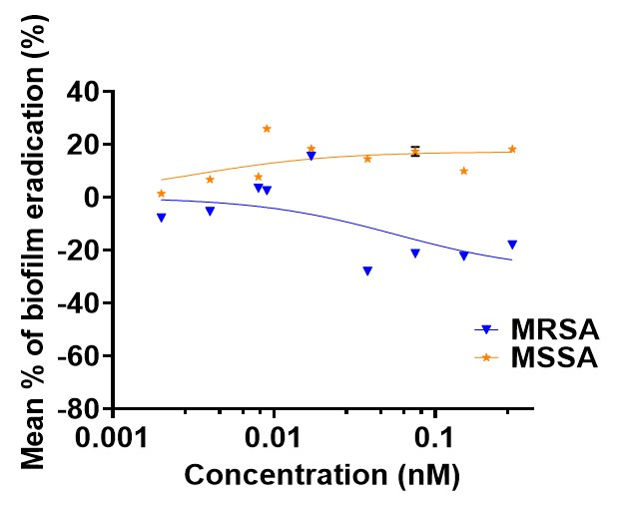
Figure S5. GNR/Alg was ineffective in eradicating the biofilms of the MRSA and MSSA at the concentration range tested (0.002 – 0.3 nM). Data are represented as mean ± SD (n = 3).

F. CLSM studies:
Figure S6 displays CLSM pictures comparing the reduction in biofilm and cell death between the GNR/Alg/PDADMAC-treated strains of MRSA and MSSA with the control strain.
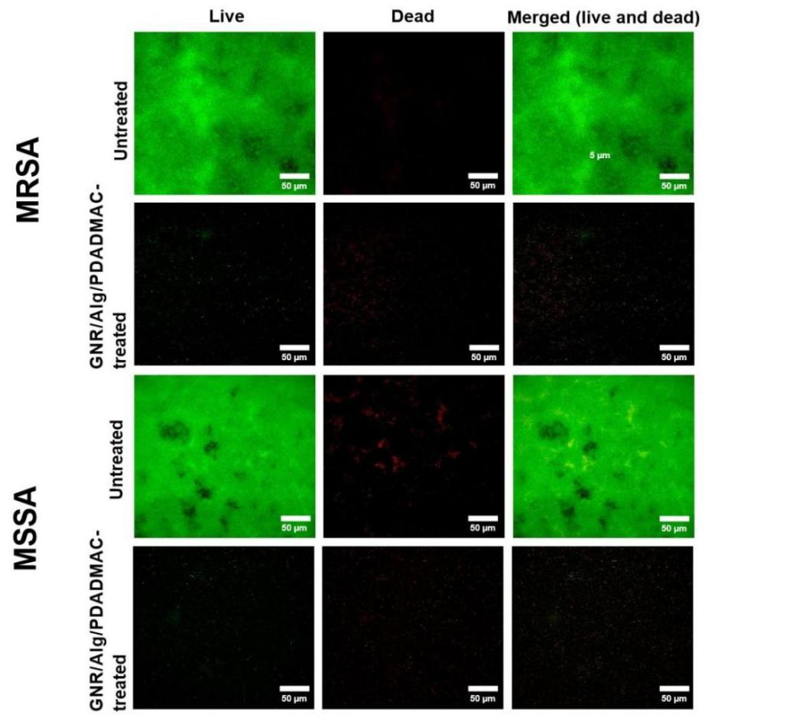
Figure S6. Two-dimensional (2D) CLSM images of MRSA and MSSA strains under 40× magnification, manifesting the viability of both PDADMAC/alginate-coated gold nanorod (GNR/Alg/PDADMAC)-treated MRSA and MSSA biofilms were reduced significantly (Scale bar = 50 µM).

REFERENCES

1. Selvaraj, A.; Jayasree, T.; Valliammai, A.; Pandian, SK., Myrtenol attenuates MRSA biofilm and virulence by suppressing sarA expression dynamism. Frontiers in Microbiology 2019, 10, 2027.

2. Nikoobakht, B.; El-Sayed, MA., Preparation and growth mechanism of gold nanorods (NRs) using seed-mediated growth method. Chemistry of Materials 2003, 15 (10), 1957-1962.

3. Orendorff, CJ.; Murphy, CJ., Quantitation of metal content in the silver-assisted growth of gold nanorods. The Journal of Physical Chemistry B, 2006, 110 (9), 3990-3994.

