Supplementary materials
Supplementary Figure S1. Simulated concentration-time profiles of busulfan after intravenous administration of once-daily dosing regimens with various infusion times. Dotted lines represent the 5th and 95th percentiles and solid lines represent the median of the simulated concentration data. Horizontal dashed lines represent the therapeutic reference values for maximum concentration ¹. The dosing regimens were derived from Lee, et al. ², Buffery, et al. ³, Yin, et al. ⁴, and Rhee, et al. ⁵.
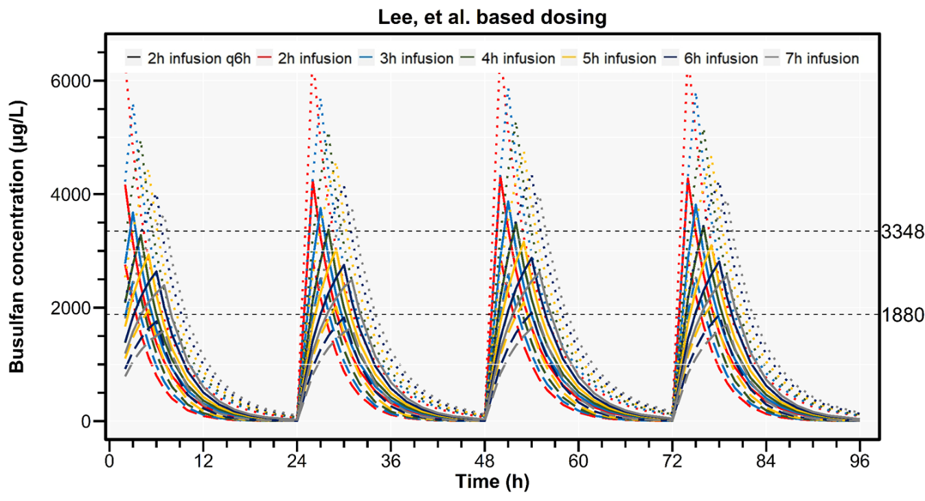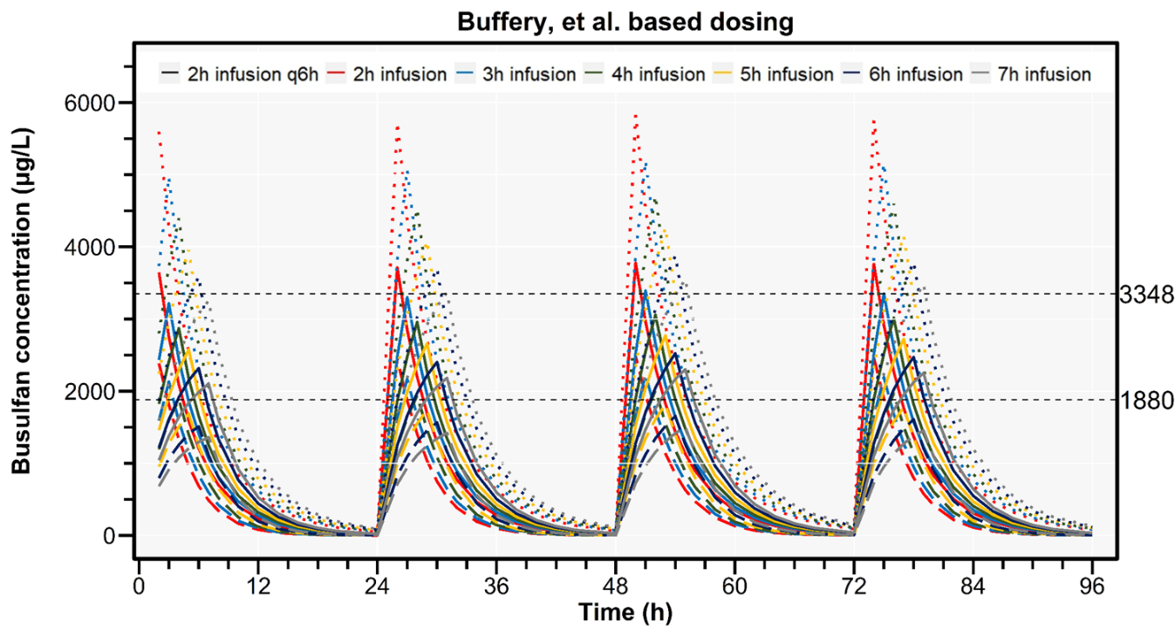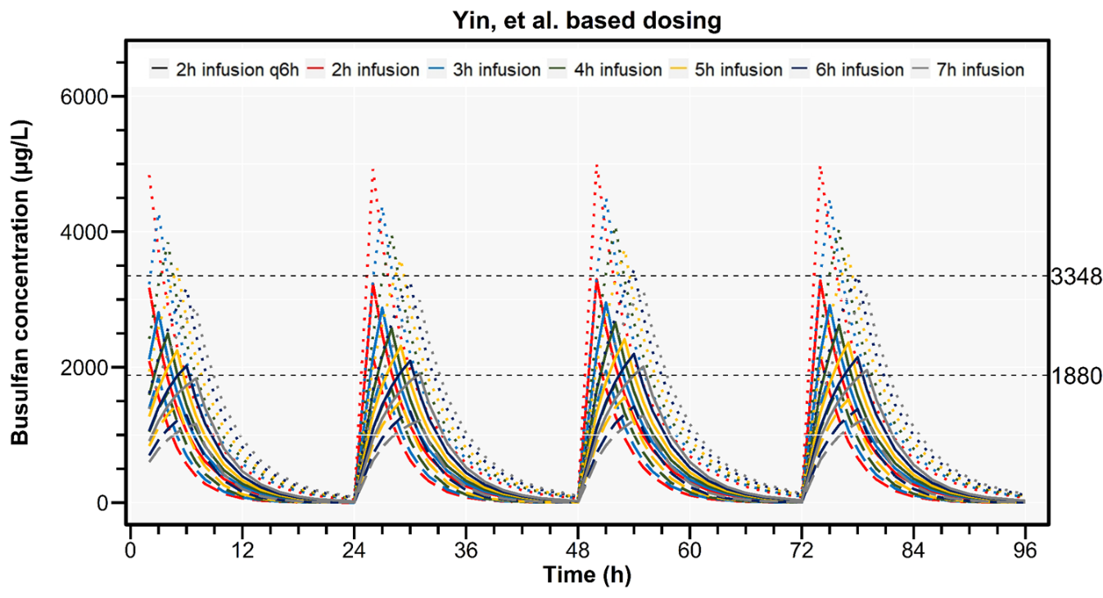
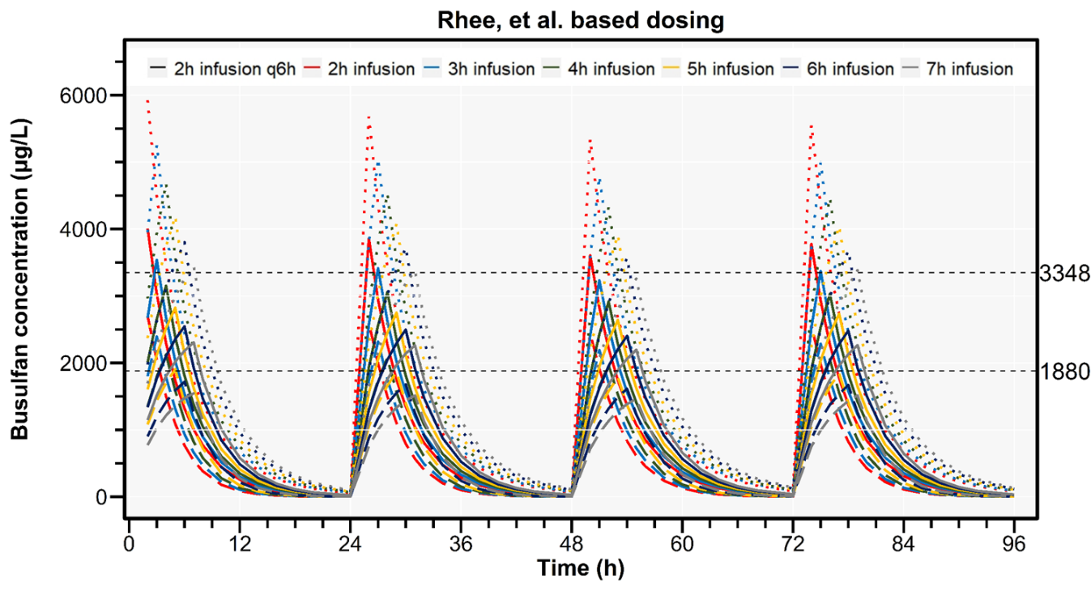

Supplementary Figure S2. Percentages of patients achieving daily Cmax within therapeutic reference values of 1880 μg/L and 3348 μg/L ¹ according to various infusion times and day after busulfan administration. The dosing regimens were derived from EMA ^{6,7,8}, FDA ^{9,10}, Lee, et al. ², Buffery, et al. ³, Yin, et al. ⁴, and Rhee, et al. ⁵.
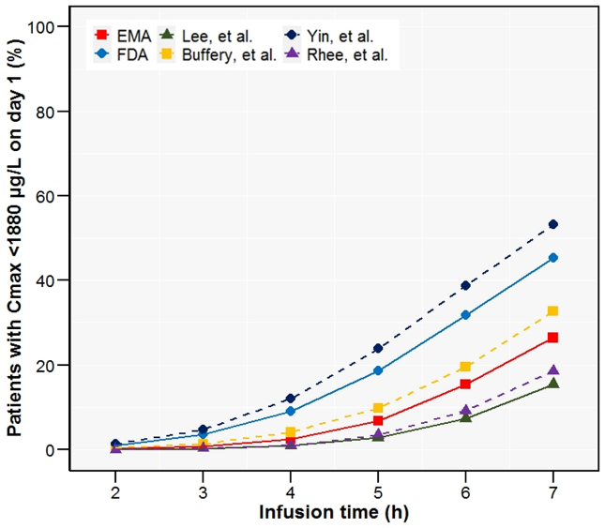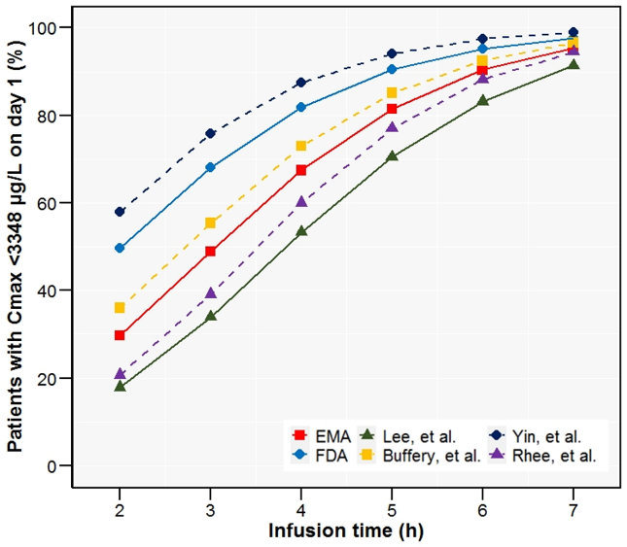
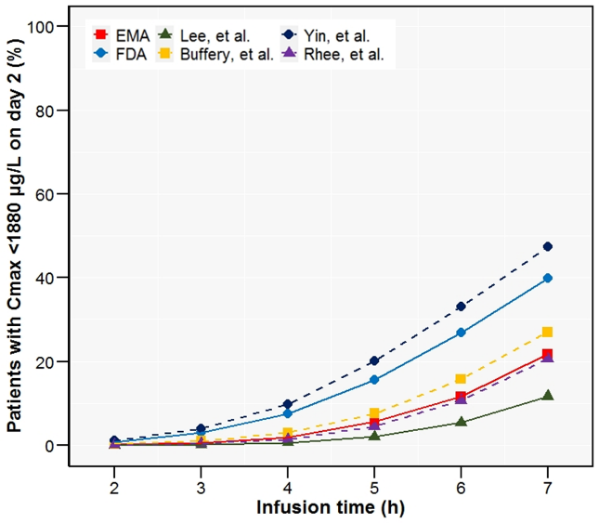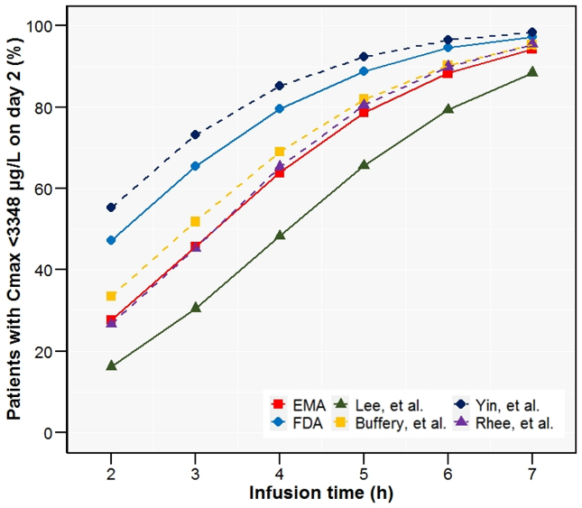
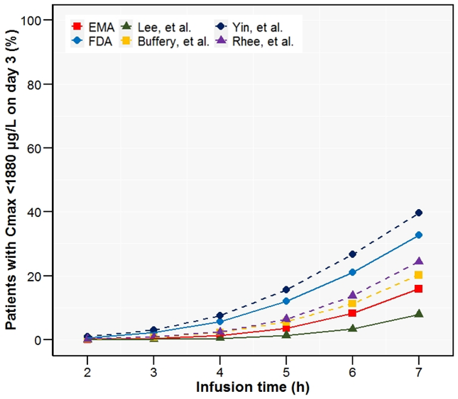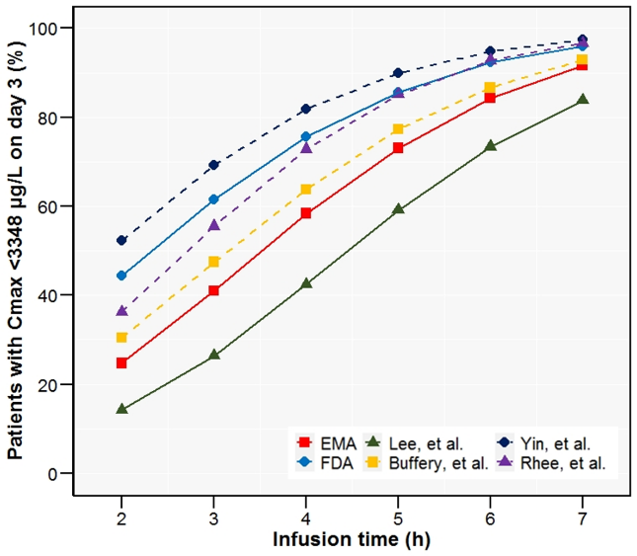
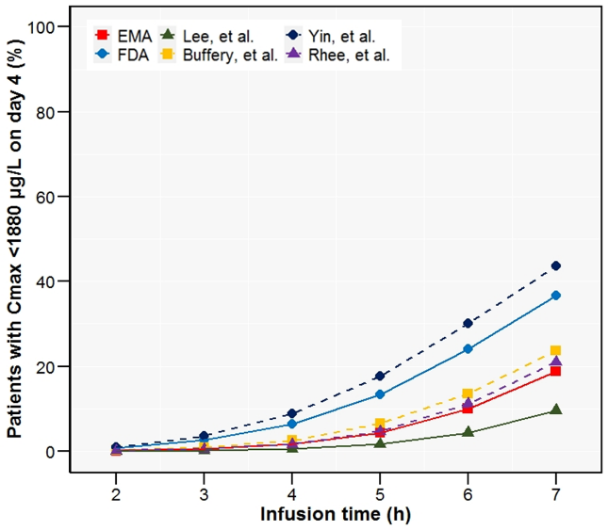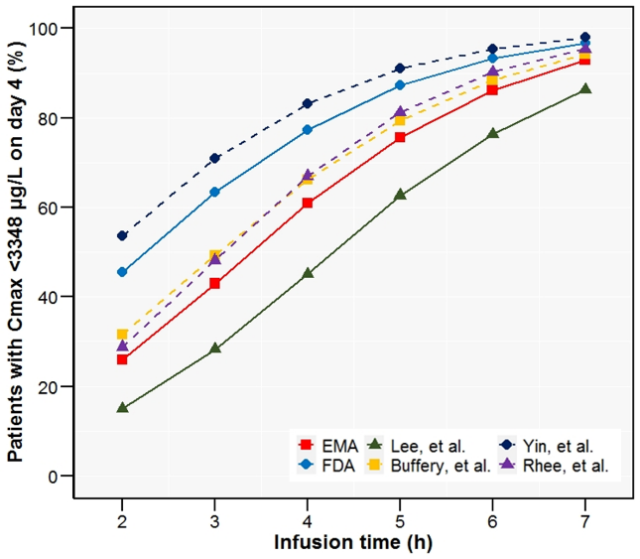

Supplementary Table S1. Percentages of patients achieving daily Cmax within therapeutic reference values of 1880 μg/L and 3348 μg/L ¹ according to various infusion times.
*Intravenous infusion for 2 hours every 6 hours
Dosing regimens were derived from EMA ^{6,7,8}, FDA ^{9,10}, Lee, et al. ², Buffery, et al. ³, Yin, et al. ⁴, and Rhee, et al. ⁵.
Colored indicators represent a gradient from lighter to darker shades, corresponding to values ranging from 0 to 100.

References
1. Philippe M, Neely M, Rushing T, Bertrand Y, Bleyzac N, Goutelle S. Maximal concentration of intravenous busulfan as a determinant of veno-occlusive disease: a pharmacokinetic-pharmacodynamic analysis in 293 hematopoietic stem cell transplanted children. Bone Marrow Transplant. 2019;54(3):448-457.
2. Lee JW, Kang HJ, Kim S, et al. Favorable outcome of hematopoietic stem cell transplantation using a targeted once-daily intravenous busulfan-fludarabine-etoposide regimen in pediatric and infant acute lymphoblastic leukemia patients. Biol Blood Marrow Transplant. Jan 2015;21(1):190-5. doi:10.1016/j.bbmt.2014.09.013
3. Buffery PJ, Allen KM, Chin PK, Moore GA, Barclay ML, Begg EJ. Thirteen years' experience of pharmacokinetic monitoring and dosing of busulfan: can the strategy be improved? Ther Drug Monit. Feb 2014;36(1):86-92. doi:10.1097/FTD.0b013e31829dc940
4. Yin J, Xiao Y, Zheng H, Zhang YC. Once-daily i.v. BU-based conditioning regimen before allogeneic hematopoietic SCT: a study of influence of GST gene polymorphisms on BU pharmacokinetics and clinical outcomes in Chinese patients. Bone Marrow Transplant. May 2015;50(5):696-705. doi:10.1038/bmt.2015.14
5. Rhee SJ, Lee JW, Yu KS, et al. Pediatric patients undergoing hematopoietic stem cell transplantation can greatly benefit from a novel once-daily intravenous busulfan dosing nomogram. Am J Hematol. Jul 2017;92(7):607-613. doi:10.1002/ajh.24734
6. Agency EM. Product Information: Busilvex; INN-busulfan, last updated: 01/02/2022, Available from: https://www.ema.europa.eu/en/documents/product-information/busilvex-epar-product-information_en.pdf.
7. Kawazoe A, Funaki T, Kim S. Population Pharmacokinetic Analysis of Busulfan in Japanese Pediatric and Adult HCT Patients. J Clin Pharmacol. Sep 2018;58(9):1196-1204. doi:10.1002/jcph.1120
8. Nguyen L, Fuller D, Lennon S, Leger F, Puozzo C. I.V. busulfan in pediatrics: a novel dosing to improve safety/efficacy for hematopoietic progenitor cell transplantation recipients. Bone Marrow Transplant. May 2004;33(10):979-87. doi:10.1038/sj.bmt.1704446
9. FDA U. HIGHLIGHTS OF PRESCRIBING INFORMATION, BUSULFEX (busulfan), Revised: 01/2015, Available from: https://www.accessdata.fda.gov/drugsatfda_docs/label/2015/020954s014lbl.pdf.
10. Booth BP, Rahman A, Dagher R, et al. Population pharmacokinetic-based dosing of intravenous busulfan in pediatric patients. J Clin Pharmacol. Jan 2007;47(1):101-11. doi:10.1177/0091270006295789

