Supplementary material

Supplementary figure 1. Scree plot of unrotated exploratory factor analysis
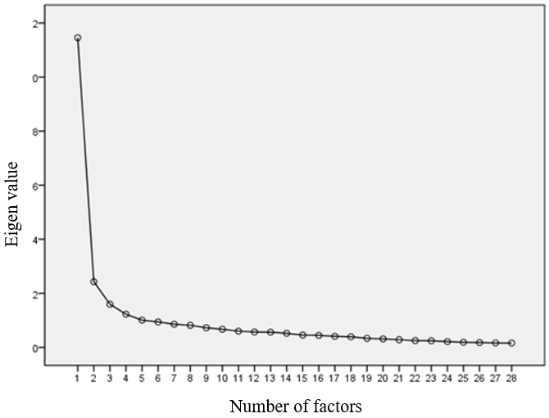

Supplementary table 1. The initial 29 homesickness items pool
Items
hs1 I feel full of power when thinking about hometown
hs2 I often enjoy local entertainment programs in my hometown
hs3 Comparing to here, I'd rather do what I am doing in my hometown
hs4 I often pay attention to the recent situation in my hometown
hs5 I hope to return to my hometown for the rest of my life
hs6 I feel warming when thinking about hometown
hs7 Once I return my hometown, I may not want to come here again
hs8 I often talk to others about my hometown
hs9 I feel empty after leaving my hometown
hs10 I think about what I would do if I returned to my hometown
hs11 I will try to speak my hometown dialect to others if possible
hs12 I miss the lively feelings in my hometown
hs13 I often think of things about my hometown
hs14 I identify with my hometown
hs15 I keep in frequent contact with my family and friends in my hometown
hs16 I feel safe in my hometown
hs17 My hometown means a lot to me
hs18 I feel the tight connection between myself and my hometown
hs19 I often feel lonely after leaving my hometown
hs20 My hometown has a unique place in my heart
hs21 I get excited every time I think about going back to my hometown
hs22 I regret leaving my hometown
hs23 I usually follow the traditional customs of my hometown
hs24 I miss my family and friends in my hometown
hs25 I often go to eat local food in my hometown
hs26 My hometown gives me a sense of belonging
hs27 Once I think of my hometown, my heart feels at peace
hs28 I often feel depressed after leaving my hometown
hs29 I will keep some things from my hometown as souvenirs

Supplementary table 2. Descriptive statistics and group comparison of homesickness for elderly
 |  | n | M（SD） | df | F | p
Gender | Male | 85 | 63.27（17.566） | 1 | 2.958 | 0.086
 | Female | 257 | 66.86（16.085）
Age | ≤ 65 years | 148 | 68.16（16.316） | 2 | 5.230** | 0.006
 | 66 - 75 years | 173 | 65.28（16.182）
 | > 75years | 21 | 56.24（17.346）
Occupation | Manual | 204 | 68.35（15.746） | 1 | 10.780*** | 0.001
 | Mental | 138 | 62.46（17.042）
Education | Elementary and Below | 111 | 67.79（16.365） | 3 | 4.747** | 0.003
Education | Junior | 87 | 69.09（14.879）
Education | Senior | 101 | 64.39（17.118）
Education | College and above | 43 | 58.67（16.485）
Marriage | Married | 271 | 66.16（16.282） | 2 | 0.183 | 0.833
 | Divorced | 16 | 66.88（18.442）
 | Widowed | 55 | 64.78（17.315）
Monthly income  (CNY) | <1000 | 108 | 68.22（15.872） | 3 | 3.788* | 0.011
Monthly income  (CNY) | 1000-3000 | 105 | 68.10（16.819）
Monthly income  (CNY) | 3000-5000 | 79 | 61.99（16.289）
Monthly income  (CNY) | > 5000 | 42 | 61.64（16.926）
Migration distance | Cross city | 55 | 61.69（16.089） | 1 | 4.448* | 0.036
 | Cross provincial | 287 | 66.79（16.493）
Purpose | Take care of relatives | 236 | 68.29（15.887） | 1 | 15.641*** | 0.000
 | Others | 106 | 60.81（16.783）
Length of arrival | < 3 years | 50 | 69.54（17.040） | 3 | 11.198*** | 0.000
Length of arrival | 3-10 years | 136 | 69.16（15.657）
Length of arrival | 10-20 years | 89 | 66.43（15.140）
Length of arrival | > 20 years | 67 | 56.22（16.085）
From rural / urban | Rural | 179 | 69.19（15.690） | 1 | 14.855*** | 0.000
From rural / urban | Urban | 163 | 62.44（16.715）
Living with partner | Yes | 137 | 66.50（15.665） | 1 | 0.238 | 0.626
Living with partner | No | 205 | 65.61（17.083）
Living with child | Yes | 288 | 67.02（16.314） | 1 | 7.467** | 0.007
Living with child | No | 54 | 60.39（16.592）
Living with grandchild | Yes | 150 | 69.71（15.623） | 1 | 14.260*** | 0.000
Living with grandchild | No | 192 | 63.05（16.636）
Real estate in hometown | Yes | 256 | 67.56（15.689） | 1 | 9.653** | 0.002
Real estate in hometown | No | 86 | 61.24（18.033）
n = 342；*p < 0.05；**p < 0.01；***p < 0.001

Supplementary table 3. The coding of demographic variables
Subject | Category | Coding
Gender | Male | 1
 | Female | 2
Age | ≤ 65 years | 1
 | 66 - 75 years | 2
 | > 75years | 3
Occupation | Manual | 1
 | Mental | 2
Education | Elementary and Below | 1
 | Junior | 2
 | Senior | 3
 | College and above | 4
Marriage | Married | 1
 | Divorced | 2
 | Widowed | 3
Monthly income (CNY) | <1000 | 1
Monthly income (CNY) | 1000-3000 | 2
Monthly income (CNY) | 3000-5000 | 3
Monthly income (CNY) | > 5000 | 4
Migration distance | Cross city | 1
 | Cross provincial | 2
Purpose | Take care of relatives | 1
 | Others | 2
Length of arrival | < 3 years | 1
 | 3-10 years | 2
 | 10-20 years | 3
 | > 20 years | 4
From rural / urban | Rural | 1
 | Urban | 2
living with partner | Yes | 1
 | No | 2
living with child | Yes | 1
 | No | 2
Living with grandchild | Yes | 1
 | No | 2
Real estate in hometown | Yes | 1
 | No | 2

