Supplementary data
Figure S1. (a) Transmission electron microscopy (TEM) images of AG NPs and AGP NPs, scale bar = 100 nm. (b) Elemental mapping of AG NPs and AGP NPs, scale bar = 100 nm.

Figure S2. XPS spectrum of AGPF NPs.

Figure S3. Survival rate of the mice.
Figure S4. Pictures and percentage of hemolysis after treatment with different samples.

Figure S5. (a) Weight change in mice after treatment with different samples. (b) Survival rate of mice under treatment with different samples.
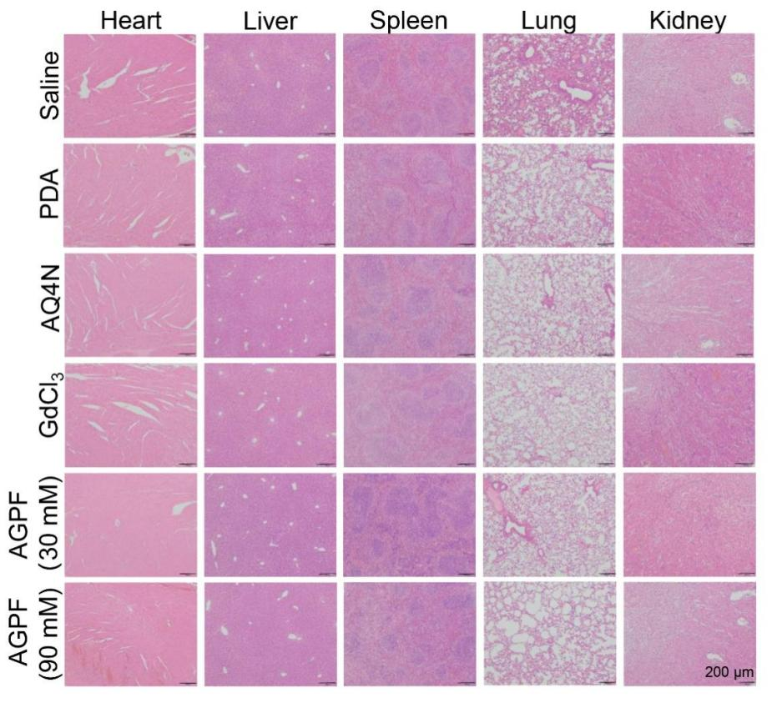
Figure S6. H&E stain results of different tissues, scale = 200 μm.

Figure S7. Biochemical and in vivo toxicity studies of AQ4N-Gd@PDA-FA NPs. (a) AST. (b) ALT. (c) LDH. (d) ALB. (e) T-BIL. (f) UREA. (g) CK. (h) CREA.
Abbreviations: AST, aspartate aminotransferase; ALT, aspartate aminotransferase; LDH, lactate dehydrogenase; ALB, albumin; T-BIL, total bilirubin; UREA, carbamide; CK, creatine kinase; CREA, creatinine.

Figure S8. Results of ELISA. (a) IL-6. (b) TNF-α.

