Supplementary materials

Table S1. Associations between serum Klotho and COPD in the multiple regression model
Variable | ln Klotho(n=5385) |  |  |  | Klotho levels quartiles (pg/ml)
Variable |  |  |  |  | Q1(n=1345) |  | Q2(n=1347) |  | Q3(n=1346) |  | Q4(n=1347)
Variable | OR (95%CI) |  | p-value |  | OR (95%CI) |  | OR (95%CI) |  | OR (95%CI) |  | OR (95%CI)
unadjusted | 0.54 (0.41~0.71) |  | <0.001 |  | 1.00(Ref) |  | 0.78 (0.61~0.99) |  | 0.62 (0.48~0.80) |  | 0.64 (0.50~0.82)
model1 | 0.61 (0.46~0.81) |  | 0.001 |  | 1.00(Ref) |  | 0.82 (0.64~1.04) |  | 0.66 (0.51~0.86) |  | 0.72 (0.56~0.93)
model2 | 0.71(0.53~0.96) |  | 0.025 |  | 1.00(Ref) |  | 0.87 (0.67~1.12) |  | 0.71 (0.55~0.93) |  | 0.84 (0.64~1.10)
model3 | 0.70 (0.52~0.95) |  | 0.021 |  | 1.00(Ref) |  | 0.87 (0.67~1.12) |  | 0.72 (0.55~0.94) |  | 0.84 (0.64~1.11)
model4 | 0.74 (0.54~0.99) |  | 0.05 |  | 1.00(Ref) |  | 0.9 (0.69~1.17) |  | 0.74 (0.56~0.97) |  | 0.86 (0.65~1.14)
Note: Crude model was unadjusted.
Model 1: adjusted for age, sex, race.
Model 2: adjusted for model 1 + education level, physical activity, marital status, smoking status, alcohol status, BMI and PIR.
Model 3: adjusted for model 2 + album, BUN, Scr, urine acid, HDL, TC, eGFR.
Model 4: adjusted for model 3 +hypertension, diabetes mellitus, cancer, CVD, CKD.
Abbreviations: OR, odds ratio; 95% CI, 95% confidence interval; ref, reference; COPD, chronic obstructive pulmonary disease; PIR, Ratio of family income to poverty; BMI, body mass index; HDL, high-density lipoprotein; TC, total cholesterol; BUN, blood urea nitrogen; SCR, serum creanine; eGFR, estimated glomerular filtration rate; CVD, cardiovascular disease; CKD, chronic kidney disease.

Table S2. Associations between serum Klotho and COPD in the multiple regression model
Variable | ln Klotho(n=4356) |  |  |  | Klotho levels quartiles (pg/ml)
Variable |  |  |  |  | Q1(n=1089) |  | Q2(n=1085) |  | Q3(n=1106) |  | Q4(n=1076)
Variable | OR (95%CI) |  | p-value |  | OR (95%CI) |  | OR (95%CI) |  | OR (95%CI) |  | OR (95%CI)
unadjusted | 0.51 (0.37~0.69) |  | <0.001 |  | 1.00(Ref) |  | 0.73 (0.56~0.95) |  | 0.62 (0.47~0.81) |  | 0.62 (0.47~0.82)
model1 | 0.58 (0.42~0.80) |  | 0.001 |  | 1.00(Ref) |  | 0.77 (0.59~1) |  | 0.67 (0.51~0.88) |  | 0.71 (0.54~0.94)
model2 | 0.68 (0.49~0.95) |  | 0.025 |  | 1.00(Ref) |  | 0.81 (0.61~1.07) |  | 0.74 (0.55~0.99) |  | 0.82 (0.61~1.1)
model3 | 0.68 (0.49~0.96) |  | 0.027 |  | 1.00(Ref) |  | 0.81 (0.61~1.07) |  | 0.74 (0.56~1) |  | 0.82 (0.61~1.11)
model4 | 0.7 (0.5~0.98) |  | 0.038 |  | 1.00(Ref) |  | 0.84 (0.63~1.11) |  | 0.75 (0.56~1.01) |  | 0.83 (0.61~1.13)
Note: Crude model was unadjusted.
Model 1: adjusted for age, sex, race.
Model 2: adjusted for model 1 + education level, physical activity, marital status, smoking status, alcohol status, BMI and PIR.
Model 3: adjusted for model 2 + album, BUN, Scr, urine acid, HDL, TC, eGFR.
Model 4: adjusted for model 3 +hypertension, diabetes mellitus, cancer, CVD, CKD.
Abbreviations: OR, odds ratio; 95% CI, 95% confidence interval; ref, reference; COPD, chronic obstructive pulmonary disease; PIR, Ratio of family income to poverty; BMI, body mass index; HDL, high-density lipoprotein; TC, total cholesterol; BUN, blood urea nitrogen; SCR, serum creanine; eGFR, estimated glomerular filtration rate; CVD, cardiovascular disease; CKD, chronic kidney disease.

Table S3. Univariate logistic analysis for COPD
Variable | OR (95%CI) | P-value
Sex(female vs male) | 1.25 (1.03~1.53) | 0.025
Age (years) | 1.03 (1.02~1.04) | <0.001
Race and ethnicity
Non-Hispanic White | 1 (ref).
Non-Hispanic Black | 0.48 (0.36~0.65) | <0.001
Mexican American | 0.37 (0.26~0.52) | <0.001
Other race | 0.51 (0.39~0.66) | <0.001
Marital status
Married | 1 (ref).
Never married | 1.09 (0.74~1.6) | 0.658
Living with a partner | 1.47 (0.94~2.3) | 0.091
Others | 1.89 (1.53~2.35) | <0.001
Non-Hispanic Black | 0.48 (0.36~0.65) | <0.001
Educational level
Below high school | 1 (ref).
High school | 0.93 (0.7~1.23) | 0.595
Above high school | 0.77 (0.61~0.98) | 0.031
PIR | 0.76 (0.71~0.82) | <0.001
Smoking status
Never smoking | 1 (ref).
Former smoking | 2.46 (1.93~3.14) | <0.001
Current smoking | 4.06 (3.17~5.21) | <0.001
Alcohol drinker (yes vs no) | 1.22 (0.97~1.52) | 0.083
BMI (kg/m2 ) | 1.04 (1.03~1.06) | <0.001
Physical activity
Never | 1 (ref).
Less than moderate | 0.66 (0.45~0.96) | 0.028
Moderate | 1.43 (1.13~1.82) | 0.003
Vigorous | 0.97 (0.74~1.27) | 0.813
Albumin (g/L) | 0.9 (0.87~0.92) | <0.001
BUN (mg/dL) | 1.02 (1~1.03) | 0.018
SCR (mg/dL) | 1.13 (1~1.27) | 0.053
Uric acid (mg/dL) | 1.06 (0.99~1.14) | 0.071
HDL (mg/dL) | 0.99 (0.98~1) | <0.001
TC (mg/dL) | 1 (0.99~1) | 0.003
Ln-transformed klotho | 0.52 (0.39~0.71) | <0.001
eGFR | 0.99 (0.98~0.99) | <0.001
Hypertension (yes vs no) | 1.95 (1.59~2.38) | <0.001
Diabetes (yes vs no) | 1.78 (1.43~2.21) | <0.001
Cancer (yes vs no) | 2.06 (1.61~2.65) | <0.001
CVD (yes vs no) | 4.2 (3.37~5.23) | <0.001
CKD (yes vs no) | 2.07 (1.49~2.89) | <0.001
Abbreviations: OR, odds ratio; 95% CI, 95% confidence interval; ref, reference; COPD, chronic obstructive pulmonary disease; PIR, Ratio of family income to poverty; BMI, body mass index; HDL, high-density lipoprotein; TC, total cholesterol; BUN, blood urea nitrogen; SCR, serum creanine; eGFR, estimated glomerular filtration rate; CVD, cardiovascular disease; CKD, chronic kidney disease.

Figure legends
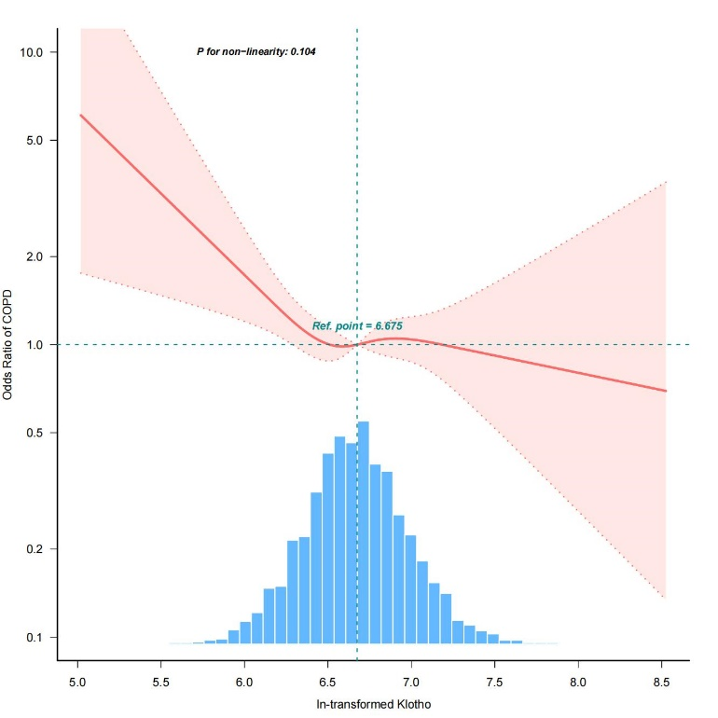

Supplement Fig.1. Odds ratio of COPD according to ln-transformed Klotho levels in the overall population. A linear association was found (P for non-linearity = 0.104) between ln-transformed serum Klotho levels and risk of COPD in a restricted cubic spline regression model. The solid line and shadow represented the odds ratio of COPD and 95 % confidence interval, respectively. All covariates were adjusted in this model.
Abbreviations: COPD, chronic obstructive pulmonary disease.

