Supplementary Material

Supplementary Table 1. Changes in trends of Candida species per quarter before and after emergence of Candida auris in Hong Kong ª
Candida species | Period 1 ^{b}  (RR, 95% CI, p value) | Period 2 ^{c}  (RR, 95% CI, p value) | Change in trend between period 1 & 2  (RR, 95% CI, p value) [remark]
All Candida species | RR: 1.005,  95% CI: 1.002–1.008,  p = 0.001 | RR: 1.012,  95% CI: 1.009–1.015,  p < 0.001 | RR: 1.007, 95% CI: 1.001–1.013, p = 0.026  [Period 2 exhibited a 0.7% faster increase compared to the trend in period 1]
Candida albicans | RR: 1.007,  95% CI: 1.006–1.009,  p < 0.001^{d} |  | RR: 1.003, 95% CI: 0.996–1.010, p = 0.416
Candida glabrata | RR: 1.054,  95% CI: 1.041–1.067,  p < 0.001 | RR: 1.029,  95% CI: 1.019–1.040,  p < 0.001 | RR: 0.977, 95% CI: 0.956–0.998, p = 0.035  [The increase in period 2 was slower compared to the trend observed in period 1]
Candida tropicalis | RR: 1.073,  95% CI: 1.060–1.087,  p < 0.001 | RR: 1.022,  95% CI: 1.012–1.031,  p < 0.001 | RR: 0.952, 95% CI: 0.933–0.971, p < 0.001  [The increase in period 2 was slower compared to the trend observed in period 1]
Candida parapsilosis | RR: 1.064,  95% CI: 1.052–1.076,  p < 0.001 | RR: 1.030,  95% CI: 1.023–1.038,  p < 0.001 | RR: 0.968, 95% CI: 0.952–0.984, p < 0.001  [The increase in period 2 was slower compared to the trend observed in period 1]
Other Candida species including Candida auris | RR: 1.005,  95% CI: 1.000–1.009,  p = 0.062 | RR: 1.015,  95% CI: 1.011–1.019,  p < 0.001 | RR: 1.011, 95% CI: 1.003–1.019, p < 0.001  [Period 2 exhibited a 1.1% faster increase compared to the trend in period 1]
CI, confidence interval; NA, not applicable; RR, relative risk.
ª The isolation of Candida species is expressed as the number of unique Candida species per 1,000 patient days. A unique Candida species refers to a non-duplicated isolate of the first Candida species identified during the same episode of hospitalization throughout the study period from 2015 1Q to 2023 2Q.
^{b} Period 1 (from 1Q 2015 to 1Q 2019, 17 quarters before the emergence of C. auris)
^{c} Period 2 (from 2Q 2019 to 2Q 2023, 17 quarters after the emergence of C. auris).
^{d} For C. albicans, there was no significant change in the trend of C. albicans isolates between period 1 and period 2
Supplementary Figure 1
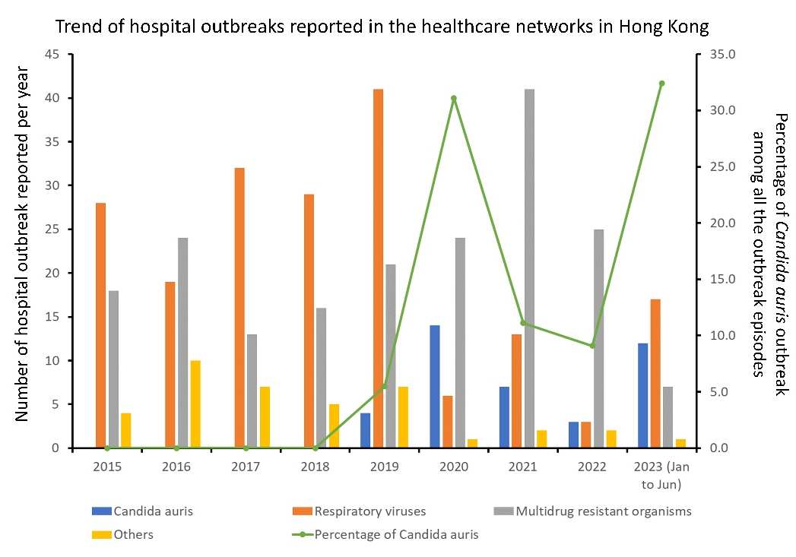

Legend of Supplementary Figure 1.
Trend of hospital outbreaks reported in the healthcare networks in Hong Kong
Note. In addition to Candida auris, outbreaks due to respiratory viruses include influenza A (n=77), rhinovirus (n=51), parainfluenza virus (n=18), human metapneumovirus (n=15), respiratory syncytial virus (n=13), influenza B (n=6), COVID-19 (n=5), and adenovirus (n=3). However, the number of COVID-19 outbreaks reported on or before 2022 was not included due to the evolving definition of COVID-19 outbreaks. Outbreaks due to multidrug-resistant organisms include multidrug-resistant Acinetobacter species (n=58), vancomycin-resistant Enterococci (n=56), carbapenemase-producing Enterobacterales (n=50), methicillin-resistant Staphylococcus aureus (MRSA) (n=15), carbapenem-resistant Acinetobacter species (n=8), and community-associated MRSA (n=2). It is worth noting that only outbreaks in pediatric patients were reported due to the endemicity of MRSA in adult patients. Outbreaks due to gastrointestinal viruses include norovirus (n=13), and rotavirus (n=1).

