SUPPLEMENTARY FILES

Table S1. Search Strategy
PUBMED
#1 | (((coronary heart disease[MeSH Terms]) OR (CAD[MeSH Terms])) OR (cardiovascular disease[MeSH Terms])) OR (heart disease[MeSH Terms]) | 114,286
#2 | risk or low risk | 30,268
#3 | discharge OR early discharge | 2,833
#4 | "length of stay"[MeSH Terms] OR hospital stay[Text Word] | 13,419
#5 | ("mortality"[Subheading] OR "mortality"[MeSH Terms] OR mortality[Text Word]) OR ("death"[MeSH Terms] OR death[Text Word]) | 136,024
#6 | readmission[All Fields] OR ("patient readmission"[MeSH Terms] OR rehospitalization[Text Word]) | 3,518
#7 | (primary[All Fields] AND ("percutaneous coronary intervention"[MeSH Terms] OR percutaneous coronary intervention[Text Word])) OR PCI[All Fields] | 5,893
#8 | #1 AND #2 AND #3 AND #4 AND #5 AND #6 AND #7  ((((((coronary heart disease or cad or heart disease) AND (primary percutaneous coronary intervention or pci)) AND (discharge or early discharge)) AND (readmission or rehospitalization)) AND (length of stay or hospital stay)) AND (mortality or death)) AND (risk or low risk) | 32
SCIENCEDIRECT
#1 | coronary heart disease or cad or heart disease | 66,973
#2 | risk or low risk | 1,000,000+
#3 | Discharge or early discharge | 814,437
#4 | Length of stay or hospital stay | 54,744
#5 | Mortality or death | 897,607
#6 | readmission or rehospitalization | 6,267
#7 | primary percutaneous coronary intervention or pci or percutaneous coronary intervention or angioplasty | 10,374
#8 | #1 AND #2 AND #3 AND #4 AND #5 AND #6 AND #7  coronary heart disease or cad or heart disease AND risk or low risk AND Discharge or early discharge AND Length of stay or hospital stay AND Mortality or death AND readmission or rehospitalization AND primary percutaneous coronary intervention or pci or percutaneous coronary intervention or angioplasty | 103
 | ((((coronary heart disease OR myocardial infarction OR cardiovascular disease) AND (low risk or risk)) AND (early discharge)) AND (primary percutaneous coronary intervention)) AND (hospital readmission) | 360
SCOPUS
#1 | coronary AND artery AND disease OR cad OR coronary AND heart AND disease AND primary AND percutaneous AND coronary AND intervention OR pci OR percutaneous AND coronary AND intervention OR angioplasty | 69,784
#2 | coronary AND artery AND disease OR cad OR coronary AND heart AND disease AND primary AND percutaneous AND coronary AND intervention OR pci OR percutaneous AND coronary AND intervention OR angioplasty AND early AND discharge OR reduce AND length AND of AND stay | 1,240
#3 | coronary AND artery AND disease OR cad OR coronary AND heart AND disease AND primary AND percutaneous AND coronary AND intervention OR pci OR percutaneous AND coronary AND intervention OR angioplasty AND early AND discharge OR reduce AND length AND of AND stay AND mortality OR death AND length AND of AND stay OR hospitalization OR length AND in AND hospital | 365
EBSCO-host Academic Search Complete
S1 | coronary artery disease or cad or coronary heart disease | 76,347
S2 | primary percutaneous coronary intervention or pci or percutaneous coronary intervention or angioplasty | 33,237
S3 | early discharge or reduce length of stay | 4825
S4 | Low risk | 48,015
S5 | readmission or rehospitalization or readmittance or re-hospitalization or re-admittance or re-admission | 29,159
S6 | mortality or death | 527,669
S7 | length of stay or hospitalization or length in hospital | 163,449
S8 | coronary artery disease or cad or coronary heart disease AND primary percutaneous coronary intervention or pci or percutaneous coronary intervention or angioplasty AND early discharge or reduce length of stay AND readmission or rehospitalization or readmittance or re-hospitalization or re-admittance or re-admission AND mortality or death AND length of stay or hospitalization or length in hospital | 5
S9 | coronary artery disease or cad or coronary heart disease AND primary percutaneous coronary intervention or pci or percutaneous coronary intervention or angioplasty AND early discharge or reduce length of stay | 21
Taylor and Francis
1 | ((((coronary heart disease OR myocardial infarction OR cardiovascular disease) AND (low risk or risk)) AND (early discharge)) AND (primary percutaneous coronary intervention)) AND (hospital readmission) | 217
2. | Coronary artery disease AND discharge AND percutaneous coronary intervention AND readmission | 199
3. | Coronary artery disease AND discharge AND percutaneous coronary intervention AND readmission AND mortality OR death AND length of stay | 91
4. | Coronary artery disease AND discharge AND percutaneous coronary intervention AND readmission AND (mortality OR death) AND length of stay | 85
Google Scholar
1. | coronary artery disease or cad or coronary heart disease AND primary percutaneous coronary intervention or pci or percutaneous coronary intervention or angioplasty AND early discharge or reduce length of stay | 5.830
2. | The first 100 articles were taken based on relevance | 100

Tabel S2. Data Extraction of Included Studies
First Author/ Year/ Country/ Study Design | Low-risk Patients Criteria and Revascularization Access | Sample | Mean Age (y) | Early Discharge Strategy | Comparison | Primary Outcome |  | Secondary Outcome | Appraisal Results
 |  |  |  |  |  | Readmission | Mortality | LOS | Appraisal Results
Randomized Controlled Trial
Kotowycz (2010)¹⁶  Canada  RCT | Zwolle score ≤ 3  N/I | 54 Patients  ED (n=27)  SD (n=27) | ED (55.6)  SD (55) | ED within 48-72 h  Received outpatient follow-up with an advanced practice nurse | SD  Follow-up were left to the treating physician. | FU-6 weeks  ED (2; 8%)  SD (1; 4%) | FU-6 weeks  ED (0)  SD (0) | Median  ED (55.6)  SD (55)  hour | 77%
Melberg et al (2015)²¹  Norway  RCT | Zwolle low-risk score ≤3 (TIMI flow 3-vessel, age, disease, anterior infarction and ischaemia time), Age <70 years, Killip class ≤2.  Radial access in ED (50.5%) | 215 Patients  ED (n=107)  Usual Care (n=108) | ED (57% <60 years)  Usual Care (62% <60 years) | ED within minimum 16-72 h total stay | Usual Discharge  (>72 h) | FU-1 month  ED  8 (7.4%)  Usual Care  8 (7.4%) | FU-1 month  ED (0)  SD (0) | ED  (2.2±0.5)  sUsual Care  (2.4±0.6)  days | 85%
Novobilsky et al (2019)⁷  Czech Republic  Randomized single centre study | TIMI flow 3, Age ≤ 75 years, LVEF ≥ 45%, Single- or two-vessel disease, No. symptoms of residual ischaemia, Killip class I, No. arrhythmia requiring treatment occurring > 2 h after PPCI.  Radial access in ED (98.7%) | 115 Patients  ED (n=76)  SD (n=75) | ED (56.7 ± 9.2)  SD (58.0 ± 8.7) | ED within 48 – 72 h  Clinical control at hospital 2 - 4 days after discharge | SD  Discharge after 72 h | FU-1 month  ED (5; 6.6%)  SD (6; 8%) | FU-1 month  ED (0)  SD (0) | ED  (60.8 ± 8.5)  SD  (92.1 ± 12.1)  hour | 92%
Satilmisoglu et al (2016)²²  Turkey  Prospective, randomized, multicenter | TIMI flow 2–3 flow and less than 20% residual stenosis after PPCI, Killip Class II to IV. Zwolle low-risk <2.  N/I | 733 patients  ED (n=370)  SD (n=363) | ED (54.55±10.2)  SD (54.63±11.8) | ED within 48–56 h.  FU at days 1, 7, and 20 by telephone | SD  Left to doctors and nurses | FU-1 month  ED (14; 3.8%)  SD (25; 6.9%) | FU-1 month  ED (2; 0.6%)  SD (3; 0.8%) | ED  (45.99 ± 9.12)  SD  (114.87 ± 63.53)  hour | 92%
Jirmar et al (2008)²⁰  Czech Republic  Open Randomized Study | TIMI-3 flow and <20% residual stenosis, Single-vessel disease, LVEF > 40%, Age < 75 years.  N/I | 56 Patients  ED (n=37)  SD (n=19) | ED (56 ± 10)  SD (58 ± 8) | ED within 24-30 h  Given health education  FU by phone on day 2, while on day 3 a physician visited the patient at home (group B) and on days 7 and 30 the patients visited the PCI center. | SD | FU-1 month  ED (1)  SD (0) | FU-1 month  ED (0)  SD (0) | ED (29 ± 3)  SD (105 ± 45)  hour | 85%
Azzalini et al (2015)²⁷  Spain  Open-label, randomized, controlled study | STEMI with symptoms-to-balloon time ≤ 12 h, successful PPCI, Zwolle low-risk score ≤ 3, LVEF >45%.  Radial access in ED (91%) | 100 Patients  ED (n=54)  CDS (n=46) | ED (58 ± 11.9)  CDS  (60.6 ± 12.5) | ED within ≤72 h,  Lifestyle modification intervention by Specialized nurse, FU (≤7 days, ≤6 weeks and ≤12 weeks) Cardiologist: 1 visit (≤12 weeks) | CDS  According to physician’s criterion, lifestyle education by general nursing | N/I | FU-3 months  ED (0)  CDS (0) | ED  (70.1±8.1)  CDS (111.8±28.3)  hour | 77%
Grines et al (1998)¹⁵  Five countries (US, Brazil, Agentina, Japan, Spain)  RCT | Age ≤70 years, LVEF >45%, one or two vessel disease, successful PTCA, no persistent arrhythmias, TIMI flow grade 2 or 3  N/I | 471 Patients  AC (n=237)  TD (n= 234) | AC (55 ± 10)  TD (56 ± 10) | AC  The patient should be discharged on day 3 | TD  Stay in hospital for at least 5 days. | FU- 6 months  AC (10; 14%)  TD (9; 12.5%) | FU- 6 months  AC (2; 0.8%)  TD (1; 0.4%) | AC (4.2 ± 2.3)  TD (7.1 ± 4.7)  days | 85%
Observational Cohort Studies
Yip et al (2003)²⁴  Taiwan  Retrospective cohort study | Killip class ≤2, without recurrent ischemia or reinfarction during the first 24 hours, no mechanical or electrical complications after d-PCI, no acute renal failure, acute stroke, or major bleeding complication, no advanced CHF and sepsis  Femoral access in all patients 98% | 463 Patients  ED (n=266)  SD (n=197) | ED (58.6±11.7)  SD (60.1±12.1) | ED within <4 days | SD  Discharged ≥4 days | N/I | FU-1 month  ED (0)  SD (1; 0.5%) | ED (3.37±0.77)  SD (5.98±0.93)  days | 73%
Rathod et al (2021)²⁸  United Kingdom  Prospective cohort study | LVEF≥40%, TIMI flow grade 3, Absence of bystander disease requiring inpatient revascularization, No recurrence of ischemic symptoms, Killip class 1 No significant arrhythmias after the procedure, Mobility with suitable social circumstances for discharge  Radial access in ED (94%) | 1.300 Patients  EHD (n=600)  SHD (n=700) | EHD  (59.2 ± 11.8)  SHD  (57.5 ± 12.1) | EHD within 24-48 h  Given cardiac rehabilitation counseling after discharge (48-hour telephone call) | SDH within >48 hours and received this counseling as planned | N/I | FU-3 months  EHD (2; 0.33%)  SHD (0.7%) | Median  EHD (24.6)  SHD (65.9)  hours | 91%
Jones et al (2012)²⁹  United Kingdom  Prospective cohort study | TIMI III flow, LVEF >40%, and rhythmic and haemodynamic stability out to 48 h.  Radial access in ED (42.5%) | 2.653 Patients  2 days (n=1117)  3 days (n=620)  >3 days (n=916) | 2 days (61.02±0.13)  3 days (63.21±0.27)  >3 days (67.33±0.27) | ED within ≤3 days  FU-1 week after discharge | SD within >3 days discharge | FU-2.8 year  ED 2-3 days (87 Total/1737  SD 3 days  42/916 | N/I | N/I | 91%
Yndigegn et al (2022)²⁵  Swedia  Prospective cohort study | Age <70 years, One- or two-vessel disease, LVEF ≥50%, and absence of serious arrhythmias requiring defibrillation/ cardioversion or pacemaker.  Radial access in ED (83.9%) | 8.092 Patients  ED (n=1.449) LD (n=6.643) | ED (59.0)  LD (59.0) | ED within ≤2 days | LD within >2 days | FU-1 month  ED (7; 0.5%)  LD (61; 0.9%) | FU-1 month  ED (6; 0.4%)  LD (20; 0.3%)  FU-1 years  ED (14; 1.0%)  LD (68;1.0%) | N/I | 91%
Noman et al (2013)¹⁹  United Kingdom  Retrospective observational cohort study. | TIMI grade flow 3 in the infarct-related artery and without haemodynamic or arrhythmic complications.  Radial access in ED (72.6%) | 2.448 Patients  ED (n=1.542)  LD (n=906) | ED (61.4±12.8)  LD (64.8±13.6) | ED within 2 days of admission | LD within >2 days of admission | N/I | FU-7 days  ED (0)  LD (4; 0.4%)  FU-1 month  ED (11;0.71%)  LD (15; 1.66%)  FU-584 days  ED (67;4.3%)  LD (111; 12.3%) | Median  ED (2)  LD (3)  days  Mean  ED (1.4)  LD (5.1) | 91%
Yousif et al (2021)²⁶  Kingdom of Bahrain  Retrospective observational cohort study | TIMI grade flow 3 in the culprit artery and without haemodynamic or arrhythmic complications, the absence of complications, LVEF>40%.  Radial access in ED (90.5%) | 301 Patients  ED (n=74)  SD (n=227) | ED (55 ± 11.5)  SD (53.4 ± 11.3) | ED within <48 h of admission | SD within >48 hour of admission | FU-1 month  ED (2; 2.7%)  SD (9; 4%) | FU-1 month  ED (0)  SD (2; 0.8%) | N/I | 91%
Swaminathan et al (2015)¹⁷  USA  Retrospective observational cohort study | No complications after PPCI, without comorbidities, Ventricular function was good before PCI, Onset of symptoms at hospital admission ≤6 hours, LVEF >45%.  Femoral access in ED (97.9%) | 33,920 Patiets  LOS ≤3 days  (n = 9,135)  LOS 4–5 days  (n = 15,704)  LOS >5 days  (n = 9,081) | LOS ≤3 days  (72.0)  LOS 4–5 days  (73.0)  LOS >5 days  (76.0) | ED  LOS ≤3 days | SD  LOS >3 days | FU-1 month  ED (91/9135)  SD (318/24785) | FU-1 month  ED (82/9135)  SD (475/24785) | N/I | 91%
Abbreviations: AC, Accelerated care; CDS, Conventional Discharge Strategy; ED, Early Discharge, EHD, Early Hospital Discharge; FU, Follow Up; LD, Late Discharge; LVEF, Left ventricular ejection fraction; N/I, Not Information; NED, Non-Early Discharge; PPCI, Primary Percutaneous Coronary Intervention; RCT, randomized controlled trials; SD, Standard Discharge; SHD, Standard Hospital Discharge; TD, Traditional Discharge; TIMI, Thrombolysis in Myocardial Infarction.

Publication Bias Results

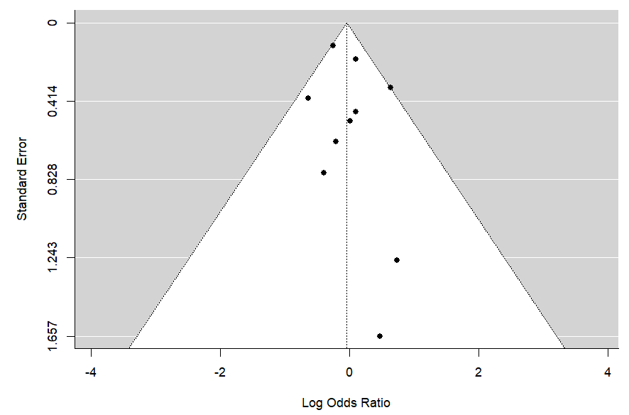
Figure S1. Funnel Plot of Readmission Outcome
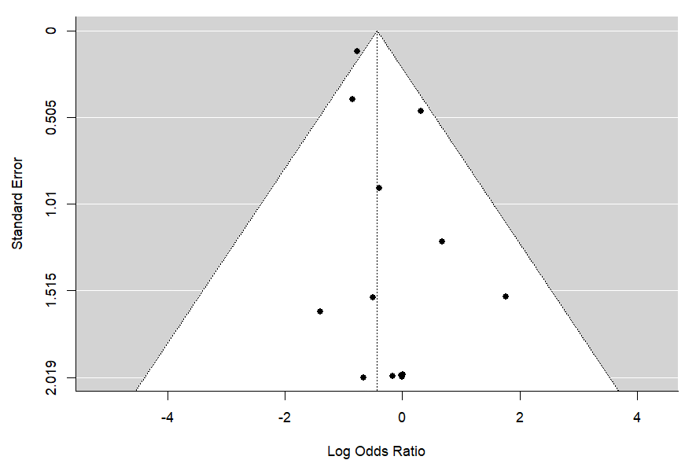
Figure S2. Funnel Plot of Mortality Outcome
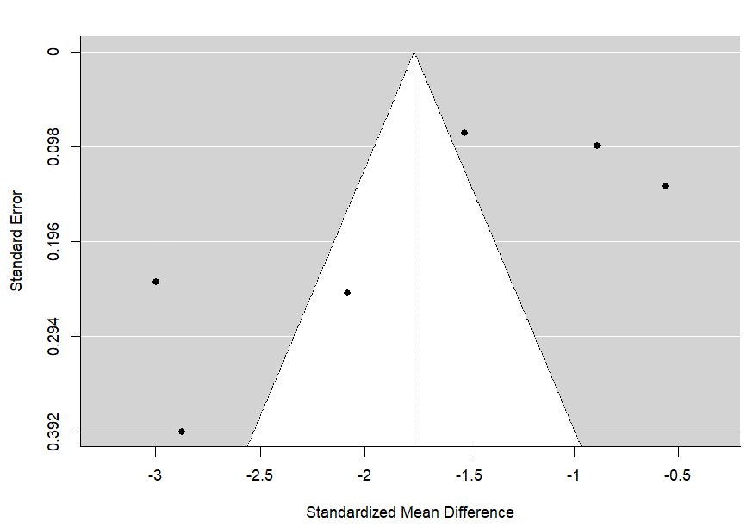
Figure S3. Funnel Plot of LOS Outcome

Subgroup Analysis Results

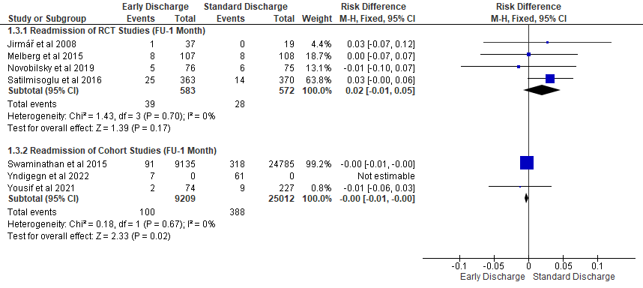
Figure S4. Forest Plot Outcome of Readmission (FU-1 Month) with Early Discharge vs Standard Discharge

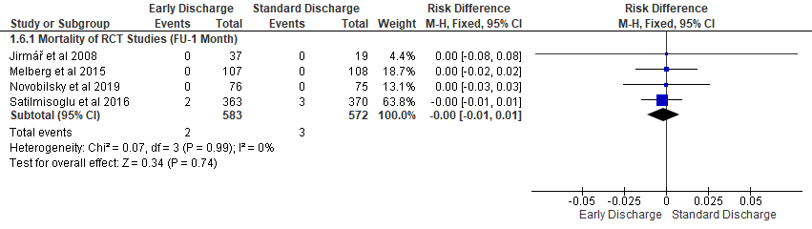
Figure S5. Forest Plot Outcome of Mortality (FU-1 Month) with Early Discharge vs Standard Discharge of RCT Studies

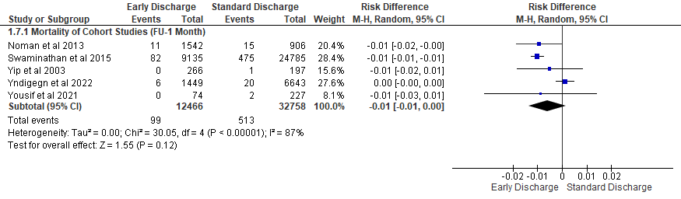
Figure S6. Forest Plot Outcome of Mortality (FU-1 Month) with Early Discharge vs Standard Discharge of Cohort Studies

