Supplementary table 1 Baseline characteristics of study participants
MHR Quartile | Q1(≤-0.67) | Q2(-0.67 to ≤-0.52) | Q3(-0.52 to ≤-0.39) | Q4(>-0.39) | P value
N | 21323 (25.00%) | 21955 (25.74%) | 21176 (24.83%) | 20839 (24.43%)
Age (years) | 49.13±12.65 | 50.17±12.97 | 50.6±13.34 | 51.29±13.89 | ＜0.001
Gender |  |  |  |  | ＜0.001
Male | 7321 (34.33%) | 12646 (57.60%) | 15934 (75.25%) | 18581 (89.16%)
Female | 14002 (65.67%) | 9309 (42.40%) | 5242 (24.75%) | 2258 (10.84%)
BMI (kg/m²) | 22.89 (20.96, 25.04) | 24.16 (22.21, 26.20) | 24.96 (23.06, 26.93) | 25.78 (23.93, 27.78) | ＜0.001
SBP (mmHg) | 122.38±17.89 | 125.65±17.79 | 127.63±17.58 | 129.24±17.17 | ＜0.001
DBP (mmHg) | 74.19±11.62 | 77.34±11.93 | 79.21±11.99 | 80.54±11.90 | ＜0.001
HbA1c (%) | 5.54±0.34 | 5.57±0.34 | 5.59±0.35 | 5.62±0.34 | ＜0.001
FPG (mmol/L) | 5.1±0.50 | 5.13±0.54 | 5.14±0.54 | 5.15±0.57 | ＜0.001
Scr (umol/L) | 62.50 (55.00, 73.00) | 68.00 (58.00, 78.00) | 72.00 (62.80, 81.00) | 74.40 (66.40, 82.50) | ＜0.001
ALT (U/L) | 16.80 (12.50, 23.00) | 19.00 (14.00, 27.00) | 22.00 (16.00, 31.00) | 24.00 (17.00, 35.00) | ＜0.001
TG (mmol/L) | 1.07 (0.79, 1.48) | 1.30 (0.94, 1.82) | 1.50 (1.09, 2.10) | 1.74 (1.26, 2.49) | ＜0.001
TC (mmol/L) | 5.09±0.98 | 4.9±0.96 | 4.78±0.95 | 4.63±0.97 | ＜0.001
HDL-C (mmol/L) | 1.57±0.33 | 1.33±0.25 | 1.19±0.21 | 1.04±0.18 | ＜0.001
LDL-C (mmol/L) | 2.97±0.81 | 2.99±0.80 | 2.96±0.80 | 2.88±0.82 | ＜0.001
UA (umol/L) | 303.96±81.23 | 336.71±84.70 | 361.36±84.45 | 384.46±83.34 | ＜0.001
WBC (10⁹/L) | 4.85 (4.20, 5.60) | 5.50 (4.80, 6.30) | 6.00 (5.25, 6.80) | 6.90 (6.00, 7.90) | ＜0.001
Monocyte (10⁹/L) | 0.25 (0.21, 0.29) | 0.34 (0.30, 0.38) | 0.41 (0.36, 0.46) | 0.53 (0.46, 0.61) | ＜0.001

Notes: values are N (%) or mean ± SD or median (quartile)

Abbreviations: body mass index (BMI), systolic blood pressure (SBP), diastolic blood pressure (DBP), Hemoglobin A1c (HbA1c), fasting plasma glucose (FPG), serum creatinine (Scr), alanine aminotransferase (ALT), triglycerides (TG), total cholesterol (TC), high-density lipoprotein cholesterol (HDL-C), low-density lipid cholesterol (LDL-C), uric acid (UA), white blood cell (WBC), monocyte-to-high-density lipoprotein ratio (MHR), MHR value was log10-transformed.

Supplementary Table 2 The characteristics of participants on both sides of the inflection point
Characteristics | MHR ≤ -0.40 | MHR＞-0.40 | P value
N | 22247 | 63046
Age (years) | 49.95±13.00 | 51.24±13.84 | ＜0.001
Gender
Male | 34758 (55.13) | 19724 (88.66) | ＜0.001
Female | 28288 (44.87) | 2523 (11.34) | ＜0.001
BMI (kg/m²) | 24.01 (21.94, 26.12) | 25.74 (23.88,27.75) | ＜0.001
SBP (mmHg) | 125.15±17.88 | 129.18±17.21 | ＜0.001
DBP (mmHg) | 76.85±12.01 | 80.5±11.93 | ＜0.001
FPG (mmol/L) | 5.57±0.34 | 5.62±0.34 | ＜0.001
Scr (umol/L) | 5.12±0.53 | 5.15±0.57 | ＜0.001
ALT (U/L) | 67.6 (57.90, 77.90) | 74.30 (66.2,82.4) | ＜0.001
TG (mmol/L) | 1.27 (0.91, 1.80) | 1.73 (1.25, 2.46) | ＜0.001
TC (mmol/L) | 4.93±0.97 | 4.64±0.98 | ＜0.001
HDL-C (mmol/L) | 1.37±0.31 | 1.04±0.19 | ＜0.001
LDL-C (mmol/L) | 2.98±0.80 | 2.88±0.82 | ＜0.001
UA (umol/L) | 327.00 (270.00, 389.00) | 379.00 (328.00, 435.00) | ＜0.001
WBC (10⁹/L) | 5.41 (4.68, 6.30) | 6.80 (5.90, 7.89) | ＜0.001
Monocyte (10⁹/L) | 0.26 (0.19, 0.32) | 0.49 (0.44, 0.57) | ＜0.001
Notes: values are N (%) or mean ± SD or median (quartile).
Abbreviations: body mass index (BMI), systolic blood pressure (SBP), diastolic blood pressure (DBP), fasting plasma glucose (FPG), serum creatinine (Scr), alanine aminotransferase (ALT), triglycerides (TG), total cholesterol (TC), high-density lipoprotein cholesterol (HDL-C), low-density lipid cholesterol (LDL-C), uric acid (UA), white blood cell (WBC). monocyte-to-high-density lipoprotein ratio (MHR), MHR value was log10-transformed.

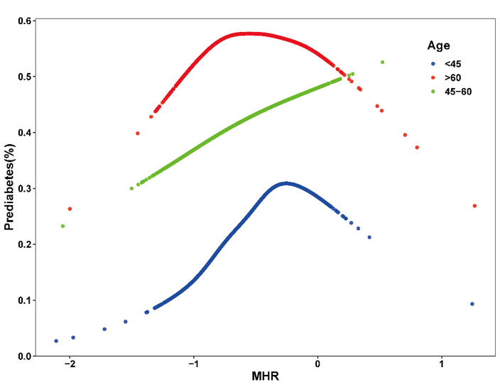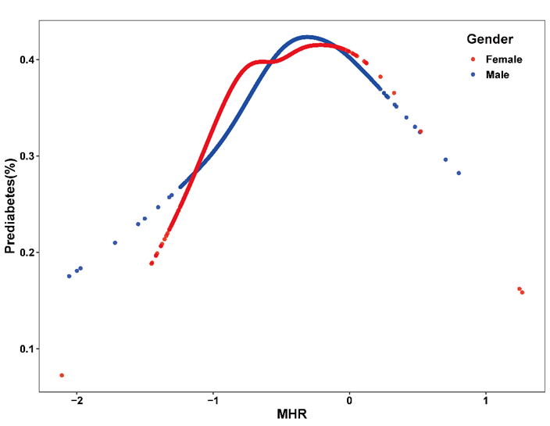
A B
C | D
E | F
G H
Supplementary Figure 1 Association between MHR and prediabetes
A: Stratified by age; B: Stratified by gender; C: Stratified by BMI; D: Stratified by SBP; E: Stratified by DBP; F: Stratified by TG; G: Stratified by TC; H: stratification by LDL-C
Adjustment factors: Adjusted for age, gender, BMI, SBP, DBP, FPG, Scr, TG, TC, LDL-C, UA, WBC. The model was not individually adjusted for age, gender, BMI, SBP, DBP, TG, TC, LDL-C. Each line represents a smooth curve fit between variables.

