Supporting Information
Acidic Environment-Responsive Metal Organic Framework-Mediated Dihydroartemisinin Delivery for Triggering Production of Reactive Oxygen Species in Drug-Resistant Lung Cancer

Xiaojie Yan¹,*, Xueying Zhao^{2,*}, Mingde Fan³, Wenfu Zheng^{4,5}, Guanxiong Zhu⁶, Bin Li¹, Le Wang¹
¹Academician Workstation, Jiangxi University of Chinese Medicine, Nanchang, Jiangxi, People’s Republic of China; ²Department of Transfusion, The Second Hospital, Cheeloo College of Medicine, Shandong University, Jinan, Shandong, People’s Republic of China; ³Department of Neurosurgery, The Second Hospital, Cheeloo College of Medicine, Shandong University, Jinan, Shandong, People’s Republic of China; ⁴CAS Key Laboratory for Biological Effects of Nanomaterials and Nanosafety, National Center for NanoScience and Technology, Beijing, People’s Republic of China; ⁵School of Nanoscience and Engineering, University of Chinese Academy of Sciences, Beijing, People’s Republic of China; ⁶Department of Preventive Dentistry, Affiliated Stomatology Hospital of Guangzhou Medical University, Guangzhou, Guangdong, People’s Republic of China

*These authors contributed equally to this work

Correspondence: Le Wang; Bin Li, Academician Workstation, Jiangxi University of Chinese Medicine, Nanchang, Jiangxi, People’s Republic of China, Tel/Fax +86-791-86362367, Email wangle@jxutcm.edu.cn; 20010260@jxutcm.edu.cn

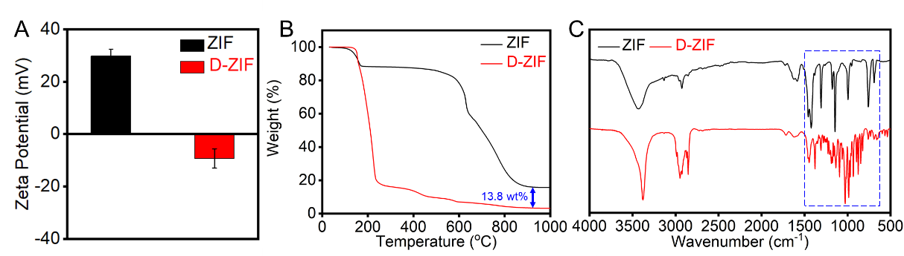
Fig. S1Characterization of ZIF and D-ZIF. (A) Zeta potential analysis of ZIF and D-ZIF. (B) TGA curves of ZIF and D-ZIF. (C) FT-IR spectra of ZIF and D-ZIF.
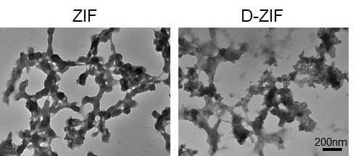
Fig. S2 Morphology of ZIF and D-ZIF in response to pH 6.5. TEM images of ZIF and D-ZIF after 24 h. Scale bar: 200 nm.

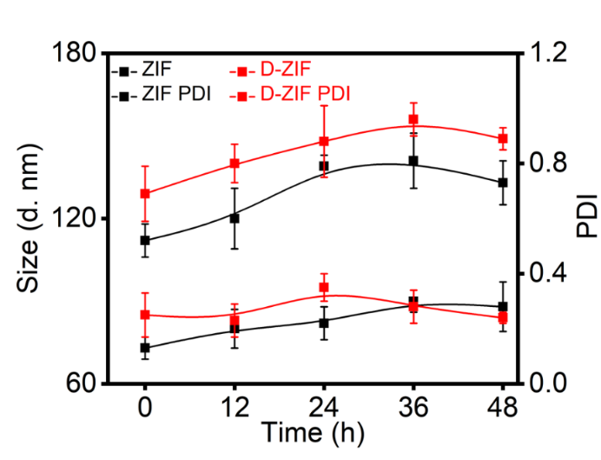
Fig. S3 The stability of ZIF and D-ZIF.

Fig. S4 The viability of sensitive A549 cells after incubation with different concentration of D-ZIF for 24 h. Statistical significance: ***p < 0.001, and ****p < 0.0001.

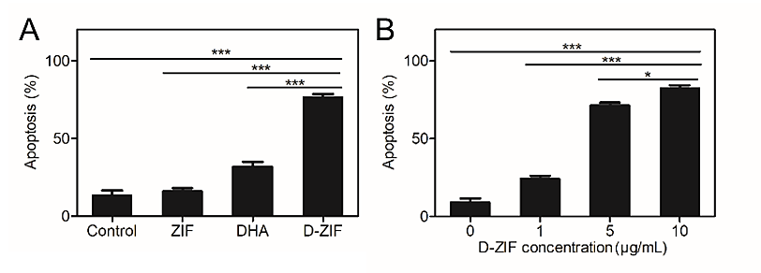
Fig. S5 The biological processes induced by various formulations. (A)The percentage of apoptotic cells treated by different formulations. (B)The percentage of apoptotic cells treated by different concentrations of D-ZIF. Statistical significance: *p < 0.05, and ***p < 0.001.

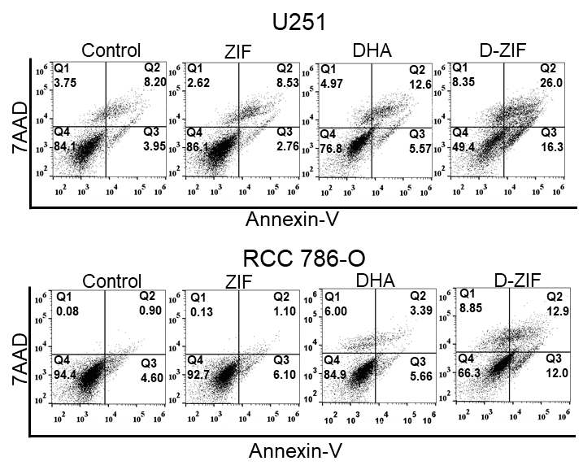
Fig. S6 FCM analysis of U251 cells and RCC786-O cells treated with different formulations.

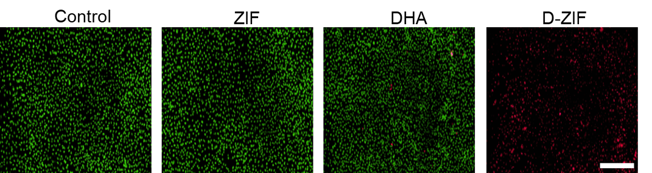
Fig. S7 AO-EB dual staining of A549-TAX cells treated with different formulations for 12 h under 10×. Scale bar: 200 μm.
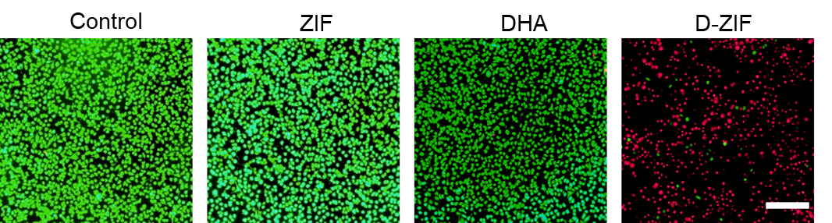 Fig. S8 Live/dead assay analysis of A549-TAX cells treated with different formulations for 12 h. Scale bar: 200 μm.

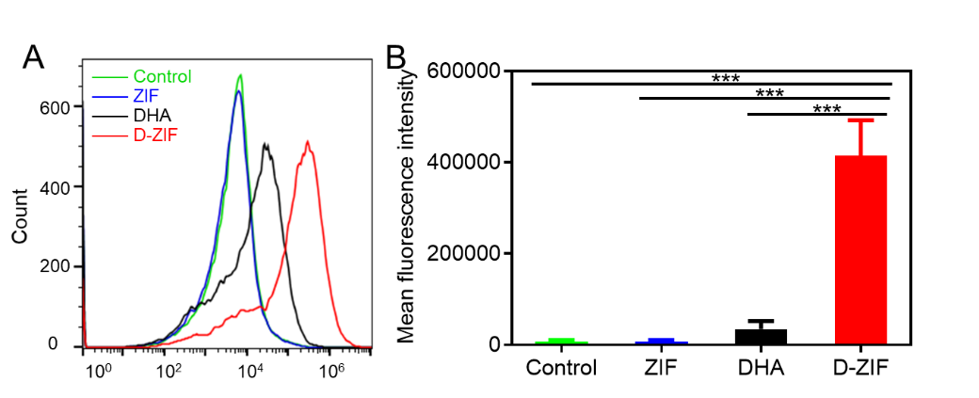
Fig. S9 ROS levels in A549-TAX cells under the treatment of different formulations. (A) FCM analysis of ROS generation in A549-TAX cells treated with different formulations. (B) Mean fluorescence intensity ROS generation in A549-TAX cells treated with different formulations. Statistical significance: ***p < 0.001.

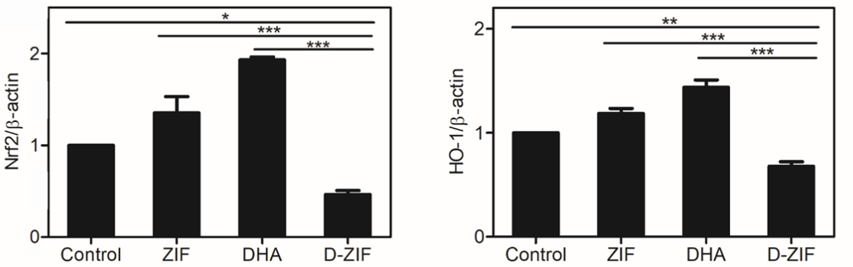
Fig. S10 A549-TAX cells treated by different formulations to evaluate the expression of Nrf2/HO-1 pathway relative proteins. Statistical significance: *p < 0.05, **p < 0.01, and ***p < 0.001.

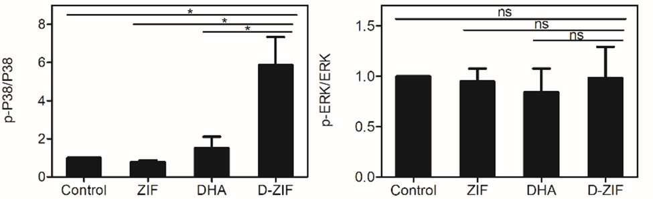
Fig. S11 A549-TAX cells treated by different formulations to evaluate the expression of P38 MAPK pathway-related proteins. Statistical significance: *p < 0.05, and ns: no significance.

Fig. S12 The weight of the excised tumors in different treatments. Statistical significance: ***p < 0.001, and ****p < 0.0001.

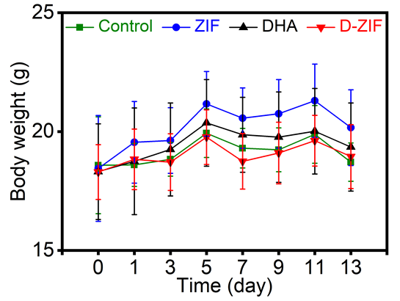
Fig. S13 The changes of the mice body weight during different treatments.

