Supplementary Material

Table S1. Means, standard deviations, skewness, and kurtosis of the PHQ-8 items and suicidality assessments
Table S2. Correlation matrix of the PHQ-8 items and suicidality assessments
Figure S1. Non-parametric bootstrapped difference test
Figure S2. Visual representation of the network after controlling for age, gender, marital status, and education.
Figure S3. An estimated network model for the depressive symptoms and suicidality in males and females
Figure S4. Comparison of network properties between females and males
Figure S5. Comparison of network centrality indices between males and females.

Table S1. Means, standard deviations, skewness, and kurtosis of the PHQ-8 items and suicidality assessments

Item | M | SD | Skewness | kurtosis
PHQ1 | 1.11 | 0.93 | 0.61 | 0.28
PHQ2 | 0.93 | 0.84 | 0.81 | 0.28
PHQ3 | 1.17 | 1.00 | 0.53 | -0.77
PHQ4 | 1.25 | 0.93 | 0.48 | -0.58
PHQ5 | 0.85 | 0.93 | 0.88 | -1.31
PHQ6 | 0.63 | 0.92 | 1.37 | 0.83
PHQ7 | 0.68 | 0.89 | 1.21 | 0.59
PHQ8 | 0.49 | 0.79 | 1.67 | 2.15
SI | 0.08 | 0.28 | 3.00 | 6.99
SP | 0.03 | 0.18 | 5.09 | 23.96
SA | 0.03 | 0.18 | 5.26 | 25.71

Note: PHQ1: Anhedonia; PHQ2: Sad Mood; PHQ3: Sleep; PHQ4: Fatigue; PHQ5: Appetite; PHQ6: Guilt; PHQ7: Concentration; PHQ8: Motor disturbance; SI: Suicidal ideation; SP: Suicide plan; SP: Suicide attempt; M: Mean; SD: Standard deviations

Table S2. Correlation matrix of the PHQ-8 item and suicidality assessments
 | PHQ-1 | PHQ-2 | PHQ-3 | PHQ-4 | PHQ-5 | PHQ-6 | PHQ-7 | PHQ-8 | SI | SP | SA
PHQ1 | 0
PHQ2 | 0.299 | 0
PHQ3 | 0.085 | 0.045 | 0
PHQ4 | 0.306 | 0.153 | 0.231 | 0
PHQ5 | 0.013 | 0.091 | 0.222 | 0.221 | 0
PHQ6 | 0.069 | 0.210 | 0.082 | 0.023 | 0.040 | 0
PHQ7 | 0.098 | 0.046 | 0.021 | 0.020 | 0.194 | 0.194 | 0
PHQ8 | 0.023 | 0.137 | 0.091 | 0.031 | 0.051 | 0.141 | 0.307 | 0
SI | 0.017 | 0.040 | 0.010 | 0.018 | 0 | 0.142 | 0.051 | 0 | 0
SP | 0 | 0 | 0.031 | 0 | 0.031 | 0 | 0 | 0.028 | 0.283 | 0
SA | 0 | 0 | 0 | 0.015 | 0 | 0 | 0 | 0 | 0.298 | 0.444 | 0

Note: PHQ1: Anhedonia; PHQ2: Sad Mood; PHQ3: Sleep; PHQ4: Fatigue; PHQ5: Appetite; PHQ6: Guilt; PHQ7: Concentration; PHQ8: Motor disturbance; SI: Suicidal ideation; SP: Suicide plan; SA: Suicide attempt; Bold text: top 3 correlation of the PHQ-8 item and top 2 correlation of suicidality items

Figure S1. Non-parametric bootstrapped difference test
A:
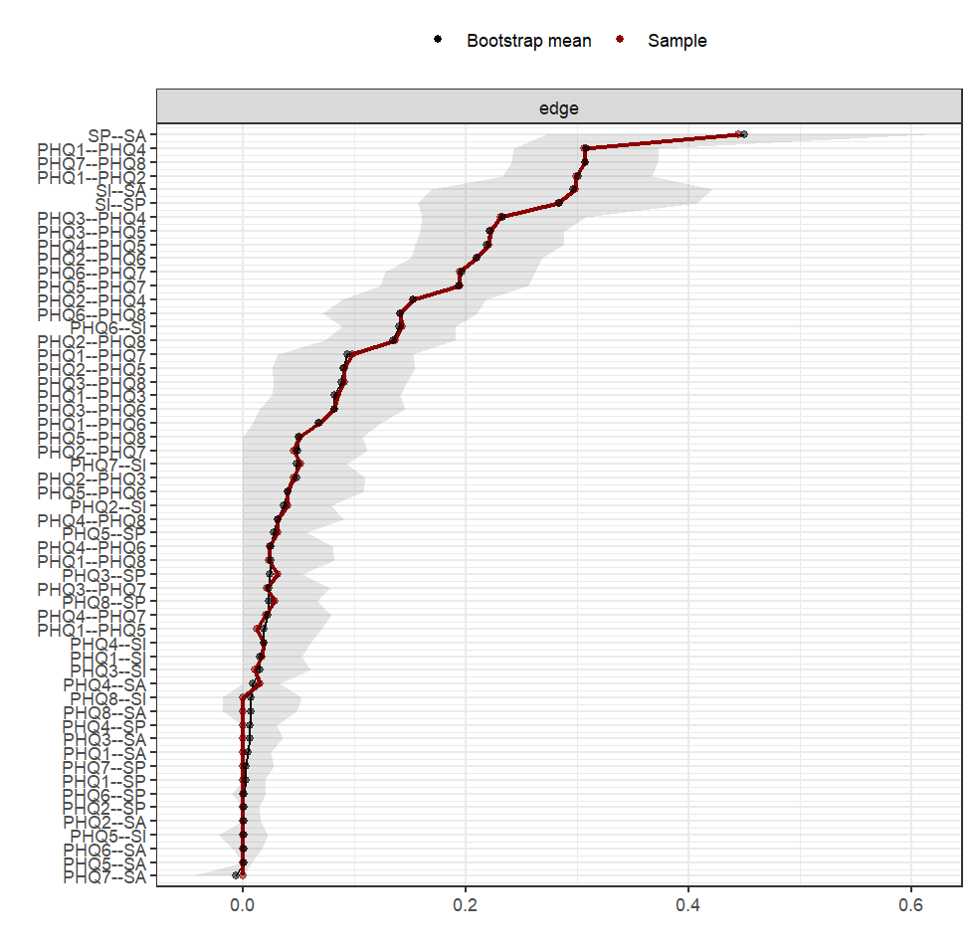
B:
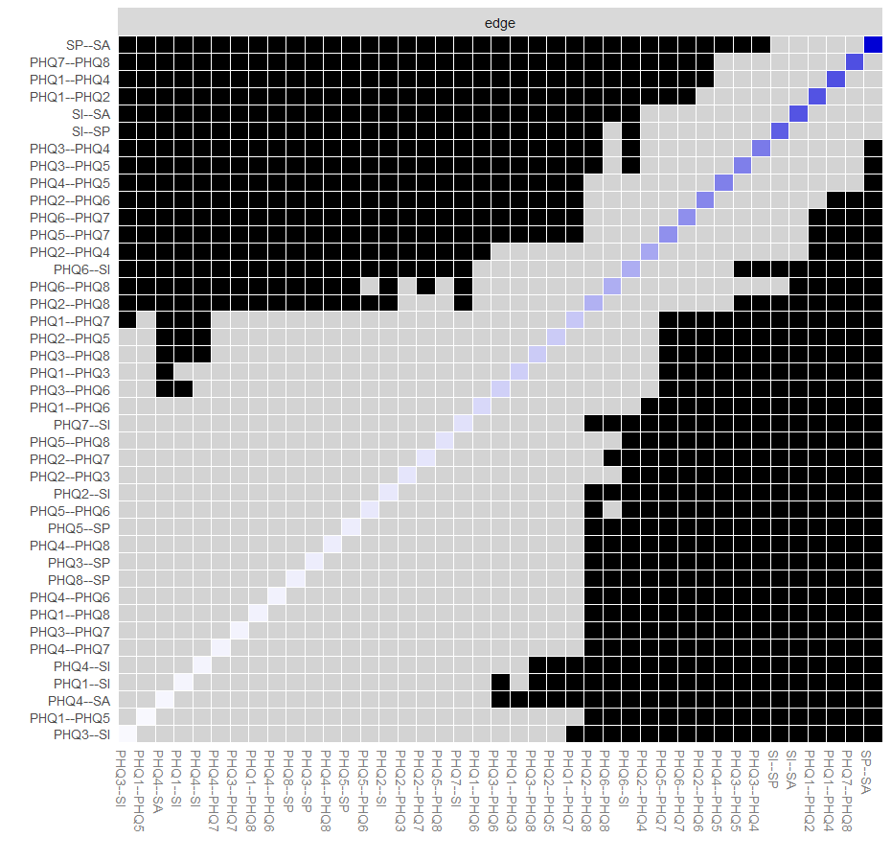
Note: The red dots indicate the value of each edge weight, arranged from highest to lowest. According to the non-parametric bootstrap procedure, the grey area represents the 95% Confidence Intervals of edge weights. Wide intervals indicate a low level of stability, whereas narrow intervals indicate a higher level of stability. B: Comparison of edge weights in the network using bootstrapped difference tests. A gray box indicates edges that do not significantly differ from one another. The black boxes indicate edges that differ significantly from one another.

Figure S2. Visual representation of the network after controlling for age, gender, marital status, and education.

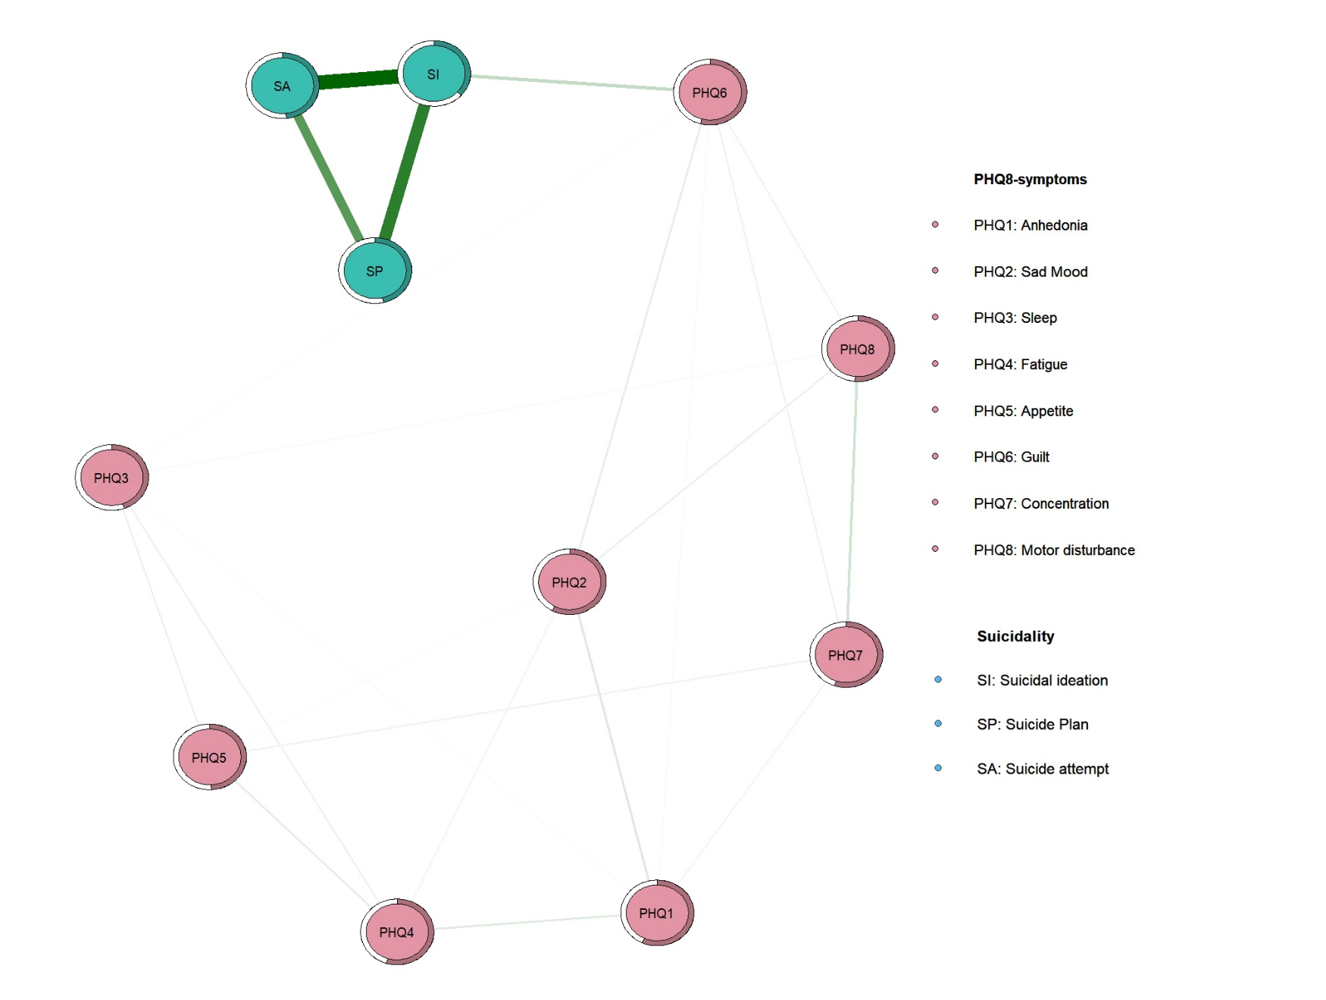
Figure S3. An estimated network model for the depressive symptoms and suicidality in males and females

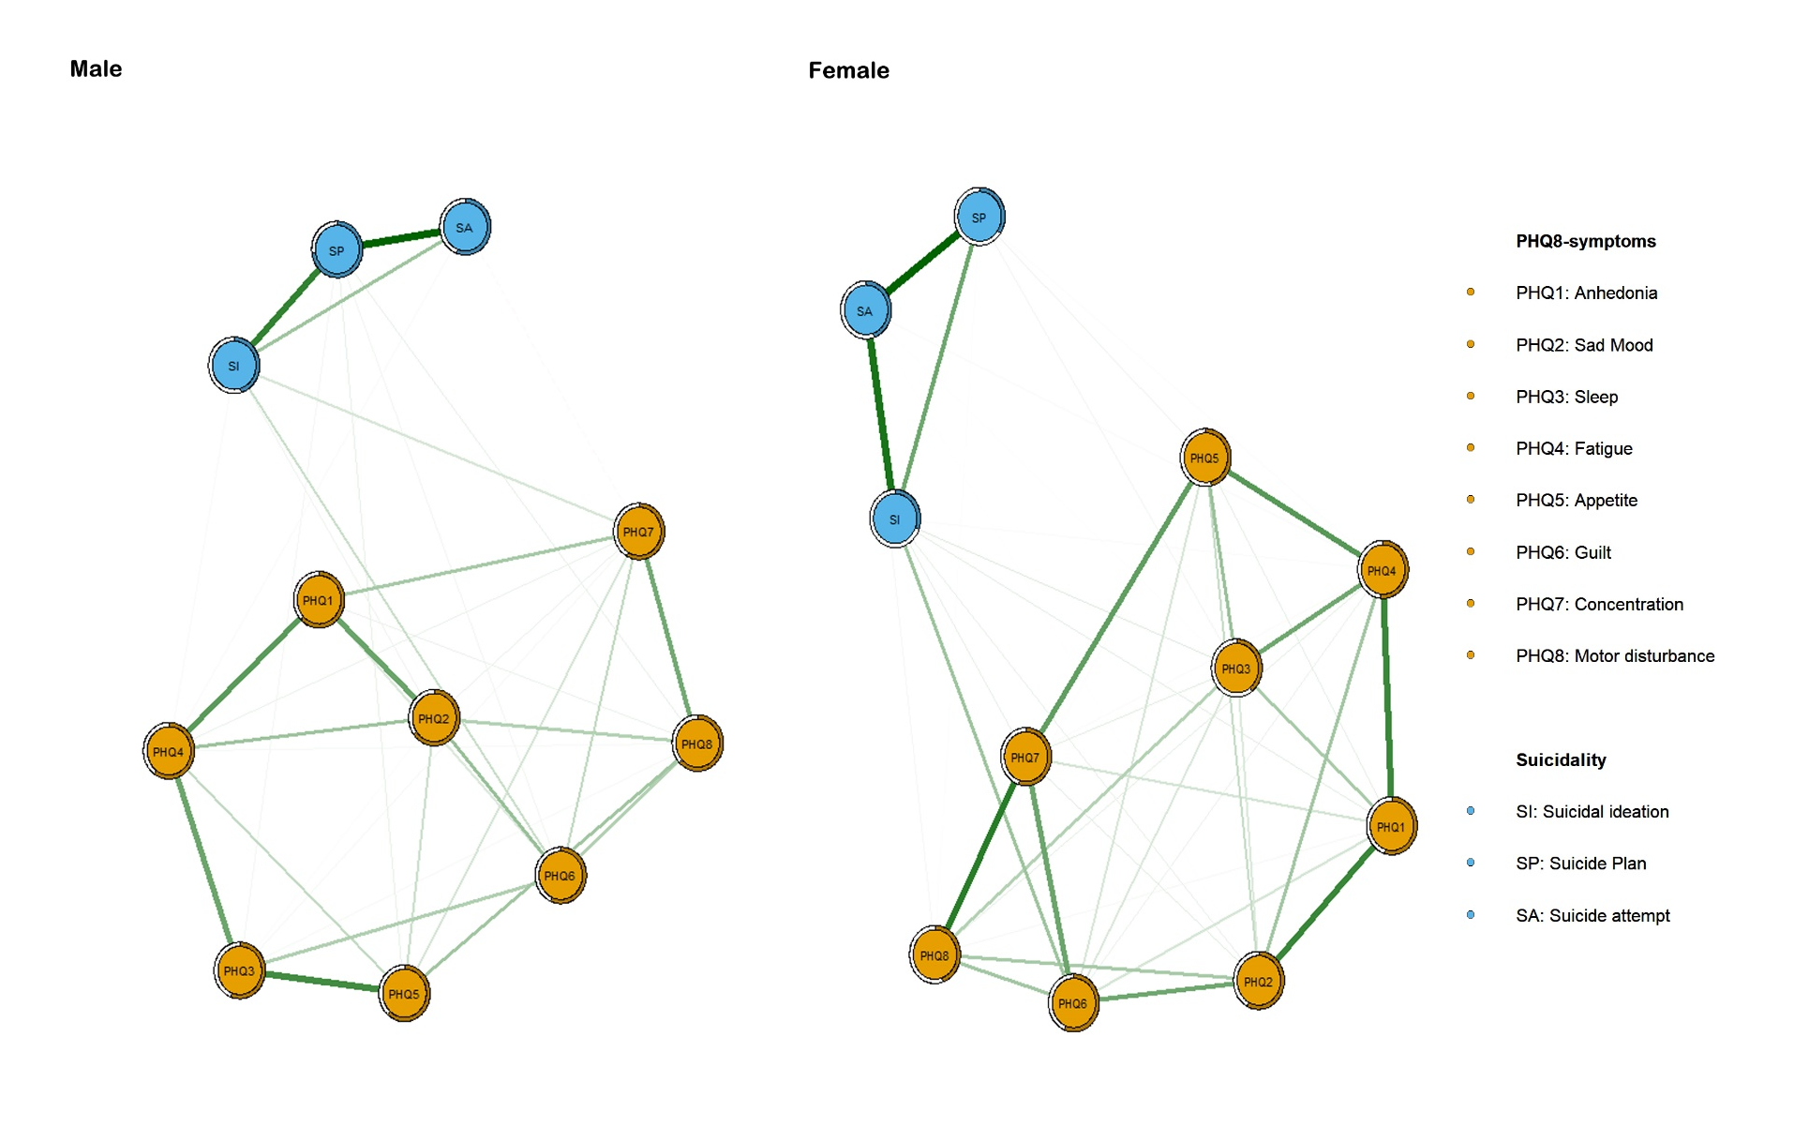

Figure S4. Comparison of network properties between females and males
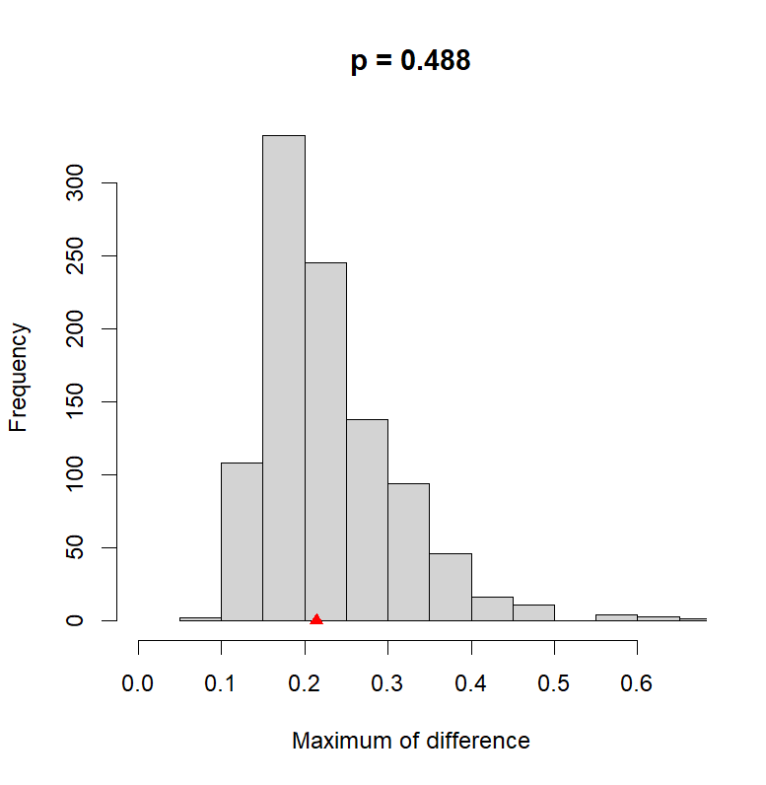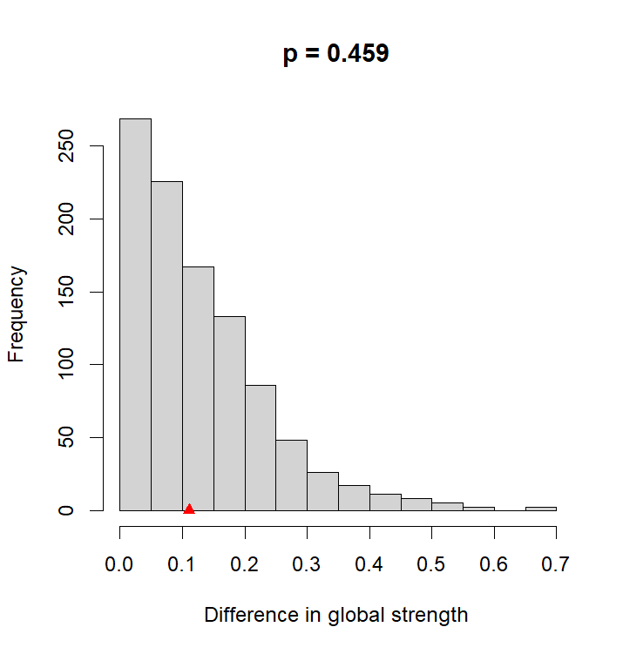
Note: Left Panel: A plot of bootstrap value of the maximum difference in any of the edge weights (1,000 permutations). The difference was not significant (M= 0.21, p=0.488).
Right Panel: A plot of bootstrap value of the difference in network global strength. The difference was not significant (network strength among male participants: 5.05; among female participants: 4.94; S: 0.11, p=0.459). For each comparison of edge-edge weights, permutation tests were used to test invariance. Holm-Bonferroni corrected p values were all >0.05 indicating absence of significant differences.
Figure S5. Comparison of network centrality indices between males and females.

